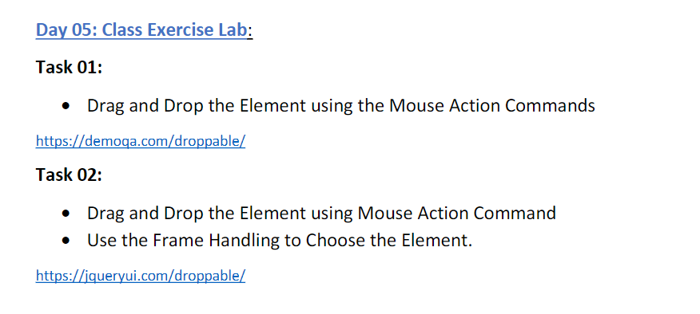

package com.day5_1;

import org.openqa.selenium.By;

import org.openqa.selenium.WebDriver;

import org.openqa.selenium.WebElement;

import org.openqa.selenium.chrome.ChromeDriver;

import org.openqa.selenium.chrome.ChromeOptions;

import org.openqa.selenium.interactions.Actions;

import io.github.bonigarcia.wdm.WebDriverManager;

public class CE_1 {

public static void main(String[] args) throws InterruptedException {

ChromeOptions co=new ChromeOptions();

co.addArguments("--remote-allow-origins=*");

WebDriverManager.chromedriver().setup();

WebDriver driver = new ChromeDriver();

String url="https://demoqa.com/droppable/";

driver.get(url);

driver.manage().window().maximize();

WebElement drag=driver.findElement(By.id("draggable"));

WebElement drop=driver.findElement(By.id("droppable"));

Actions a=new Actions(driver);

Thread.sleep(4000);

a.dragAndDrop(drag, drop).build().perform();

Thread.sleep(4000);

}

}

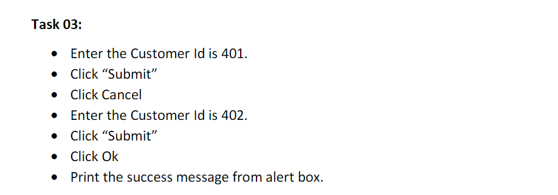

package com.day5_1;

import org.openqa.selenium.By;

import org.openqa.selenium.WebDriver;

import org.openqa.selenium.chrome.ChromeDriver;

import org.openqa.selenium.chrome.ChromeOptions;

import io.github.bonigarcia.wdm.WebDriverManager;

public class CE_2 {

public static void main(String args[]) throws InterruptedException {

ChromeOptions co = new ChromeOptions();

co.addArguments("--remote-allow-origins=*");

WebDriverManager.chromedriver().setup();

WebDriver driver = new ChromeDriver();

String url = "https://demo.guru99.com/test/delete_customer.php";

driver.get(url);

driver.manage().window().maximize();

driver.findElement(By.name("cusid")).sendKeys("401");

driver.findElement(By.name("submit")).click();

Thread.sleep(3000);

driver.switchTo().alert().dismiss();

Thread.sleep(3000);

driver.findElement(By.name("cusid")).clear();

Thread.sleep(3000);

driver.findElement(By.name("cusid")).sendKeys("402");

Thread.sleep(3000);

driver.findElement(By.name("submit")).click();

Thread.sleep(3000);

driver.switchTo().alert().accept();

Thread.sleep(3000);

System.out.print(driver.switchTo().alert().getText());

driver.switchTo().alert().accept();

}

}

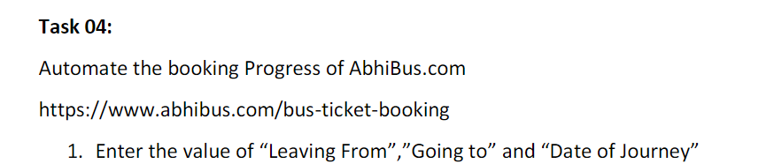

package com.day5_1;

import org.openqa.selenium.By;

import org.openqa.selenium.WebDriver;

import org.openqa.selenium.chrome.ChromeDriver;

import org.openqa.selenium.chrome.ChromeOptions;

import io.github.bonigarcia.wdm.WebDriverManager;

public class CE_4 {

public static void main(String[] args) throws InterruptedException {

ChromeOptions co=new ChromeOptions();

co.addArguments("--remote-allow-origins=*");

WebDriverManager.chromedriver().setup();

WebDriver driver=new ChromeDriver();

String url="https://www.abhibus.com/bus-ticket-booking";

driver.get(url);

driver.manage().window().maximize();

driver.findElement(By.id("source")).sendKeys("Kotagiri (Tamil Nadu)");

Thread.sleep(3000);

driver.findElement(By.id("destination")).sendKeys("Chennai");

Thread.sleep(3000);

driver.findElement(By.id("datepicker1")).click();

Thread.sleep(3000);

driver.findElement(By.xpath("//*[@id=\"ui-datepicker-div\"]/div[1]/table/tbody/tr[5]/td[5]/a")).click();

// Thread.sleep(3000);

// driver.findElement(By.xpath("//button[@type='button']")).click();

}

}

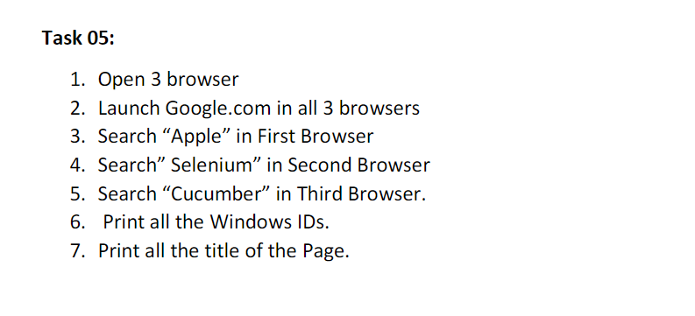

package com.day5_1;

import org.openqa.selenium.By;

import org.openqa.selenium.WebDriver;

import org.openqa.selenium.chrome.ChromeDriver;

import org.openqa.selenium.chrome.ChromeOptions;

import org.openqa.selenium.edge.EdgeDriver;

import io.github.bonigarcia.wdm.WebDriverManager;

public class CE_5 {

public static void main(String args[]) throws InterruptedException {

ChromeOptions co=new ChromeOptions();

co.addArguments("--remote-allow-origins=*");

WebDriverManager.chromedriver().setup();

WebDriver driver=new ChromeDriver();

String gog="https://www.google.com/";

driver.get(gog);

driver.manage().window().maximize();

WebDriver driver1=new EdgeDriver();

String gog1="https://www.google.com/";

driver1.get(gog1);

driver1.manage().window().maximize();

WebDriver driver2=new ChromeDriver();

String gog2="https://www.google.com/";

driver2.get(gog2);

driver2.manage().window().maximize();

driver.findElement(By.id("APjFqb")).sendKeys("Apple");

driver.findElement(By.xpath("/html/body/div[1]/div[3]/form/div[1]/div[1]/div[4]/center/input[1]")).click();

Thread.sleep(3000);

driver1.findElement(By.id("APjFqb")).sendKeys("Selenium");

driver1.findElement(By.xpath("/html/body/div[1]/div[3]/form/div[1]/div[1]/div[4]/center/input[1]")).click();

Thread.sleep(3000);

driver2.findElement(By.id("APjFqb")).sendKeys("cucumber");

driver2.findElement(By.xpath("/html/body/div[1]/div[3]/form/div[1]/div[1]/div[4]/center/input[1]")).click();

Thread.sleep(3000);

System.out.println(driver.getWindowHandle());

System.out.println(driver1.getWindowHandle());

System.out.println(driver2.getWindowHandle());

System.out.println(driver.getTitle());

System.out.println(driver1.getTitle());

System.out.println(driver2.getTitle());

}

}