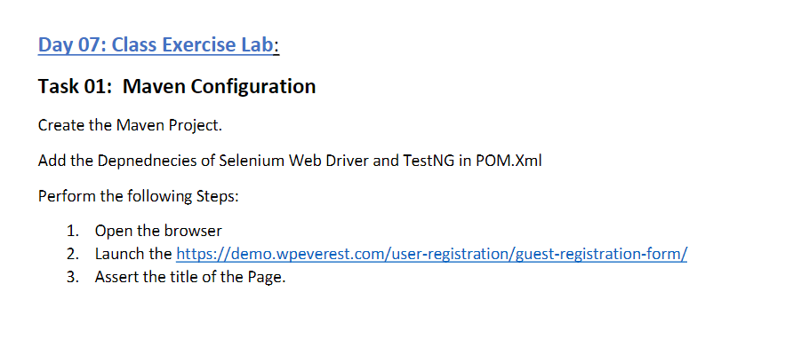

package day6;

import org.testng.annotations.Test;

import org.testng.annotations.BeforeMethod;

import org.openqa.selenium.WebDriver;

import org.openqa.selenium.chrome.ChromeDriver;

import org.testng.Assert;

import org.testng.annotations.AfterMethod;

public class CE_1 {

WebDriver driver;

@Test

public void title() {

String exp="Guest Registration Form – User Registration";

String tit=driver.getTitle();

Assert.assertEquals(exp, tit);

}

@BeforeMethod

public void beforeMethod() {

driver = new ChromeDriver();

String gog = "https://demo.wpeverest.com/user-registration/guest-registration-form/";

driver.get(gog);

driver.manage().window().maximize();

}

@AfterMethod

public void afterMethod() {

driver.quit();

}

}

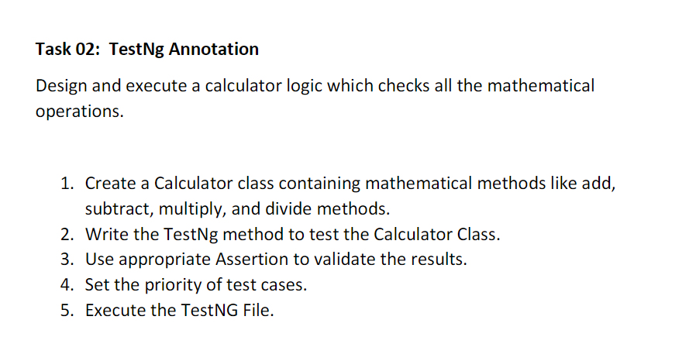

package day6;

import org.testng.annotations.Test;

import org.testng.annotations.BeforeMethod;

import org.testng.Assert;

import org.testng.annotations.AfterMethod;

public class CE_2 {

int a=234,b=124,res=0;

@Test(priority=2)

public void add() {

res=a+b;

System.out.println("Addition = "+res);

Assert.assertEquals(res, (a+b));

}

@Test(priority=1)

public void sub()

{

res=a-b;

System.out.println("Subtraction = "+res);

Assert.assertEquals(res, (a-b));

}

@Test(priority=4)

public void mult()

{

res=a*b;

System.out.println("Multiplication = "+res);

Assert.assertEquals(res, (a*b));

}

@Test(priority=3)

public void div()

{

res=a/b;

System.out.println("Division = "+res);

Assert.assertEquals(res, (a/b));

}

@BeforeMethod

public void beforeMethod() {

}

@AfterMethod

public void afterMethod() {

}

}

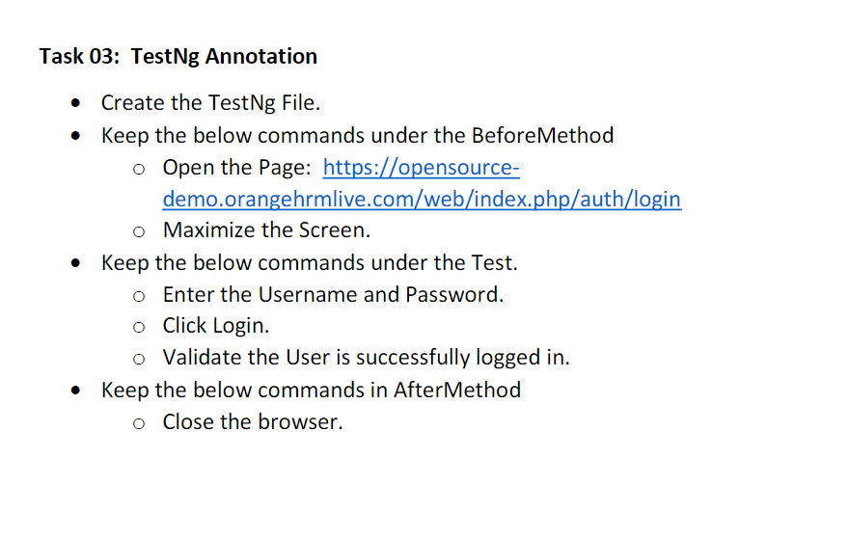

package day6;

import org.testng.annotations.Test;

import org.testng.annotations.BeforeMethod;

import org.openqa.selenium.By;

import org.openqa.selenium.WebDriver;

import org.openqa.selenium.WebElement;

import org.openqa.selenium.chrome.ChromeDriver;

import org.testng.Assert;

import org.testng.annotations.AfterMethod;

public class CE_3 {

WebDriver driver;

@Test

public void test() throws InterruptedException {

driver.findElement(By.xpath("//*[@id=\"app\"]/div[1]/div/div[1]/div/div[2]/div[2]/form/div[1]/div/div[2]/input")).sendKeys("Admin");

Thread.sleep(3000);

driver.findElement(By.xpath("//*[@id=\"app\"]/div[1]/div/div[1]/div/div[2]/div[2]/form/div[2]/div/div[2]/input")).sendKeys("admin123");

Thread.sleep(3000);

driver.findElement(By.xpath("//*[@id=\'app\']/div[1]/div/div[1]/div/div[2]/div[2]/form/div[3]/button")).click();

Thread.sleep(3000);

String dash="Dashboard";

WebElement txt=driver.findElement(By.xpath("//*[@id=\"app\"]/div[1]/div[1]/header/div[1]/div[1]/span/h6"));

String exp=txt.getText();

Assert.assertEquals(dash, exp);

}

@BeforeMethod

public void beforeMethod() throws InterruptedException {

driver=new ChromeDriver();

String url="https://opensource-demo.orangehrmlive.com/web/index.php/auth/login";

driver.get(url);

driver.manage().window().maximize();

Thread.sleep(2000);

}

@AfterMethod

public void afterMethod() {

driver.quit();

}

}

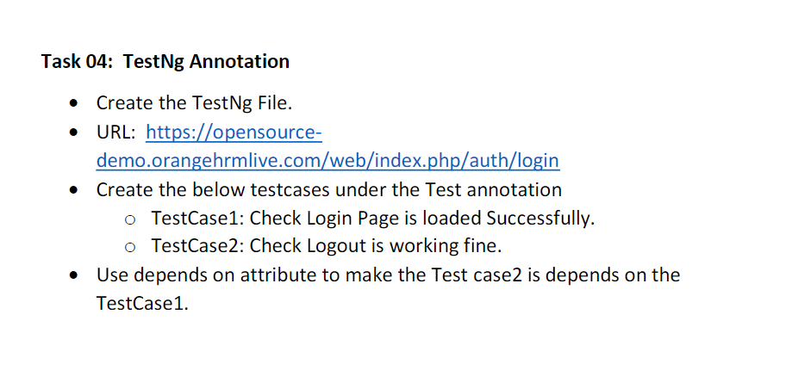

package day6;

import org.testng.annotations.Test;

import org.testng.annotations.BeforeMethod;

import org.openqa.selenium.By;

import org.openqa.selenium.WebDriver;

import org.openqa.selenium.WebElement;

import org.openqa.selenium.chrome.ChromeDriver;

import org.testng.Assert;

import org.testng.annotations.AfterClass;

import org.testng.annotations.AfterMethod;

import org.testng.annotations.BeforeClass;

public class CE_4 {

WebDriver driver;

@Test(dependsOnMethods = "Case1")

public void Case2() throws InterruptedException {

driver.findElement(

By.xpath("//*[@id=\"app\"]/div[1]/div/div[1]/div/div[2]/div[2]/form/div[1]/div/div[2]/input"))

.sendKeys("Admin");

Thread.sleep(3000);

driver.findElement(

By.xpath("//*[@id=\"app\"]/div[1]/div/div[1]/div/div[2]/div[2]/form/div[2]/div/div[2]/input"))

.sendKeys("admin123");

Thread.sleep(3000);

driver.findElement(By.xpath("//*[@id=\'app\']/div[1]/div/div[1]/div/div[2]/div[2]/form/div[3]/button")).click();

Thread.sleep(3000);

driver.findElement(By.xpath("//*[@id=\"app\"]/div[1]/div[1]/header/div[1]/div[2]/ul/li/span")).click();

Thread.sleep(2000);

driver.findElement(By.xpath("//*[@id=\"app\"]/div[1]/div[1]/header/div[1]/div[2]/ul/li/ul/li[4]/a")).click();

Thread.sleep(2000);

WebElement txt = driver.findElement(By.xpath("//*[@id=\"app\"]/div[1]/div/div[1]/div/div[2]/h5"));

String log = txt.getText();

String logout = "Login";

Assert.assertEquals(logout, log);

System.out.println("logout page successfull");

}

@Test

public void Case1() {

WebElement txt = driver.findElement(By.xpath("//*[@id=\"app\"]/div[1]/div/div[1]/div/div[2]/h5"));

String log = txt.getText();

String login = "Login";

Assert.assertEquals(login, log);

System.out.println("login page successfull");

}

@BeforeClass

public void beforeMethod() throws InterruptedException {

driver = new ChromeDriver();

String url = "https://opensource-demo.orangehrmlive.com/web/index.php/auth/login";

driver.get(url);

driver.manage().window().maximize();

Thread.sleep(2000);

}

@AfterClass

public void afterMethod() {

driver.quit();

}

}

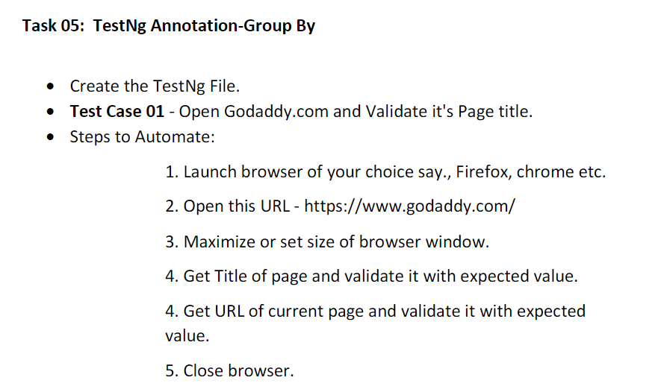

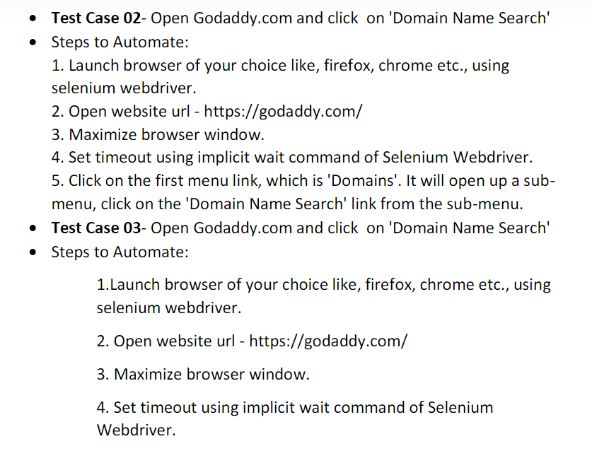

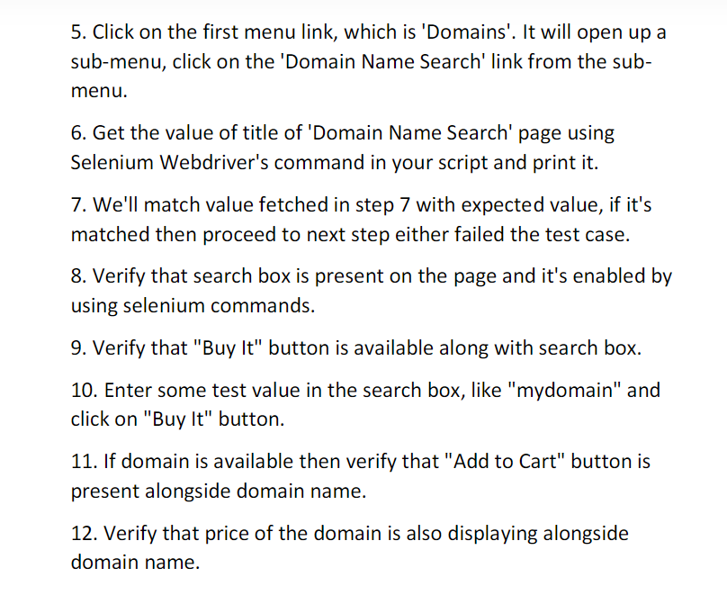

package day6;

import org.testng.annotations.Test;

import org.testng.annotations.BeforeMethod;

import java.util.concurrent.TimeUnit;

import org.openqa.selenium.By;

import org.openqa.selenium.WebDriver;

import org.openqa.selenium.WebElement;

import org.openqa.selenium.chrome.ChromeDriver;

import org.testng.Assert;

import org.testng.annotations.AfterMethod;

public class CE_5 {

WebDriver driver;

@Test(groups = "smokeTest",priority =1)

public void Case1() {

String title = "Domain Names, Websites, Hosting & Online Marketing Tools - GoDaddy IN";

String exp = driver.getTitle();

Assert.assertEquals(title, exp);

String url = "https://www.godaddy.com/en-in";

String expurl = driver.getCurrentUrl();

Assert.assertEquals(url, expurl);

System.out.println("Both the title and url are matched");

}

// @SuppressWarnings("deprecation")

@Test(groups = "regressionTest", dependsOnGroups = "smokeTest",priority=2)

public void Case2() throws InterruptedException {

// driver.manage().timeouts().implicitlyWait(3000, TimeUnit.MILLISECONDS);

driver.findElement(By.xpath("//button[@aria-label='Open Menu']")).click();

Thread.sleep(3000);

driver.findElement(

By.xpath("//*[@id=\"id-631b049a-e9c0-4d24-8710-c504745206dd\"]/div[2]/div[1]/ul/li[1]/button")).click();

Thread.sleep(3000);

driver.findElement(By.xpath(

"//*[@id=\"id-631b049a-e9c0-4d24-8710-c504745206dd\"]/div[2]/div[1]/ul/li[1]/div/div[2]/div[1]/ul/li[2]/a"))

.click();

Thread.sleep(3000);

System.out.println("Test Case 2 Successfull");

}

@Test(groups ="regressionTest" ,dependsOnGroups = "smokeTest",priority = 3)

public void Case3() throws InterruptedException {

driver.findElement(By.xpath("//button[@aria-label='Open Menu']")).click();

Thread.sleep(3000);

driver.findElement(

By.xpath("//*[@id=\"id-631b049a-e9c0-4d24-8710-c504745206dd\"]/div[2]/div[1]/ul/li[1]/button")).click();

Thread.sleep(3000);

driver.findElement(By.xpath(

"//*[@id=\"id-631b049a-e9c0-4d24-8710-c504745206dd\"]/div[2]/div[1]/ul/li[1]/div/div[2]/div[1]/ul/li[2]/a"))

.click();

String title="Domain Names, Websites, Hosting & Online Marketing Tools - GoDaddy IN";

String exp=driver.getTitle();

Assert.assertEquals(title, exp);

System.out.println(exp);

Thread.sleep(3000);

WebElement search=driver.findElement(By.xpath("//*[@id=\"8469f0c3-e08f-4343-9756-ce0390b0d581\"]"));

search.isDisplayed();

System.out.println("Search bar checked");

Thread.sleep(3000);

WebElement buy=driver.findElement(By.xpath("//*[@id=\"id-1467954b-c5e3-4b0c-9046-9fc94d8ca892\"]/section/div/div/section/div/div[1]/div/div/div[2]/button"));

buy.isDisplayed();

System.out.println("Buy checked");

Thread.sleep(3000);

driver.findElement(By.xpath("//input[@name='searchText']")).sendKeys("site");

Thread.sleep(10000);

driver.findElement(By.xpath("//button[@aria-label='Buy It']")).click();

Thread.sleep(25000);

WebElement cart=driver.findElement(By.xpath("//button[@aria-label='Add sites.club to cart']"));

cart.isDisplayed();

System.out.println("Cart checked");

Thread.sleep(3000);

WebElement price=driver.findElement(By.xpath("//*[@id=\"search-app\"]/div/div/div/div[2]/div[2]/div/div/div[1]/div/div/div[1]/div/div[1]/div[2]/div/div[1]/div/span"));

System.out.println(price.getText());

}

@BeforeMethod

public void beforeClass() throws InterruptedException {

driver = new ChromeDriver();

String url = "https://www.godaddy.com/en-in";

driver.get(url);

driver.manage().window().maximize();

Thread.sleep(3000);

}

@AfterMethod

public void afterClass() {

driver.quit();

}

}