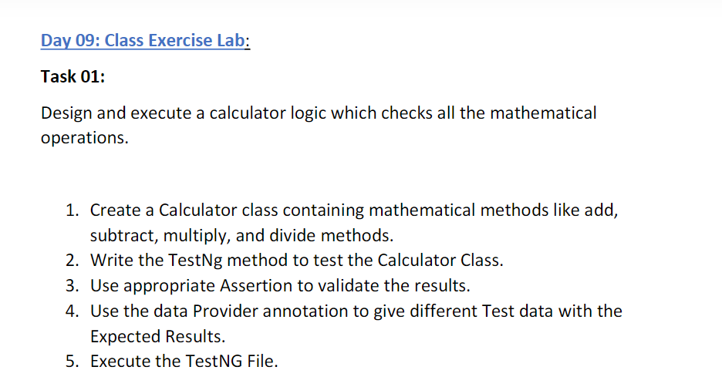

package day7;

import org.testng.annotations.Test;

import org.testng.annotations.DataProvider;

public class CE_1 {

@Test(dataProvider = "dp")

public void add(Integer n, Integer s) {

int sum=n+s;

System.out.println("Addition "+sum);

}

@Test(dataProvider = "dp")

public void sub(Integer n, Integer s) {

int sum=n-s;

System.out.println("Subtraction "+sum);

}

@Test(dataProvider = "dp")

public void mul(Integer n, Integer s) {

int sum=n*s;

System.out.println("Multiplication "+sum);

}

@Test(dataProvider = "dp")

public void div(Integer n, Integer s) {

int sum=n/s;

System.out.println("Division "+sum);

}

@DataProvider

public Object[][] dp() {

return new Object[][]

{

new Object[] { 8, 4 },

};

}

}

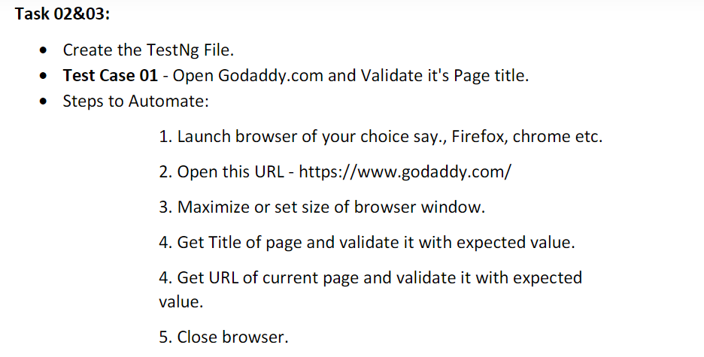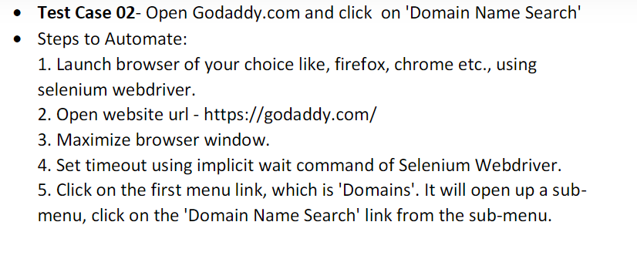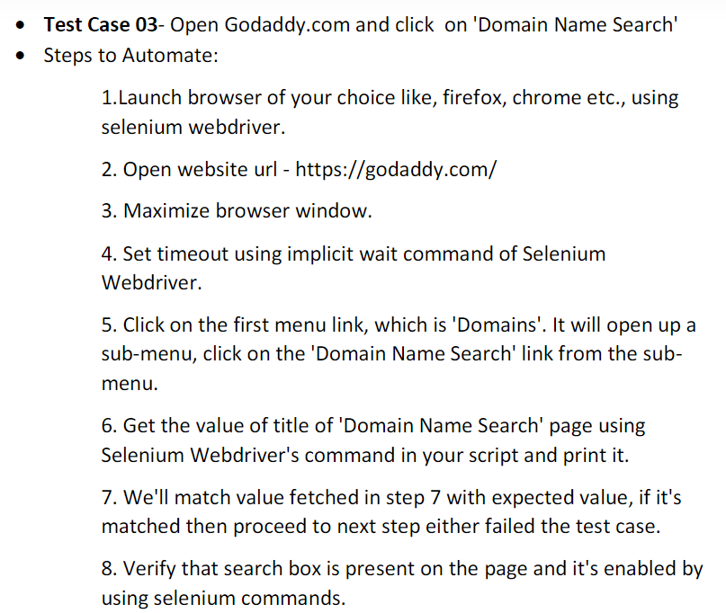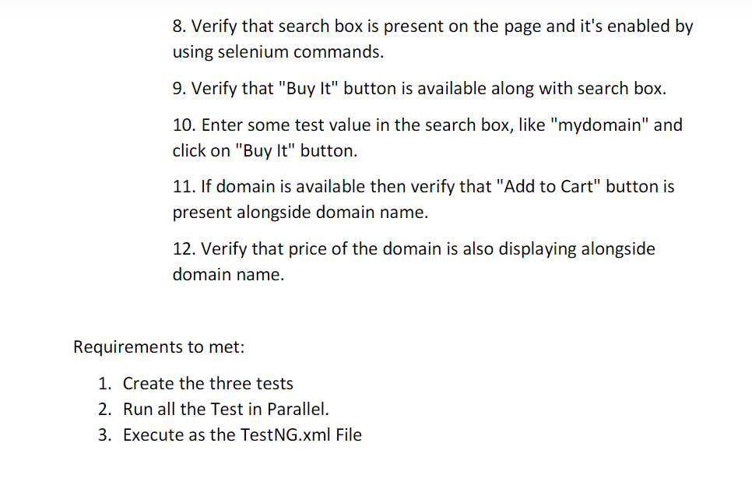

package day7;

import org.testng.annotations.Test;

import org.testng.annotations.BeforeMethod;

import org.openqa.selenium.By;

import org.openqa.selenium.Keys;

import org.openqa.selenium.WebDriver;

import org.openqa.selenium.chrome.ChromeDriver;

import org.testng.Assert;

import org.testng.annotations.AfterMethod;

import org.testng.annotations.DataProvider;

public class CE_2 {

WebDriver driver;

@Test(dataProvider = "dp")

public void Case1(String tit,String ur) {

String s=driver.getTitle();

Assert.assertEquals(tit, s);

String url=driver.getCurrentUrl();

Assert.assertEquals(ur, url);

}

@Test

public void Case2() throws InterruptedException {

driver.findElement(By.xpath("//button[@aria-label='Open Menu']")).click();

Thread.sleep(3000);

driver.findElement(By.xpath("//*[@id=\"id-631b049a-e9c0-4d24-8710-c504745206dd\"]/div[2]/div[1]/ul/li[1]/button")).click();

Thread.sleep(3000);

driver.findElement(By.xpath("//*[@id=\"id-631b049a-e9c0-4d24-8710-c504745206dd\"]/div[2]/div[1]/ul/li[1]/div/div[2]/div[1]/ul/li[2]/a")).click();

Thread.sleep(3000);

}

@Test

public void Case3() throws InterruptedException {

driver.findElement(By.xpath("//button[@aria-label='Open Menu']")).click();

Thread.sleep(3000);

driver.findElement(By.xpath("//*[@id=\"id-631b049a-e9c0-4d24-8710-c504745206dd\"]/div[2]/div[1]/ul/li[1]/button")).click();

Thread.sleep(3000);

driver.findElement(By.xpath("//*[@id=\"id-631b049a-e9c0-4d24-8710-c504745206dd\"]/div[2]/div[1]/ul/li[1]/div/div[2]/div[1]/ul/li[2]/a")).click();

Thread.sleep(3000);

String tit="GoDaddy Domain Search - Buy and Register Available Domain Names";

String exp=driver.getTitle();

Assert.assertEquals(tit,exp );

System.out.println(exp);

Thread.sleep(4000);

driver.findElement(By.xpath("//*[@id=\"8469f0c3-e08f-4343-9756-ce0390b0d581\"]")).isEnabled();

Thread.sleep(15000);

driver.findElement(By.xpath("//button[@aria-label='Buy It']")).isEnabled();

driver.findElement(By.xpath("//*[@id=\"8469f0c3-e08f-4343-9756-ce0390b0d581\"]")).sendKeys("mydomain");

Thread.sleep(2000);

driver.findElement(By.xpath("//button[@aria-label='Buy It']")).sendKeys(Keys.ENTER);

Thread.sleep(20000);

driver.findElement(By.xpath("//button[@class='ux-button ux-button-primary']")).isEnabled();

Thread.sleep(3000);

driver.findElement(By.xpath("//*[@id=\"search-app\"]/div/div/div/div[2]/div[1]/div[2]/div[1]/div[2]/div[4]/div[2]/div[2]/span")).isDisplayed();

}

@BeforeMethod

public void beforeMethod() throws InterruptedException {

driver = new ChromeDriver();

String url = "https://www.godaddy.com/en-in";

driver.get(url);

driver.manage().window().maximize();

Thread.sleep(3000);

}

@AfterMethod

public void afterMethod() {

driver.close();

}

@DataProvider

public Object[][] dp() {

return new Object[][] {

new Object[] { "Domain Names, Websites, Hosting & Online Marketing Tools - GoDaddy IN" ,"https://www.godaddy.com/en-in" }

};

}

}

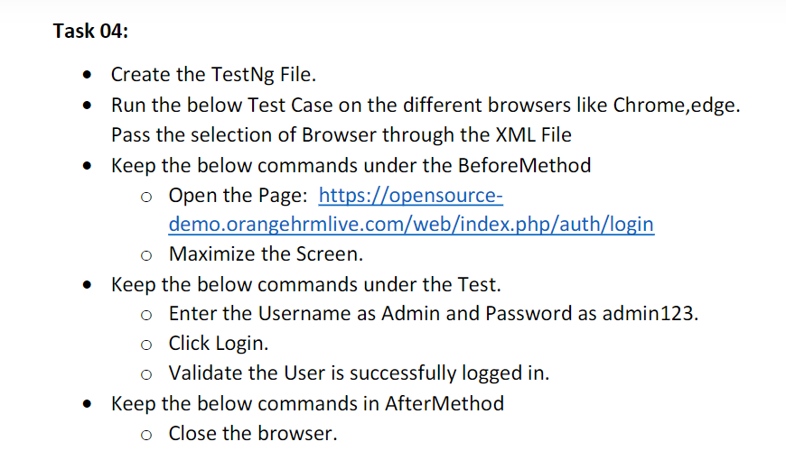

**package** day7;

**import** org.openqa.selenium.By;

**import** org.openqa.selenium.WebDriver;

**import** org.openqa.selenium.WebElement;

**import** org.openqa.selenium.chrome.ChromeDriver;

**import** org.openqa.selenium.edge.EdgeDriver;

**import** org.testng.Assert;

**import** org.testng.annotations.AfterClass;

**import** org.testng.annotations.BeforeClass;

**import** org.testng.annotations.Parameters;

**import** org.testng.annotations.Test;

**public** **class** CE_4 {

WebDriver driver;

@Test

**public** **void** Case1() **throws** InterruptedException {

driver.findElement(By.*xpath*("//input[@name='username']")).sendKeys("Admin");

driver.findElement(By.*xpath*("//input[@name='password']")).sendKeys("admin123");

Thread.*sleep*(2000);

driver.findElement(By.*xpath*("//button[@type='submit']")).click();

Thread.*sleep*(4000);

String dash="Dashboard";

WebElement d=driver.findElement(By.*xpath*("//*[@id=\"app\"]/div[1]/div[1]/header/div[1]/div[1]/span/h6"));

String m=d.getText();

Thread.*sleep*(3000);

Assert.*assertEquals*(m, dash);

}

@Parameters("browser")

@BeforeClass

**public** **void** beforeMethod(String browser) **throws** InterruptedException {

**if**(browser.equals("chrome"))

{

driver=**new** ChromeDriver();

String gog="https://opensource-demo.orangehrmlive.com/web/index.php/auth/login";

driver.get(gog);

driver.manage().window().maximize();

Thread.*sleep*(2000);

}

**else** **if**(browser.equals("edge"))

{

driver=**new** EdgeDriver();

String gog1="https://opensource-demo.orangehrmlive.com/web/index.php/auth/login";

driver.get(gog1);

driver.manage().window().maximize();

Thread.*sleep*(2000);

}

**else** **if**(browser.equals("chrome1"))

{

driver=**new** ChromeDriver();

String gog2="https://opensource-demo.orangehrmlive.com/web/index.php/auth/login";

driver.get(gog2);

driver.manage().window().maximize();

Thread.*sleep*(2000);

}

}

@AfterClass

**public** **void** afterMethod() {

driver.quit();

}

}

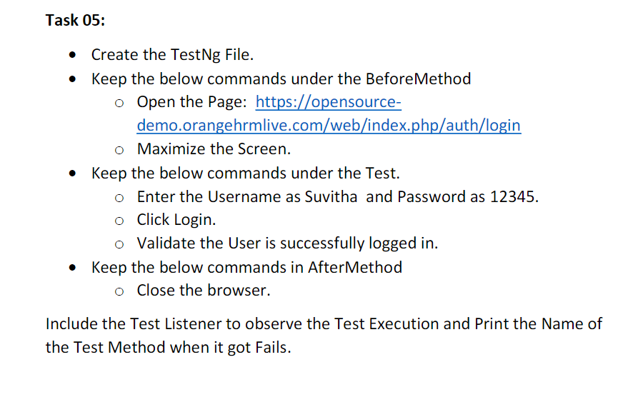

**package** day7;

**import** org.openqa.selenium.By;

**import** org.openqa.selenium.WebDriver;

**import** org.openqa.selenium.WebElement;

**import** org.openqa.selenium.chrome.ChromeDriver;

**import** org.openqa.selenium.edge.EdgeDriver;

**import** org.testng.Assert;

**import** org.testng.annotations.AfterClass;

**import** org.testng.annotations.BeforeClass;

**import** org.testng.annotations.Parameters;

**import** org.testng.annotations.Test;

**public** **class** CE_5 {

WebDriver driver;

@Test

**public** **void** Login() **throws** InterruptedException {

driver.findElement(By.*xpath*("//input[@name='username']")).sendKeys("Suvitha");

driver.findElement(By.*xpath*("//input[@name='password']")).sendKeys("1234");

Thread.*sleep*(2000);

driver.findElement(By.*xpath*("//button[@type='submit']")).click();

Thread.*sleep*(4000);

String dash="Dashboard";

WebElement d=driver.findElement(By.*xpath*("//*[@id=\"app\"]/div[1]/div[1]/header/div[1]/div[1]/span/h6"));

String m=d.getText();

Thread.*sleep*(3000);

Assert.*assertEquals*(m, dash);

}

@Parameters("browser")

@BeforeClass

**public** **void** beforeMethod(String browser) **throws** InterruptedException {

**if**(browser.equals("chrome"))

{

driver=**new** ChromeDriver();

String gog="https://opensource-demo.orangehrmlive.com/web/index.php/auth/login";

driver.get(gog);

driver.manage().window().maximize();

Thread.*sleep*(2000);

}

**else** **if**(browser.equals("edge"))

{

driver=**new** EdgeDriver();

String gog1="https://opensource-demo.orangehrmlive.com/web/index.php/auth/login";

driver.get(gog1);

driver.manage().window().maximize();

Thread.*sleep*(2000);

}

**else** **if**(browser.equals("chrome1"))

{

driver=**new** ChromeDriver();

String gog2="https://opensource-demo.orangehrmlive.com/web/index.php/auth/login";

driver.get(gog2);

driver.manage().window().maximize();

Thread.*sleep*(2000);

}

}

@AfterClass

**public** **void** afterMethod() {

driver.quit();

}

}

**POM.XML**

<?xml version="1.0" encoding="UTF-8"?>

<!DOCTYPE suite SYSTEM "https://testng.org/testng-1.0.dtd">

<suite parallel="methods" name="Suite">

<listeners><listener class-name="day7.Listner_1"></listener></listeners>

<test thread-count="5" parallel="methods" name="Test">

<parameter name="browser" value="edge"></parameter>

<classes>

<!-- <class name="day7.CE_2"/>-->

<!-- <class name="day7.CE_1"/>-->

<!--<class name="day7.CE_4"/>-->

<class name="day7.CE_5"/>

</classes>

</test> <!-- Test -->

</suite> <!-- Suite -->