CIA-1

VIGNESH N

727721EUCS178

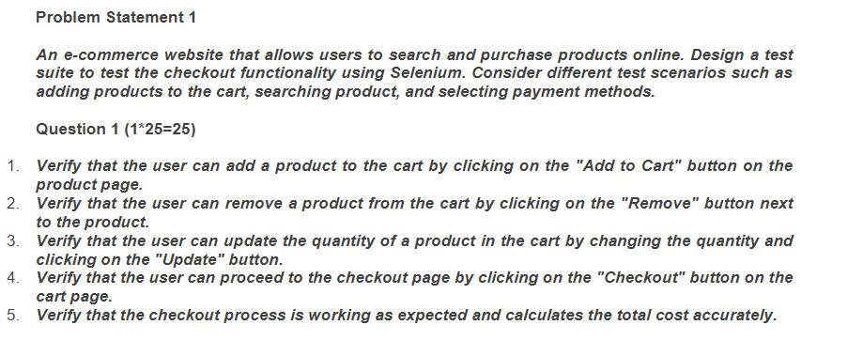

Code:-

**package** cia;

**import** org.openqa.selenium.By;

**import** org.openqa.selenium.JavascriptExecutor;

**import** org.openqa.selenium.WebDriver;

**import** org.openqa.selenium.chrome.ChromeDriver;

**import** org.openqa.selenium.chrome.ChromeOptions;

**import** io.github.bonigarcia.wdm.WebDriverManager;

**public** **class** Question_1{

**public** **static** **void** main(String[] args) **throws** InterruptedException {

ChromeOptions co=**new** ChromeOptions();

co.addArguments("--remote-allow-origins=*");

WebDriverManager.*chromedriver*().setup();

WebDriver driver=**new** ChromeDriver();

String url="https://www.amazon.in/";

driver.get(url);

Thread.*sleep*(1000);

driver.findElement(By.*xpath*("//*[@id=\"nav-link-accountList\"]/span/span")).click();

Thread.*sleep*(2000);

driver.findElement(By.*xpath*("//*[@id=\"ap_email\"]")).sendKeys("8870051808");

Thread.*sleep*(2000);

driver.findElement(By.*xpath*("//*[@id=\"continue\"]")).click();

Thread.*sleep*(2000);

driver.findElement(By.*xpath*("//*[@id=\"ap_password\"]")).sendKeys("vinodhan1808");

Thread.*sleep*(2000);

driver.findElement(By.*xpath*("//*[@id=\"signInSubmit\"]")).click();

Thread.*sleep*(6000);

JavascriptExecutor js = (JavascriptExecutor) driver;

js.executeScript("window.scrollBy(0,200)", "");

driver.findElement(By.*xpath*("//img[@alt='Samsung Galaxy M14 5G (Berry Blue, 4GB, 128GB Storage) | 50MP Triple Cam | 6000 mAh Battery | 5nm Octa-Core Processor | Andro']")).click();

Thread.*sleep*(15000);

driver.findElement(By.*xpath*("//*[@id=\"add-to-cart-button\"]")).click();

Thread.*sleep*(10000);

**boolean** pop=driver.findElement(By.*xpath*("//*[@id=\"attach-accessory-pane\"]/div")).isDisplayed();

**if**(pop)

{

System.***out***.println("The item is added to cart");

}

**else**

{

System.***out***.println("Not Added");

}

Thread.*sleep*(3000);

driver.findElement(By.*xpath*("//*[@id=\"attach-sidesheet-view-cart-button\"]/span/input")).click();

Thread.*sleep*(5000);

driver.findElement(By.*xpath*("//*[@id=\"sc-active-3a6a1fc5-f82a-4fba-942d-cb97a829484e\"]/div[4]/div/div[3]/div[1]/span[2]/span/input")).click();

String no="Your Amazon Cart is empty.";

String del=driver.findElement(By.*xpath*("//*[@id=\"sc-active-cart\"]/div/div[1]/div/h1")).getText();

**if**(no.equals(del))

{

System.***out***.println("Nothing in your cart");

}

**else**

{

System.***out***.println("Many there");

}

**boolean** one=driver.findElement(By.*xpath*("//*[@id=\"a-autoid-0-announce\"]/span[2]")).isDisplayed();

driver.findElement(By.*xpath*("//*[@id=\"a-autoid-0-announce\"]")).click();

Thread.*sleep*(3000);

driver.findElement(By.*xpath*("//*[@id=\"quantity_4\"]")).click();

**if**(!one)

{

System.***out***.println("The item quantity is updated");

}

**else**

{

System.***out***.println("The item is not updated");

}

Thread.*sleep*(3000);

driver.findElement(By.*xpath*("//*[@id=\"sc-buy-box-ptc-button\"]/span/input"));

Thread.*sleep*(3000);

driver.findElement(By.*xpath*("//*[@id=\"sc-buy-box-ptc-button\"]/span/input")).click();

Thread.*sleep*(3000);

String check="Checkout";

String out=driver.findElement(By.*xpath*("//*[@id=\"header\"]/div/div[3]/h1")).getText();

**if**(check.equals(out))

{

System.***out***.println("Checkout page is appeared");

}

**else**

{

System.***out***.println("Failure");

}

Thread.*sleep*(3000);

driver.quit();

}

}

Output:-

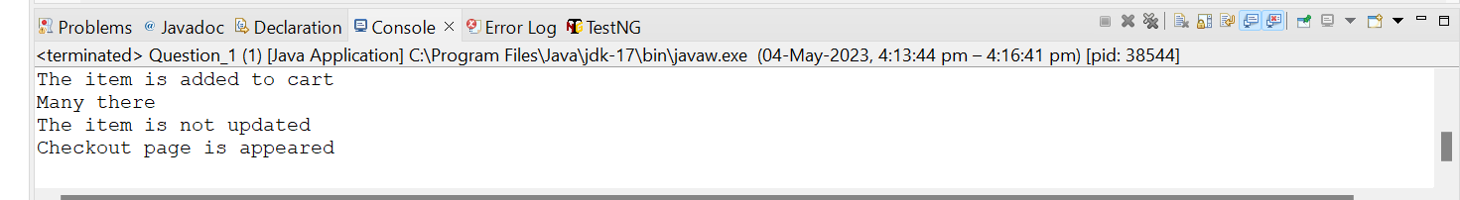

Question-2

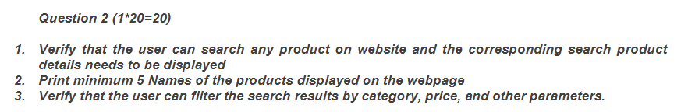

Code:-

**package** cia;

**import** java.util.List;

**import** org.openqa.selenium.By;

**import** org.openqa.selenium.WebDriver;

**import** org.openqa.selenium.WebElement;

**import** org.openqa.selenium.chrome.ChromeDriver;

**import** org.openqa.selenium.chrome.ChromeOptions;

**import** io.github.bonigarcia.wdm.WebDriverManager;

**public** **class** Question_2 {

**public** **static** **void** main(String[] args) **throws** InterruptedException {

// **TODO** Auto-generated method stub

ChromeOptions co=**new** ChromeOptions();

co.addArguments("--remote-allow-origins=*");

WebDriverManager.*chromedriver*().setup();

WebDriver driver=**new** ChromeDriver();

String url="https://www.amazon.in/";

driver.get(url);

Thread.*sleep*(1000);

driver.findElement(By.*xpath*("//*[@id=\"nav-link-accountList\"]/span/span")).click();

Thread.*sleep*(2000);

driver.findElement(By.*xpath*("//*[@id=\"ap_email\"]")).sendKeys("8870051808");

Thread.*sleep*(2000);

driver.findElement(By.*xpath*("//*[@id=\"continue\"]")).click();

Thread.*sleep*(2000);

driver.findElement(By.*xpath*("//*[@id=\"ap_password\"]")).sendKeys("vinodhan1808");

Thread.*sleep*(2000);

driver.findElement(By.*xpath*("//*[@id=\"signInSubmit\"]")).click();

driver.findElement(By.*xpath*("//*[@id=\"twotabsearchtextbox\"]")).sendKeys("Iphone 14");

driver.findElement(By.*xpath*("//*[@id=\"nav-search-submit-button\"]")).click();

List<WebElement> name=driver.findElements(By.*xpath*("//h2[@class='a-size-mini a-spacing-none a-color-base s-line-clamp-2']"));

**for**(**int** i=0;i<5;i++)

{

String s=name.get(i).getText();

System.***out***.println(s);

}

Thread.*sleep*(3000);

driver.findElement(By.*xpath*("//*[@id=\"p_89/Samsung\"]/span/a/div/label/i")).click();

Thread.*sleep*(3000);

driver.navigate().back();

System.***out***.println("filter 1 done");

driver.findElement(By.*xpath*("//*[@id=\"p_n_feature_eight_browse-bin/14267636031\"]/span/a/div/label/i")).click();

Thread.*sleep*(3000);

driver.navigate().back();

System.***out***.println("filter 2 done");

driver.findElement(By.*xpath*("//*[@id=\"p_n_size_two_browse-vebin/15564000031\"]/span/a/span/div")).click();

Thread.*sleep*(3000);

driver.navigate().back();

System.***out***.println("filter 3 done");

}

}

Output:-

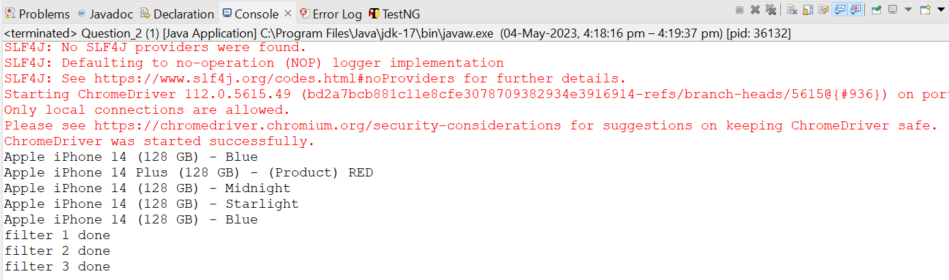

Question-3

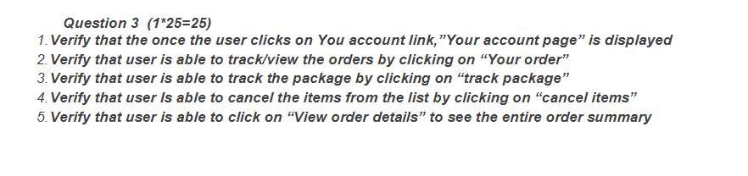

Code:-

**package** cia;

**import** org.openqa.selenium.By;

**import** org.openqa.selenium.WebDriver;

**import** org.openqa.selenium.chrome.ChromeDriver;

**import** org.openqa.selenium.chrome.ChromeOptions;

**import** io.github.bonigarcia.wdm.WebDriverManager;

**public** **class** Question_3 {

**public** **static** **void** main(String[] args) **throws** InterruptedException {

// **TODO** Auto-generated method stub

ChromeOptions co=**new** ChromeOptions();

co.addArguments("--remote-allow-origins=*");

WebDriverManager.*chromedriver*().setup();

WebDriver driver=**new** ChromeDriver();

String url="https://www.amazon.in/";

driver.get(url);

Thread.*sleep*(1000);

driver.findElement(By.*xpath*("//*[@id=\"nav-link-accountList\"]/span/span")).click();

Thread.*sleep*(2000);

driver.findElement(By.*xpath*("//*[@id=\"ap_email\"]")).sendKeys("8870051808");

Thread.*sleep*(2000);

driver.findElement(By.*xpath*("//*[@id=\"continue\"]")).click();

Thread.*sleep*(2000);

driver.findElement(By.*xpath*("//*[@id=\"ap_password\"]")).sendKeys("vinodhan1808");

Thread.*sleep*(2000);

driver.findElement(By.*xpath*("//*[@id=\"signInSubmit\"]")).click();

Thread.*sleep*(3000);

driver.findElement(By.*xpath*("//*[@id=\"nav-link-accountList\"]/span/span")).click();

String acc="Your Account";

String ac=driver.findElement(By.*xpath*("//*[@id=\"a-page\"]/div[2]/div/div[1]/h1")).getText();

**if**(acc.equals(ac))

{

System.***out***.println("your account page is opened");

}

**else**

{

System.***out***.println("Not ur page");

}

Thread.*sleep*(3000);

driver.findElement(By.*xpath*("//*[@id=\"a-page\"]/div[2]/div/div[2]/div[1]/a/div/div")).click();

String ord="Your Orders";

String or=driver.findElement(By.*xpath*("//*[@id=\"a-page\"]/section/div/div[2]/div[1]/h1")).getText();

**if**(ord.equals(or))

{

System.***out***.println("ur in order page");

}

**else**

{

System.***out***.println("ur not");

}

System.***out***.println(driver.findElement(By.*xpath*("//*[@id=\"a-page\"]/section/div/div[8]/div")).getText());

}

}

Output:-

