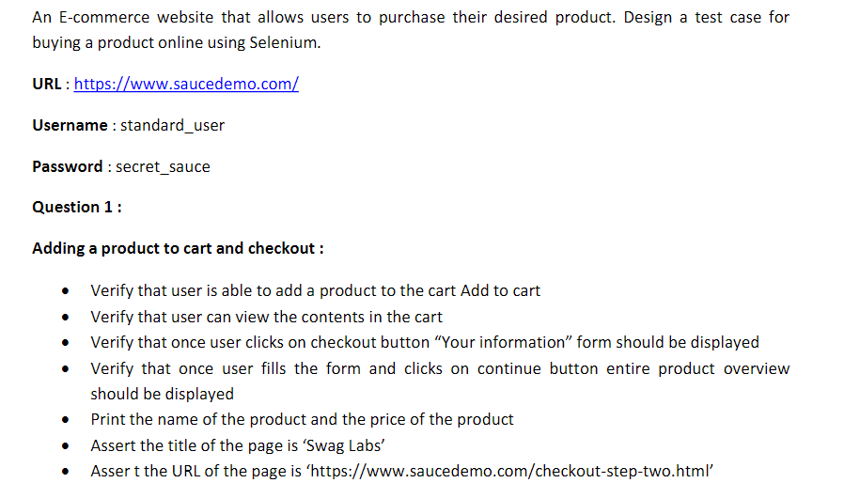

**package** exam;

**import** org.openqa.selenium.By;

**import** org.openqa.selenium.SearchContext;

**import** org.openqa.selenium.WebDriver;

**import** org.openqa.selenium.WebElement;

**import** org.openqa.selenium.chrome.ChromeDriver;

**import** org.openqa.selenium.chrome.ChromeOptions;

**import** dev.failsafe.internal.util.Assert;

**import** io.github.bonigarcia.wdm.WebDriverManager;

**public** **class** Question_1{

**public** **static** **void** main(String[] args) **throws** InterruptedException {

ChromeOptions co=**new** ChromeOptions();

co.addArguments("--remote-allow-origins=*");

WebDriverManager.*chromedriver*().setup();

WebDriver driver=**new** ChromeDriver();

String url="https://www.saucedemo.com/";

driver.get(url);

driver.findElement(By.*id*("user-name")).sendKeys("standard_user");

Thread.*sleep*(3000);

driver.findElement(By.*id*("password")).sendKeys("secret_sauce");

Thread.*sleep*(3000);

driver.findElement(By.*id*("login-button")).click();

Thread.*sleep*(3000);

driver.findElement(By.*xpath*("//*[@id=\"add-to-cart-sauce-labs-backpack\"]")).click();

Thread.*sleep*(3000);

**boolean** cart=driver.findElement(By.*xpath*("//*[@id=\"shopping_cart_container\"]/a/span")).isDisplayed();

**if**(cart)

{

System.***out***.println("Item is added to cart");

}

**else**

{

System.***out***.println("No item in cart");

}

Thread.*sleep*(3000);

driver.findElement(By.*xpath*("//*[@id=\"shopping_cart_container\"]/a")).click();

Thread.*sleep*(3000);

**boolean** cartchk=driver.findElement(By.*xpath*("//*[@id=\"cart_contents_container\"]/div/div[1]/div[3]")).isDisplayed();

**if**(cartchk)

{

System.***out***.println("The items are present");

}

**else**

{

System.***out***.println("The items are not present");

}

Thread.*sleep*(3000);

driver.findElement(By.*xpath*("//*[@id=\"checkout\"]")).click();

String info="Checkout: Your Information";

WebElement infoo=driver.findElement(By.*xpath*("//*[@id=\"header_container\"]/div[2]/span"));

String inf=infoo.getText();

**if**(inf.equals(info))

{

System.***out***.println("Correct page");

}

**else**

{

System.***out***.println("Wrong page");

}

Thread.*sleep*(3000);

driver.findElement(By.*xpath*("//*[@id=\"first-name\"]")).sendKeys("vignesh");

driver.findElement(By.*xpath*("//*[@id=\"last-name\"]")).sendKeys("N");

driver.findElement(By.*xpath*("//*[@id=\"postal-code\"]")).sendKeys("123456");

driver.findElement(By.*xpath*("//*[@id=\"continue\"]")).click();

Thread.*sleep*(3000);

System.***out***.println(driver.findElement(By.*xpath*("//*[@id=\"item_4_title_link\"]/div")).getText());

System.***out***.println(driver.findElement(By.*xpath*("//*[@id=\"checkout_summary_container\"]/div/div[1]/div[3]/div[2]/div[2]")).getText());

String tit=driver.getTitle();

**if**(tit.equals("Swag Labs"))

{

System.***out***.println(tit+"Yes it is same");

}

**else**

{

System.***out***.println(tit+"Not Same");

}

String url1=driver.getCurrentUrl();

**if**(url1.equals("https://www.saucedemo.com/checkout-step-two.html"))

{

System.***out***.println(url1+"Yes it is same");

}

**else**

{

System.***out***.println(url1+"is not same");

}

driver.quit();

}

}

**OUTPUT**

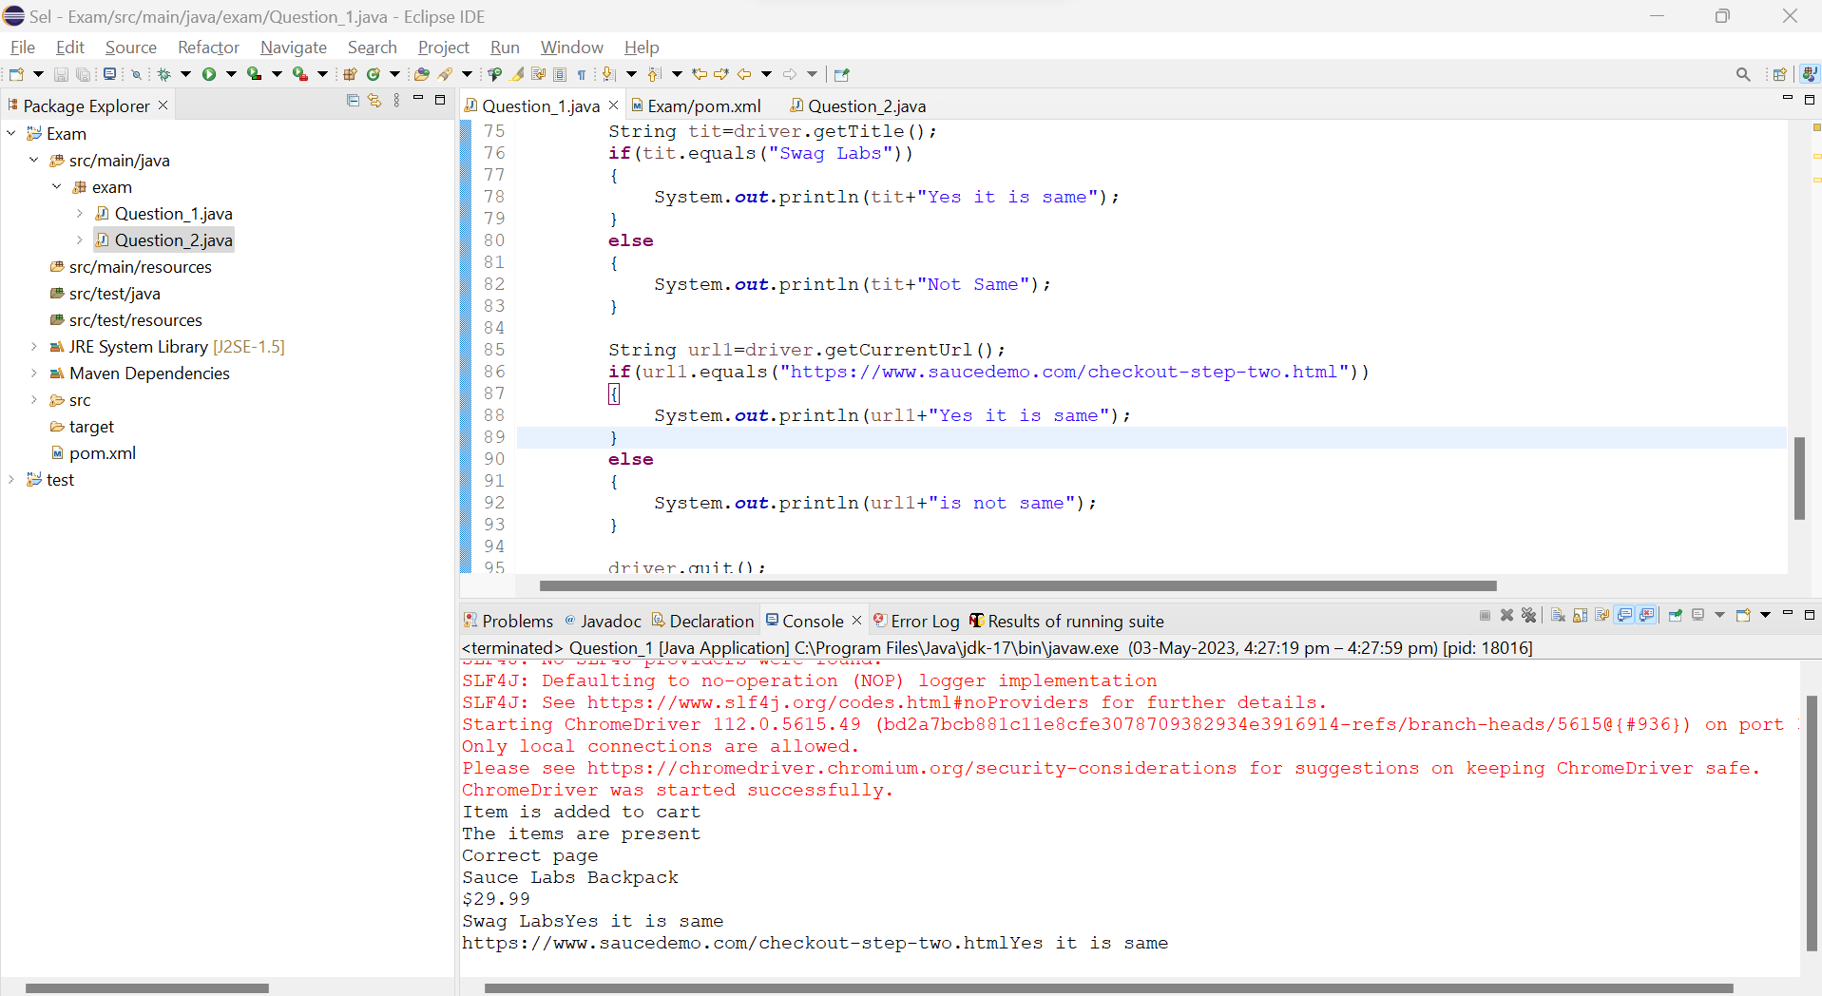

**QUESTION-2**

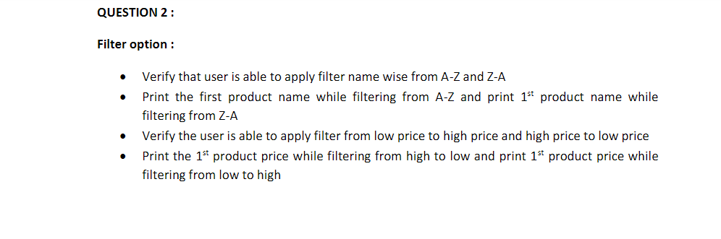

**package** exam;

**import** org.openqa.selenium.By;

**import** org.openqa.selenium.SearchContext;

**import** org.openqa.selenium.WebDriver;

**import** org.openqa.selenium.WebElement;

**import** org.openqa.selenium.chrome.ChromeDriver;

**import** org.openqa.selenium.chrome.ChromeOptions;

**import** dev.failsafe.internal.util.Assert;

**import** io.github.bonigarcia.wdm.WebDriverManager;

**public** **class** Question_2{

**public** **static** **void** main(String[] args) **throws** InterruptedException {

ChromeOptions co=**new** ChromeOptions();

co.addArguments("--remote-allow-origins=*");

WebDriverManager.*chromedriver*().setup();

WebDriver driver=**new** ChromeDriver();

String url="https://www.saucedemo.com/";

driver.get(url);

driver.findElement(By.*id*("user-name")).sendKeys("standard_user");

Thread.*sleep*(3000);

driver.findElement(By.*id*("password")).sendKeys("secret_sauce");

Thread.*sleep*(3000);

driver.findElement(By.*id*("login-button")).click();

Thread.*sleep*(3000);

driver.findElement(By.*xpath*("//*[@id=\"add-to-cart-sauce-labs-backpack\"]")).click();

Thread.*sleep*(3000);

driver.findElement(By.*xpath*("//*[@id=\"header_container\"]/div[2]/div/span/select")).click();

driver.findElement(By.*xpath*("//*[@id=\"header_container\"]/div[2]/div/span/select/option[1]")).click();

Thread.*sleep*(3000);

System.***out***.println(driver.findElement(By.*xpath*("//*[@id=\"item_4_title_link\"]/div")).getText());

Thread.*sleep*(3000);

driver.findElement(By.*xpath*("//*[@id=\"header_container\"]/div[2]/div/span/select")).click();

driver.findElement(By.*xpath*("//*[@id=\"header_container\"]/div[2]/div/span/select/option[2]")).click();

System.***out***.println(driver.findElement(By.*xpath*("//*[@id=\"item_3_title_link\"]/div")).getText());

Thread.*sleep*(3000);

driver.findElement(By.*xpath*("//*[@id=\"header_container\"]/div[2]/div/span/select")).click();

driver.findElement(By.*xpath*("//*[@id=\"header_container\"]/div[2]/div/span/select/option[4]")).click();

System.***out***.println(driver.findElement(By.*xpath*("//*[@id=\"inventory_container\"]/div/div[1]/div[2]/div[2]/div")).getText());

Thread.*sleep*(3000);

driver.findElement(By.*xpath*("//*[@id=\"header_container\"]/div[2]/div/span/select")).click();

driver.findElement(By.*xpath*("//*[@id=\"header_container\"]/div[2]/div/span/select/option[3]")).click();

System.***out***.println(driver.findElement(By.*xpath*("//*[@id=\"inventory_container\"]/div/div[1]/div[2]/div[2]/div")).getText());

driver.quit();

}

}

**OUTPUT**

