Sreyas Institute of Engineering and Technology

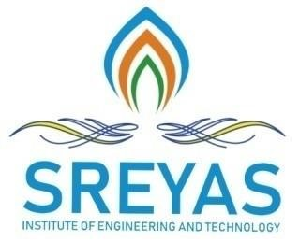

An Autonomous Institution

Approved by AICTE, Affiliated to JNTUH

Accredited by NAAC-A Grade, NBA (CSE, ECE & ME) & ISO 9001:2015 Certified

DEPARTMENT OF COMPUTER SCIENCE AND ENGINEERING-

DATA SCIENCE

III-II INDUSTRIAL ORIENTED MINI PROJECT ABSTRACT

Date: 24-2-2025

TITLE OF THE PROJECT – AI powered mobile application using Healthify+

DOMAIN OF THE PROJECT –Artificial Intelligence

BATCH NUMBER – 10

YEAR & SECTION – III B

PROJECT GUIDE NAME –

|  |  |
| --- | --- |
| ROLL NUMBER OF THE STUDENT | NAME OF THE STUDENT |
| 22VE1A67A4 | VIGNESH POBBATHI |
| 22VE1A6783 | BHARATH KODIDALA |
| 22VE1A67A3 | MOKSHAGNA PINNANI |
| 22VE1A67B1 | SAI SHARAN RACHAMALLA |
| 23VE5A6712 | SHIVAKUMAR SILIVERU |

**ABSTRACT -**

Healthify+ is an AI-driven mobile application designed to enhance healthcare accessibility by integrating advanced symptom analysis, first aid guidance, doctor consultations, and insurance support. The app employs Natural Language Processing (NLP) and Computer Vision to analyze symptoms, predict potential diseases, and assist in emergency medical situations.

For symptom analysis, Healthify+ leverages MedBERT, a transformer-based NLP model fine-tuned on medical text, to generate accurate preliminary diagnoses. Additionally, an AI-powered image recognition system assists users with first aid by analyzing injuries and recommending appropriate treatments. The app also features one-on-one virtual doctor consultations and location-based referrals, connecting users with nearby hospitals, specialists, and pharmacies. To enhance financial accessibility, Healthify+ integrates a health insurance recommendation system powered by machine learning algorithms to suggest personalized coverage plans.

By combining AI-driven diagnostics, remote medical assistance, and financial planning tools, Healthify+ empowers users to make informed healthcare decisions and respond effectively to medical emergencies. The platform bridges the gap between healthcare accessibility and technology, making quality medical assistance available anytime, anywhere.

STUDENT SIGNATURE

1.

2.

3.

4.

5.

GUIDE SIGNATURE

PROJECT COORDINATOR SIGNATURE

HOD – CSE(DS)