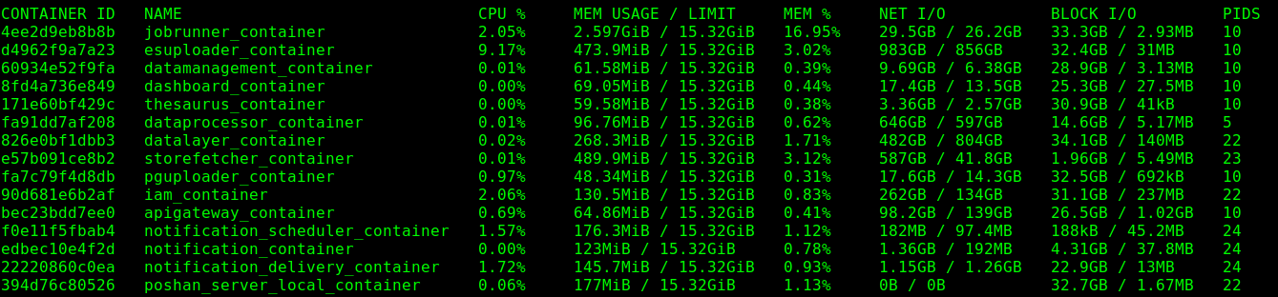
Nhm-analytics Docker:

In this server there is no volume and there is no bind mounts, it is using only /var/ to store containers for there storage.

Sang-rah Docker:

In this server there is no volume and there is no bind mounts, it is using only /var/ to store containers for there storage.

DB SERVERS:

ECD DB Docker:

This server has 5 local volumes and all of them are mounted to /var/lib/docker/volumes/ and two local volumes are bind to the containers

Nhm-Appverse Docker :
This server has 2 local volumes and 2 bind mount, bind mounted to /home/ubuntu/Redis/REDIS_DATA for one container and another one was mounted to "Source": "/var/lib/nhm_pgdata", "Destination": "/var/lib/postgresql/data", volumes are mounted to /var/lib/docker/volumes/ and one local volume was bind to the container.

nhm-Analyd Docker:

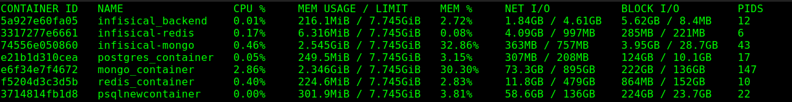

nhmsangrah Docker:

This server has 7 local volumes and 1 bind mount, bind mounted to /home/ubuntu/Redis/REDIS_DATA for one container and 3 containers are using local volumes

CPU UTILIZATION:
1, name -NHM_Prod Analytics_01, i-01dc6ea60b6b43c6d - no need for resize, (76%)
2, name -Nhm-Payment-01, i-03888794eb317bc2f - We can resize this, (12.3%),
3, name -NHM-ASHAPAY_DB_1, i-061e6bbc492f40436 - 5 & 2 crons, deleting files (36.8%),
4, name -Ashapay_h2_db_1, i-06e2482f11392d334 - We can resize this, (32.5%),
5, name -NHM-ECD-01, i-07c7469edde2015cb - We can resize this, (10%),
6, name -New_NHM_Payment_DB_1, i-08417f894e1079a40 - We can resize this, (3%),
7, name -NHM_Ecd_Db_1, i-0910df3629f051e85 - We can resize this, (37.1%),
8, name -megh_cancare, i-0a19fa2da014d4b52 - We can resize this, (13%),
9, name -NHM_Analytics _DB1, i-0b1a4935e03d187ee - We can resize this, (61.8%),
10, name -Prod-Nhm-Sanghra-01, i-0c6c99c1bd0c85cec - 00.00 cron, (55.7%),
11, name -Prod-ashapay-01, i-0d9dc5b3802ed313d - We can resize this, (31.9% only once),
12, name -NHM_Sangarh_Db1, i-0dcb2724fe4b67f6e - 20.00 cron, (62.5%),

Crons -
NHM-ASHAPAY_DB_1_PG -
at 5'o clock it is syncing to s3
at 1.30 it is backing up pg DBs
at 4.30 find and deletes directories older than 4 days

SANG_RAH_DB -
at 1.30 clock it is backing up the DBs
at 4.30 clock it is removing the backups older than 5 days
at 5 clock it is syncing to s3

NEW_NHM_PAYMENT_DB -
at 02.05 backing up PG DBs
at 4.30 finds and deletes backups older than 5 days
at 5.30 syncing to s3

NHM_ANALYTICS_DB -
at 12.30 backing ups
at 4.30 finds and deletes the backups older than 6 days
at 5 clock syncing to s3

Server Name | CPU Utilization | RAM Memory | Disk Usage
 |  |  | / | /boot/efi | /home | /var | /var/log | /var/log/audit | /var/tmp | /tmp | /DATA

Ashapay_h2db_1 | 1.00% | 3.66% | 60.00% | 6.00% | 20.00% | 22.00% | 5.00% | 1.00% | - | 1.00% | -
Ashapay_pg_db_1 | 1.00% | 2.36% | 65.00% | 6.00% | 7.00% | 81.00% | 6.00% | 1.00% | - | 1.00% | -
Ecddb1 | 9.19% | 16.88% | 64.00% | 6.00% | 58.00% | 44.00% | 5.00% | 1.00% | - | 1.00% | -
Newnhm_appverse | 1.00% | 35.50% | 31.00% | 6.00% | 1.00% | 11.00% | 2.00% | 1.00% | 1.00% | - | 65.00%
Nhmanalyd2 | 5.73% | 76.60% | 65.00% | 6.00% | 29.00% | 56.00% | 12.00% | 1.00% | - | 1.00% | -
Nhmsangrah | 8.96% | 64.00% | 68.00% | 6.00% | 34.00% | 27.00% | 7.00% | 1.00% | - | 1.00% | -

