**PHASE-3**

SMART WATER

MANAGEMENT

**TEAM MEMBERS:**

G Bharathi 412721106007

S Kalpana 412721106022

T Raghul 412721106036

M Vignesh 412721106051

**OBJECTIVE:**

Our aim is to create a system, for monitoring the consumption The objective of this project is to create a simple and cost-effective water leak detection system using an ultrasonic sensor and an LED indicator.The key goals and objectives of this project include:

Leak Detection: The primary objective is to detect the presence of water leaks in a designated area or liquid containment system. By utilizing an ultrasonic sensor, the project aims to accurately measure the distance between the sensor and the liquid surface, allowing for the early identification of any undesired liquid level changes.

Visual Alert: The project provides a visual alert mechanism through an LED indicator. When a water leak is detected, the LED blinksto alert users or operators, ensuring they are promptly informed of potential issues.

Simplicity and Affordability: This project is designed to be simple and cost-effective, making it accessible to a wide range of users.It serves as a basic yet effective solution for individuals or small-scale applications, such as home water tank monitoring or small aquariums.

Real-Time Monitoring: The system continuously monitors the liquid level in real-time, allowing for the immediate identification of any changes or leaks. Real-time monitoring is essential for taking timely corrective actions in response to detected issues.

Customization: The project is designed to be adaptable to different liquid containment systems. Users can customize the threshold distance (distance at which a leak is detected) to suit their specific requirements and tank setups.

Prevent Water Damage: The core objective is to prevent potential water damage and associated risks. By detecting leaks early, users can take preventive measures to avoid water damage to property, equipment, or the environment.

**CODING:**

import machine

import time

# Pin assignments for the ultrasonic sensor

TRIGGER_PIN = 23  # GPIO23 for trigger

ECHO_PIN = 22     # GPIO22 for echo

# Pin assignment for the LED

LEAK_LED_PIN = 19  # GPIO19 for the LED

# Set the pin modes

trigger = machine.Pin(TRIGGER_PIN, machine.Pin.OUT)

echo = machine.Pin(ECHO_PIN, machine.Pin.IN)

leak_led = machine.Pin(LEAK_LED_PIN, machine.Pin.OUT)

# Function to measure distance using the ultrasonic sensor

def measure_distance():

    # Generate a short trigger pulse

    trigger.value(0)

    time.sleep_us(5)

    trigger.value(1)

    time.sleep_us(10)

    trigger.value(0)

    # Measure the echo pulse duration to calculate distance

    pulse_start = pulse_end = 0

    while echo.value() == 0:

        pulse_start = time.ticks_us()

    while echo.value() == 1:

        pulse_end = time.ticks_us()

    pulse_duration = pulse_end - pulse_start

    # Calculate distance in centimeters (assuming the speed of sound is 343 m/s)

    distance = (pulse_duration * 0.0343) / 2  # Divide by 2 for one-way travel

    return distance

# Function to check for a water leak

def check_for_leak():

    # Measure the distance from the ultrasonic sensor

    distance = measure_distance()

    # Set the threshold distance for detecting a leak (adjust as needed)

    threshold_distance = 10  # Adjust this value based on your tank setup

    if distance < threshold_distance:

        # If the distance is less than the threshold, a leak is detected

        return True

    else:

        return False

# Main loop

while True:

    if check_for_leak():

        # Blink the LED to indicate a leak

        leak_led.value(1)  # LED ON

        time.sleep(0.5)

        leak_led.value(0)  # LED OFF

        time.sleep(0.5)

    else:

        leak_led.value(0)  # LED OFF

    time.sleep(1)  # Delay between measurements

**CODING: CODE EXPLANATION:**

This code is a Micro Python script designed to detect water leaks using an ultrasonic sensor and indicate the presence of a leak with an LED. Let's break down the code and explain each part: This code imports the machine module for hardware control and the time module for time-related functions.

Here, the code sets up the pins defined in the previous step, configuring trigger and leak led as output pins and echo as an input pin.

Measure distance Function: This function is responsible for measuring the distance using the ultrasonic sensor.

It triggers the sensor, measures the echo pulse duration, and calculates the distance based on the speed of sound.The distance in centi meters is returned.

Check for leak Function: This function checks if a water leak is detected by calling measure distance. It compares the measured distance with a threshold distance, and if the measured distance is less than the threshold, it returns True to indicate a leak. Otherwise, it returns False.

The main loop continuously checks for leaks using the check_for_leak function. If a leak is detected, it blinks the LED for visual indication. The LED is turned on for 0.5 seconds and then turned off for 0.5 seconds. If no leak is detected, the LED remains off. There's also a 1-second delay between measurements.

**SIMULATION:**

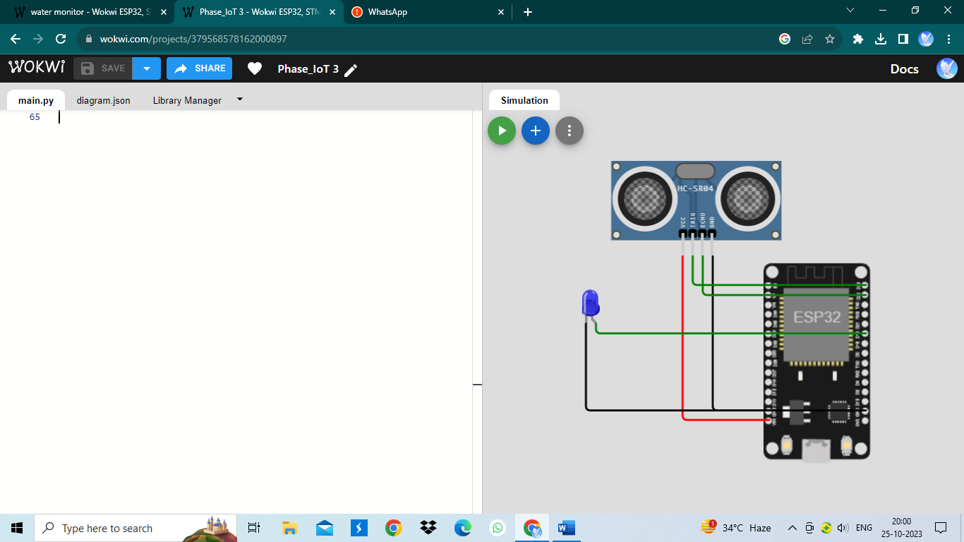

**CONCLUSION:**

In conclusion, this project helps us to monitoring the consumption of water. This project serves as a foundation for more advanced water monitoring and leak detection systems.It can be further expanded by integrating with other sensors, communication modules, or logging capabilities to enhance the functionality and convenience of the monitoring system To know the output of our project, the below mentioned hyperlink will make you to see our work done in the wokwi website and we apologize for any mistake if happenned in the code and also in the simulation .Also we hope that our simulation is fullfill yours expectation.

**OUR SIMULATION:**

https://wokwi.com/projects/379568578162000897