PHASE 2: INNOVATION

SMART WATER SYSTEM

SUBMITTED BY:

BHARATHI G 412721106007

KALPANA S 412721106022

RAGHUL T 412721106036

VIGNESH M 412721106051

OBJECTIVE:

Water is essential for human life, but access to safe drinking water is a challenge for many people, especially in urban areas. Industrial pollution and microbial contamination can make water unsafe to drink, even if it is chlorinated. We are developing new technologies and processes to provide safe drinking water for all, including using machine learning and IoT to detect water quality and flow in municipal water distribution systems. This could help to curb waterborne diseases and improve water management efficiency.

To review technologies used to detect and monitor water leakages and pilferage.

 To review technologies used to detect and monitor the quality of water.

 To design an IoT model for monitoring water quality and leakages

 To make recommendations for existing water quality and leakages monitoring systems.

SYSTEM COMPONENTS AND WORKING (Internet of Things):

Sensors: The proposed system will have the following sensors:

1. The temperature sensor monitors water temperature. A sudden change in temperature could signify the presence of chemical or industrial effluents.
2. The turbidity sensor monitors the presence of suspended particles. This sensor can easily detect industrial effluents.
3. Flow sensor monitors the flow velocity of water and helps detect leakages and pilferage along the water backbone.
4. The dissolved oxygen sensor monitors the amount of oxygen present in water. Sudden fluctuations could signify chemical reactions. Water temperature and salinity can also affect oxygen concentrations in water.
5. pH sensor monitors the amount of acidity or alkalinity in water.
6. Specialised chemical sensors can also be added to check for specific chemicals.

These sensors will be distributed at different points of the water distribution backbone to measure and monitor.

Controller: The controller extracts data from the different sensors and sends the same to the Raspberry Pi. Different sensors can have different controllers.

Raspberry Pi: The component interfaces the controllers and the data centre, extracts data from the controllers through the appropriate General-Purpose Input/Output (GPIO) pins and sends it to the data centre for analysis.

Data Centric: This subsystem is placed in the cloud and connects to the Raspberry Pi through an I.P. address. It comprises a server and a database and plays two vital roles, the storage of data received from different sensors positioned at different locations along the water supply backbone and the analysis of the same data for consumption by the various end-users. Since the server has more processing power, all processing is off loaded from the Raspberry Pi to the server. This is typical of cloud computing, where users connect to a pool of rich resources over the Internet.

End-user Subsystem: The module consists of different devices that end-users willaccess information from the data centre. They could be Android or iPhone mobile phones for city dwellers, while authorities monitoring the water distribution systemcould use desktops and laptops

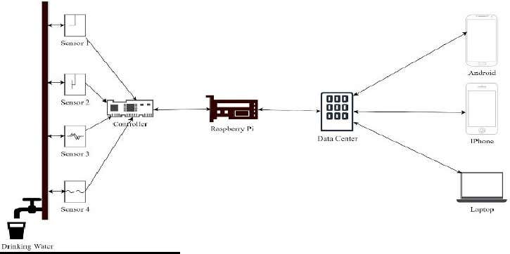

DATA ANALYSIS AND SYATEM WORKING (Machine Learning):

The data centre receives data from different sensors placed at different locations. The aggregation of the received values will help in decision-making

Tav = TL1+TL2+TL3+…+TLn

Equation (1) shows aggregation of different temperature values received from temperature sensors at varied locations.

Represents TL1 is the location 1, while Tav is the aggregated value of all the sensors along the water supply backbone. Similar equations will be used to calculate aggregated values from all sensors. Specific thresholds will be set for decision-making. The data centre used machine learning algorithms for decision-making. The algorithms become more accurate as more data is received at the data centre. Since the sensors continuously send data to the data centre, machine learning algorithms build models that can detect any outliers. Outliers refer to data that falls out of the general or expected data behaviour Such outliers do not only refer to “bad” values but also missing data, meaning the systems can detect when some sensor nodes do not send data to the data centre within the expected intervals. This allows for timely detection of failed sensors, either by losing connection or battery running. Such occurrences are common in wireless sensor networks. Whenever such outliers are detected in real-time, push notifications are sent to mobile users while appropriate triggers are sent to the municipal or government officials. Such notifications could be triggered due to sudden change in the water flow rate.

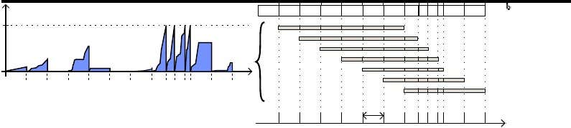

The above Graphical Representation describes the following:

Operating principle of the sliding window for ensuring the redundancy of transmitted data

from smart water meters through successive frames

 Water Consumption Time Series

A time series is a sequence of temporal data. The time stamp of the series can beexplicit such that a date is given for each data value or controlled by the appearance of thedata represented by events perfectly dated. This is referred to as an unevenly spaced time. In the context of water consumption, an event corresponds to each consumed is thus a sequence of scalar values of an incremented variable therefore corresponds to the raw data extracted from the previously described platform for one smart meter and is the result of a process observed during a period T The platform and AMI proposed by offer the possibility of recording the instants of consumption of water.

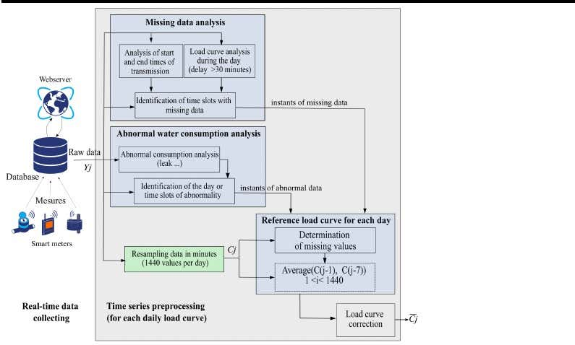

The above diagram represents the Global architecture of the water consumption using LC preprocessing.

Water Consumption Forecasting

A three-month database (from October 2018 to December 2018) has been chosen to forecast the number of consumed water liters in the next coming hour. The data sequence is resampled with a resolution of one hour and is represented in following graphical representation. This consumption has been recorded in a domestic house in France occupied by two people who consume on average 194 L per day (l/d). Household information will not be used by the ML approaches.

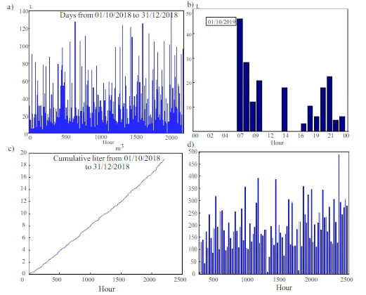

The above graphical representation gives the Water consumption time series:

1. LC from 1 October to 31 December 2018, **b**) close-up view of the same time series for the ﬁrst 24hours. **c**) cumulative water LC over the whole period, **d**) number of liters consumed per day.

Two ML approaches have been implemented for a one-hour water consumption

forecasting, the LSTM and the BPNN of the forecast approaches. Here we used a dataset of 4321 events dated in milliseconds, each representing the time difference between two consecutive liters, to predict the next liters of water to be consumed. They used two learning approaches: LSTM and BPNN. The LSTM model achieved an error (test RMSE) of 13 ms, while the BPNN model achieved an error of 48 ms. The authors also predicted the next 5 liters of water to be consumed, and the predicted instants were correct according to industrial specifications.

The below mentioned tabulation represents the  prediction of water consumption in liters with the LSTM and BPNN.

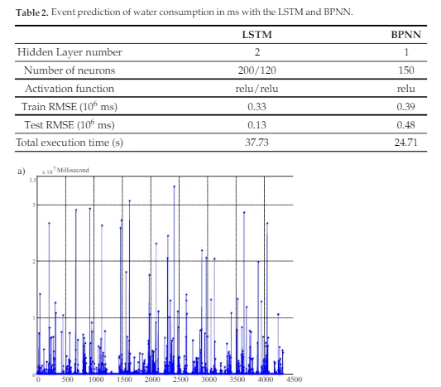

results of two learning approaches are provided in Table. The instant of the next consumed liter of water is predicted respectively with an error (test RMSE) of 13ms and 48ms respectively with the LSTM and the BPNN. In addition, the forecast of the instant of the 5 next liters have also been calculated and are respectively estimated to occur at instants 450,925, 450,800, 451,200, 451,500 and 451,300 milliseconds. In other words, the next consumed liters have been correctly predicted on December 21 (2018) at 00:08:07.487,00:15:38.287, 00:23:09.487, 00:30:40,987 and at 00:38:12.287. The accuracy objective of thepredicted instants is justiﬁed by industrial speciﬁcations

OUTCOME:

City municipals will be able to detect water pilferages and leakages once they occur.

•City municipals will be able to monitor parameters such as alkalinity, acidity, dissolved oxygen, and turbidity of water. With these parameters, a decision on the suitability of the water can be made.

•The community will benefit from high-quality water with minimal leakages since this system will detect and report such leakages in real-time.

CONCLUSION:

It explores the potential of Machine Learning and IoT to solve the water challenges in cities and thus help build smart cities. IoT will provide a heterogeneous network of devices that communicate and cooperate amongst themselves, while Machine

Learning will make such devices “smart” to decide water quality and the presence or

absence of pilferage. The system will avail such crucial information to the relevant end-users.