Testphp.vulnweb.com

Security Assessment Report Prepared For



Report Issued: 03/04/2025

By: VIGNESH.R

**TABLE OF CONTENTS**

EXECUTIVE SUMMARY 4

Recommendation 4

HIGH LEVEL ASSESSMENT OVERVIEW 5

Observed Security Strengths 5

Areas for Improvement 5

Short Term Recommendations 5

Long Term Recommendations 5

SCOPE 7

Networks 7

Other 7

Provided Credentials 7

TESTING METHODOLOGY 8

CLASSIFICATION DEFINITIONS 9

Risk Classifications 9

Exploitation Likelihood Classifications 9

Business Impact Classifications 10

Remediation Difficulty Classifications 10

ASSESSMENT FINDINGS 11

APPENDIX A - TOOLS USED 14

APPENDIX B - ENGAGEMENT INFORMATION 15

Client Information 15

Contact Information 15

# EXECUTIVE SUMMARY

Performed a security assessment of a [testphp.vulnweb.com](C:\\Users\\vigne\\Downloads\\testphp.vulnweb.com) website on 03/04/2025. I have identified a total of 8 vulnerabilities within the scope of the engagement which are broken down by severity in the table below.

|  |  |  |
| --- | --- | --- |
| **HIGH** | **MEDIUM** | **LOW** |
| **4** | **2** | **2** |

The highest severity vulnerabilities give potential attackers the opportunity to exploit the database and modify the web application. In order to ensure data confidentiality, integrity, and availability, security remediations should be implemented as described in the security assessment findings.

# SCOPE

The scope is defined in the assignment mail and official written communications. The items in scope are listed below.

## Networks

|  |  |
| --- | --- |
| **Network** | **Note** |
| 44.228.249.3 | Testphp.vulnweb.com |

# 

# TESTING METHODOLOGY

Testing methodology was split into three phases: *Reconnaissance*, *Target Assessment*, and *Execution of Vulnerabilities*. During reconnaissance, I gathered information about testphp.vulnweb.com. 80 used port scanning and other enumeration methods to refine target information and assess target values. Next, I conducted our targeted assessment. Completed three scan from zap those are spider, passive scan, active scan. Then exploited vulnerabilities. I gathered evidence of vulnerabilities during this phase of the engagement while conducting the simulation in a manner that would not disrupt normal business operations.

The following image is a graphical representation of this methodology.

# vapt.png

# CLASSIFICATION DEFINITIONS

## Risk Classifications

|  |  |  |
| --- | --- | --- |
| **Level** | **Score** | **Description** |
| **High** | **10-8** | The vulnerability poses an urgent threat to the organization, and remediation should be prioritized. |
| **Medium** | **4-7** | Successful exploitation is possible and may result in notable disruption of business functionality. This vulnerability should be remediated when feasible. |
| **Low** | **1-3** | The vulnerability poses a negligible/minimal threat to the organization. The presence of this vulnerability should be noted and remediated if possible. |
| **Informational** | **0** | These findings have no clear threat to the organization, but may cause business processes to function differently than desired or reveal sensitive information about the company. |

## Exploitation Likelihood Classifications

|  |  |
| --- | --- |
| **Likelihood** | **Description** |
| **Likely** | Exploitation methods are well-known and can be performed using publicly available tools. Low-skilled attackers and automated tools could successfully exploit the vulnerability with minimal difficulty. |
| **Possible** | Exploitation methods are well-known, may be performed using public tools, but require configuration. Understanding of the underlying system is required for successful exploitation. |
| **Unlikely** | Exploitation requires deep understanding of the underlying systems or advanced technical skills. Precise conditions may be required for successful exploitation. |

## Business Impact Classifications

|  |  |
| --- | --- |
| **Impact** | **Description** |
| **Major** | Successful exploitation may result in large disruptions of critical business functions across the organization and significant financial damage. |
| **Moderate** | Successful exploitation may cause significant disruptions to non-critical business functions. |
| **Minor** | Successful exploitation may affect few users, without causing much disruption to routine business functions. |

## Remediation Difficulty Classifications

|  |  |
| --- | --- |
| **Difficulty** | **Description** |
| **Hard** | Remediation may require extensive reconfiguration of underlying systems that is time consuming. Remediation may require disruption of normal business functions. |
| **Moderate** | Remediation may require minor reconfigurations or additions that may be time-intensive or expensive. |
| **Easy** | Remediation can be accomplished in a short amount of time, with little difficulty. |

## 

# ASSESSMENT FINDINGS

|  |  |  |  |
| --- | --- | --- | --- |
| **Number** | **Finding** | **Risk Score** | **Risk** |
| 1 | SQL Injection | **9** | **High** |
| 2 | Cross Site Scripting (XSS) | **9** | **High** |
| 3 | *Cross Site Request Forgery (CSRF)* | **8** | **High** |
| 4 | Broken Access Control | **8** | **High** |
| 5 | Content Security Policy (CSP) Header Not Set | **5sss** | **Medium** |
| 6 | Missing Anti-clickjacking Header | **4** | **Low** |
| 7 | Server Leaks Information via "X-Powered-By" HTTP Response Header Field(s) | **3** | **Low** |
| 8 | Content-Type-Options Header Missing | **2** | **Low** |

**1 – SQL Injection Vulnerability Finding :**

|  |  |
| --- | --- |
| **HIGH RISK (9/10)** | |
| **Exploitation Likelihood** | **Possible** |
| **Business Impact** | **Severe** |
| **Remediation Difficulty** | **Easy** |

**Security Implications**

SQL Injection is one of the most critical vulnerabilities as it allows attackers to execute arbitrary SQL commands on the backend database. Exploitation of this vulnerability can lead to data theft, data manipulation, or even complete compromise of the database. If left unchecked, this can lead to severe reputational damage, financial loss, and regulatory consequences.

**Analysis**

**1. SQL Injection in listproducts.php (Union-based)**

The first SQL Injection vulnerability was discovered in the listproducts.php page, which is responsible for displaying products based on the cat parameter in the URL. The parameter was found to be vulnerable to SQL Injection, allowing attackers to execute arbitrary SQL queries and exfiltrate sensitive data.

**Payload Used:**

[http://testphp.vulnweb.com/listproducts.php?cat=1%20union%20select%201,version(),3,4,5,6,database(),8,group_concat(uname,%27-%27,pass,%27-%27,cc,%27-%27,address,%27-%27,email,%27-%27,name,%27-%27,phone,%27-%27,cart),10,11%20from%20users%20--](http://testphp.vulnweb.com/listproducts.php?cat=1%20union%20select%201,version(),3,4,5,6,database(),8,group_concat(uname,%27-%27,pass,%27-%27,cc,%27-%27,address,%27-%27,email,%27-%27,name,%27-%27,phone,%27-%27,cart),10,11%20from%20users%20--%20)

**Analysis:**

* **UNION-based SQL**

SELECT * FROM products WHERE cat = 1 UNION SELECT 1, version(), 3, 4, 5, 6, database(), 8, group_concat(uname, '-', pass, '-', cc, '-', address, '-', email, '-', name, '-', phone, '-', cart), 10, 11 FROM users;

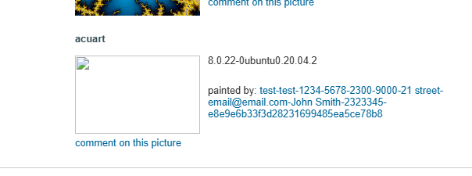

**2. SQL Injection in login.jsp (Authentication Bypass)**

The second SQL Injection vulnerability was discovered on the login.jsp page, which is used for user authentication. The username and password fields are vulnerable to SQL Injection, allowing attackers to bypass authentication and log in as any user, including administrators.

**Payload Used:**

username=' OR '1'='1'; --

password=' OR '1'='1'; --

**Analysis:**

* The SQL query for authentication can be manipulated with the payload above to always return true, allowing unauthorized access.
* **Example of Vulnerable Query**

SELECT * FROM users WHERE username = '' OR '1'='1' AND password = '' OR '1'='1';

* This query bypasses the username and password checks and grants login access, regardless of the provided credentials.

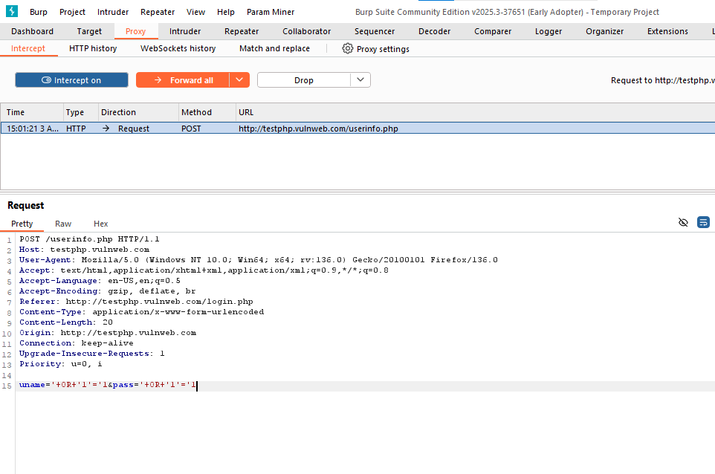

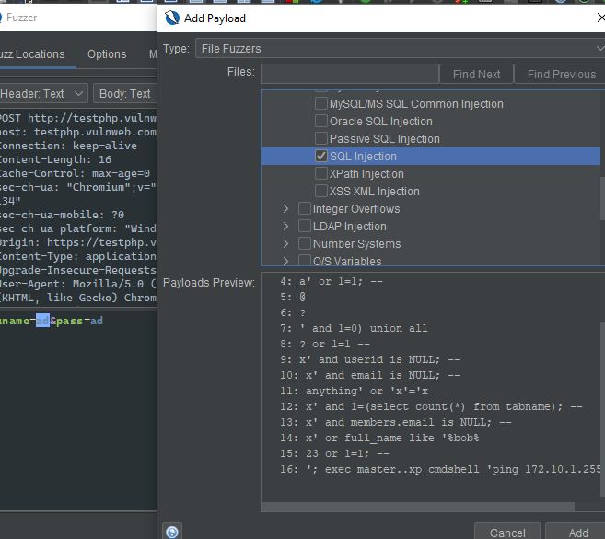

**Recommendations**

* Immutable queries serve as the strongest defense against SQL injection by preventing data interpretation.
* Static queries do not interpret input data and present a lower risk of exploitation through SQL injection.
* Parameterized queries utilize placeholders for user input, thereby binding data to specific columns without executing it as code.
* The use of a PreparedStatement in parameterized queries ensures that input is treated as data rather than SQL command.
* Stored procedures can enhance security, but only if they do not incorporate dynamic SQL.
* SQL injection risks are paramount when user input is directly concatenated into commands, as demonstrated in the example of static queries.
* Implementing best practices in SQL coding is critical to ensuring application security and safeguarding against attacks.
* A safe stored procedure uses parameters to prevent SQL injection, ensuring that user input does not manipulate query structure.

# APPENDIX A - TOOLS USED

|  |  |
| --- | --- |
| **TOOL** | **DESCRIPTION** |
| **BurpSuite Community Edition** | Used for testing of web applications. |
| **SQLMAP** | Used for exploitation of vulnerable services and vulnerability scanning. |
| **Zap Fuzzer** | To exploit sql payload |

**2 – Cross Site Scripting Vulnerability Finding :**

|  |  |
| --- | --- |
| **HIGH RISK (9/10)** | |
| **Exploitation Likelihood** | **Possible** |
| **Business Impact** | **Severe** |
| **Remediation Difficulty** | **Easy** |

**Security Implications**

Cross-Site Scripting (XSS) vulnerabilities can allow attackers to inject malicious scripts into web pages that are viewed by other users. These scripts can be executed within the victim's browser, leading to a variety of attacks such as session hijacking, credential theft, or spreading malware. In the case of **Stored XSS**, the payload is permanently stored on the server and can affect any user who views the affected page. **Reflected XSS** payloads, on the other hand, are executed immediately upon the victim's interaction with a vulnerable URL. Both types of XSS present significant risks for user data, application integrity, and trust.

**Analysis**

**1. Stored Cross-Site Scripting (XSS) in userinfo.php**

The first XSS vulnerability was found on the userinfo.php page, where user inputs are not properly sanitized before being displayed. This allows for Stored XSS, where an attacker can inject a malicious script that gets executed when another user accesses the page.

**Payload Used:**

**<script>setTimeout(()=>location="https://youtu.be/YR12Z8f1Dh8",1);</script>**

**Analysis:**

* This Stored XSS payload is injected into the application, and when other users visit the page, the malicious script is executed in their browsers.
* Redirects to the kolveri song.

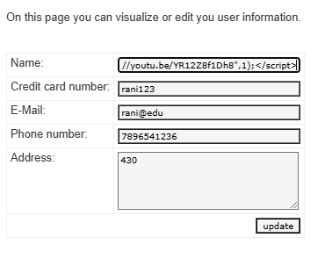

**2. Reflected Cross-Site Scripting (XSS) in guestbook.php**

The second XSS vulnerability was found on the guestbook.php page, where the application reflects unsanitized user input (e.g., from the guestbook form) directly back to the page in the response. This results in a Reflected XSS vulnerability.

**Payload Used:**

<script>

function rotatePage() {

document.body.style.transition = "transform 30s";

document.body.style.transform = "rotate(5400deg)";

}

function displayDogImage() {

var img = document.createElement("img");

img.src = "https://upload.wikimedia.org/wikipedia/commons/1/18/Dog_Breeds.jpg

img.style.position = "fixed";

img.style.top = "50%";

img.style.left = "50%";

img.style.transform = "translate(-50%, -50%)";

document.body.appendChild(img);

}

function redirectToKolaveriSong() {

window.location.href = "https://www.youtube.com/watch?v=YR12Z8f1Dh8";

}

window.onload = function() {

rotatePage();

displayDogImage();

setTimeout(redirectToKolaveriSong, 30000);

};

</script>

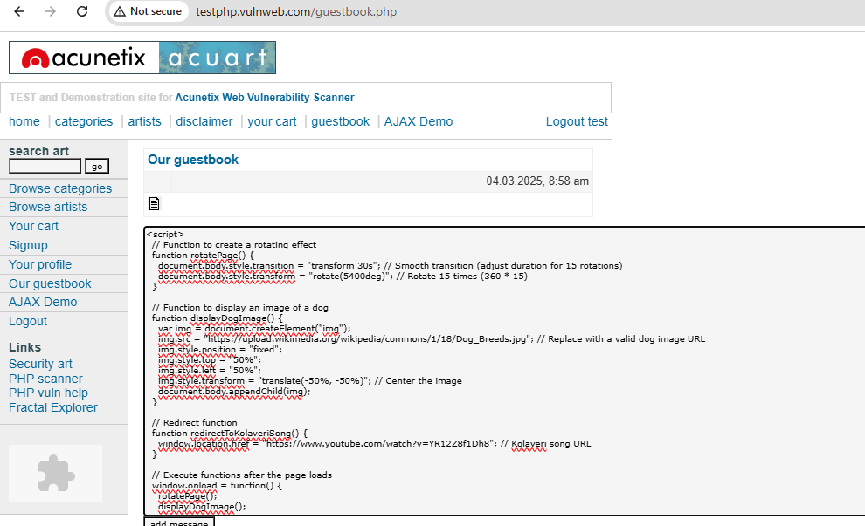

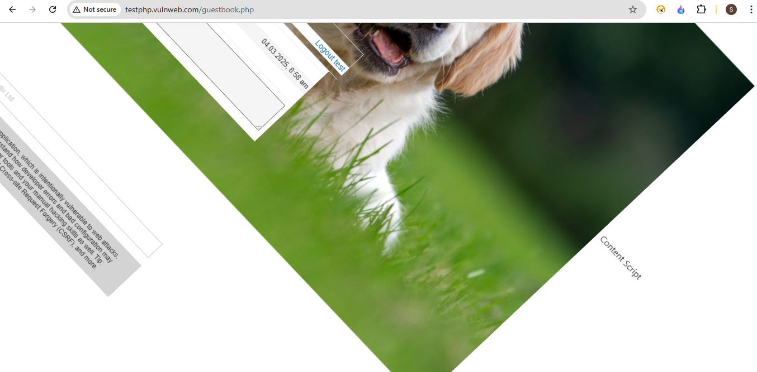

Analysis:

* The Reflected XSS vulnerability allows attackers to inject the payload via a URL parameter or form input, which then gets reflected back and executed immediately.
* The payload includes the same rotating page effect, image display, and redirect function as the stored variant, but it is executed instantly when the URL containing the payload is accessed by the victim.

**Recommendations**

* Encode as HTML Entities in HTML Body
* Encode as HTML Entities in HTML Attribute
* Encode for JavaScript if outputting user input to JavaScript

APPENDIX B - TOOLS USED

|  |  |
| --- | --- |
| **TOOL** | **DESCRIPTION** |
| **BurpSuite Community Edition** | Used for testing of web applications. |
| **Visual Studio** | To start live server for the code. |

***3 – Cross Site Request Forgery Vulnerability Finding :***

|  |  |
| --- | --- |
| ***HIGH RISK (8/10)*** | |
| ***Exploitation Likelihood*** | ***High*** |
| ***Business Impact*** | ***Severe*** |
| ***Remediation Difficulty*** | ***Moderate*** |

***Security Implications***

*Cross-Site Request Forgery (CSRF) vulnerabilities allow attackers to perform unauthorized actions on behalf of authenticated users without their knowledge. By tricking a user into submitting a malicious request (e.g., placing an order or transferring funds), an attacker can bypass authentication and authorization mechanisms. In this case, a CSRF attack could allow an attacker to place orders on behalf of a user, potentially leading to unauthorized purchases, financial loss, or system abuse.*

***Analysis***

***CSRF in cart.php***

The CSRF vulnerability was discovered on the cart.php page, where a form is used to place an order via the sendcommand.php page. The form contains hidden input fields that are used to place an order, but it lacks protection against CSRF attacks.

Form Structure Payload Example:

**<form name="getstuff" method="POST" action="http://testphp.vulnweb.com/sendcommand.php">**

**<input type="hidden" value="741b12df2badb8c8f179775a14715964" name="cart_id">**

**<input type="submit" name="submitForm" value="place a command for these items">**

**</form>**

When the form is submitted, the user's cart ID is sent to sendcommand.php to process the purchase. The form doesn't include any anti-CSRF protection, such as a token or a unique session check, allowing an attacker to exploit this vulnerability.

Exploitation Scenario:

1. The attacker sends a malicious link or embeds the form in a page.
2. If the victim is logged into the application and visits the malicious page, the form will be automatically submitted using the victim's session, placing an order on their behalf.
3. The victim receives a confirmation page indicating that their order has been processed, without realizing they were tricked into placing an order.

**Malicious Form (crafted by attacker):**

<form action="http://testphp.vulnweb.com/sendcommand.php" method="POST">

<input type="hidden" name="cart_id" value="741b12df2badb8c8f179775a14715964">

<input type="submit" value="Click here to claim your free gift!">

</form>

* When the victim visits this page, the form is automatically submitted, causing the victim to unknowingly place an order.

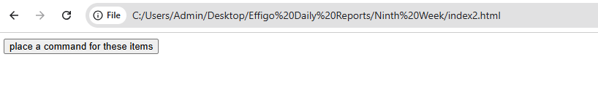

Script local file

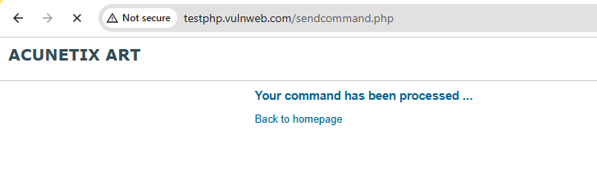

After clicking the button only if user is logged in

Impact:

* Unauthorized Actions: The attacker can cause the victim to place orders, resulting in financial loss, abuse of the system, or unnecessary items being purchased.
* System Integrity: If the attacker places multiple orders, it could cause a strain on system resources or create fraudulent transactions.
* Reputation Damage: Users may lose trust in the platform if such attacks can occur.

***Recommendations***

* ***Implement Anti-CSRF Tokens****:*

*<form name="getstuff" method="POST" action="http://testphp.vulnweb.com/sendcommand.php">*

*<input type="hidden" value="741b12df2badb8c8f179775a14715964" name="cart_id">*

*<input type="hidden" name="csrf_token" value="unique_session_token">*

*<input type="submit" name="submitForm" value="place a command for these items">*

*</form>*

* ***Check Referer Header****:*
* ***SameSite Cookies****:*
* ***Use Secure HTTP Methods****:*
* ***User Confirmation for Critical Actions****:*

*APPENDIX C - TOOLS USED*

|  |  |
| --- | --- |
| ***TOOL*** | ***DESCRIPTION*** |
| ***BurpSuite Community Edition*** | *Used for testing of web applications.* |
| ***Zap Fuzzer*** | *To exploit XSS payload* |

***4 – Broken Access Control Vulnerability Finding :***

|  |  |
| --- | --- |
| ***HIGH RISK (8/10)*** | |
| ***Exploitation Likelihood*** | ***High*** |
| ***Business Impact*** | ***Severe*** |
| ***Remediation Difficulty*** | ***Moderate*** |

***Security Implications***

*Broken Access Control vulnerabilities allow unauthorized users to gain access to resources or functionality that should be restricted. In this case, the ability to directly navigate to the /admin/ directory without proper access controls can result in unauthorized users viewing sensitive administrative files or interacting with admin-specific functionality. This can lead to information disclosure, privilege escalation, and potentially complete system compromise.*

***Analysis***

***Broken Access Control in /admin/ Directory***

After successfully logging into the application, an attacker can manipulate the URL or change directories directly to /admin/. This exposes a directory listing and allows access to files meant to be restricted to administrators.

Steps to Exploit:

1. Login to the application using valid credentials.
2. Change the URL or directory path to /admin/.
   * Example URL:

<http://testphp.vulnweb.com/admin/>

1. Directory Listing Exposure:  
   The server responds with a directory listing that shows sensitive files such as create.sql, which could be used to gain further insight into the system.
   * The directory listing output is:

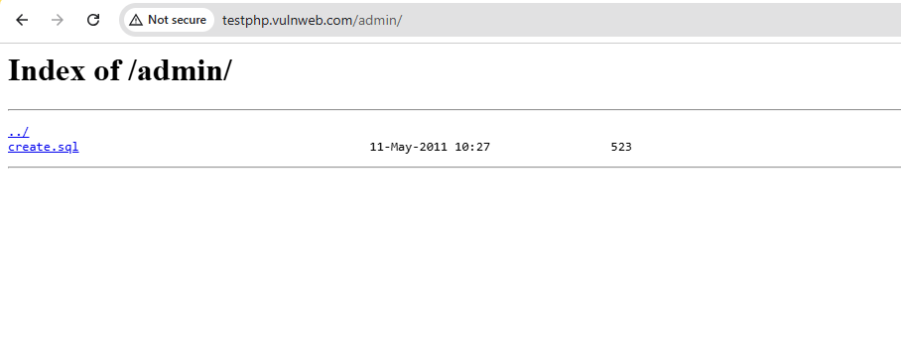

Impact:

* Information Disclosure: Sensitive files such as create.sql might contain important system or database information that attackers can use for further attacks, such as SQL Injection, privilege escalation, or gaining control of the application.
* Privilege Escalation: If an attacker can access administrative functions or files, they may be able to perform actions that should be restricted, such as modifying the database, deleting data, or escalating their privileges.
* System Compromise: If the exposed files contain configuration or script files, attackers could potentially use them to compromise the entire system.

***Recommendations***

* Proper Access Control
* Restrict Directory Listings
* File Permissions:
* Logging and Monitoring:
* URL Rewriting and Hiding Sensitive Paths

*APPENDIX D- TOOLS USED*

|  |  |
| --- | --- |
| ***TOOL*** | ***DESCRIPTION*** |
| ***Zap Fuzzer*** | *To exploit Directory Fuzzer* |

***5 – Content Security Policy (CSP) Header Not Set Vulnerability Finding :***

|  |  |
| --- | --- |
| ***Medium RISK (5/10)*** | |
| ***Exploitation Likelihood*** | ***Medium*** |
| ***Business Impact*** | ***Moderate*** |
| ***Remediation Difficulty*** | ***Easy*** |

***Security Implications***

*The* ***Content Security Policy (CSP)*** *header is an important security measure that helps prevent attacks such as* ***Cross-Site Scripting (XSS)****,* ***data injection****, and* ***malicious content loading*** *(e.g., from unauthorized or malicious sources). By not setting a CSP header, the application is exposed to these types of attacks. Without CSP, attackers can inject malicious scripts or resources into a web page, leading to data theft, session hijacking, malware distribution, or even site defacement.*

***Analysis***

CSP Header Missing

The application doesn't include a Content Security Policy (CSP) header, which leaves it vulnerable to a variety of attacks. CSP is a security feature that allows web developers to control the resources that can be loaded by a webpage, such as JavaScript, CSS, images, and other media. Without CSP, attackers can inject malicious scripts or load content from untrusted sources.

URLs Affected:

1. <http://testphp.vulnweb.com/AJAX/index.php>
2. <http://testphp.vulnweb.com/artists.php>
3. http://testphp.vulnweb.com/artists.php?artist=1
4. http://testphp.vulnweb.com/artists.php?artist=2
5. http://testphp.vulnweb.com/artists.php?artist=3
6. http://testphp.vulnweb.com/cart.php
7. http://testphp.vulnweb.com/categories.php
8. http://testphp.vulnweb.com/disclaimer.php
9. http://testphp.vulnweb.com/guestbook.php
10. http://testphp.vulnweb.com/high
11. http://testphp.vulnweb.com/hpp/
12. http://testphp.vulnweb.com/hpp/?pp=12
13. http://testphp.vulnweb.com/hpp/params.php?p=valid&pp=12
14. http://testphp.vulnweb.com/index.php
15. http://testphp.vulnweb.com/listproducts.php?artist=1
16. http://testphp.vulnweb.com/listproducts.php?artist=2
17. <http://testphp.vulnweb.com/listproducts.php?artist=3>
18. Still 18 more are affected

All of the above URLs do not include a CSP header, leaving them vulnerable to content injection and data theft attacks.

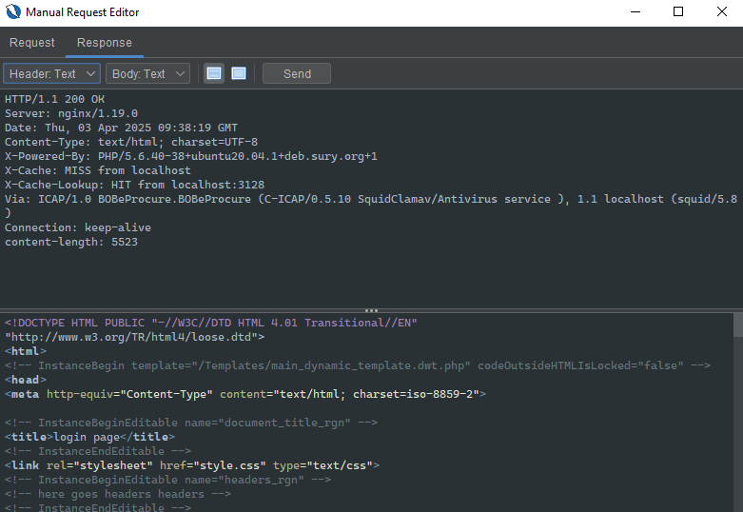

### ****Remediation Recommendations****

1. **Implement Content Security Policy (CSP) Header:**

Content-Security-Policy: default-src 'self'; script-src 'self'; style-src 'self'; img-src 'self';

1. **Review and Customize CSP Rules:**
2. **Test CSP Policies:**
3. **Use HTTPS for All Resources:**
4. **Audit and Update Regularly:**

*APPENDIX E- TOOLS USED*

|  |  |
| --- | --- |
| ***TOOL*** | ***DESCRIPTION*** |
| ***Zap*** | *To see the request and response* |

6  ***– Missing Anti-clickjacking Header Vulnerability Finding :***

|  |  |
| --- | --- |
| ***Medium RISK (4/10)*** | |
| ***Exploitation Likelihood*** | ***Medium*** |
| ***Business Impact*** | ***Moderate*** |
| ***Remediation Difficulty*** | ***Easy*** |

***Security Implications***

*Clickjacking is a type of attack where a malicious site can trick a user into interacting with a page that is hidden in a frame. This can lead to unintended actions being performed by the user, such as changing account settings or making a purchase, without their knowledge. The* ***X-Frame-Options*** *header or* ***Content-Security-Policy (CSP)*** *with the frame-ancestors directive can prevent this vulnerability by ensuring that the site cannot be embedded in a frame on another domain.*

***Analysis***

**Missing Anti-clickjacking Header**

The application does not include the **X-Frame-Options** header or a **Content-Security-Policy (CSP)** with the frame-ancestors directive to protect against **Clickjacking** attacks. Without this protection, malicious websites could embed the application's pages in a frame, potentially tricking users into performing actions on the application without their knowledge.

**URLs Affected:**

1. http://testphp.vulnweb.com/AJAX/index.php
2. http://testphp.vulnweb.com/artists.php
3. http://testphp.vulnweb.com/artists.php?artist=1
4. http://testphp.vulnweb.com/artists.php?artist=2
5. http://testphp.vulnweb.com/artists.php?artist=3
6. http://testphp.vulnweb.com/cart.php
7. http://testphp.vulnweb.com/categories.php
8. http://testphp.vulnweb.com/disclaimer.php
9. http://testphp.vulnweb.com/guestbook.php
10. http://testphp.vulnweb.com/hpp/
11. http://testphp.vulnweb.com/hpp/?pp=12
12. http://testphp.vulnweb.com/hpp/params.php?p=valid&pp=12
13. http://testphp.vulnweb.com/index.php
14. http://testphp.vulnweb.com/listproducts.php?artist=1
15. http://testphp.vulnweb.com/listproducts.php?artist=2
16. http://testphp.vulnweb.com/listproducts.php?artist=3
17. http://testphp.vulnweb.com/listproducts.php?cat=1

All of these URLs are vulnerable because they do not include the **X-Frame-Options** header or **CSP** header with frame-ancestors directive to prevent clickjacking attacks.



**Remediation Recommendations**

1. **Implement the X-Frame-Options Header:**

**X-Frame-Options: SAMEORIGIN**

1. **Implement Content-Security-Policy (CSP) with frame-ancestors:**

**Content-Security-Policy: frame-ancestors 'self';**

1. **Test the Protection Mechanisms:**

*APPENDIX F- TOOLS USED*

|  |  |
| --- | --- |
| ***TOOL*** | ***DESCRIPTION*** |
| ***Zap*** | *To see the request and response* |

***7 – Server Leaks Information via X-Powered-By HTTP Response Header Vulnerability Finding :***

|  |  |
| --- | --- |
| ***Low RISK (3/10)*** | |
| ***Exploitation Likelihood*** | ***Medium*** |
| ***Business Impact*** | ***Moderate*** |
| ***Remediation Difficulty*** | ***Easy*** |

***Security Implications***

*The* ***X-Powered-By*** *HTTP header leaks the underlying technologies and their versions used by the server. In this case, the header reveals the version of PHP (PHP/5.6.40), which could be exploited by attackers to target vulnerabilities specific to that version. While this is a low-risk vulnerability, it is still best practice to remove unnecessary information from HTTP headers to prevent attackers from gaining insights into your server stack.*

***Analysis***

*The* ***X-Powered-By*** *header is found in the HTTP responses from several pages on the website, such as:*

*X-Powered-By: PHP/5.6.40-38+ubuntu20.04.1+deb.sury.org+1*

This header is present on the following URLs:

* http://testphp.vulnweb.com/AJAX/index.php
* http://testphp.vulnweb.com/artists.php
* http://testphp.vulnweb.com/cart.php
* http://testphp.vulnweb.com/categories.php
* http://testphp.vulnweb.com/guestbook.php
* (and many others).

***URLs Affected:***

* *http://testphp.vulnweb.com/AJAX/index.php*
* *http://testphp.vulnweb.com/artists.php*
* *http://testphp.vulnweb.com/cart.php*
* *http://testphp.vulnweb.com/categories.php*
* *http://testphp.vulnweb.com/disclaimer.php*
* *http://testphp.vulnweb.com/guestbook.php*
* *http://testphp.vulnweb.com/hpp/*
* *http://testphp.vulnweb.com/index.php*
* *http://testphp.vulnweb.com/listproducts.php?artist=1*
* *... (additional affected URLs as per the evidence).*

**Impact:**

* **Information Disclosure**: The exposed **X-Powered-By** header discloses the PHP version being used, which could be used by attackers to identify specific vulnerabilities associated with that PHP version.
* **Increased Attack Surface**: Attackers can search for exploits targeting that PHP version, making it easier for them to craft attacks or identify existing weaknesses in the server-side technology.

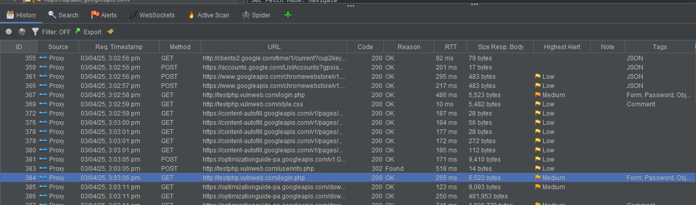



**Remediation Recommendations**

To mitigate this issue, the X-Powered-By header should be removed from all HTTP responses. You can do this as follows:

1. In PHP:  
   Modify the php.ini configuration file to disable the X-Powered-By header:

expose_php = Off

1. In Apache:  
   Add the following directive to your Apache server configuration to remove the X-Powered-By header:

Header unset X-Powered-By

1. In Nginx:  
   For Nginx, use the following directive to clear the header:

more_clear_headers 'X-Powered-By';

*APPENDIX E- TOOLS USED*

|  |  |
| --- | --- |
| ***TOOL*** | ***DESCRIPTION*** |
| ***Zap*** | *To see the request and response* |

8  ***– Content –Type -Options Header missing Vulnerability Finding :***

|  |  |
| --- | --- |
| ***Medium RISK (2/10)*** | |
| ***Exploitation Likelihood*** | ***Medium*** |
| ***Business Impact*** | ***Moderate*** |
| ***Remediation Difficulty*** | ***Easy*** |

***Security Implications***

*The* ***Content Security Policy (CSP)*** *header is an important security measure that helps prevent attacks such as* ***Cross-Site Scripting (XSS)****,* ***data injection****, and* ***malicious content loading*** *(e.g., from unauthorized or malicious sources). By not setting a CSP header, the application is exposed to these types of attacks. Without CSP, attackers can inject malicious scripts or resources into a web page, leading to data theft, session hijacking, malware distribution, or even site defacement.*

***Analysis***

CSP Header Missing

The application doesn't include a Content Security Policy (CSP) header, which leaves it vulnerable to a variety of attacks. CSP is a security feature that allows web developers to control the resources that can be loaded by a webpage, such as JavaScript, CSS, images, and other media. Without CSP, attackers can inject malicious scripts or load content from untrusted sources.

URLs Affected:

1. <http://testphp.vulnweb.com/AJAX/index.php>
2. <http://testphp.vulnweb.com/artists.php>
3. http://testphp.vulnweb.com/artists.php?artist=1
4. http://testphp.vulnweb.com/artists.php?artist=2
5. http://testphp.vulnweb.com/artists.php?artist=3
6. http://testphp.vulnweb.com/cart.php
7. http://testphp.vulnweb.com/categories.php
8. http://testphp.vulnweb.com/disclaimer.php
9. http://testphp.vulnweb.com/guestbook.php
10. http://testphp.vulnweb.com/high
11. http://testphp.vulnweb.com/hpp/
12. http://testphp.vulnweb.com/hpp/?pp=12
13. http://testphp.vulnweb.com/hpp/params.php?p=valid&pp=12
14. http://testphp.vulnweb.com/index.php
15. http://testphp.vulnweb.com/listproducts.php?artist=1
16. http://testphp.vulnweb.com/listproducts.php?artist=2
17. <http://testphp.vulnweb.com/listproducts.php?artist=3>
18. Still 18 more are affected

All of the above URLs do not include a CSP header, leaving them vulnerable to content injection and data theft attacks.



**Remediation Recommendations**

1. **Implement Content Security Policy (CSP) Header:**

Content-Security-Policy: default-src 'self'; script-src 'self'; style-src 'self'; img-src 'self';

1. **Review and Customize CSP Rules:**
2. **Test CSP Policies:**
3. **Use HTTPS for All Resources:**
4. **Audit and Update Regularly:**

*APPENDIX E- TOOLS USED*

|  |  |
| --- | --- |
| ***TOOL*** | ***DESCRIPTION*** |
| ***Zap*** | *To see the request and response* |

# APPENDIX B - ENGAGEMENT INFORMATION

## Client Information

|  |  |
| --- | --- |
| **Client** | EFFIGO |

## Contact Information

|  |  |
| --- | --- |
| **Name** | VIGNESH .R |
| **Email** | vignesh.r@effigo.tech |