**BIONIC ARM - ARTIFICIAL LIMB**



**A report submitted in partial Fullfillmentof the Academic requirements for the award of the degree of**

**Bachelor of Technology**

Submitted by

**ELIGETI VIGNESH (21H51A66B8)**

**E. SRAVAN (21H51A66B9)**

**K. VAMSHI KRISHNA (21H51A66C4)**

**BANOTH GOWTHAM (22H55A6604)**

**P. KIRTHI (22H55A6616)**

**UNDER THE COURSE**

**SOCIAL INNOVATION AND PRACTICE**



# CENTRE FOR ENGINEERING EDUCATION RESEARCH

**CMR COLLEGE OF ENGINEERING & TECHNOLOGY**

**(Autonomous)**

**(NAAC Accredited with ‘A+’ Grade & NBA Accredited)**

**(Approved by AICTE, Permanently Affiliated to JNTU Hyderabad)**

**KANDLAKOYA, MEDCHAL ROAD, HYDERABAD-501401**

**2022-2023**

*CMR COLLEGE OF ENGINEERING & TECHNOLOGY* CENTER

# CENTRE FOR ENGINEERING EDUCATION RESEARCH

**CMR COLLEGE OF ENGINEERING & TECHNOLOGY**

**(Autonomous)**

**(NAAC Accredited with ‘A+’ Grade & NBA Accredited)**

**(Approved by AICTE, Permanently Affiliated to JNTU Hyderabad)**

**KANDLAKOYA, MEDCHAL ROAD, HYDERABAD-501401**



**CERTIFICATE**

This is to certify that the report entitled **“BIONIC ARM”** is a bonafide work done by **G ELIGETI VIGNESH (21H51A66B8), P.KIRTHI (22H55A6616), K. VAMSHI KRISHNA (21H51A66C4), BANOTH GOWTHAM (22H55A6604), E SRAVAN KUMAR (21H51A66B9)** of II BTech, in partial fulfillment of the requirements for the award of the degree of Bachelor of Technology submitted to the Centre for Engineering Education Research, CMR College of Engineering & Technology, Hyderabad during the Academic Year 2022-23.

|  |  |
| --- | --- |
| **(Names of the Project Coordinators)** | **B. Suresh Ram (Associative Professor)** |
| 1. **Mr. B VENKATESHWAR RAO(**Asst. Prof) 2. **Mrs. Md Asma** (Asst. Prof) 3. **Mr. B KONDALU** (Asst. Prof) | CEER HOD |

**DECLARATION**

We, the students of II B. Tech of Centre for Engineering Education Research, CMR COLLEGE OF ENGINEERING AND TECHNOLOGY, Kandlakoya, Hyderabad, hereby declare, that under the supervision of our course coordinators, we have independently carried out the project titled “BIONIC ARM” and submitted the report in partial fulfillment of the requirement for the award of Bachelor of Technology in by the Jawaharlal Nehru Technological University, Hyderabad (JNTUH) during the academic year 2022-2023.

**DETAILS OF STUDENTS:**

|  |  |  |
| --- | --- | --- |
| NAME | ROLL NUMBER | SIGNATURE |
| **ELIGETI VIGNESH** | **(21H51A66B8)** |  |
| **E SRAVAN KUMAR** | **(21H52A66B9)** |  |
| **K. VAMSHI KRISHNA** | **(21H51A66C4)** |  |
| **P. KIRTHI** | **(22H55A6616)** |  |
| **BANOTH GOWTHAM** | **(22H55A6604)** |  |

**Internal examiner External examiner**

**ACKNOWLEDGEMENT**

We are obliged and grateful to thank B. Suresh ram, Head (CEER), CMRCET, for his cooperation in all respects during the course.

We would like to thank the Principal of CMRCET, Dr. V.A. Narayana, for his support during this project work.

We would like to thank my Project coordinators **B. Suresh Ram** (Associative Professor) CEER HOD**, Mr. B Venkaeshwar Roa**(Asst. Prof), **Mrs. Md Asma** (Asst. Prof), **Mr. B Kondalu** (Asst.

Prof), for his/her guidance to complete my project work.

Finally, we thank all our faculty members and Lab Assistants for their valid support.

We owe all our success to our beloved parents, whose vision, love, and inspiration have made us reach out for these glories.

**TABLE OF CONTENTS:**

|  |  |  |  |
| --- | --- | --- | --- |
| CHAPTERS | DIVISIONS | DESCRIPTION | PAGE NO |
| 1 |  | Abstract | 6 |
| 2 |  | Introduction | 7 |
| 3 |  | Problem Definition | 8 |
|  | 3.1 | Problem Statement | 8 |
|  | 3.2 | Objective | 8 |
|  | 3.3 | Requirement Analysis | 9 |
|  | 3.4 | Methodology | 13 |
| 4 | 4.1 | Working Model | 14 |
|  | 4.2 | Block Diagram/Flowchart | 14 |
|  | 4.3 | Design Description | 15 |
| 5 |  | Implementation | 17 |
|  | 5.1 | Results and Discussions | 17 |
|  | 5.2 | Conclusions | 17 |
| 6 |  | Appendix | 18 |
|  | 6.1 | References | 18 |

1. **ABSTRACT:**

Bionic arms, also known as prosthetic arms, are advanced technological devices designed to replace a missing or non-functioning limb. These devices use a combination of mechanical and electronic components to mimic the movements and functions of a natural arm. They are controlled by the user's remaining muscle signals and can be customized to suit the individual's needs. Bionic arms can be used for a variety of tasks, including grasping objects, writing, and even playing musical instruments.

The technology behind bionic arms continues to evolve, with the development of new materials and control systems that improve their functionality and durability. With the advancements in bionic technology, people with limb loss can regain their independence and improve their quality of life.

By using EMG Sensor(used to trackdown the muscle movements in a limb or muscle where it is attached by taking the electrical signals generated at that particular muscle and measuring the current intensity and gives an electrical signal to the arduino by analysing the muscle signals) we get the movement of the muscles and by applying these signals to the Servo-motors we can produce the movement to the fingers.

1. **INTRODUCTION:**

A bionic arm, also known as a prosthetic arm, is an artificial limb that is designed to mimic the function of a human arm. It is controlled by electrical signals from the user's muscles and is often equipped with sensors and other technology to provide a more natural and intuitive experience. The number of people using bionic arms varies depending on the country, but it is estimated that there are millions of people worldwide who use prosthetic limbs. However, not all people can afford a bionic arm, as titcan bit cane expensive. Some insurance plans may cover the cost of a prosthetic limb, but many people still have to pay for them out of pocket. Additionally, many organizations are dedicated to providing bionic arms to people in need, often through donations and fundraising.

1. **PROBLEM DEFINITION:**

People use bionic arms for a variety of reasons. The most common reason is due to an amputation, which can be caused by injury, illness, or congenital conditions. Some people may also choose to use a bionic arm as an alternative to a traditional prosthetic limb, as it can provide greater functionality and a more natural experience. Bionic arms can also be used for people who have lost the use of their ararmsue to a neurologialarmsition such as a spinal cord injury or stroke. Additionally, some people may choose to use a bionic arm for cosmetic reasons, as it can improve their self-esteem and confidence.

* 1. **PROBLEM STATEMENT:**

People may need bionic arms, also known as prosthetic arms, for a variety of reasons. The most common reason is due to an amputation, which can be caused by injury, illness, or congenital conditions. Amputations can occur as a result of accidents, such as car accidents, workplace accidents, or combat injuries. Some illnesses, such as cancer, may require amputations as a treatment option. Additionally, some people may be born with congenital conditions that require amputation, such as symbrachydactyly, a condition where the hand does not fully develop.

Bionic arms can help individuals who have lost an arm regain some level of independence and functionality. They can help with everyday tasks such as eating, dressing, grooand groomind also help with activities such as sports, ho,bbies or hobbies. They can also improve self-esteem and body image.

* 1. **OBJECTIVE:**

Bionic arms, also known as prosthetic arms, work by replicating the function of a human arm. They are controlled by electrical signals from the user's muscles, and ar often equipped with sensors and other technology to provide a more natural and intuitive experience.

There are several different types of bionic arms, each with its unique features and functionality. Some common types include:

Body-powered: These bionic arms are controlled by cables and harnesses that are attached to the user's residual limb. They use the movement of the user's own body to control the movement of the bionic arm.

Myoelectric: These bionic arms are controlled by electrical signals from the user's muscles. Sensors are placed on the user's residual limb, which detects the detects al signals and uses them tousesntrol the movement of the bionic arm.

Hybrid: These bionic arms are a combination of body-powered and myoelectric technology. They use a combination of cables and sensors to control the movement of the bionic arm.

Exoskeleton: Exoskeleton bionic arms is a wearmle device that is placed on the user's arm and it uses motors, batteries and sensors ,to help the user to move the arm.

Each type of bionic arm has its advantages and disadvantages, and the best option for an individual will depend on their specific needs and abilities.

In summary, bionic arms work by replicating the function of a human arm and are controlled by electrical signals from the user's muscles, and are often quipped with sensors and other technology to provide a more natural and intuitive experience. There are different types of bionic arms, each with its unique features and functionality.

1. Daily living: Bionic arms can help with everyday tasks such as eating, dressing, grooming and other activities of daily living.

2. About one in every 2000 newborn babies willnewbornme a form of a limb deficiency; it may be absent parts of fingers or toes, the complete absence of the ll four limbs or something in , between. Another larger group of children lose lchildrenccidents, especially tolawnmowerss, trains, all-terrain vehicles, and motorcycles; or to disease, including cancer

3.Work and hobbies: They can help individuals return to work or engage in hobbies that require using their arms.

4.Sports and recreation: Some bionic arms are specifically designed for sports and recreation, such as rock climbing, cycling and swimming.

5.Cosmetics: Some people may choose to use a bionic arm for cosmetic reasons, as it can improve their self-esteem and confidence.

6.Research and Development: Bionic arms are also used in research and development ttohe technology and make it more accessible to more people.

**REQUIREMENT ANALYSIS:**

**HARDWARE DESCRIPTION:**

* + 1. Arduino UNO microcontroller
    2. Breadboard
    3. Jump Wires
    4. EMG sensor
    5. Servo motors
    6. Battery
    7. Foamboard
    8. Thread(nylon)
    9. capacitor

**SOFTWARE DESCRIPTION:**

1. Arduino tool (IDE)

1. **ARDUINO UNO:**

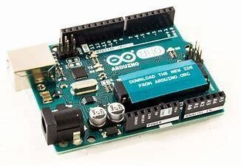

fig:3.3.1

The microcontroller is an embedded computer chip that controls most of the electronic gadgets and appliances that people use daily, right from mobile phones, washing machines to anti- lock brakes in cars. The microcontroller was introduced in the electronics industry with the purpose of making our tasks easy that come with even a remote connection with automation in any way. Arduino Uno is a microcontroller board based on 8- bit ATmega328P microcontroller. Along with Atmega328P it consists other components such as crystal oscillator, serial communication, voltage regulator, etc. to support the microcontroller.

1. **THE BREADBOARD:**

The breadboard is a white rectangular board with small, embedded holes to insert electronic components. It is commonly used in electronics projects. We can also say that breadboard is a prototype that acts as a construction base of electronics. A breadboard is also categorized as a **Solderless board**. It means that the component does not require any soldering to fit into the board. Thus, we can say that breadboard can be reused. We can easily fit the components by plugging their end terminal into the board. Hence, a breadboard is often called a **plugboard**.

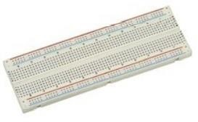fig:3.3

1. **JUMP WIRES:**

A jump wire (also known as jumper, jumper wire, DuPont wire) is an [electrical wire,](https://en.wikipedia.org/wiki/Electrical_wire) or group of them in a cable, with a connector or pin at each end (or sometimes without them – simply "tinned"), which is normally used to interconnect the components of a [breadboard](https://en.wikipedia.org/wiki/Breadboard) or other prototype or test circuit, internally or with other equipment or components, without soldering.Individual jump wires are fitted by inserting their "end connectors" into the slots provided in a breadboard, the [header connector](https://en.wikipedia.org/wiki/Pin_header) of a circuit board, or a piece of test equipment.

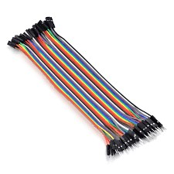

fig:3.3.3

**4.GPS NEO-6MV2:**

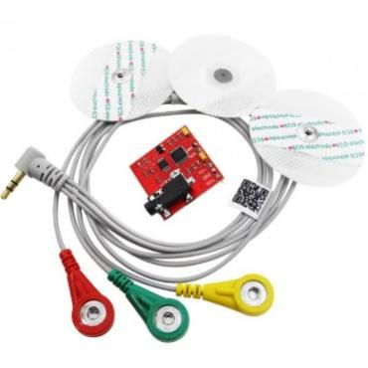

Fig:3.3.4

EMG Sensor, also known as electromyography sensor measures small electrical signals generated by your muscles when you move them! This includes lifting your arm, clenchiyour fist, or even the simplest of movements like moving a finger!

**5.SERVO MOTORS:**

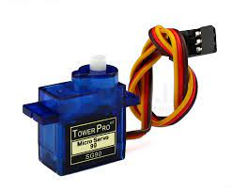

Fig:3.3.5

Servo motors or “servos”, as they are known, are electronic devices and rotary or linear actuators that rotate and push parts of a machine with precision. Servos are mainly used on angular or linear position and for specific velocity, and acceleration.

1. **9V BATTERY :**

The nine-volt battery, or 9-volt battery, is an [electric battery](https://en.wikipedia.org/wiki/Electric_battery) that supplies a nominal voltage of 9 [volts.](https://en.wikipedia.org/wiki/Volt) Actual voltage measures 7.2 to 9.6 volts, depending on battery chemistry. Batteries of various sizes and capacities are manufactured; a very common size is known as PP3, introduced for early [transistor radios.](https://en.wikipedia.org/wiki/Transistor_radio) The PP3 has a rectangular prism shape with rounded edges and two polarized snap connectors on the top. It is a multipurpose used battery.

1. **CAPACITOR:**

A [capacitor](https://en.wikipedia.org/wiki/Capacitor) is a device that can store (and release) charge. It is made up of 2 metallic electrodes (or plates) that are separated by a thin dielectric material. When you apply a voltage over the two plates, an electric field is created. Positive charge will collect on one plate and negative charge on the other.

In short, a capacitor lets the AC component through and blocks the DC component.

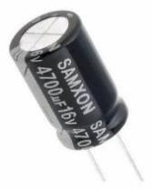

Fig:3.3.7

**3.4 METHODOLOGY:**

Bionic arms, also known as prosthetic arms, work by replicating the function of a human arm. They are controlled by electrical signals from the user's muscles, and are often equipped with sensors and other technology to provide a more natural and intuitive experience.

1.Body-powered: These bionic arms are controlled by cables and harnesses that are attached to the user's residual limb. They use the movement of the user's own body to control the movement of the bionic arm.

2.Myoelectric: These bionic arms are controlled by electrical signals from the user's muscles. Sensors are placed on the user's residual limb, which detect the electrical signals and use them to control the movement of the bionic arm.

3.Convert muscler signal to electric signal: These bionic arms are a combination of body-powered and myoelectric technology. They use a combination of cables and sensors to control the movement of the bionic arm.

4.Movements: Exoskeleton bionic arms is a wearable device that is placed on the user's arm and it uses motors, batteries and sensors to help the user to move the arm.

5Each type of bionic arm has its advantages and disadvantages, and the best option for an individual will depend on their specific needs and abilities..

**4**

**4.1 WORKING MODEL :**

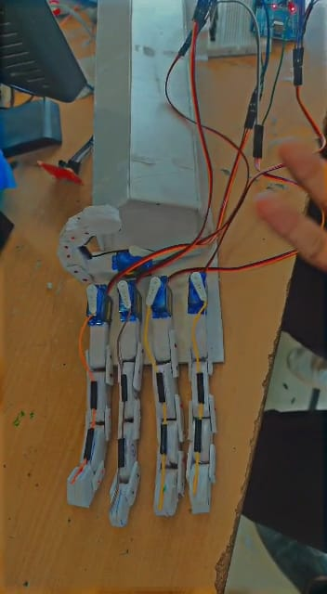

**Fig:4.1.1**

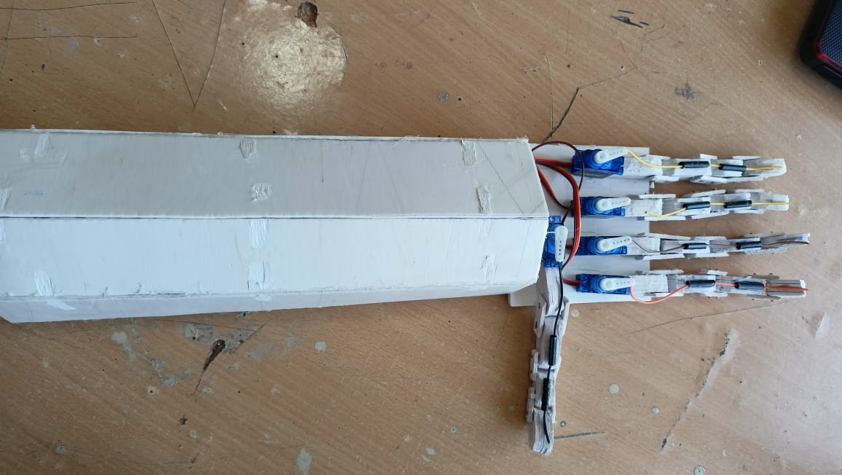

**Fig:4.1.2**

**4.2. BLOCK DIAGRAM/FLOW CHART:**

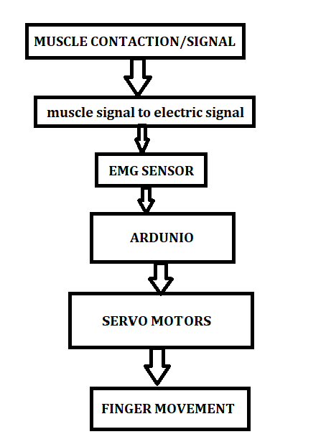

**4.3 DESIGN DESCRIPTION**:

**Hardware Used:**

* + 1. Arduino UNO microcontroller
    2. Breadboard
    3. Jump Wires
    4. EMG sensor
    5. Servo motors
    6. Battery
    7. Foamboard
    8. Thread(nylon)
    9. capacitor

**Software Used:**

Arduino Uno – It is the host which controls the other components

Arduino (IDE) – it is a platform where the coding part is done according to the requirements.

**Advantages:**

* + Improved functionality
  + Increased mobility
  + More natural experience
  + Improved appearance
  + Advancement in technology:
  + Helping in Rehabilitation:
  + Helping to reduce phantom pain:
  + Helping to re-integration:

1. **IMPLEMENTATIONS:**

* 1. **RESULTS AND DISCUSSIONS:**

The results of using bionic arms, also known as prosthetic arms, can vary depending on the individual's specific needs and abilities, as well as the type of bionic arm they are using.

1. Improved independence and functionality: Bionic arms can help individuals regain some level of independence and functionality, allowing them to perform everyday tasks and engage in activities they may not have been able to do before.

2. More natural experience: Bionic arms are often equipped with sensors and other technology that provide a more natural and intuitive experience, making them easier and more comfortable to use.

3.Improved appearance: Some bionic arms are designed to be cosmetically pleasing, this can improve self-esteem and body image.

4. Helping in Rehabilitation: Bionic arms can be used in rehabilitation programs, helping individuals to relearn how to use their arms and improve their overall muscle strength and dexterity.

* 1. **CONCLUSIONS:**

In conclusion, artificial hands can be beneficial for those with limited mobility or physical disabilities. They can be used to help with everyday tasks and activities, and can provide a sense of independence and empowerment to those who use them. However, there are some disadvantages to using artificial hands, including the cost, the risk of infection, and the risk of malfunctioning. Ultimately, it is important to weigh the pros and cons before deciding if an artificial hand is a right choice for you.

Bionic arms are a revolutionary technology that can be used for a variety of applications. They are continually improving, and the potential for their use is growing. With the development of more affordable and user-friendly bionic arms, the possibilities for their use are only just beginning.

This document has provided an overview of bionic arms and their current state of development. It has also looked at some of the potential applications and future developments of this technology.

1. **APPENDIX:**

* 1. **REFERENCES:**

* <https://bionicsforeveryone.com/bionic-arms-hands/>
* https://www.youtube.com/watch?v=luHmXHEpFw
* https://www.youtube.com/watch?v=sI3LLa0uKlI

**TEAM DETAILS:**



E. Sravan E. Vignesh K.Vamshi Krishna

21H51A66B9 21H51A66b8 21H51A66C4

21h51a66b9@cmrcet.ac.in 21h51a66b8@cmrcet.ac.in 21h51a66c4@cmrcet.ac.in

 

B. Gowtham P. Kirthi

22H55A6604 22H55A6616

22h55a6604@cmrcet.ac.in 22h55a6616@cmrcet.ac.in



ARDUINO BASED POTHOLE FILLER

# ABSTRACT:

Bionic arms, also known as prosthetic arms, are advanced technological devices designed to replace a missing or non-functioning limb. These devices use a combination of mechanical and electronic components to mimic ‘the movements and functions of a natural arm.

# DESCRIPTION:

Bionic arms, also known as prosthetic arms, are advanced technological devices designed to replace a missing

or non-functioning limb. These devices use a combination of mechanical and electronic components to mimic

‘the movements and functions of a natural arm.

# CONCLUSION:

In conclusion artificial hands canbe beneficial for those with limited mobility or physical disabilities. They can

be used to help with everyday tasks and activities, and can provide a sense of independence and empowerment

to those wi use them. However there are some disadvantages to using artificial hands. including the cost the

Tisk of infection, and the risk of malfunctioning Utimately, iis important to weigh the pros and cons before

deciding ifan artificial handis aright choice for you.

# FACULTY: TEAM-12

B.Venkateshwar Rao(Asst Prof) 21H51A66B8- ELIGETI VIGNESH

Ma. Asma( Asst Prof) 21H51A66C4 -K VAMSHI KRISHNA

B KaudalAsst Prod) 21H51A66B9 -E SRAVAN KUMAR

22H55A6604-BANOTH GOWTHAM

22H55A6616-PKIRTHI

