CONTENT

CHAPTER TITLE PAGE NO

1 INTRODUCTION

1.1 Overview

1.2 Purpose

2 Problem Definition & Design

Thinking

2.1 Empathy Map

2.2 Ideation &

Brainstorming Map

3 RESULT

4 ADVANTAGES &

DISADVANTAGES

5 APPLICATIONS

6 CONCLUSION

7 FUTURE SCOPE

8 APPENDIX

**1. INTRODUCTION**

**1.1 Overview:**

Irregular sleeping patterns are a common problem. This web app will fulfil the user's needs in tracking their sleeping patterns, including duration and timings. You will create a web app to track three parameters: sleep time, wake up time, and sleep duration. Users can add, edit, or remove any sleep entries.

we'll learn how to create a sleep tracker web application hosted on Code Capsules. Users will register an account with the sleep tracker and log in. To track their sleep data, users will enter a date and number of hours slept. We'll present users with a graph showing the sleep data they've logged, so users can get a visual representation of their sleep habits over time.

**1.2 Purpose:**

A project that demonstrates the use of Android Jetpack Compose to build a UI for a sleep tracking app . The app allows users to track their sleep. With the “Sleep Tracker” app, you can assess the quality of sleep they have had in a day. It has been time and again proven that a good quality sleep is pretty essential for effective functioning of both mind and body.

“Sleep Tracker” application enables you to start the timer when they are in the bed and about to fall asleep. The timer will keep running in the background until it is stopped, whenever the user wakes up. Based on the sleep experience, you can rate your sleep quality. Finally, the app will display an analysis of the kind of sleep, you had the previous night.

**2. Problem Definition & Design Thinking**

**2.1 Empathy Map:**

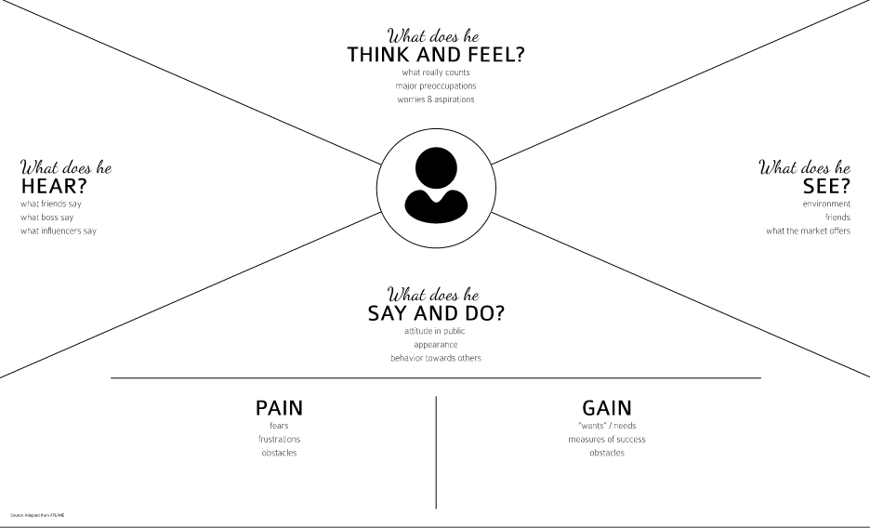

**2.2 IDEATION AND BRAINSTONING MAP:**

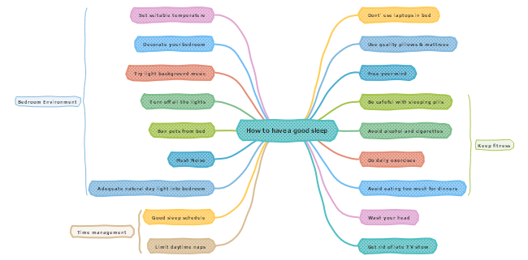

**3.RESULT :**

This android mobile application where user to track the sleep of the user. The main focus of this application is to connect the sleeping algorithm and deliver it to user as fast as possible in best visualize way. A quality yield is one, which meets the necessities of the end client and presents the data unmistakably. In any framework aftereffects of preparing are conveyed to the clients and to other framework through yields. In yield outline it is resolved how the data is to be uprooted for quick need .it is most critical and direct source data to the client. Effective and canny yield configuration enhances the framework’s relationship to help client basic in android development application.

1. Outlining PC yield ought to continue in a sorted out, well thoroughly considered way; the correct yield must be produced while guaranteeing that each yield component is composed with the goal that individuals will discover the framework can utilize effortlessly and adequately. At the point when investigation outline PC yield, they ought to Identify the particular yield that is expected to meet the necessities.

2. Select strategies for exhibiting data.

3. Make record the time of the sleep tracking, report, or different organizations that contain data delivered by the framework.

The yield type of a data framework ought to fulfill at least one of the accompanying goals.

➢    Convey data about past exercises, current status or projections of the Future.

➢    Signal essential occasions, openings, issues, or notices.

➢    Trigger an activity.

➢    Confirm an activity.

**4.ADVANTAGES AND DISADVANTAGES :**

**ADVANTAGES:**1. Real time application is allowed and have live layout.

2. It has built in support for google platform.

3. Less time is consumed compared to newspaper reading. Easy to use and fast.

* Information through videos can be easily understood.
* Time Saving
* Can replace
* Sleep tracking
* Timer
* Appealing user interface

**DISADVANTAGES:**

1. The battery life in android drains quickly.
2. Ads are displayed with most of the free applications either on the top or at bottom of the screen.

**APPLICATIONS:**

The main focus of this application is to connect sleep tracking algoritham and run the timer when we start then end when we stop.

**CONCLUSION:**

The application developed algorithm is to track the sleep of human, like the timer. when we start the timer and stop the timer to record the timer .

**FUTURE SCOPE:**

The Future Scope of the sleep tracking is to track the sleep of the human to automatically, sometime the human can forget to start the tracking so that we add the AI to track the sleep algorithm.

**APPENDIX:**