PROJECT TITLE
SCHOOL INFORMATION MANAGEMENT SYSTEM (SIMS)

SUBMITTED BY
[Your Name]
[Your ID/Roll Number]

ABSTRACT
The School Information Management System (SIMS) is a comprehensive digital platform designed to automate and streamline the administrative and academic operations of educational institutions. In the modern era, managing large volumes of student data, faculty records, and academic schedules manually is prone to errors and inefficiencies. SIMS addresses these challenges by providing a centralized web-based solution that facilitates real-time data access and communication between administrators, teachers, students, and parents. The system incorporates modules for student registration, attendance tracking, assignment management, examination scheduling, fee processing, and library management. Built using a modern tech stack—FastAPI for the backend and React for the frontend—SIMS ensures high performance, security, and scalability. The ultimate goal of this project is to enhance operational transparency and improve the overall educational experience through digital transformation.

HARDWARE AND SOFTWARE REQUIREMENTS

Hardware Requirements:
Processor : Intel Core i3 or above (Client), i5/i7 or equivalent (Server)
RAM : Minimum 4 GB (8 GB recommended)
Hard Disk : Minimum 100 GB of available storage
Monitor : 15” or higher
Input Devices : Standard keyboard and mouse
Internet : Stable broadband connection for API communication

Software Requirements:
Frontend : React.js (with Vite and Tailwind CSS)
Backend : Python (FastAPI)
Database : PostgreSQL
ORM/Migrations : SQLAlchemy and Alembic
Tools : Visual Studio Code, Postman, Git, Docker

EXISTING SYSTEM & PROPOSED SYSTEM

Existing System
Manual Record Keeping: Most schools still rely on physical registers for attendance, marks, and student profiles.
Data Redundancy: Information is often repeated across multiple paper files, leading to inconsistencies.
Delayed Communication: Parents receive updates only during periodic meetings or via physical notices.
Inefficient Retrieval: Searching for specific student history or old records is time-consuming.

Proposed System
Centralized Digital Repository: All data is stored in a secure, relational database (PostgreSQL).
Role-Based Access Control: Specialized dashboards for Admins, Teachers, Students, and Parents.
Real-time Updates: Immediate access to attendance, marks, and fee status.
Automated Workflows: Automatic calculation of fees, grades, and generation of reports.
Enhanced Communication: Digital notifications and event calendars keep all stakeholders informed.

LITERATURE SURVEY

1. Introduction
A literature survey is essential to understand the evolution of educational management tools. This survey examines existing School Management Systems (SMS), Enterprise Resource Planning (ERP) solutions for education, and the shift towards web-based cloud architectures. The objective is to identify how current systems support school operations and where they fall short.

2. Study of Existing Systems / Research Papers
• 'Moodle' (Open Source LMS) provides excellent course management but often lacks integrated administrative features like fee and library management.
• 'PowerSchool' is a highly comprehensive but expensive enterprise solution, making it inaccessible for smaller institutions.
• Research by A. Sharma (2020) on 'Digital Transformation in Schools' highlights that many legacy systems are difficult to use and lack mobile responsiveness.
• Studies on 'Cloud-based Education Management' (2021) suggest that RESTful architectures significantly improve data synchronization across departments.

3. Technologies Used in Existing Works
Historically, PHP and MySQL were the standards for school portals. Recent trends show a move towards the MERN stack (MongoDB, Express, React, Node). However, for systems requiring complex relational data (like SIMS), Python with FastAPI and PostgreSQL is emerging as a preferred choice due to high performance and strong typing.

4. Advantages of Existing Systems
Existing systems successfully digitized the basic registration process and provided a centralized way to store marks, reducing the reliance on physical files.

5. Limitations / Drawbacks of Existing Systems
Many systems are bloated with features that are never used, leading to a steep learning curve. Others lack real-time notification systems or have poor user interfaces that discourage adoption by parents and teachers.

6. Research Gap / Need for the Proposed System
There is a need for a modular, high-performance system that balances ease of use with comprehensive functionality. SIMS fills this gap by using a modern asynchronous backend (FastAPI) and a reactive frontend, ensuring a smooth user experience even on low-bandwidth connections.

7. Summary
The survey confirms that while digital tools exist, there is a clear demand for a more integrated, user-friendly, and cost-effective solution tailored for modern educational needs.

References
1. Moodle Open Source Learning Management System (moodle.org)
2. FastAPI Documentation: High performance, easy to learn, fast to code, ready for production (fastapi.tiangolo.com)
3. React Documentation: A JavaScript library for building user interfaces (reactjs.org)
4. A. Sharma, 'Digital Transformation in Modern Education Systems', Journal of Educational Technology, 2020.
5. 'Cloud-based Architecture for School ERP', International Conference on Web Engineering, 2021.

RESEARCH METHODOLOGY

1. Research Approach
This project follows an Applied Research Approach, aiming to solve the practical problem of school administrative inefficiency through digital automation.

2. Data Collection Method
Requirements were gathered by analyzing standard school workflows, interviewing educators, and reviewing academic reporting standards.

3. System Architecture / Design Methodology
The system uses a Client-Server Architecture. The Frontend (React) communicates with the Backend (FastAPI) via RESTful APIs. PostgreSQL serves as the primary relational data store.

4. Tools and Technologies Used
• Frontend: React.js, Vite, Tailwind CSS
• Backend: Python 3.x, FastAPI
• Database: PostgreSQL
• Deployment: Docker (optional), Uvicorn

5. Development Methodology
Incremental Development Methodology was used, starting with core authentication and followed by student, teacher, and academic modules.

6. Module Description
Auth Module : Handles secure login/logout and role-based redirection.
Admin Module : Management of teachers, students, classes, and subjects.
Teacher Module : Attendance marking, assignment uploads, and marks entry.
Student Module : Viewing profile, attendance, marks, and submitting assignments.
Academic Module : Timetable management and classroom organization.
Fee Module : Fee structure definition and payment tracking.
Library Module : Book cataloging and issue/return tracking.
Notification Module : Real-time alerts and event announcements.

7. Process Flow / Working Method
1. User authentication via JWT.
2. Dashboard redirection based on Role (Admin/Teacher/Student).
3. Data entry/update through specific module forms.
4. Backend validation and persistence in PostgreSQL.
5. Real-time feedback and state updates in the React frontend.

8. Testing Methodology
Unit testing for backend routes using Pytest. Component testing in React. Integration testing for API endpoints.

9. Security Measures
Password hashing using bcrypt, JWT-based authentication, Role-Based Access Control (RBAC), and SQL injection protection via SQLAlchemy ORM.

10. Summary of Research Methodology
The systematic approach ensured that each component was built on a solid foundation, from secure auth to complex library and fee logic.

SYSTEM DIAGRAMS

ARCHITECTURE DIAGRAM
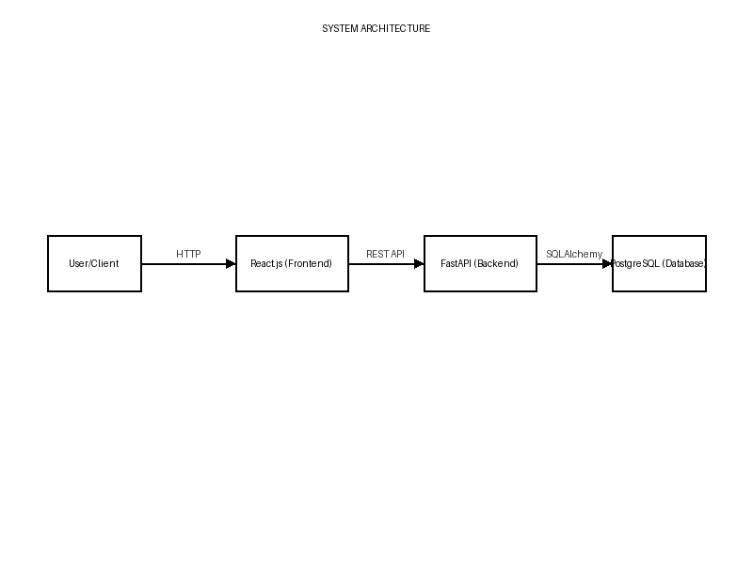

CLASS DIAGRAM
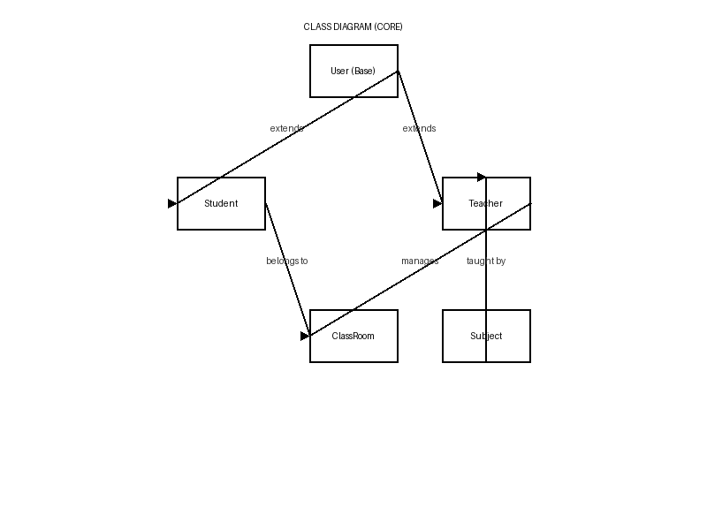

USECASE DIAGRAM
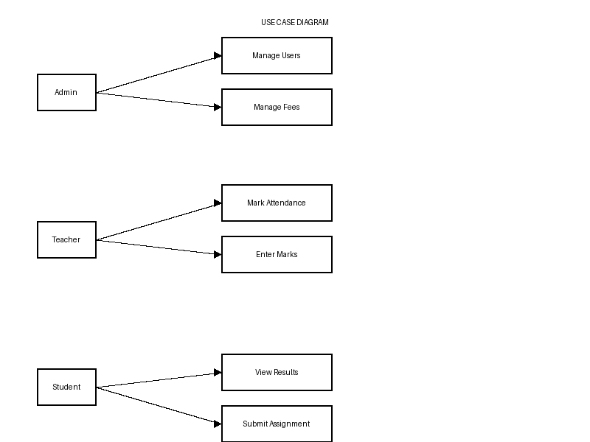

DATA FLOW DIAGRAM (DFD)
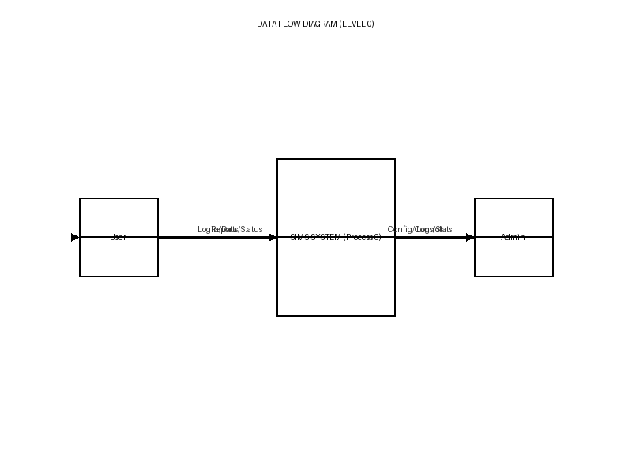

ER DIAGRAM
