AGENTIC AI
A Practitioner’s Week

Build real agents in five days — visually and in code
Five patterns, two tracks per day: wire it on a drag-and-drop canvas, then implement it in Python.
What you’ll learn The agent loop; reflection; memory; tool use; planning; multi-agent orchestration; and the evaluation discipline that separates shipped agents from stuck ones.
How you’ll learn it Each day pairs a no-code visual lab (Langflow) with a hands-on coding exercise (a runnable Python scaffold with solutions). Build intuition fast, then make it precise.
Synthesized from the field’s most-cited engineering sources on agents — vendor-neutral, framework-agnostic. Full references in the appendix.
Prereqs Basic Python for the coding track; none for the visual track.

Contents
Contents 2
The ideas this course is built on 3
Your two tracks, and the visual tool 5
The week at a glance 6
Day 1 — Foundations — workflows, agents, and the loop 6
Day 2 — Reflection & memory 7
Day 3 — Tool use — connect the agent to the world 8
Day 4 — Planning & multi-agent orchestration 9
Day 5 — Evaluation, reliability & the capstone 10
Six ideas to leave with 11
Appendix 12
From canvas to code to production 12
Glossary 12
Sources & further learning 12

The ideas this course is built on
Agent-building has matured from folklore into a small set of durable engineering ideas that the best practitioners now agree on. This course distills them so you learn principles, not one vendor’s API.
Workflows vs. agents. A useful distinction: workflows orchestrate LLMs and tools through predefined code paths, while agents let the model direct its own actions in a loop based on feedback. Agents trade predictability for flexibility — so use the least autonomy that solves the task. For many jobs, a simple workflow (or even one well-crafted LLM call with retrieval) beats a full agent.
Five composable workflow patterns. Most production designs are combinations of five building blocks. You’ll meet each this week.
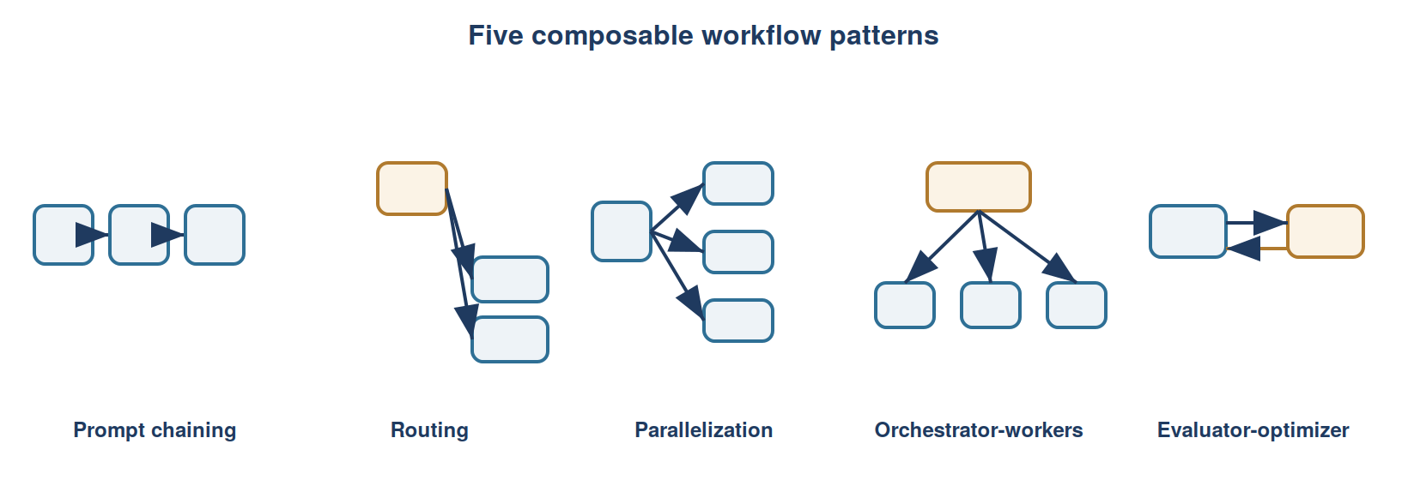
Pattern | What it does | You’ll build it on
Prompt chaining | Sequential steps; each LLM output feeds the next, with gates between | Day 1 (concept), Day 5 capstone
Routing | Classify the input, send it to a specialized handler | Day 4
Parallelization | Run subtasks (or votes) at once and aggregate | Day 4
Orchestrator-workers | A lead LLM decomposes a task and delegates to workers | Day 4
Evaluator-optimizer | One LLM generates, another critiques, in a loop (“reflection”) | Day 2
Anatomy of an agent. When you do need a full agent, it’s always the same four parts around a model: it plans, it remembers (you engineer its context), it uses tools, and it loops on feedback. Each day adds one part.
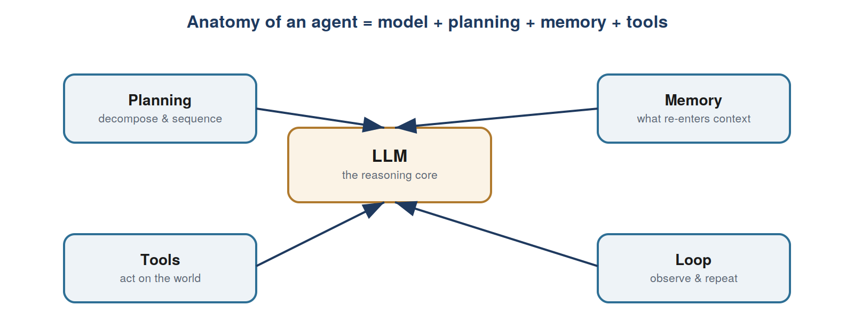
The lesson that matters most
The biggest predictor of whether a team builds effective agents is whether it runs a disciplined evaluation and error-analysis process. Teams that only tweak prompts hit a ceiling they can’t see; teams that measure, trace, and fix the weakest component keep improving. Day 5 is devoted to this, and the mindset threads through every day — treat evals as the main event.
A production north star: deterministic scaffolding around a probabilistic core
Reliable agents are mostly well-engineered software with an LLM placed only where probabilistic reasoning truly helps. Own your prompts and your context window; treat tools as structured outputs your code validates and runs; keep agents small and focused; make human approval a first-class step. These principles keep agents debuggable, auditable, and cheap enough to ship.

Your two tracks, and the visual tool
Every day has two labs. The visual track wires the pattern on a canvas so you see the whole agent at once. The coding track implements the same pattern in ~30 lines of Python so you understand the mechanism and can take it to production. Do either or both; they reinforce each other.
Coding track setup. Unzip the companion agentic-ai-labs/ folder, then:
python -m venv .venv && source .venv/bin/activate
pip install -r requirements.txt
cp .env.example .env # add your ANTHROPIC_API_KEY

# each day: open exercise.py, fill the TODOs, run it, diff against solution.py
Visual track: which tool? Four no-code builders dominate in 2026. For learning these patterns the best fit is Langflow, with n8n and Flowise as situational alternatives.
Tool | Best at | License / cost | Reach for it when
Langflow ★ | Pure agent building; native RAG + MCP; live chat testing; exports to Python | MIT, free self-host; free cloud tier | Learning the patterns (our primary pick)
Flowise | Fast RAG; the only native human-in-the-loop approval node | Apache-2.0, free; cloud ~$35/mo | Flows needing an approval gate
n8n | Real-world actions & looping across 400+ apps | Fair-code; free self-host; cloud ~€24/mo | The capstone — agents that DO things
Dify | All-in-one builder + RAG + observability | Open-source; paid cloud | You want one bundled platform
Why Langflow leads for learning: largest open-source community (so templates and answers for every lab), RAG and tool use are native node types, a live chat pane lets you test while you build, and it exports every flow to Python — the bridge from the visual track to the coding track.
Visual setup (about 10 minutes)
Fastest: the free Langflow Cloud tier — nothing to install. Local: pip install langflow then langflow run, or the Docker image. Add one model key in Settings. For the Day-5 capstone add a free web-search key (Tavily/Serper); if you build that one in n8n, a free n8n Cloud account.

The week at a glance
Day | Pattern | Visual lab (Langflow) | Coding exercise
1 | The agent loop | Your first agent | day1_agent_loop/exercise.py
2 | Reflection + memory | Generate→critique→revise loop | reflection_exercise.py
3 | Tool use | Agent + search, calc, MCP tool | day3_tool_use/exercise.py
4 | Planning + multi-agent | Orchestrator + worker team | orchestrator_exercise.py
5 | Evaluation + capstone | Tracing + eval set | eval_exercise.py, research agent
Each day: a concept block, a visual lab with numbered build steps, a coding exercise with a starter snippet, and an applied use case. Roughly 2–3 hours.

Day 1 — Foundations — workflows, agents, and the loop
When to use an agent at all, and the ~15 lines of code that make one.
Learning objectives
- Tell workflows and agents apart, and choose the least autonomy that solves the task.
- Name the five workflow patterns and recognize where each fits.
- Trace the agent loop: model proposes an action → your code runs it → result feeds back → repeat.
- Get an agent running — on a canvas and in code.
Core concepts
- Workflow vs. agent — Predefined code paths vs. model-directed action in a loop. Start simple; add autonomy only when it earns its keep.
- The agent loop — The whole of “agentic” is a loop over: call model → if it asks for a tool, run it and feed back → else finish.
- Own your control flow — That loop is ordinary code you control (prompt, switch, context, repeat), not framework magic.
- Autonomy spectrum — More autonomy means more capability and more failure modes; match it to the stakes.
Visual lab · Langflow · New Flow → “Simple Agent” template
- Drag an Agent component (or Chat Input → Model → Chat Output) onto the canvas.
- Pick your model and paste an API key if prompted.
- Give it a system prompt and connect Chat Input → Agent → Chat Output.
- Open the Playground chat pane and test live; tweak the prompt and re-run to feel the loop.
Coding exercise · Python · day1_agent_loop/exercise.py
Objective: Implement the four TODOs that make the agent loop run — call the model, detect completion, execute requested tools, feed results back.
for turn in range(max_turns):
resp = call_model(messages, system=SYSTEM, tools=ALL_SCHEMAS)
if resp.stop_reason != "tool_use":
return text_of(resp) # done
# ...else run each requested tool and append results, then loop
Applied use case: An operations assistant that looks up a policy and computes a fee — solved by the loop you just wrote.

Day 2 — Reflection & memory
Make the agent improve its own work — and remember what matters.
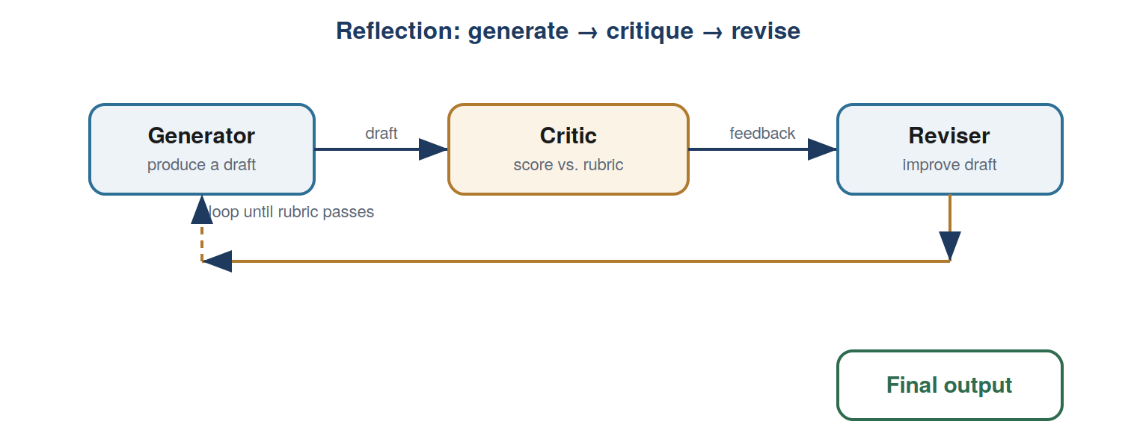
Learning objectives
- Build a generate → critique → revise loop (the evaluator-optimizer pattern).
- Write a rubric-based critic and know why it beats a vague quality score.
- Engineer memory: buffer, summary, and retrieval — because context is the new memory.
Core concepts
- Reflection / evaluator-optimizer — One LLM drafts, another critiques against criteria, the draft is revised — looped until good enough.
- Rubrics beat vibes — A critic scoring specific yes/no criteria outperforms “rate this 1–10.” The rubric is the real work.
- Memory is context engineering — Models are stateless; “memory” is what you choose to put back in the window — buffer, rolling summary, or retrieved facts.
- Own your context window — Curate what enters the model’s attention; more isn’t better. This alone can cut tokens and lift accuracy.
Visual lab · Langflow · wire two agents into a loop
- Add a Generator agent (“Write a short product announcement for the input.”).
- Add a Critic agent with a rubric: score yes/no on hook, one benefit, under 60 words, call-to-action; list failures.
- Add a Reviser that takes draft + critique and improves it; loop Reviser → Critic until it passes or hits a max.
- Test in the chat pane; watch the draft improve across passes.
Coding exercise · Python · day2_reflection_memory/reflection_exercise.py
Objective: Implement generate(), a rubric-based critique(), and the reflect() loop; then explore memory_solution.py for the three memory patterns.
draft = generate(task)
for r in range(max_rounds):
ok, feedback = critique(draft) # yes/no per rubric item
if ok: return draft
draft = generate(task, feedback) # revise using the critique
Applied use case: Marketing copy that polishes itself against a brand rubric — or code that critiques and fixes itself before review.

Day 3 — Tool use — connect the agent to the world
The model requests; your code executes. Tools are just structured outputs.
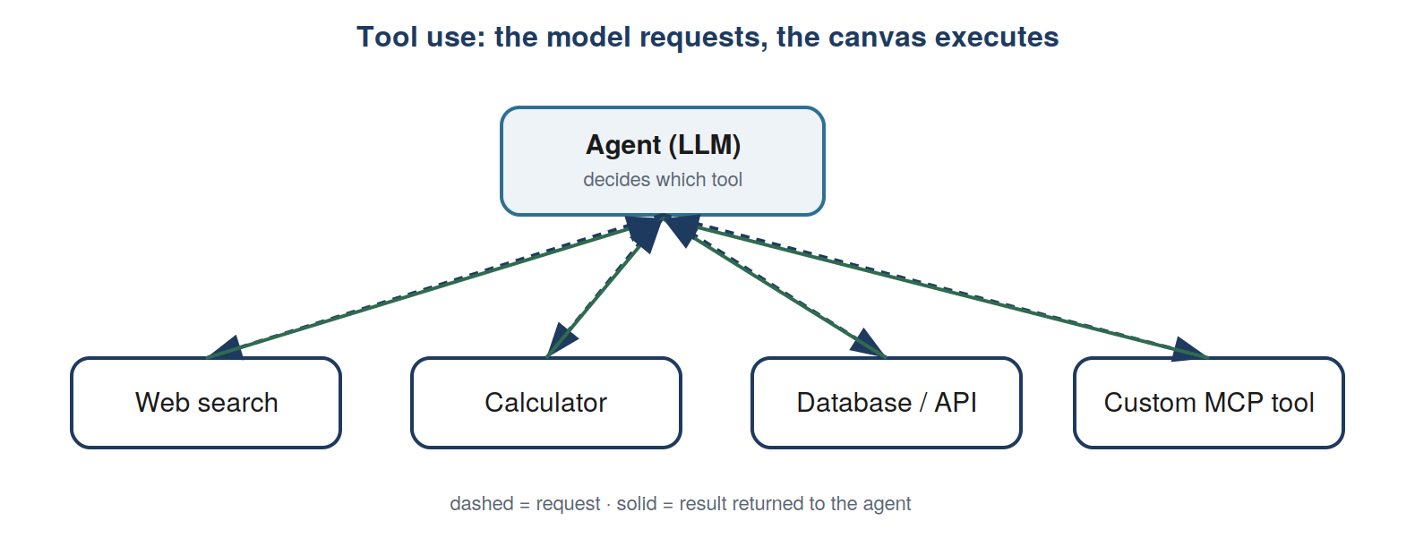
Learning objectives
- Give an agent multiple tools and watch it choose.
- Write tool descriptions precisely — the description is the model’s whole manual.
- Add a custom tool, force structured extraction, and connect an MCP server.
Core concepts
- Tools are structured outputs — “Tool use” is the model emitting JSON that names a tool + arguments; your code validates and runs it. The model decides, your code acts.
- Description quality — Vague descriptions cause wrong tool calls. State what it does, its inputs, and when to prefer it.
- Structured extraction — Force a tool call to guarantee schema-shaped output — the clean hand-off from probabilistic model to deterministic code.
- MCP — The Model Context Protocol standardizes connecting agents to tools and data; Langflow speaks it as client and server.
Visual lab · Langflow · attach tools to an Agent component
- Start from one Agent component (note its Tools input port).
- Connect a Web Search tool (e.g. Tavily) and add your search key.
- Add a Calculator tool, then one custom API/function tool with a crisp description.
- Ask a question that forces a choice (“EUR/USD rate, then 4,000 euros in dollars?”) and watch which tools fire.
Coding exercise · Python · day3_tool_use/exercise.py
Objective: Define a new tool (schema + function), register it, and force structured extraction with a tool call.
CONVERT_SCHEMA = {"name":"convert_currency",
"description": "...precise manual for the model...",
"input_schema": {...} }
# then: tool_choice={"type":"tool","name":"record_lead"} forces clean JSON out
Applied use case: A research/email assistant that looks up live facts, does the math, and calls your internal API instead of guessing.

Day 4 — Planning & multi-agent orchestration
From one agent to a coordinated team: plan, route, delegate, parallelize.
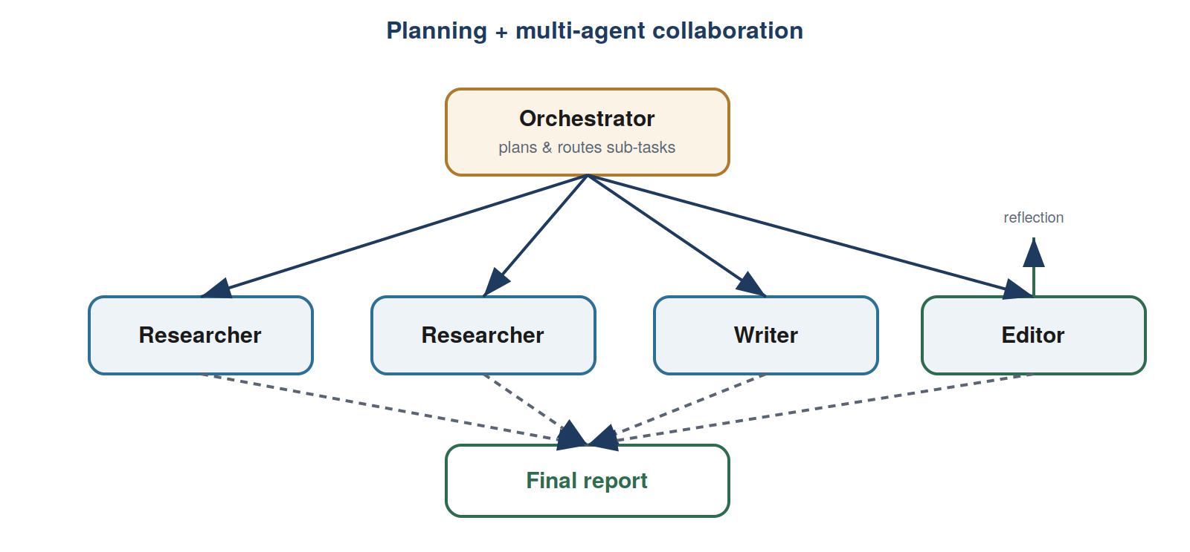
Learning objectives
- Turn a plan into structured steps the system executes and adapts (plan-as-JSON).
- Build an orchestrator that delegates subtasks to focused specialist workers.
- Apply routing and parallelization, and know orchestration vs. choreography.
Core concepts
- Planning — Have the agent emit a structured plan (often JSON), then execute step by step, revising when a step fails.
- Orchestrator-workers — A lead agent decomposes the goal and delegates to specialists; a worker is exposed to the lead as a tool.
- Routing & parallelization — Route distinct inputs to specialized handlers; run independent subtasks (or votes) at once and aggregate.
- Small, focused agents — Narrow responsibilities beat one monolith — easier to test, cheaper, and more accurate.
Visual lab · Langflow · build a research team
- Add an Orchestrator whose prompt returns a JSON plan (2–3 research questions, a write step, an edit step).
- Add two Researcher agents (with the Day-3 search tool) to answer questions in parallel.
- Add a Writer that drafts from the research, and an Editor that applies your Day-2 reflection rubric.
- Wire Orchestrator → Researchers → Writer → Editor → output; inspect each agent’s contribution.
Coding exercise · Python · day4_planning_multiagent/orchestrator_exercise.py
Objective: Implement plan() to emit a JSON step list, then orchestrate() to run each step through the right worker. See router_solution.py for the routing pattern.
steps = plan(request) # -> [{"worker":"policy","task":...}, ...]
for step in steps:
result = WORKERS[step["worker"]](step["task"])
# then synthesize the workers’ results into one answer
Applied use case: A four-role research team — planner, researchers, writer, editor — that turns one topic into a coherent brief.

Day 5 — Evaluation, reliability & the capstone
The skill that separates shipped agents from stuck ones — then build the deep-research agent.
Learning objectives
- Distinguish objective (code) from subjective (LLM-judge) evals; run them over a dataset.
- Read traces to find the weakest component (error analysis); track cost and latency.
- Add guardrails and a human-approval step; then assemble the capstone.
Core concepts
- Eval-driven development — Objective checks where you can, an LLM judge (against a rubric) where you can’t; track pass-rate as you change things.
- Error analysis via traces — A trace records every step; find the component that fails most and fix that one — don’t guess.
- Guardrails & humans-in-the-loop — Deterministic input/output checks around the model; route high-stakes actions to a person as a first-class step.
- Cost & latency, stateless design — Agents fan out into many calls; account for tokens and time, and keep each step a clean input→output function so it can pause, resume, and scale.
Visual lab · Langflow · turn on tracing, then run an eval set
- Connect a tracing backend (LangSmith or Langfuse) so every run is recorded step by step.
- Write 5–10 test inputs with expected properties (a required fact, a required format).
- Add objective checks plus one LLM-judge check with a rubric; run the set.
- Open the traces, find the component that fails most, improve just that one, and re-run to compare pass-rate.
Coding exercise · Python · day5_eval_capstone/eval_exercise.py
Objective: Implement the LLM judge and the eval runner (objective + subjective). Then study eval_solution.py for guardrails and research_agent_solution.py for the capstone.
for c in CASES:
out = agent(c["input"])
ok = c["check"](out) if c["kind"]=="objective" \
else llm_judge(c["input"], out, c["rubric"])
# track pass-rate; grow the set every time you find a bug
Capstone — the deep-research agent. Compose everything: plan research questions, search the web, fetch pages, synthesize and rank, outline, edit (reflection), and emit a Markdown report — looping back to search when gaps remain. The coding version (research_agent_solution.py) runs offline on a small corpus; swap in a real search API to go live.
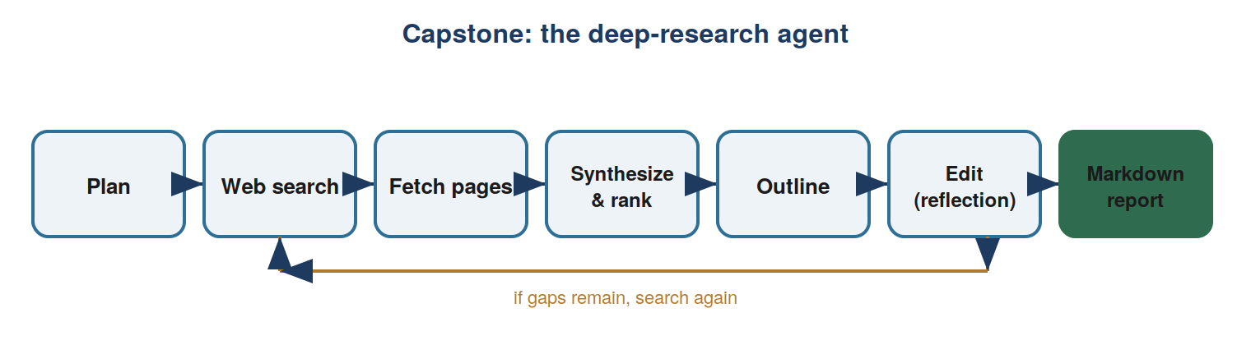
Build the capstone where it’s easiest
Consider n8n for this one: its looping and 400+ integrations make “search, check, search again, then save/send the report” natural. Keep the Day-4 research team as the reasoning core. In regulated settings, use Flowise’s human-in-the-loop node to require approval before the report is sent, and keep the trace as your audit record.
Applied use case: One topic in; a sourced, edited Markdown research report out — the archetypal agentic application.

Six ideas to leave with
- 1. Use the least autonomy that works. Prefer a workflow (or one good LLM call) until a task genuinely needs a model-driven loop.
- 2. The agent loop is the whole game. Call model, run requested tools, feed back, repeat. Everything else is elaboration.
- 3. Rubrics beat vibes. Specific yes/no criteria drive better reflection and better evals than a vague quality score.
- 4. Tools are structured outputs. The model decides; your code validates and acts. That boundary is where safety and audit live.
- 5. Compose small, focused agents. Planning routes work to specialists; reflection polishes it. Monoliths get confused.
- 6. Evals and error analysis are the real skill. Measure, trace, fix the weakest component. Teams that only tweak prompts stall.

Appendix

From canvas to code to production
The two tracks converge. Build a pattern visually to grasp its shape, implement it in the agentic-ai-labs/ scaffold to own the mechanism, then take it to production by exporting your Langflow flow to Python or re-implementing in a code-first framework — LangGraph for stateful loops, CrewAI for teams, or plain Python. The node graph is the mental model; the code makes it testable and auditable.

Glossary
- Workflow vs. agent — Predefined code paths orchestrating LLMs, vs. an LLM directing its own actions in a loop.
- Agent loop — Call model → run requested tools → feed results back → repeat until done.
- Reflection / evaluator-optimizer — Generate, critique against criteria, revise — in a loop.
- Tool use — The model emitting structured JSON that names a tool + args; your code runs it.
- Planning — Decomposing a task into executable, adaptable steps, often as JSON.
- Orchestrator-workers — A lead agent delegating subtasks to focused specialist agents.
- Routing / parallelization — Sending inputs to specialized handlers / running subtasks at once and aggregating.
- Context engineering — Deliberately choosing what enters the model’s context window each step (“memory”).
- Eval-driven development — Improving an agent by measuring it against test cases and analyzing failures.
- MCP — Model Context Protocol — a standard for connecting agents to tools and data.

Sources & further learning
- Anthropic, “Building Effective Agents” — the workflow-vs-agent distinction and the five composable workflow patterns.
- HumanLayer, “12-Factor Agents” — production principles: own your prompts and context window, tools as structured outputs, stateless design, humans as first-class steps.
- Widely-shared agentic design patterns — reflection, tool use, planning, and multi-agent collaboration — as taught across the major practitioner courses and papers (ReAct, Reflexion, plan-and-execute).
- Langflow (docs.langflow.org); n8n and Flowise — the visual builders used in the labs.

