**M S Ramaiah Institute of Technology**

(An Autonomous Institute, Affiliated to VTU)

MSR nagar, MSRIT post, Bangalore-54

A Dissertation Report on

**Android based Monitoring Human Knee Joint Movement Using Wearable Computing**

Under the guidance of

Mr. M. Mallegowda

Submitted by

Sanjana K. S 1MS12CS098

Vidit Jain 1MS12CS127

Vignesh P 1MS12CS128

Vishal H 1MS12CS132

*In partial fulfillment for the award of the degree of*

# *Bachelor of Engineering in Computer Science & Engineering*



**DEPARTMENT OF COMPUTER SCIENCE & ENGINEERING**

**M.S. RAMAIAH INSTITUTE OF TECHNOLOGY**

**(Autonomous Institute, Affiliated to VTU)**

**BANGALORE-560054**

[www.msrit.edu](http://www.msrit.edu), **May 2015**

**Android based Monitoring Human Knee Joint Movement Using Wearable Computing**

**Abstract**

In today’s fast moving lifestyle, incidents regarding health issues are surfacing every day. One of the major issues relating to medical concern is, ‘weakness in joints caused due to much stress’. Hence there is a demand in the market for devices to measure rapid movement of human joints when under recovery. The other reason for this increased need for monitoring human joint movements is to establish a ‘speedy recovery of bones near joint areas with proper correction’. Medical applications are various and the most common is physical therapy and rehabilitation. Some other examples of medical applications are 1] dynamic measuring of lumbar curvature, 2] dynamic monitoring of finger joints, 3] monitoring of limbs and many others. In addition to medicine, monitoring of human joint movements also provides benefits to athletes in sports. We would be developing a system implementing two accelerometer sensors which is placed around the joints in order to detect the amount of bending thereby providing the correct information to an individual’s family physician.

**Objective**

If an individual, say an athlete, is injured in the knee utmost care has to be taken in-order to recover as soon as possible. For thispurpose, the amount of bending around the knee due to an athlete’s day-to-day activity, needs to be monitored at every instant of time. If the athlete bends his injured knee too much accidently, then chances of damage to the injured knee would increase and the speed of recovery would take more time.

To facilitate proper correction for speed recovery from damage caused at joints, in this case knee, we propose a system which uses **accelerometer sensors** placed on both the side (one **above** the joint and the other **below** the joint) of the joint as shown in Figure 1. Whenever the bends around the joints is more, the athlete is alerted and hence can make the necessary correction. In this case the speed of recovery around the joints will be much faster. Also a **pie chart** will be maintained on an Android based Smartphone. This chart can provide an insight to physician or doctor regarding the amount of bending around the joints.

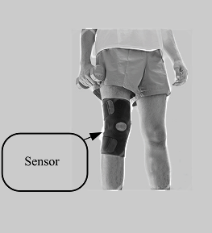

**Figure 1. Sensor**

**Introduction**

The sensors used are made up of MEMS technology thereby of great use for small curvature measurements, and has a high sensitivity in a wide measuring range. The sensor is wearable, non-invasive, nonintrusive, and totally safe. The primary favorable circumstances of this sensor are straightforwardness, softness, and adaptability. This sensor is insusceptible to electromagnetic obstruction. The application, which provides a possibility of monitoring human joints movement using wearable computing, is implemented along with an Android software package.

In this project the acceleration readings are provided by accelerometers on different axis – x, y and z. These readings are obtained with by monitoring changes in the positions of two accelerometers, placed on either side of the joint of an individual. Any movement that occurs at particular joints where accelerometers is placed will cause the accelerometer to generate an output voltage corresponding to the change in gravity. These voltages are fed as input to the microcontroller. The microcontroller further processes this information and delivers an output which is transmitted via Bluetooth to an Android based application mobile. The Android application converts incoming messages into voice output.

Many embedded systems have substantially different designs according to their functions and utilities. In this project design, structured modular design concept is adopted and the system is mainly composed of a single microcontroller, accelerometer, buzzer, Bluetooth and Android cell phone. This is shown in Figure 2.

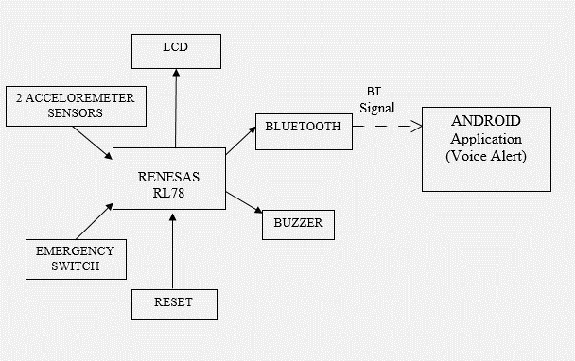

**Figure 2. Block Diagram**

The microcontroller located at the center of the block diagram forms the control unit of the entire project. Embedded within the microcontroller is a program that helps the microcontroller to take action based on the inputs provided by the output of the sensors.

A pair of accelerometer is attached, one above the particular joint and the other below the joint of an individual’s body whose movement needs to be monitored because health issues. Any movement at the particular joint would cause anyone of the accelerometer or both the accelerometer to generate an output voltage. These output voltage (or voltages) corresponds to the change in gravity. These output voltages are fed as input to the microcontroller input pins.

The microcontroller processes the incoming voltages from the sensor depending on the program embedded within it. The output of the microcontroller is passed to Android cell phone via Bluetooth. Through the Android cell phone the incoming signal can be converted into voice message. With this information the particular individual can control his/her limb movement.

An emergency switch is included in this project demonstration. If there arises a scenario, wherein the individual may require assistance of another human being who is not present in that particular room, pressing emergency switch would cause the buzzer to buzz, thereby drawing the attention to another human being.

In the above block diagram LCD is utilized to demonstrate the working of the entire unit. Further a web application with cloud storage for monitoring the values of sensor from anywhere along with Gmail alerts has been planned to be implemented.