Application Deployment
(Deploy the given React application to a production ready state)

Application:
Clone the below mentioned repository and deploy the application (Run application in port 3000).
Repo URL : https://github.com/Vennilavanguvi/Brain-Tasks-App.git
STEP:1
Forked the given URL into my GitHub repo,
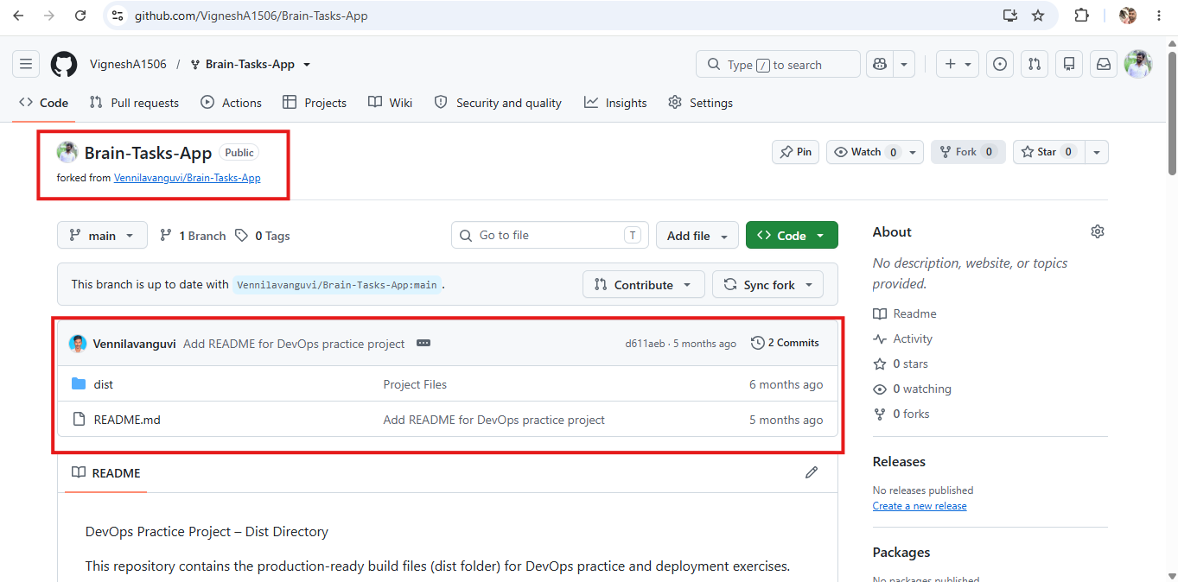
Tested the Brain tasks application by building it using docker locally,
Created the Dockerfile and executed the Docker commands.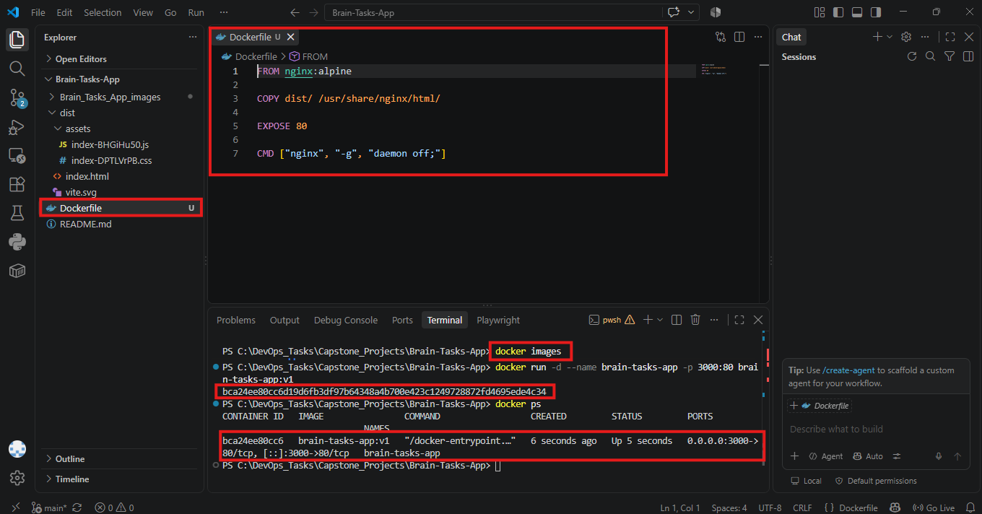
docker build -t brain-tasks-app:v1 .
docker run -d --name brain-tasks-app -p 3000:80 brain-tasks-app:v1
Now using http://localhost:3000 we can view our Brain Tasks App
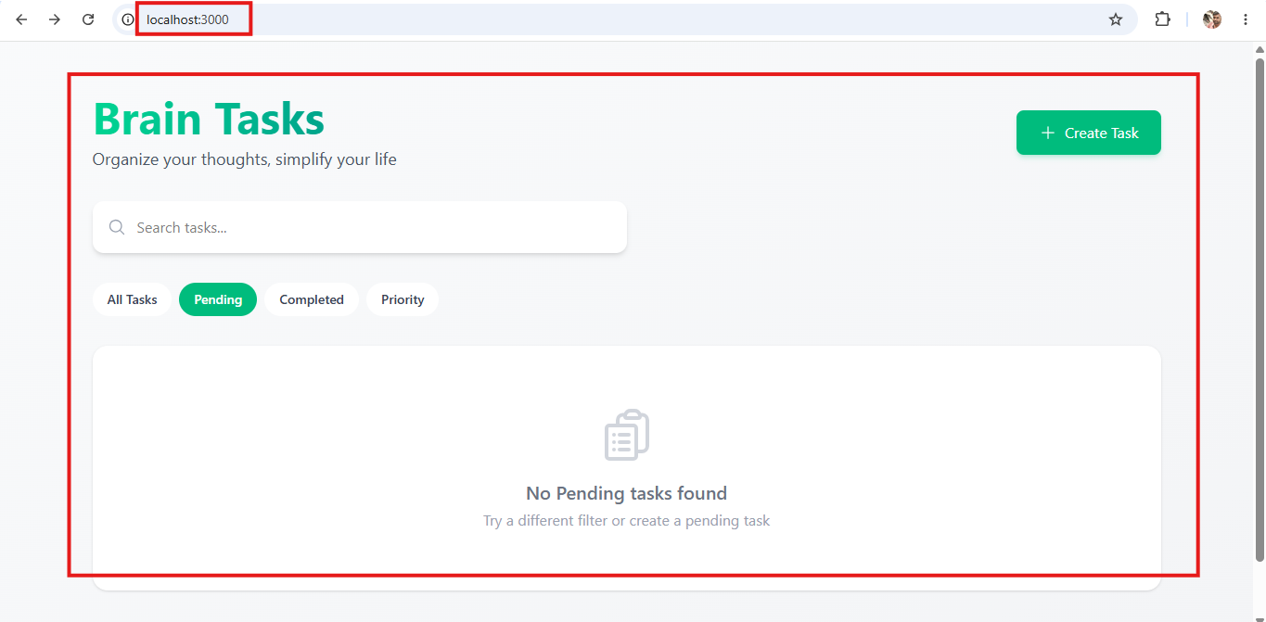
Created ECR repo “brain-task-app” for docker images
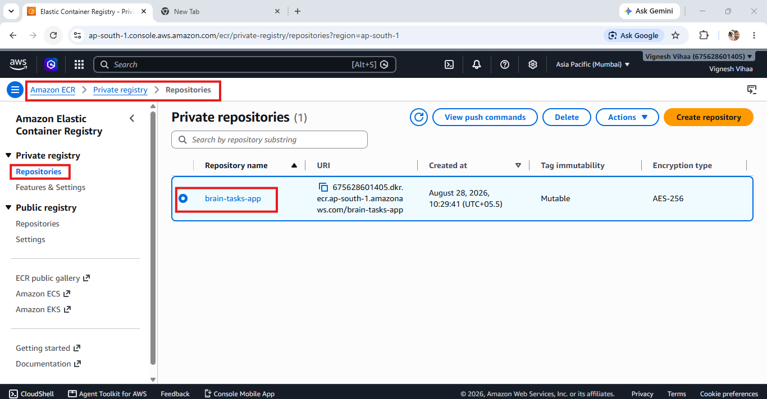

Configured AWS CLI and created docker image and pushed that into AWS ECR repo
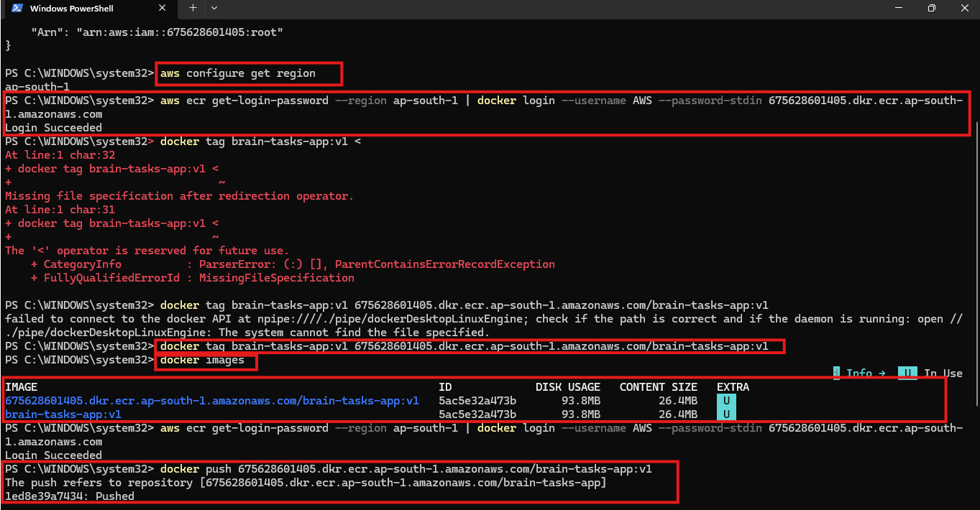
Image has been pushed to the ECR repo,
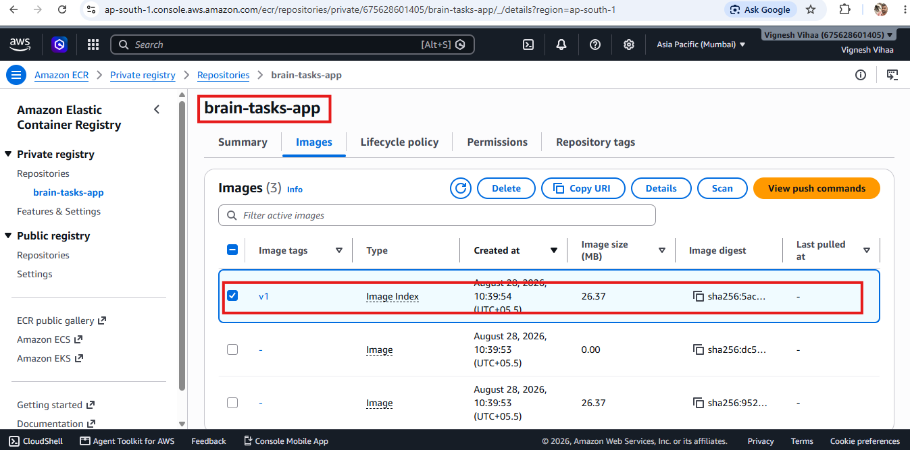

Installing eksctl command and verifying its version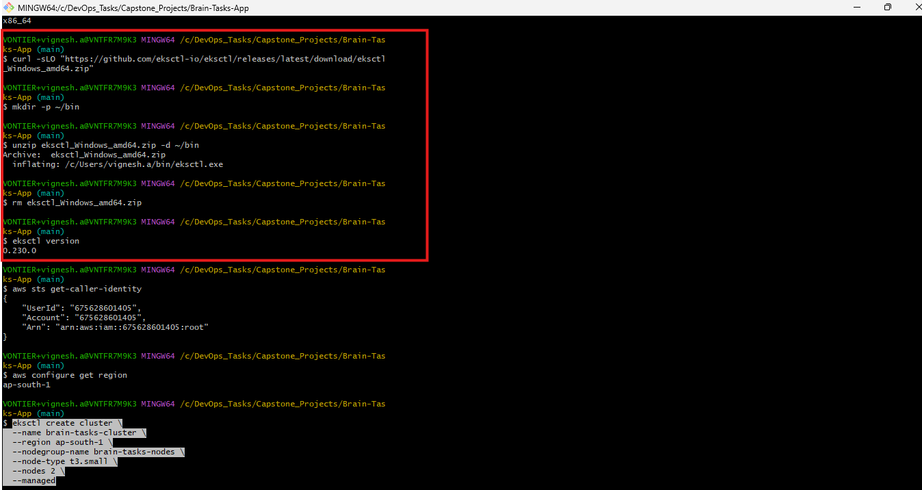

EKS Cluster has been created in bash terminal using eksctl create cluster command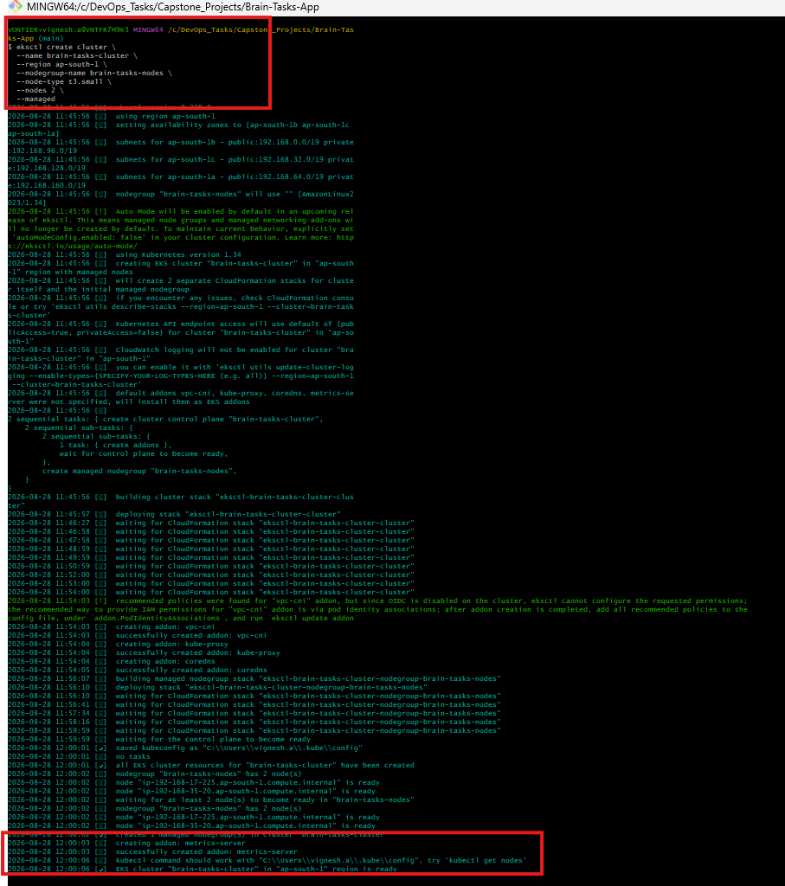

Cluster created in the name of brain-tasks-cluster
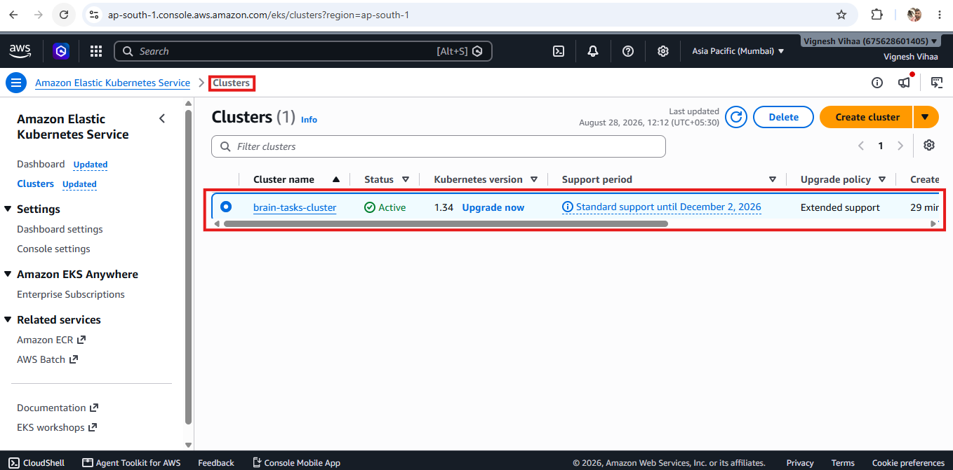
Two node groups are also created with t3.small instance type
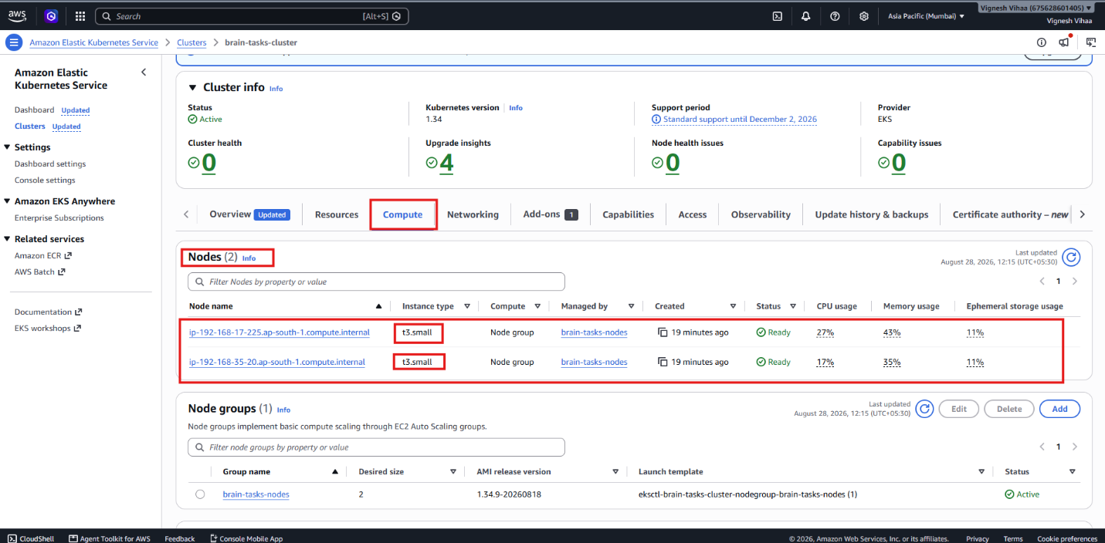

Cluster was created and can be able to access the cluster details from gitbash terminal
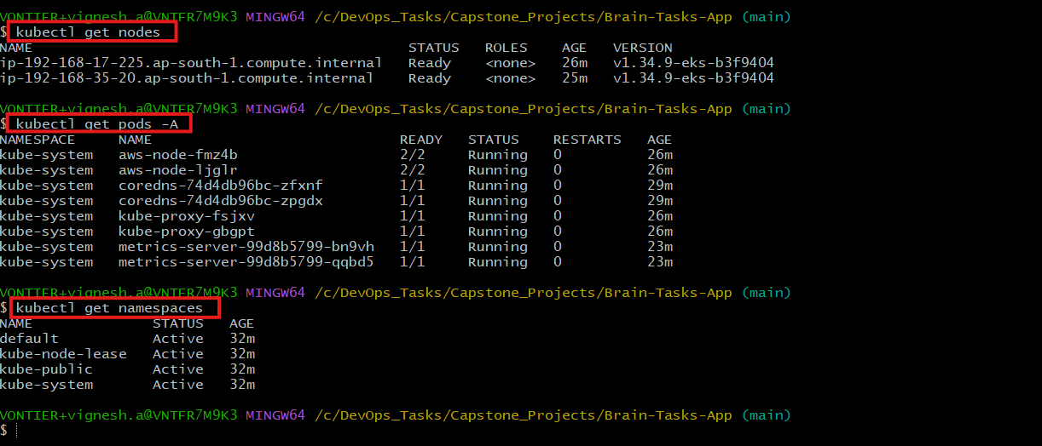
Deployment yaml file created for deploying the image into EKS as pod
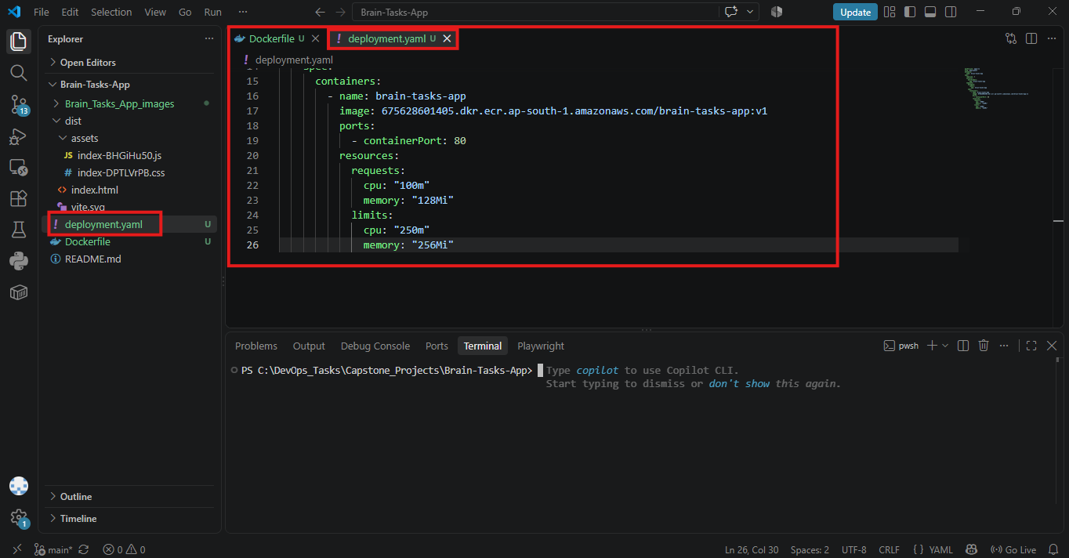

PODs were created using deployment yaml file first deployment created successfully followed by two POD
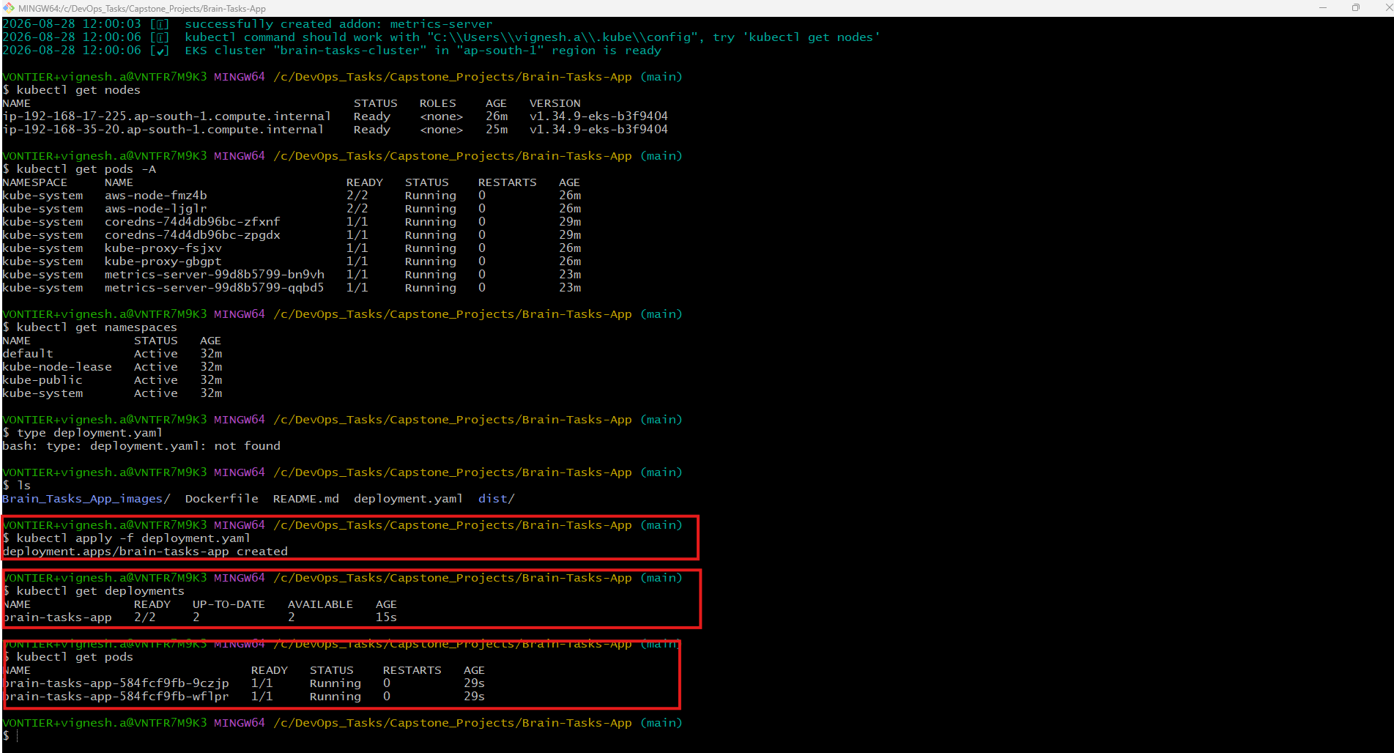
Service yaml was created to expose the app to outside world by creating the Loadbalancer
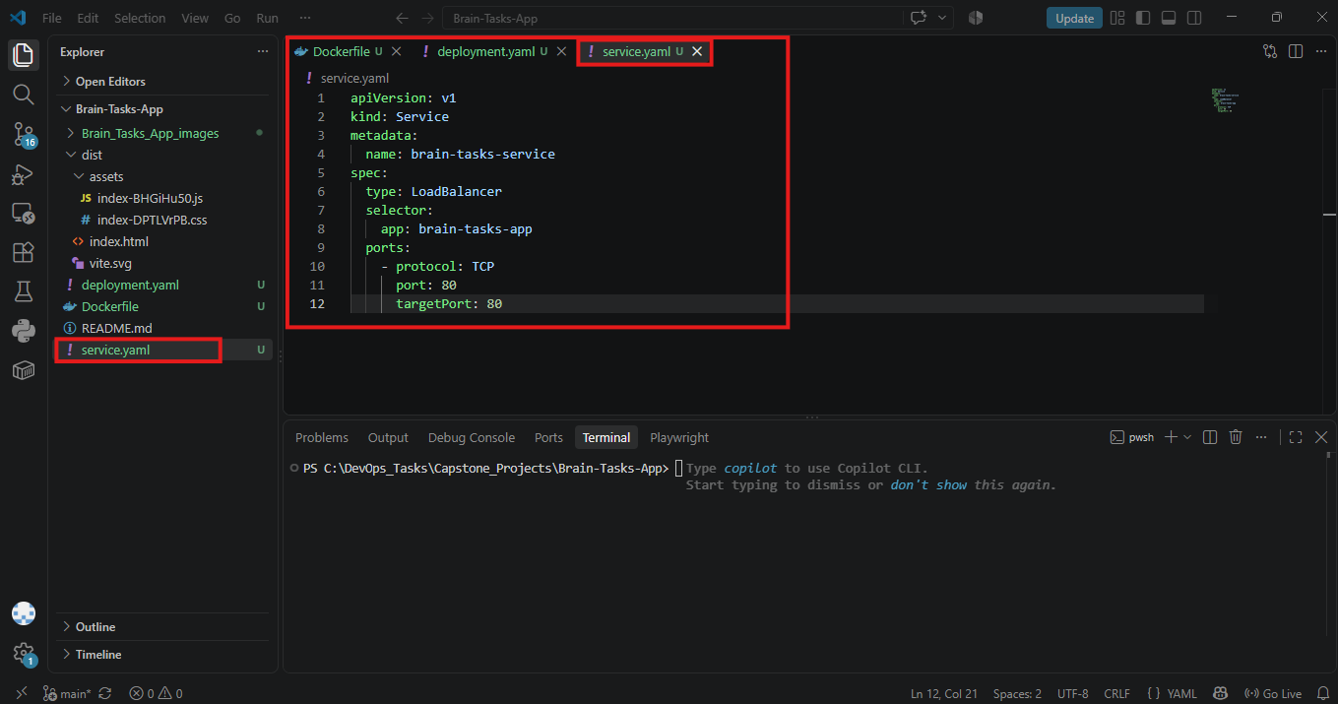
Service yaml applied using kubectl apply command and external IP was generated
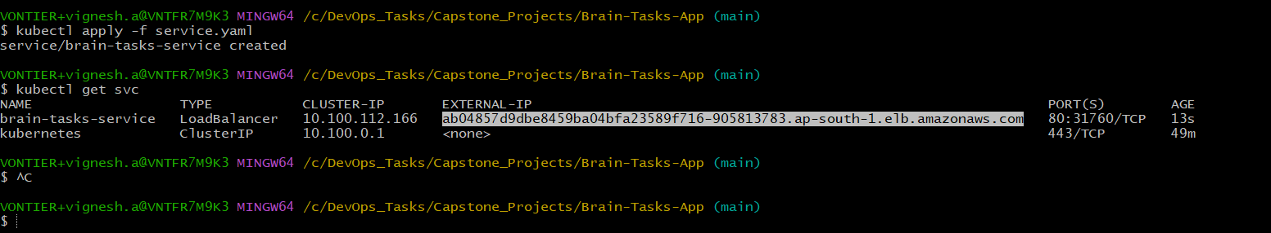
Loadbalancer created with DNS address
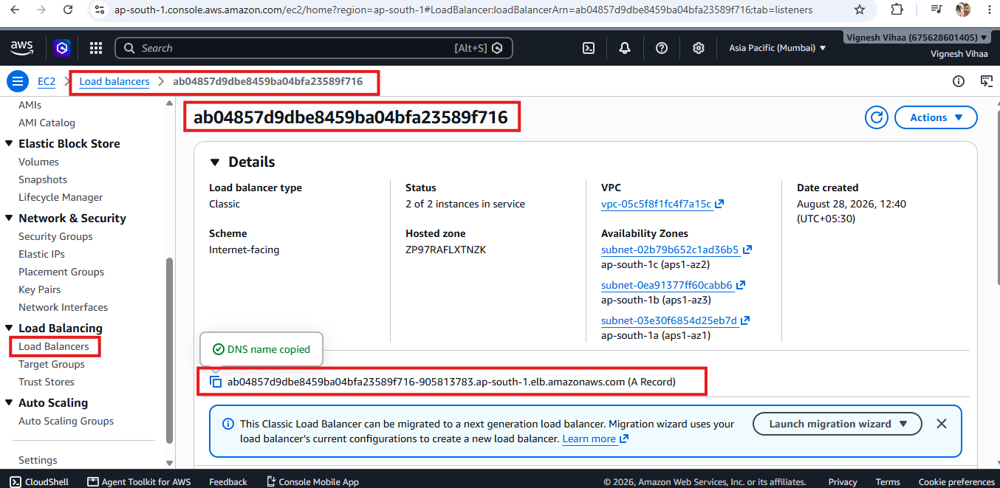

Using ExternalIP created using service yaml file the application was viewed in the browser
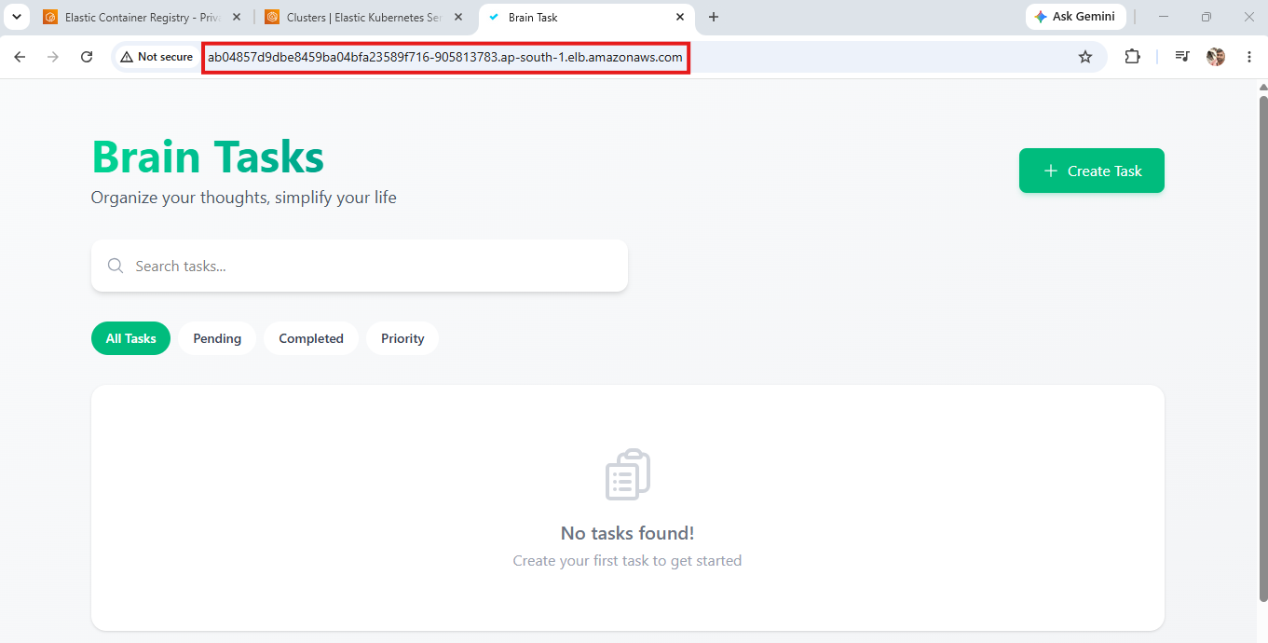
Added buildspec yaml file to check out the code from github and build the application
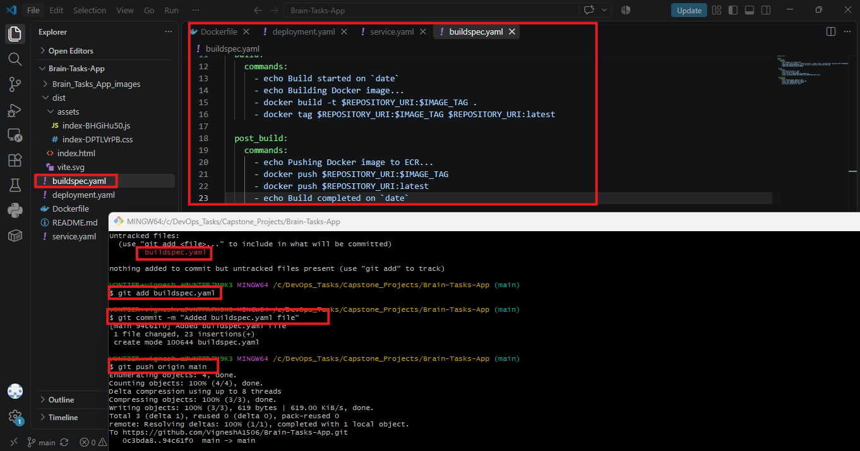

buildspec.yaml
version: 0.2

phases:
pre_build:
commands:
- echo Logging in to Amazon ECR...
- aws ecr get-login-password --region ap-south-1 | docker login --username AWS --password-stdin 675628601405.dkr.ecr.ap-south-1.amazonaws.com
- REPOSITORY_URI=675628601405.dkr.ecr.ap-south-1.amazonaws.com/brain-tasks-app
- IMAGE_TAG=$CODEBUILD_BUILD_NUMBER

build:
commands:
- echo Build started on `date`
- echo Building Docker image...
- docker build -t $REPOSITORY_URI:$IMAGE_TAG .
- docker tag $REPOSITORY_URI:$IMAGE_TAG $REPOSITORY_URI:latest

post_build:
commands:
- echo Pushing Docker image to ECR...
- docker push $REPOSITORY_URI:$IMAGE_TAG
- docker push $REPOSITORY_URI:latest
- echo Build completed on `date`

Configured AWS Code Pipeline V2
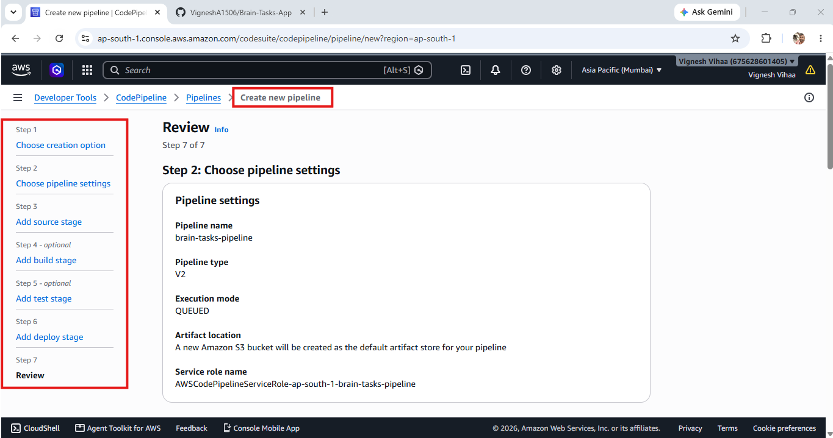

After configuring and setting up the buildspec and deployment yaml files pileline is successfully executed
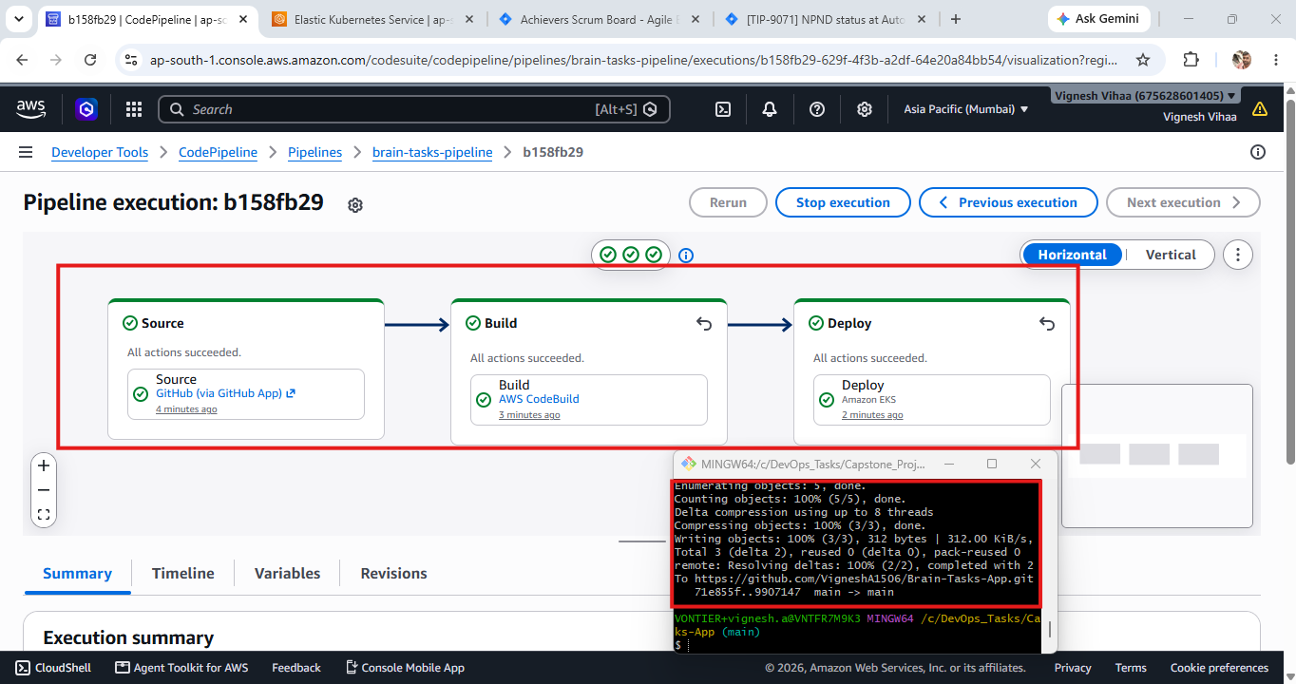

Inside resources verified deployments and they are successful
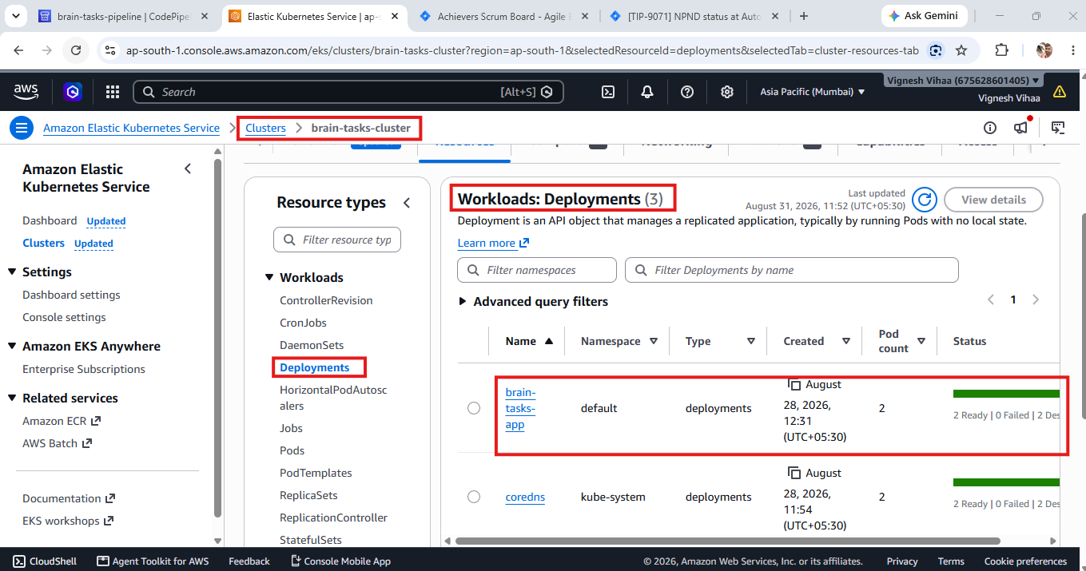

Inside resources verified pods and it is successfully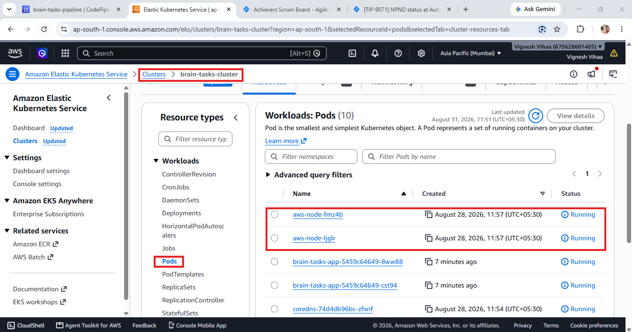

Inside resources verified services and it is successful
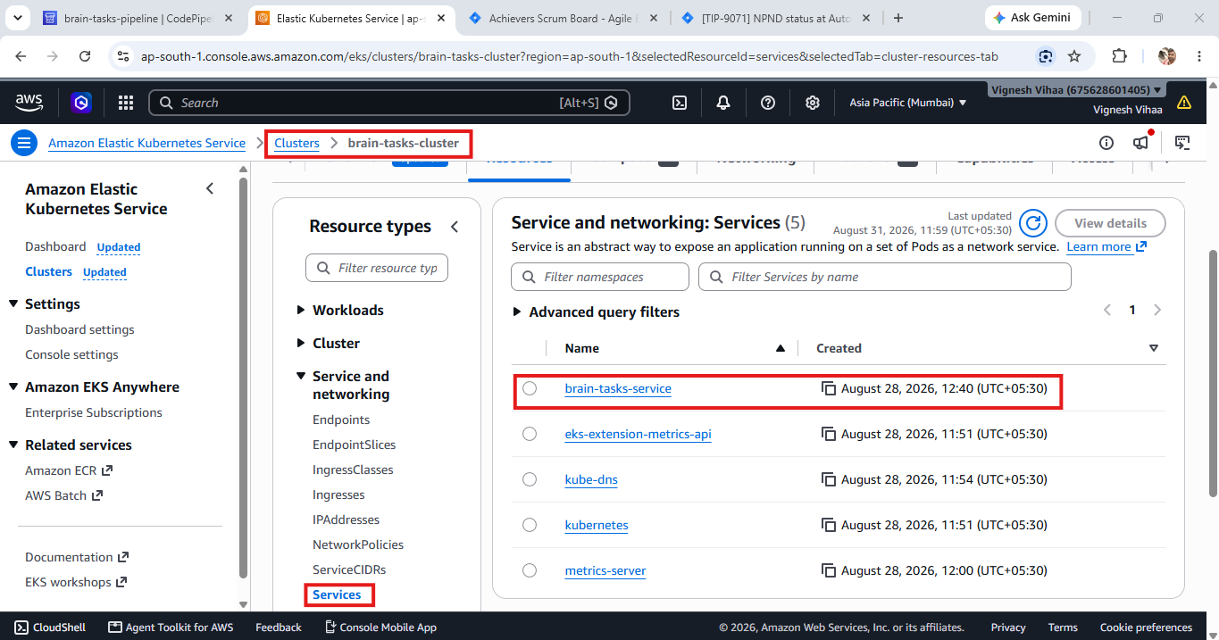

Final External endpoint was available inside service
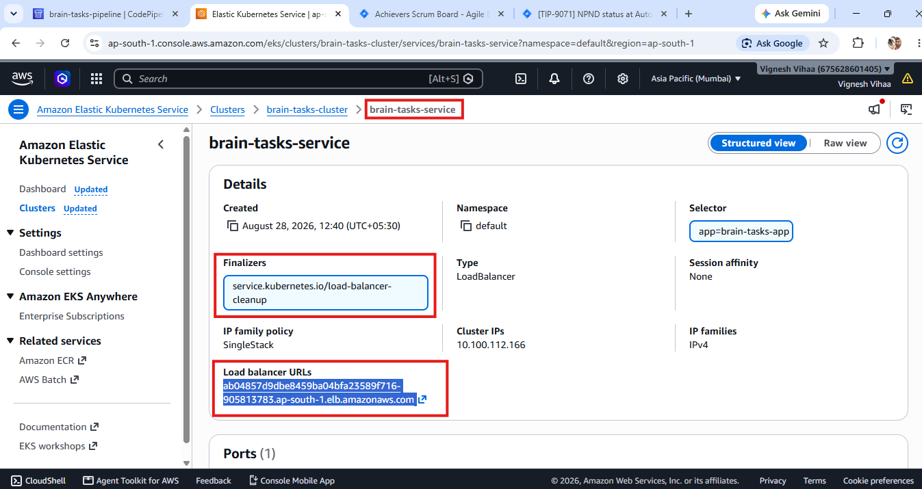

Finally, the Brain Task application got exposed after completing the AWS code pipeline
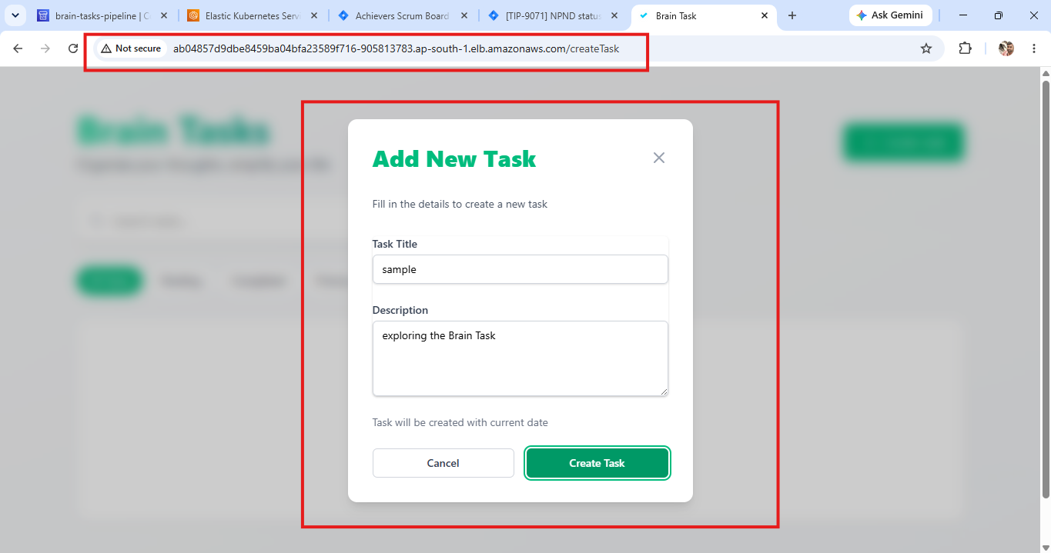

Adding AWS Cloudwatch Observability addons for monitoring the application using cloud watch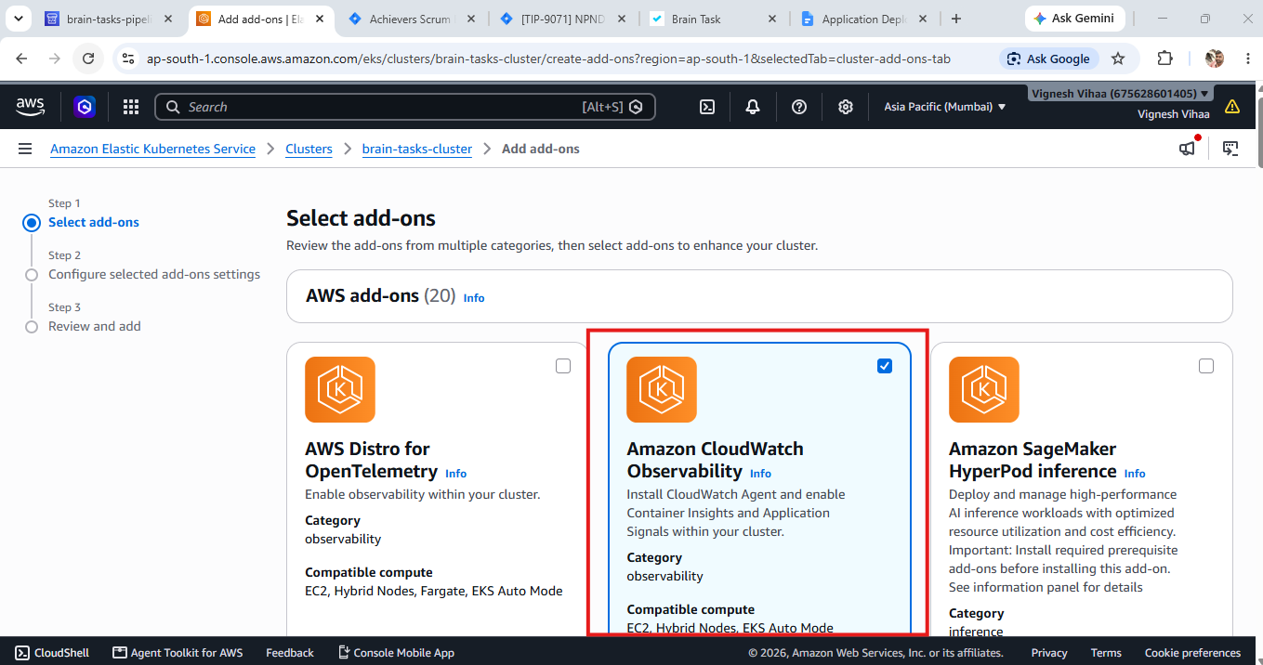

Finally, Cloud watch is configured successfully with all the metrics in the dashboard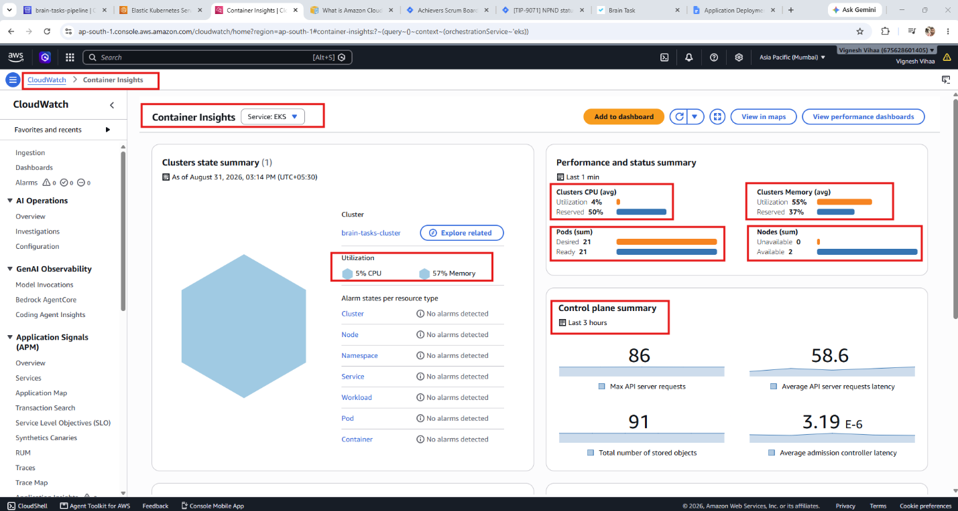

Cloudwatch output

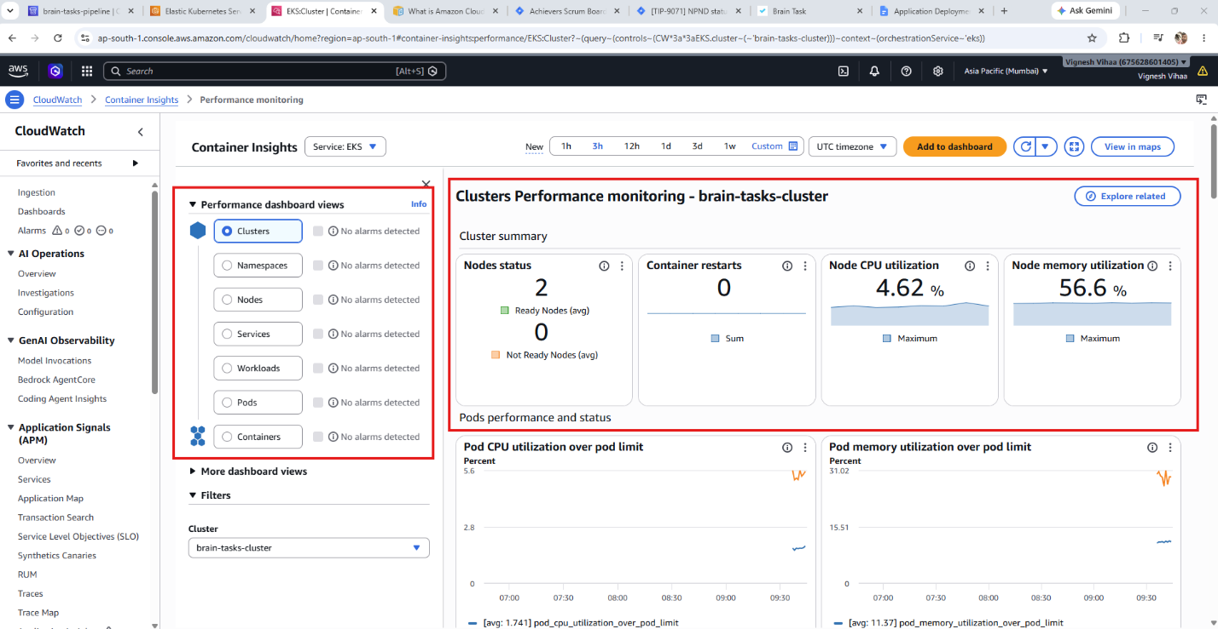

Final Deployment link:
http://ab04857d9dbe8459ba04bfa23589f716-905813783.ap-south-1.elb.amazonaws.com/createTask

