Application Deployment
(Deploy the given React application to a production ready state)

Application: TRENDIFY Application
Clone the below mentioned repository and deploy the application (Run application in port 3000). Repo URL : https://github.com/Vennilavanguvi/Trend.git

STEP:1 (Already the source codes was built, so output of built folder dist was created)
Cloned the Repository to my local and it contains,
dist/ – Compiled and production-ready static files
HTML
CSS
JavaScript
Assets (images, fonts, etc.)
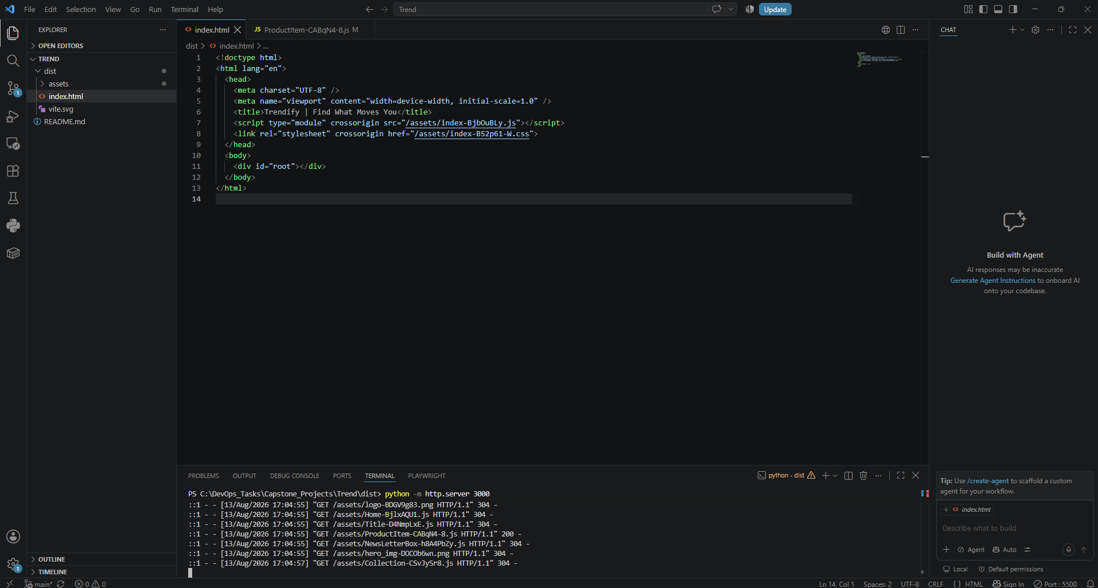
I have cloned the repo to my local and tested the application, Home page was loaded successfully but the collection page I faced issue the images were not loaded properly, so, I changed dist/assets/ProductItem-CABqN4-8.js file from undefined/images/ to https://bug-cart-server.onrender.com/images/. Now, the issue has been resolved.

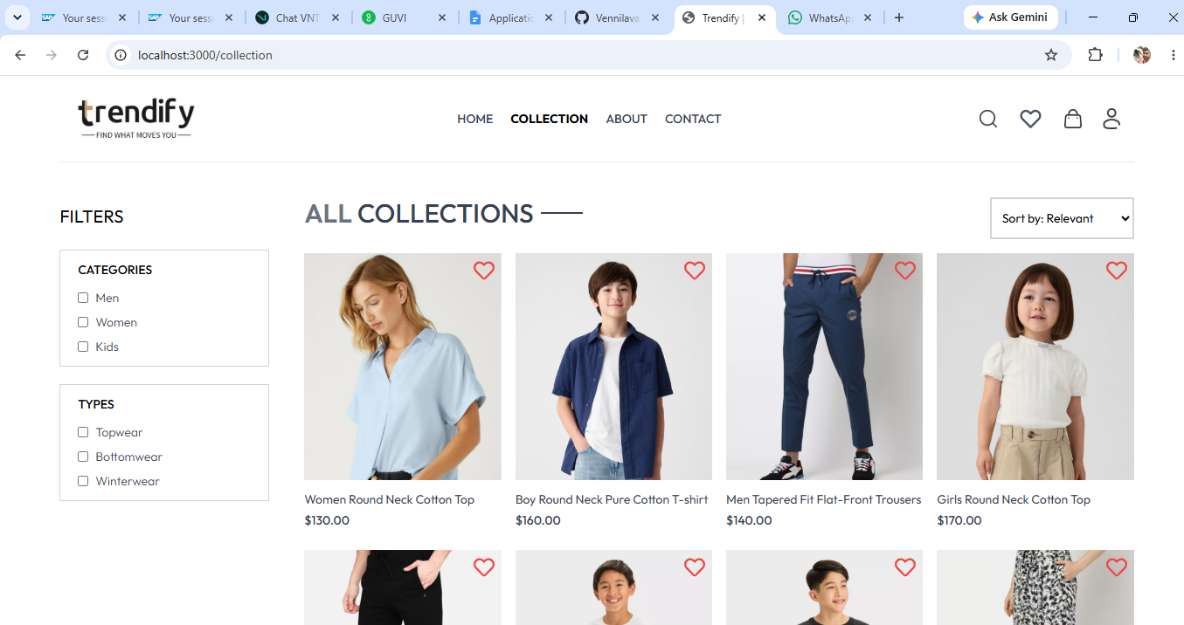

React application
↓
Developer already built it
↓
dist/ folder
↓
Fixed image URL
↓
Python HTTP server
↓
http://localhost:3000
↓
✅ Trend application working

We are using Python only to temporarily serve the already built dist folder as a web server.
Why?
Your dist folder contains static files.
A browser needs those files to be served through an HTTP server.
Python has a simple built-in HTTP server, so:
python -m http.server 3000
means:
"Start a simple web server using Python and serve the files from this folder on port 3000."
Then you access:
http://localhost:3000
STEP:2
Docker:
- Dockerize the application by creating Dockerfile
- Build an application and check output using docker image.

Created the Dockerfile inside Trend Folder as shown in the below image and ran the command
docker build -t trend-app .

NOTE: Since we are running locally, Docker desktop should be running in our desktop.

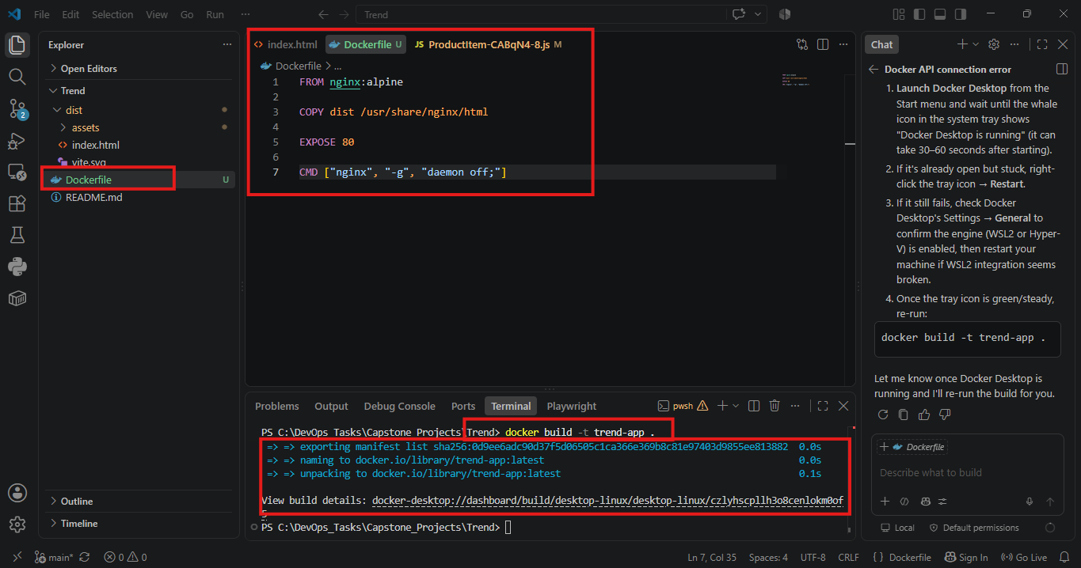

Docker image is created in Docker desktop as shown in below image,
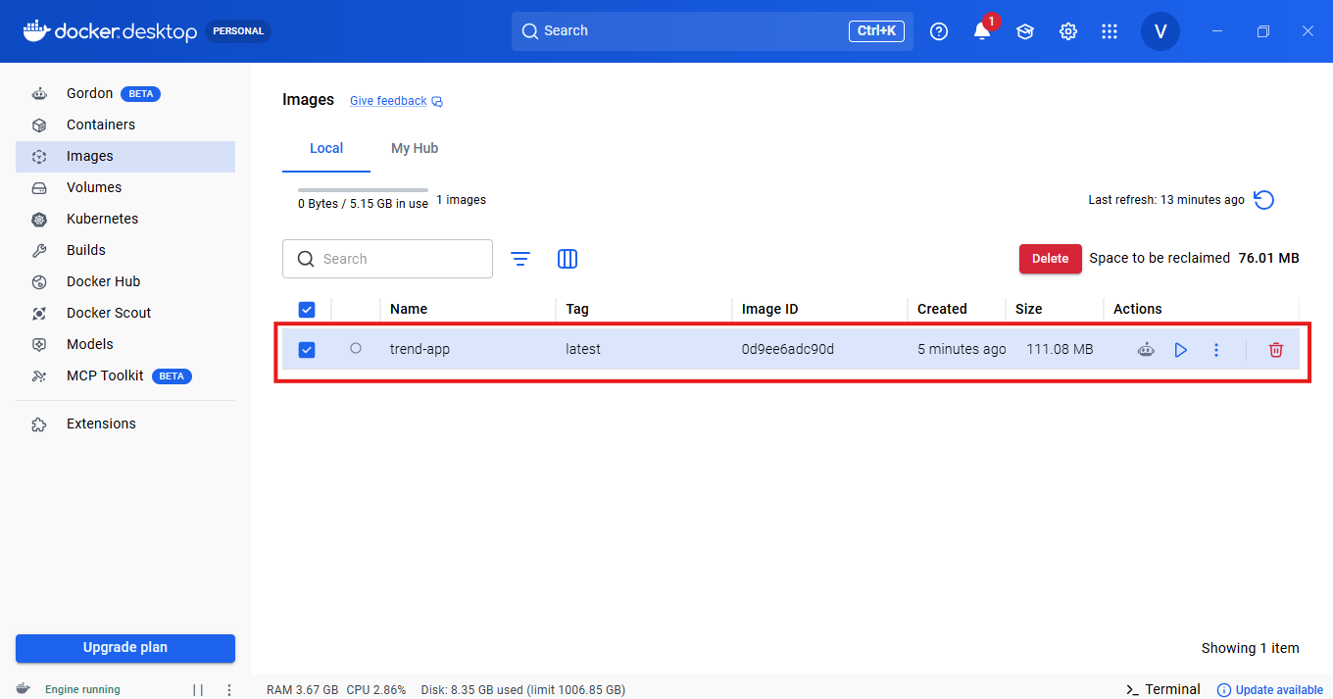
Now running the image as Container using below command.
docker run -d -p 3000:80 –-name trend-container trend-app
docker run → Create and start a container
-d → Run in background
-p 3000:80 → Host port 3000 (My computer port) → Container port 80
--name → Give container a name
trend-app → Image we just created
Container is created in docker desktop, after running the above command.
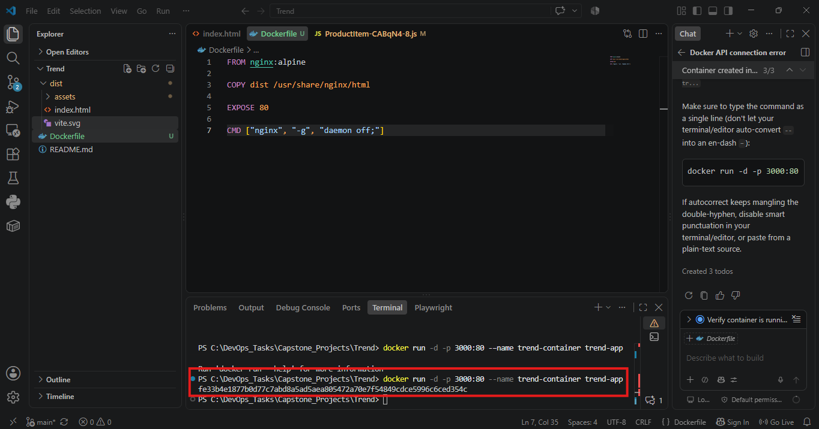
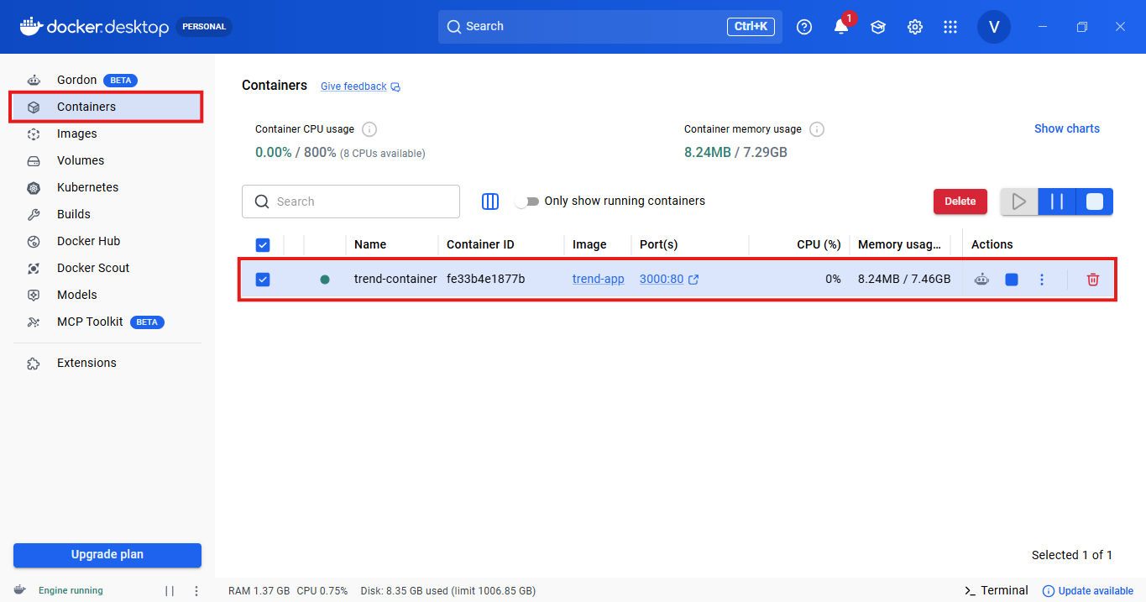
docker ps command to ensure container is running,
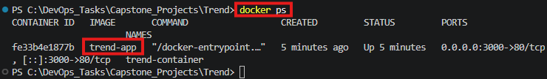
My Doubt:
Since we are running locally, we are using 3000. So that port 3000 is mapped to container port 80 so the application is exposed now.
Is my understanding correct?
Exactly! 💯 Your understanding is correct.
You can remember it this way:

Local computer
│
│ localhost:3000
▼
Port 3000
│
│ Docker port mapping
│ 3000 : 80
▼
Container
│
│ Port 80
▼
Nginx
│
▼
Trend application
So, this command:
docker run -d -p 3000:80 --name trend-container trend-app
means:
"Expose the application's container port 80 through port 3000 on my local computer."
Therefore, we access it using: http://localhost:3000

One important point:
It's not specifically because "local always uses 3000." We choose 3000 for the host port. We could choose another available port: -p 8080:80
Then we'd access: http://localhost:8080
The container port remains 80 because Nginx is listening on port 80. So, you've got the key Docker concept now: Host Port → Container Port
3000 → 80 ✅
Finally, Application is exposed by running container locally, http://localhost:3000



Note:
Friday it ran successfully in my local host by hitting this in web browser http://localhost:3000 after that day I shutdown my lap and Monday I hit the same URL but in web browser it shows error.
Reason: Docker desktop was up when I hit the URL on Friday.
Docker desktop was not up when I hit the URL on Monday.
(Because Docker desktop was closed when I shutdown on Friday. So, when I hit URL on Monday Docker Hub is not up till I open the Docker desktop)
Docker Engine will be shut down till the time docker desktop is up.
PUSHING THE DOCKER IMAGE INTO DOCKERHUB:
- Created the docker repo using docker login and credentials
- Run command docker tag trend-app vickyamav/trend-app:latest
What does docker tag do?
When you built your image: docker build -t trend-app .
you gave the image a local name: trend-app:latest
Now DockerHub needs the image to follow this naming format:
DOCKERHUB_USERNAME/REPOSITORY_NAME:TAG
So we use: docker tag trend-app vickyamav/trend-app:latest
This means:
docker tag
├── Existing image → trend-app
│
└── New name → vickyamav/trend-app:latest
- Running the command below to push docker image into dockerhub:
docker push vickyamav/trend-app:latest

Repo created and pushed the image into dockerhub:
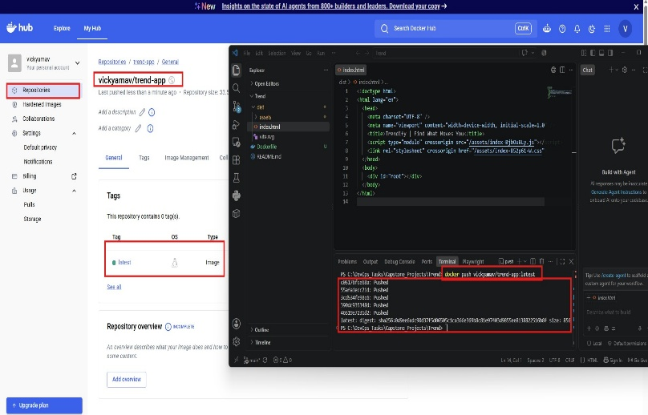
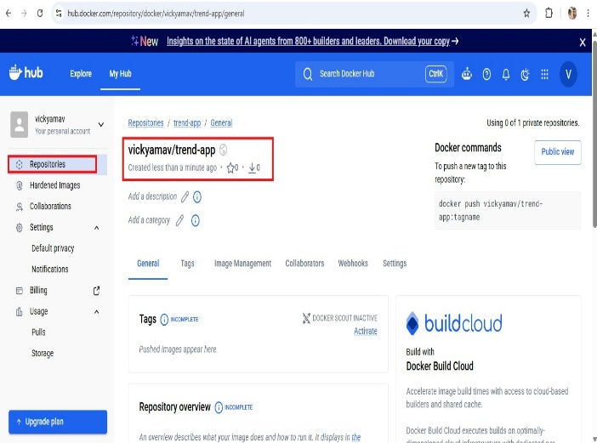

STEP:3
Terraform:
- Define infrastructure in main.tf to create VPC, IAM, EC2 with Jenkins, etc.
- Use terraform command to provision infrastructure.

- Downloaded Terraform from chrome,
https://developer.hashicorp.com/terraform/install#windows
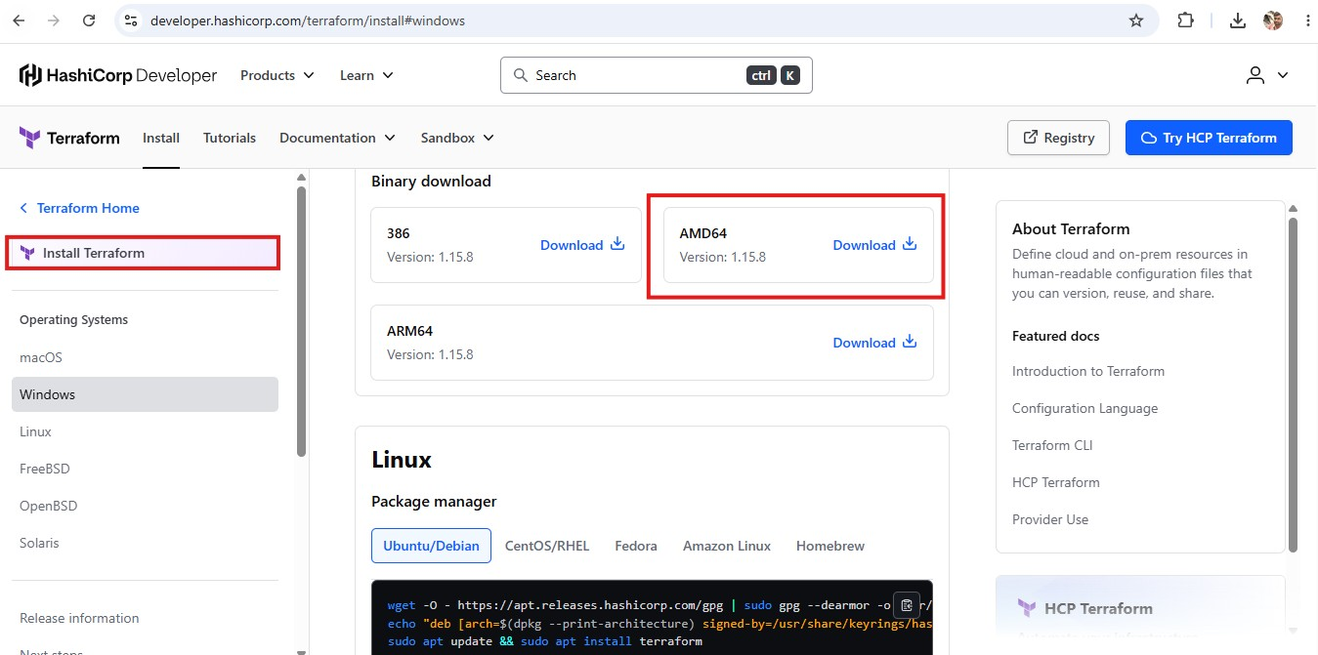

- Created the separate folder for terraform, (Environment variables also added)

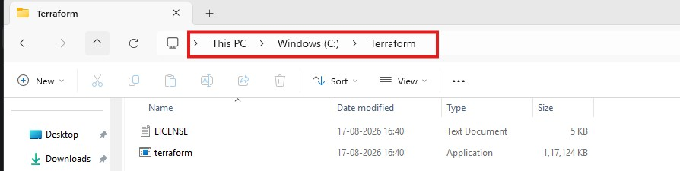

- Created Terraform main.tf also checked terraform -version,
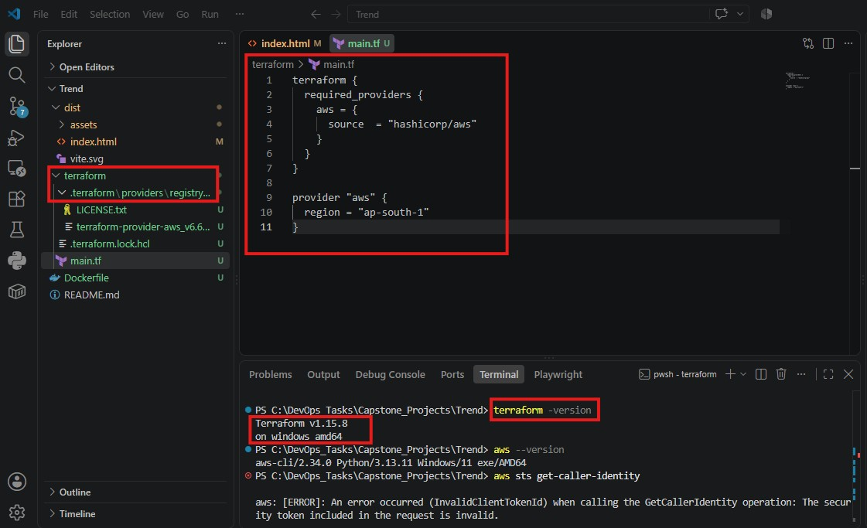
As a next step checking Terraform installed in VS Code using the command,
terraform -version
- Now, running terraform init command
What terraform init does?
It is mainly:
- Initializes the Terraform working directory
- Downloads required providers which were mentioned in main.tf(AWS)
- Creates the .terraform directory
- Creates/updates .terraform.lock.hcl to record the provider version/checksum information

Prepares Terraform for commands such as:
terraform plan
terraform apply
Important distinction
terraform init does NOT create anything in AWS. ❌
It only prepares your local Terraform project.
terraform init
↓
Your laptop
↓
Downloads AWS provider
↓
Ready for Terraform

Whereas:
terraform apply
↓
AWS
↓
Creates VPC / EC2 / IAM / etc.

So, your status is:
Terraform initialized ✅ → AWS provider ready ✅ → No AWS infrastructure created yet.
That's why terraform init comes before terraform plan and terraform apply.

- Added VPC part inside main.tf,
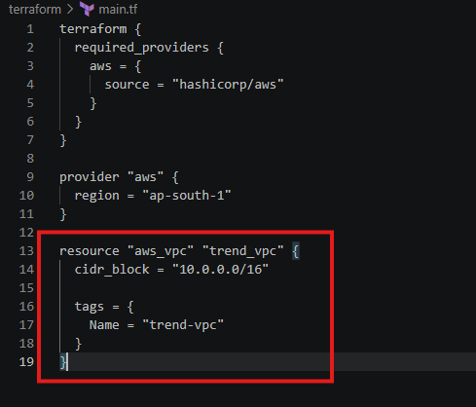

- Now running below to commands,
PS C:\DevOps_Tasks\Capstone_Projects\Trend\terraform> terraform fmt
main.tf

terraform fmt → Format the code -> fmt means format.
It automatically formats your .tf files according to Terraform's standard style.

PS C:\DevOps_Tasks\Capstone_Projects\Trend\terraform> terraform validate
Success! The configuration is valid.

terraform validate → Check the configuration
This checks whether your Terraform configuration is syntactically and structurally valid.

- Now going to run terraform plan command,

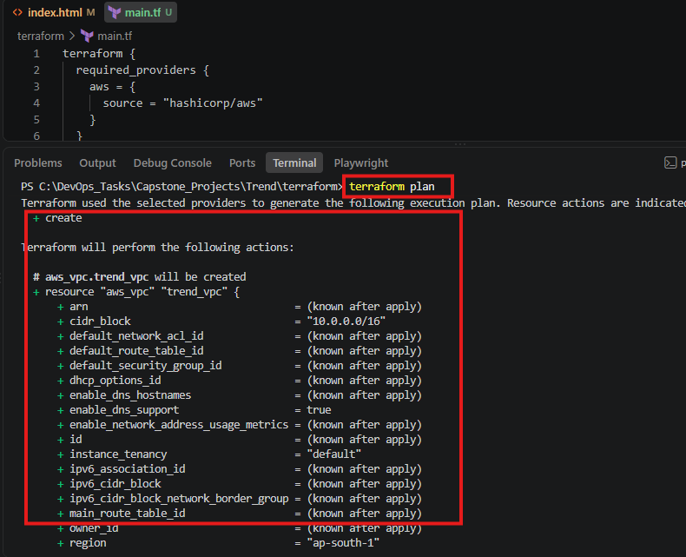

- After the above step I run the command,
terraform apply
All my required resources mentioned inside main.tf has been created automatically,
Main.tf
terraform {
required_providers {
aws = {
source = "hashicorp/aws"
}
}
}

provider "aws" {
region = "ap-south-1"
}

resource "aws_vpc" "trend_vpc" {
cidr_block = "10.0.0.0/16"

tags = {
Name = "trend-vpc"
}
}

resource "aws_subnet" "trend_subnet" {
vpc_id = aws_vpc.trend_vpc.id
cidr_block = "10.0.1.0/24"

tags = {
Name = "trend-subnet"
}
}

resource "aws_internet_gateway" "trend_igw" {
vpc_id = aws_vpc.trend_vpc.id

tags = {
Name = "trend-igw"
}
}

resource "aws_route_table" "trend_route_table" {
vpc_id = aws_vpc.trend_vpc.id

route {
cidr_block = "0.0.0.0/0"
gateway_id = aws_internet_gateway.trend_igw.id
}

tags = {
Name = "trend-route-table"
}
}

resource "aws_route_table_association" "trend_subnet_association" {
subnet_id = aws_subnet.trend_subnet.id
route_table_id = aws_route_table.trend_route_table.id
}

resource "aws_security_group" "trend_sg" {
name = "trend-sg"
description = "Security group for Trend EC2"
vpc_id = aws_vpc.trend_vpc.id

ingress {
description = "SSH"
from_port = 22
to_port = 22
protocol = "tcp"
cidr_blocks = ["0.0.0.0/0"]
}

ingress {
description = "Jenkins"
from_port = 8080
to_port = 8080
protocol = "tcp"
cidr_blocks = ["0.0.0.0/0"]
}

ingress {
description = "HTTP"
from_port = 80
to_port = 80
protocol = "tcp"
cidr_blocks = ["0.0.0.0/0"]
}

egress {
from_port = 0
to_port = 0
protocol = "-1"
cidr_blocks = ["0.0.0.0/0"]
}

tags = {
Name = "trend-sg"
}
}

resource "aws_instance" "trend_ec2" {
ami = "ami-0d15e9052c94acb75"
instance_type = "t3.micro"

subnet_id = aws_subnet.trend_subnet.id
vpc_security_group_ids = [aws_security_group.trend_sg.id]
associate_public_ip_address = true

tags = {
Name = "trend-ec2"
}
}

Terraform main.tf — complete configuration was created as below,
- VPC
- Subnet
- Internet Gateway
- Route Table
- Route Table Association
- Security Group
- EC2
EC2:
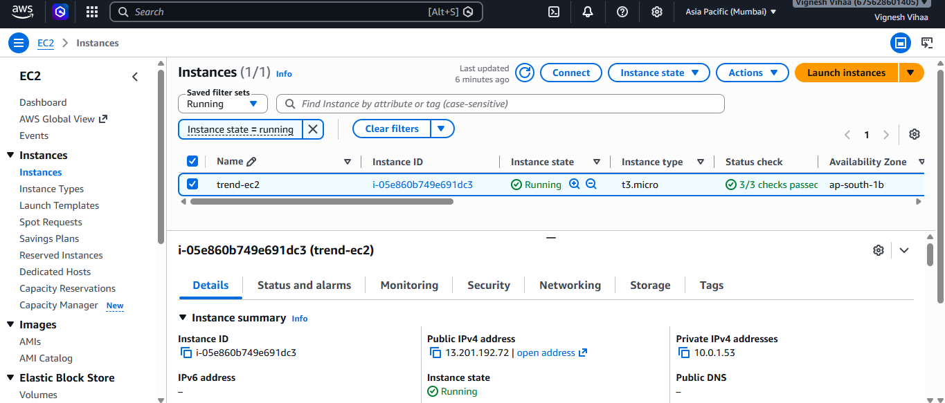
Security Group:
VPC:
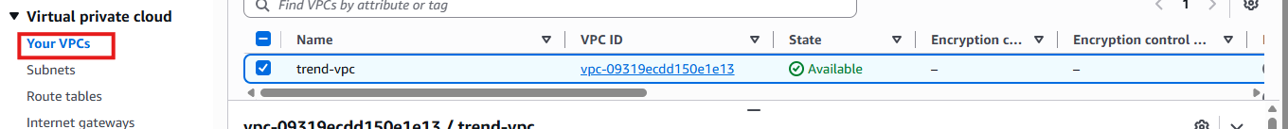
Subnets:
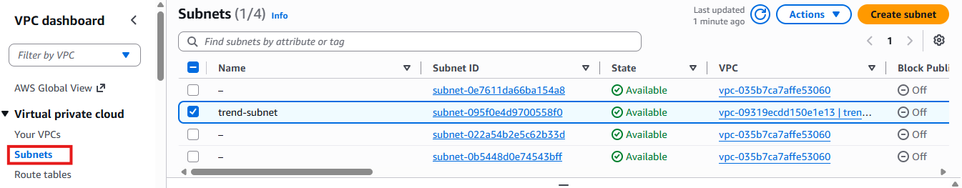
Route Tables:
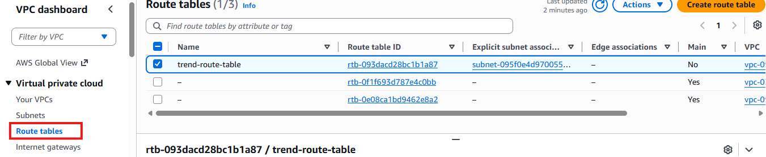
Internet Gateway:
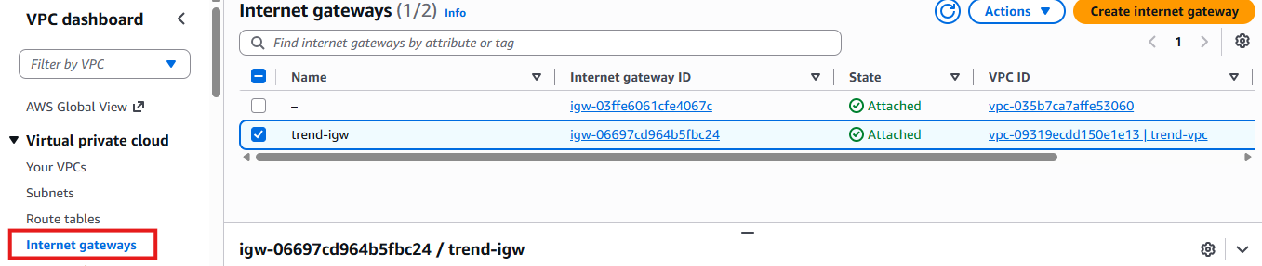

Docker & Jenkins Installation in this EC2,
Docker commands:
sudo dnf update -y
sudo dnf install docker -y
sudo systemctl start docker
sudo systemctl enable docker
sudo systemctl status docker --no-pager
docker --version
sudo usermod -aG docker ec2-user
newgrp docker
docker ps
docker run hello-world
If everything is successful, the last command should display:
Hello from Docker!
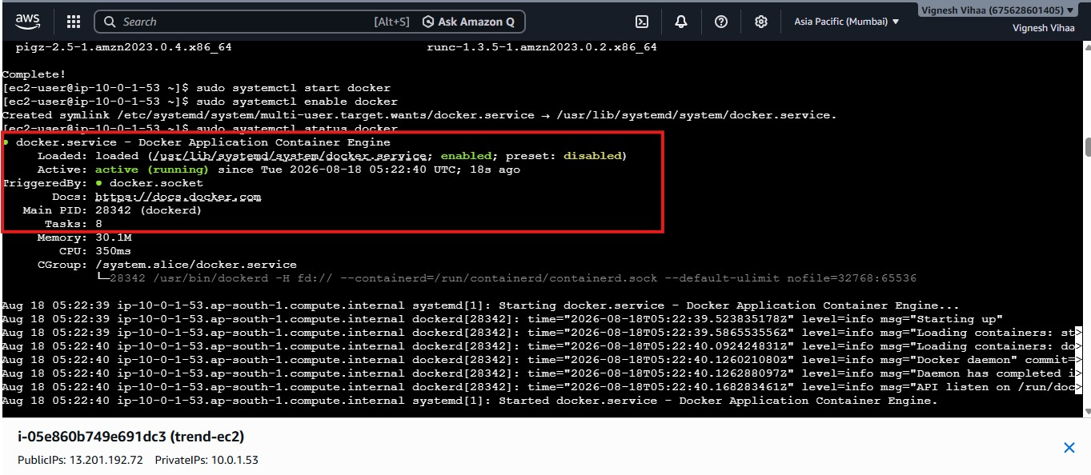

Jenkins commands:
- sudo dnf install java-21-amazon-corretto -y
- java -version
- sudo wget -O /etc/yum.repos.d/jenkins.repo \
https://pkg.jenkins.io/rpm-stable/jenkins.repo
- sudo rpm --import https://pkg.jenkins.io/rpm-stable/jenkins.io-2026.key
- sudo dnf upgrade -y
- sudo dnf install jenkins -y
- sudo systemctl daemon-reload
- sudo systemctl enable jenkins
- sudo systemctl start jenkins
- sudo systemctl status jenkins --no-pager

To get the initial password:
sudo cat /var/lib/jenkins/secrets/initialAdminPassword
b173effad4364beaa0361c306d325b00

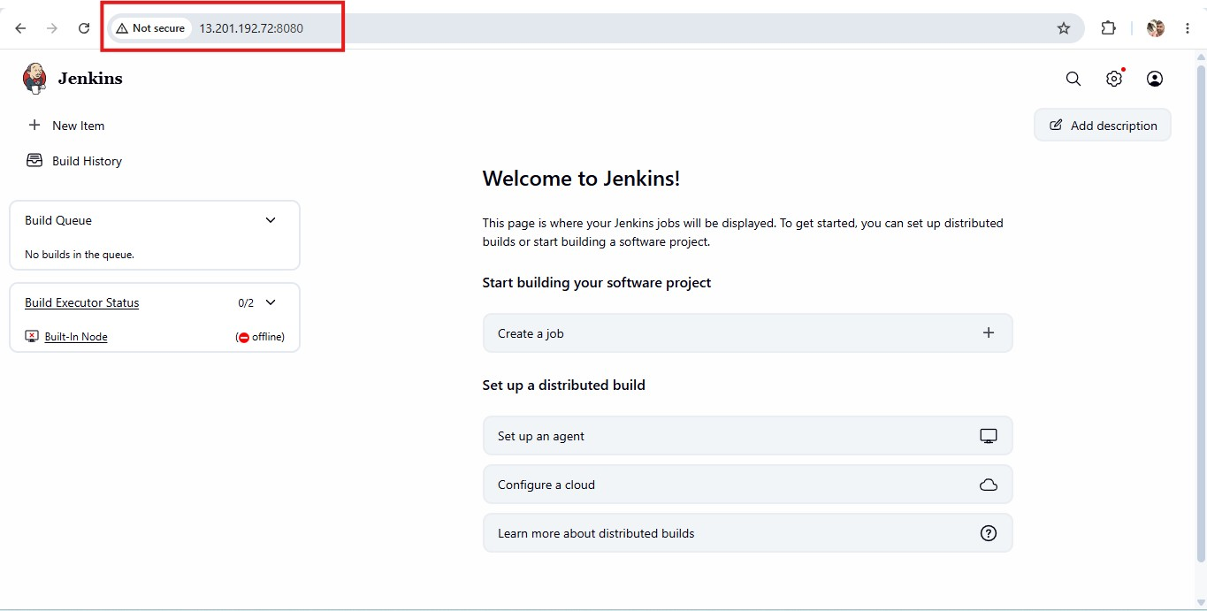

After creating the user and password login credentials. Install the following plugins in Jenkins,

Manage Jenkins → Plugins → Available Plugins
Search and install:
- Git
- GitHub
- Pipeline
- Docker Pipeline
- Credentials Binding
- Kubernetes
- GitHub API

OUR FINAL PIPELINE:
GitHub
↓
Jenkins
↓
Pipeline
↓
Docker Build
↓
DockerHub
↓
Kubernetes / EKS
The situation:
You have Jenkins and Docker installed on the same EC2 server:
AWS EC2
│
├── Jenkins
│ │
│ └── needs to build Docker images
│
└── Docker
│
└── builds/runs Docker containers

The problem is:
Jenkins is a separate Linux user.
By default, Jenkins is not allowed to control Docker.

What have we changed?
We added the Jenkins user to the Docker group:
sudo usermod -aG docker Jenkins

Think of it like this:
Before:
Jenkins ❌ → Docker

After:
Jenkins ✅ → Docker

Then:
sudo systemctl restart docker
sudo systemctl restart jenkins
We restarted the services, so the new permission takes effect.

Finally:
sudo -u jenkins docker ps

This means:
"Pretend I am the Jenkins user and run docker ps."

Because this worked, we proved:
Jenkins user
↓
Docker
↓
Working ✅

Why is this important for your project?
Later, Jenkins will automatically execute something like:
GitHub
↓
Jenkins
↓
Docker build
↓
Docker image
↓
DockerHub
↓
EKS
So, Jenkins must have permission to use Docker.
You have now completed that requirement. ✅
Nothing else needs to be changed in this step.

Jenkins needs permission to log in to your DockerHub account to push the image.
Created Personal Access Token and added that into Jenkins credentials.
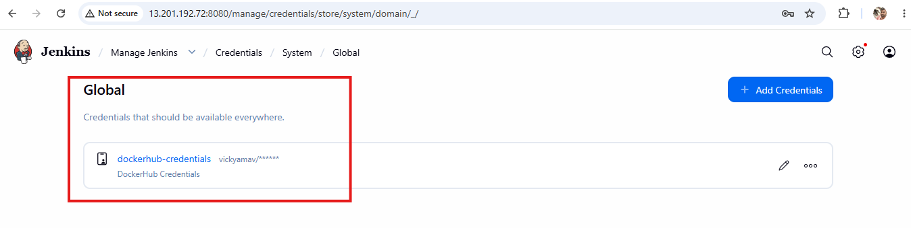
Why are we doing this?
It creates a secure connection:
Jenkins
│
│ DockerHub credentials
↓
DockerHub
↓
vickyamav/trend-app
So later Jenkins can automatically execute:
docker build
docker login
docker push

Now, need to clone the repo into ec2 server using Jenkins pipeline,
Trend-Capstone-Pipeline,

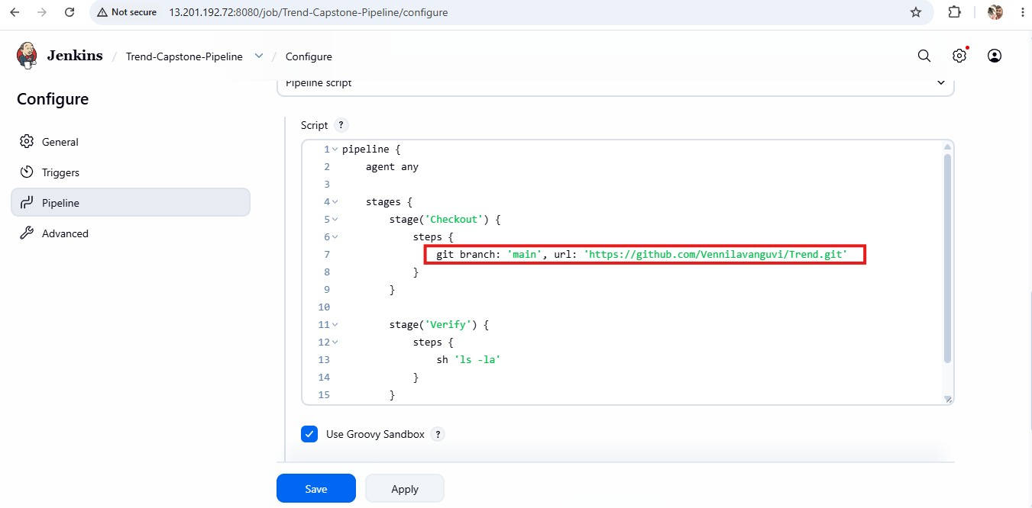

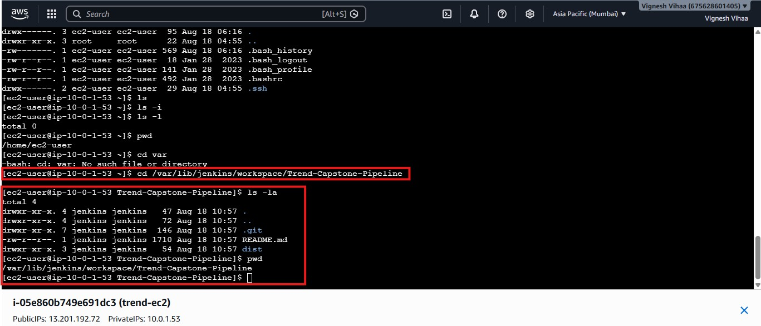
Now, Upgrading the pipeline script by adding docker hub credential sections,

pipeline {
agent any

stages {

stage('Checkout') {
steps {
git branch: 'main', url: 'https://github.com/Vennilavanguvi/Trend.git'
}
}

stage('Docker Build') {
steps {
sh 'docker build -t trend-app .'
}
}

stage('DockerHub Push') {
steps {
withCredentials([usernamePassword(
credentialsId: 'dockerhub-credentials',
usernameVariable: 'DOCKER_USERNAME',
passwordVariable: 'DOCKER_PASSWORD'
)]) {

sh '''
echo "$DOCKER_PASSWORD" | docker login -u "$DOCKER_USERNAME" --password-stdin
docker tag trend-app vickyamav/trend-app:latest
docker push vickyamav/trend-app:latest
docker logout
'''
}
}
}
}
}

Pipeline script updated to checkout, to build and push into DockerHUB
