
NForce-OneHR
Unit Test Case - ONEHR-581 US-A02: Manager view of benched direct reports
Parent epic: ONEHR-577 - Workforce Availability & Bench Management
Tested: 13 October 2026
Environment: local run - frontend http://localhost:5180, backend http://localhost:8081 (Spring Boot, Java 22), shared dev database. Roles used: HR Admin (hradmin@nforceone.com), Manager (manager@nforceone.com), Employee (emponenforce@nforce.com).
Summary
Test cases | 5 total: 5 passed, 0 passed after a defect was found and fixed, 0 verified by unit test only, 0 not executed

UT-581-01 - Manager with no benched direct reports
Test ID | UT-581-01
Module | Workforce Availability & Bench Management / Team Bench
Class / Method | BenchStatusController.team -> BenchStatusService.teamBench (GET /api/bench-status/team); TeamBenchSection
Scenario | Manager with no benched direct reports
Steps | 1. Sign in as Manager (manager@nforceone.com)  2. Open Employee Services > Team Bench
Expected Result | A read-only page with the empty message "None of your direct reports are on bench".
Actual Result | Empty message shown. Note that two other employees were on bench at that moment (under different managers) and are not shown.
Tested as | Manager
Status | Pass
Developer | Abuzar Siddiqui

Screenshot 1 - Manager - no benched reports
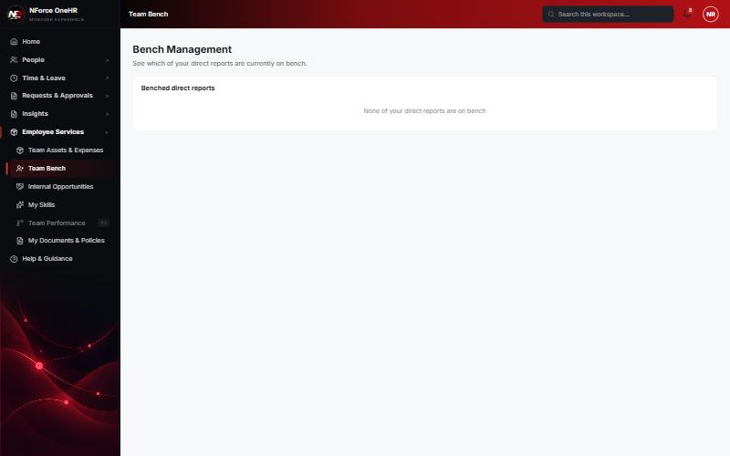

UT-581-02 - A direct report is put on bench - the manager sees name, reason, days on bench and last project
Test ID | UT-581-02
Module | Workforce Availability & Bench Management / Team Bench
Class / Method | BenchStatusService.teamBench
Scenario | A direct report is put on bench - the manager sees name, reason, days on bench and last project
Steps | 1. HR marks Abbas DarubaiGari (reports to Narendra Reddy) on bench from 08/20/2026, reason "Role ended"  2. Manager reloads Team Bench
Expected Result | One row: Abbas DarubaiGari, Role ended, 54 days, last project "-" (he has no allocations).
Actual Result | Row shown exactly as expected.
Tested as | Manager, HR Admin
Status | Pass
Developer | Abuzar Siddiqui

Screenshot 2 - Manager view with one benched direct report
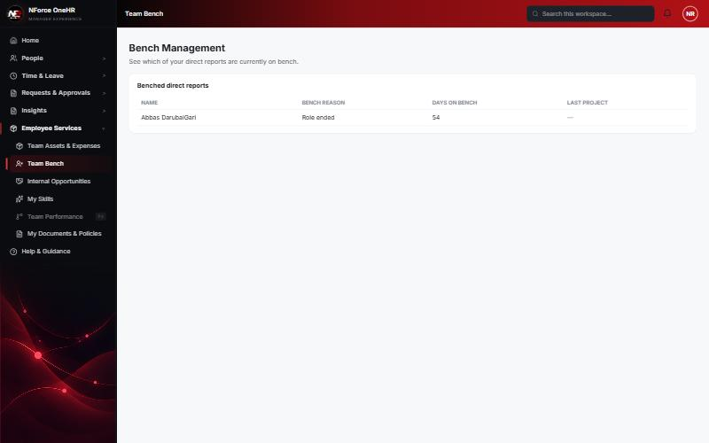

UT-581-03 - "Last project" comes from the most recent allocation
Test ID | UT-581-03
Module | Workforce Availability & Bench Management / Team Bench
Class / Method | BenchStatusService.lastProjectNames / ProjectAllocationRepository.findLatestEndingForEmployees
Scenario | "Last project" comes from the most recent allocation
Steps | 1. HR gives Abbas an allocation on "Bench QA Project (sample)" from 06/01/2026 to 08/19/2026  2. Manager reloads Team Bench
Expected Result | Last project column shows "Bench QA Project (sample)".
Actual Result | Column shows "Bench QA Project (sample)".
Tested as | Manager
Status | Pass
Developer | Abuzar Siddiqui

Screenshot 3 - Last project populated from the allocation
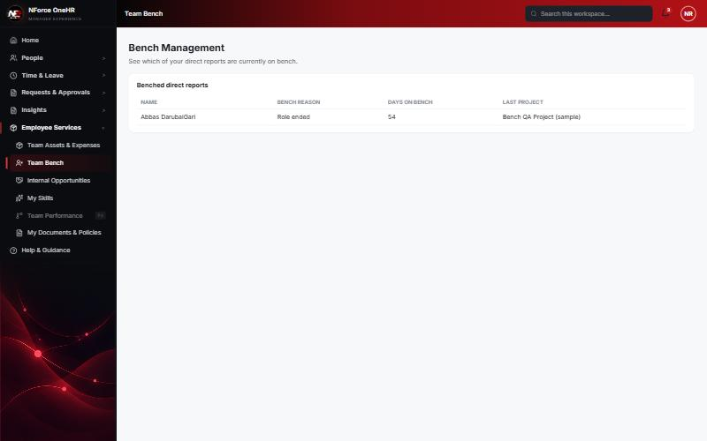

UT-581-04 - Only the manager's own hierarchy is visible - and a client-supplied manager id is ignored
Test ID | UT-581-04
Module | Workforce Availability & Bench Management / Team Bench
Class / Method | DirectReportScopeService (hierarchy scope)
Scenario | Only the manager's own hierarchy is visible - and a client-supplied manager id is ignored
Steps | 1. While 3 employees are on bench (HR list), look at the Manager's Team Bench  2. Call GET /api/bench-status/team?managerId=<another manager's id>
Expected Result | The manager sees only their own direct report (Abbas); the managerId parameter changes nothing.
Actual Result | HR list showed Abbas, Chandrasekhar and Test; the Manager saw only Abbas. The parameter call returned 200 [] (no data from the other manager's team).
Tested as | Manager, HR Admin
Status | Pass
Developer | Abuzar Siddiqui
Evidence (recorded response) | Signed in as the Manager (Narendra Reddy, role MANAGER):  POST /api/bench-status -> 403 Access denied  GET /api/bench-status -> 403 Access denied  GET /api/bench-status/dashboard -> 403 Access denied  GET /api/bench-status/cost -> 403 Access denied  GET /api/compensation-bands -> 403 Access denied  PUT /api/bench-status/aging-config -> 403 Access denied  POST /api/opportunities/{id}/close -> 403 Access denied  GET /api/bench-status/team?managerId=<another manager's id> -> 200 [] (the parameter is ignored; only the caller's own reports are ever returned)

Screenshot 4 - HR sees all three benched employees
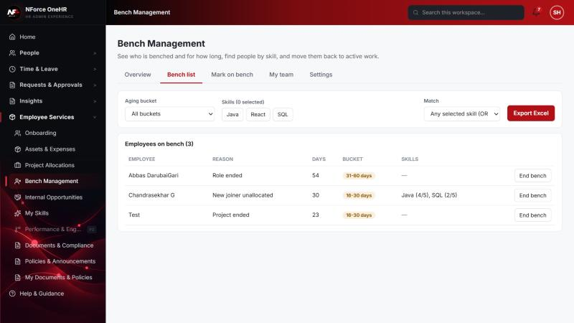
Screenshot 5 - Manager sees only their own report

UT-581-05 - Manager cannot use the HR bench endpoints
Test ID | UT-581-05
Module | Workforce Availability & Bench Management / Team Bench
Class / Method | @PreAuthorize / hierarchy
Scenario | Manager cannot use the HR bench endpoints
Steps | 1. As Manager, call the HR list, dashboard, cost and settings endpoints
Expected Result | 403 for each.
Actual Result | 403 for each (see evidence).
Tested as | Manager
Status | Pass
Developer | Abuzar Siddiqui
Evidence (recorded response) | Signed in as the Manager (Narendra Reddy, role MANAGER):  POST /api/bench-status -> 403 Access denied  GET /api/bench-status -> 403 Access denied  GET /api/bench-status/dashboard -> 403 Access denied  GET /api/bench-status/cost -> 403 Access denied  GET /api/compensation-bands -> 403 Access denied  PUT /api/bench-status/aging-config -> 403 Access denied  POST /api/opportunities/{id}/close -> 403 Access denied  GET /api/bench-status/team?managerId=<another manager's id> -> 200 [] (the parameter is ignored; only the caller's own reports are ever returned)

Notes
- Audit History is slow on this remote database: the first load took over a minute and the "Other" filter timed out once (the same query returned in 25 seconds when called directly). Existing behaviour, not caused by the bench changes.
- A request to a route that does not exist for that method (for example DELETE /api/bench-status/{id}) returns a generic 500 from the shared error handler rather than 404/405. Left unchanged because it is shared behaviour; the useful fact is that no delete route exists.
- The company policy-acknowledgement pop-up appears for the Manager and Employee accounts and blocks clicks until dismissed ("Remind Me Later" was used). Unrelated to the bench module.
- QA data left in the shared dev database (all named "QA sample"): 3 skills, 1 compensation band, 1 project, 4 allocations, 2 opportunities, bench history for five employees (all ended), and a "30+ days" notification to the Manager. The Manager's direct report Abbas DarubaiGari and the Employee test account Chandrasekhar G were used as test subjects.

