
NForce-OneHR
Unit Test Case - ONEHR-585 US-A06: End bench status via allocation or manual close
Parent epic: ONEHR-577 - Workforce Availability & Bench Management
Tested: 13 October 2026
Environment: local run - frontend http://localhost:5180, backend http://localhost:8081 (Spring Boot, Java 22), shared dev database. Roles used: HR Admin (hradmin@nforceone.com), Manager (manager@nforceone.com), Employee (emponenforce@nforce.com).
Summary
Test cases | 6 total: 5 passed, 0 passed after a defect was found and fixed, 1 verified by unit test only, 0 not executed

UT-585-01 - The End bench panel offers the employee's own allocations and a list of close-out reasons
Test ID | UT-585-01
Module | Workforce Availability & Bench Management / Bench Status
Class / Method | BenchStatusController.end (PATCH /api/bench-status/{id}/end); BenchReportService.allocationOptions
Scenario | The End bench panel offers the employee's own allocations and a list of close-out reasons
Steps | 1. Bench list > "End bench" on Abbas DarubaiGari
Expected Result | "Link an allocation" lists only Abbas's allocations; "close without an allocation" offers Returned to active work / Resigned / Other.
Actual Result | Allocation list shows "Bench QA Project (sample) - 100% - 2026-06-01 -> 2026-08-19"; reasons as expected.
Tested as | HR Admin
Status | Pass
Developer | Abuzar Siddiqui

Screenshot 1 - End bench panel
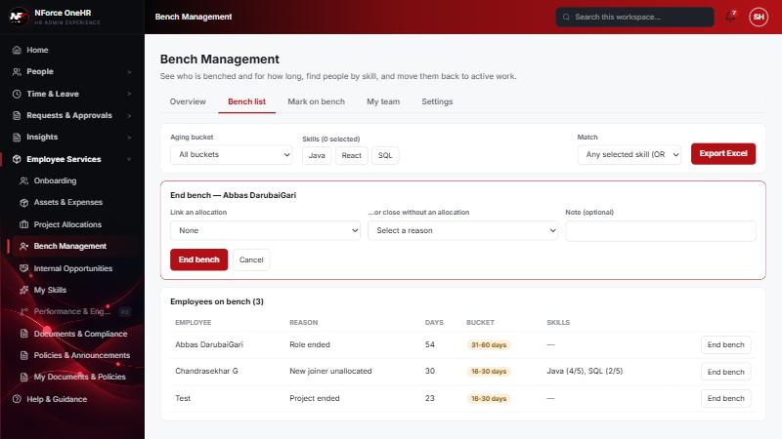

UT-585-02 - Ending bench with neither an allocation nor a reason is refused
Test ID | UT-585-02
Module | Workforce Availability & Bench Management / Bench Status
Class / Method | BenchStatusService.close
Scenario | Ending bench with neither an allocation nor a reason is refused
Steps | 1. Click "End bench" without choosing anything
Expected Result | A message asking for an allocation or a reason; nothing changes.
Actual Result | "Link an allocation, or choose a reason for closing without one" shown; the employee stays on bench.
Tested as | HR Admin
Status | Pass
Developer | Abuzar Siddiqui

Screenshot 2 - Rule enforced
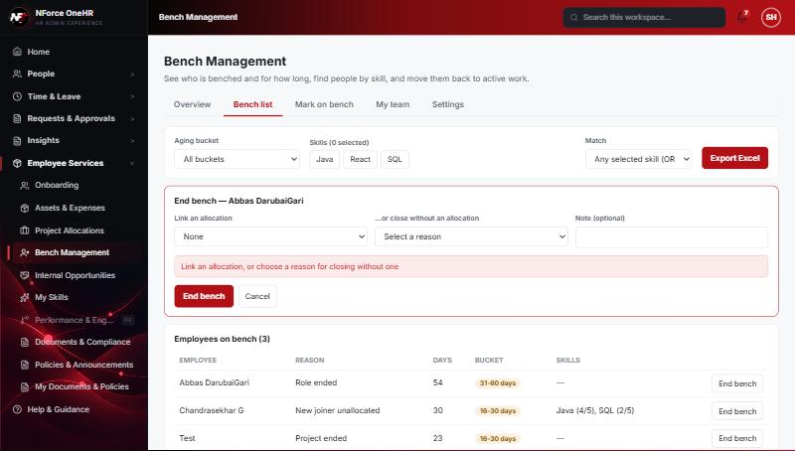

UT-585-03 - End bench by linking an allocation
Test ID | UT-585-03
Module | Workforce Availability & Bench Management / Bench Status
Class / Method | BenchStatusService.close (allocation path)
Scenario | End bench by linking an allocation
Steps | 1. Choose the allocation  2. Click "End bench"
Expected Result | Episode ends today, linked to the allocation; employee leaves the active list.
Actual Result | Abbas disappeared from the active list (3 -> 2); the audit entry shows active false, endDate 2026-10-13 and the allocationId.
Tested as | HR Admin
Status | Pass
Developer | Abuzar Siddiqui
Evidence (recorded response) | GET /api/audit-logs?action=BENCH_STATUS_CHANGE (as HR Admin) - entry written when Chandrasekhar's bench ended with an allocation:  actor: Suresh Kumar Hanumalla (HR Admin)  before: {"active": true, "endDate": null, "startDate": "2026-09-13", "reasonCode": "NEW_JOINER_UNALLOCATED", "closeReason": null, "allocationId": null}  after : {"active": false, "endDate": "2026-10-13", "startDate": "2026-09-13", "reasonCode": "NEW_JOINER_UNALLOCATED", "closeReason": null, "allocationId": "2ced7334-769b-4f92-b646-8c879f34c4a7"}  Entry written when Abbas was first marked on bench:  before: null  after : {"active": true, "endDate": null, "startDate": "2026-08-20", "reasonCode": "ROLE_ENDED", ...}

Screenshot 3 - Allocation chosen
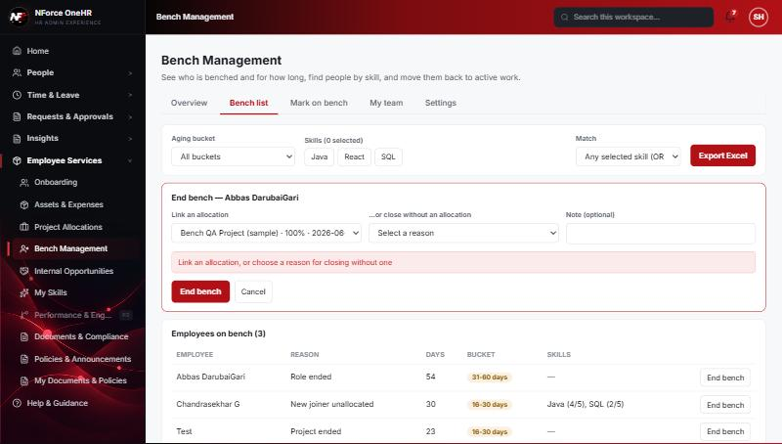
Screenshot 4 - Abbas no longer on bench
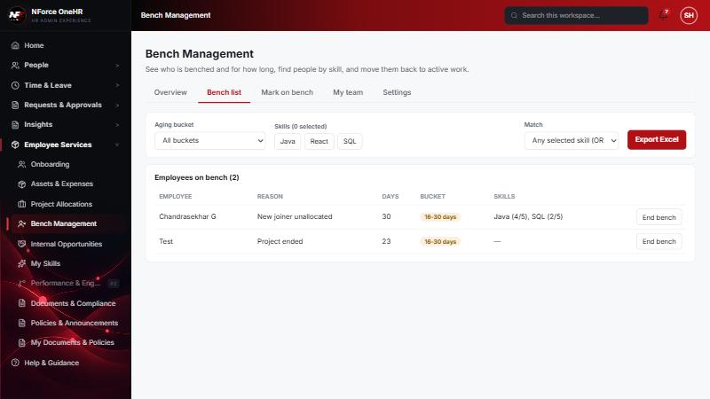

UT-585-04 - End bench with a close-out reason and note
Test ID | UT-585-04
Module | Workforce Availability & Bench Management / Bench Status
Class / Method | BenchStatusService.close (reason path)
Scenario | End bench with a close-out reason and note
Steps | 1. On "Test" choose "Returned to active work"  2. Add the note "QA: back on a project"  3. Click "End bench"
Expected Result | Episode ends with the reason and note recorded.
Actual Result | Ended; list is now empty ("No benched employees").
Tested as | HR Admin
Status | Pass
Developer | Abuzar Siddiqui

Screenshot 5 - Reason and note chosen
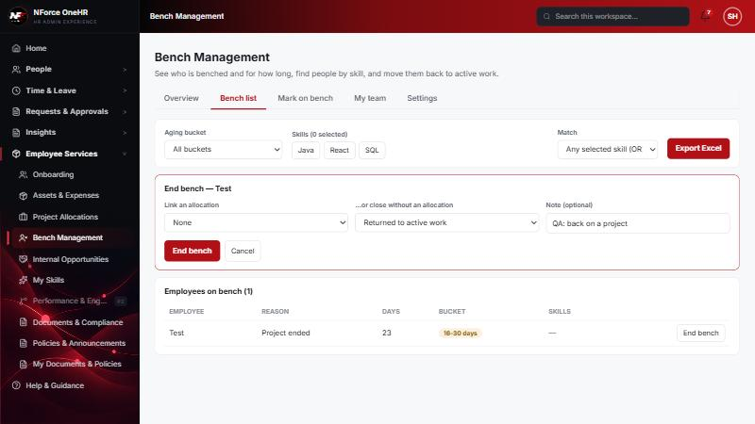
Screenshot 6 - No one on bench afterwards
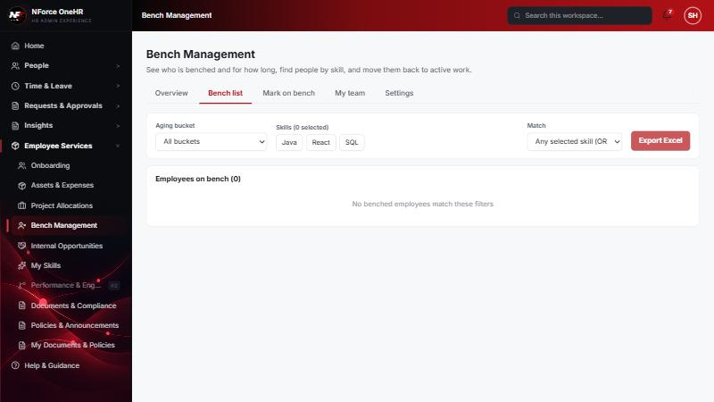

UT-585-05 - End date and duration are retained - the record is never deleted
Test ID | UT-585-05
Module | Workforce Availability & Bench Management / Bench Status
Class / Method | BenchStatus (append-only history)
Scenario | End date and duration are retained - the record is never deleted
Steps | 1. Try to end an already-ended episode  2. Try to delete an episode
Expected Result | Refused; history kept.
Actual Result | Re-ending returns 409. There is no delete route. Start date, end date, reason/allocation are kept in the database row and in the audit trail.
Tested as | HR Admin
Status | Pass
Developer | Abuzar Siddiqui
Evidence (recorded response) | PATCH /api/bench-status/{already-ended id}/end -> 409 "Bench status has already ended"  DELETE /api/bench-status/{id} -> there is no delete route (the request is rejected); ended episodes only ever leave the active list.  The audit log keeps start date, end date and the linked allocation for every episode (see ONEHR-593).

UT-585-06 - Allocation belonging to a different employee, or an unknown allocation, is rejected
Test ID | UT-585-06
Module | Workforce Availability & Bench Management / Bench Status
Class / Method | BenchStatusServiceTest
Scenario | Allocation belonging to a different employee, or an unknown allocation, is rejected
Steps | 1. Unit tests end_rejectsAnAllocationThatBelongsToSomeoneElse and end_rejectsAnUnknownAllocation
Expected Result | 400 / 404, episode stays active.
Actual Result | Passing unit tests. Not reproducible through the UI because the dropdown only offers the employee's own allocations.
Tested as | -
Status | Pass (unit test only)
Developer | Abuzar Siddiqui

Notes
- Audit History is slow on this remote database: the first load took over a minute and the "Other" filter timed out once (the same query returned in 25 seconds when called directly). Existing behaviour, not caused by the bench changes.
- A request to a route that does not exist for that method (for example DELETE /api/bench-status/{id}) returns a generic 500 from the shared error handler rather than 404/405. Left unchanged because it is shared behaviour; the useful fact is that no delete route exists.
- The company policy-acknowledgement pop-up appears for the Manager and Employee accounts and blocks clicks until dismissed ("Remind Me Later" was used). Unrelated to the bench module.
- QA data left in the shared dev database (all named "QA sample"): 3 skills, 1 compensation band, 1 project, 4 allocations, 2 opportunities, bench history for five employees (all ended), and a "30+ days" notification to the Manager. The Manager's direct report Abbas DarubaiGari and the Employee test account Chandrasekhar G were used as test subjects.

