
NForce-OneHR
Unit Test Case - ONEHR-582 US-A03: Company-wide Bench Dashboard with trend
Parent epic: ONEHR-577 - Workforce Availability & Bench Management
Tested: 13 October 2026
Environment: local run - frontend http://localhost:5180, backend http://localhost:8081 (Spring Boot, Java 22), shared dev database. Roles used: HR Admin (hradmin@nforceone.com), Manager (manager@nforceone.com), Employee (emponenforce@nforce.com).
Summary
Test cases | 4 total: 4 passed, 0 passed after a defect was found and fixed, 0 verified by unit test only, 0 not executed

UT-582-01 - Dashboard numbers reconcile with the Employee module headcount
Test ID | UT-582-01
Module | Workforce Availability & Bench Management / Dashboard
Class / Method | BenchReportService.dashboard (GET /api/bench-status/dashboard); OverviewSection
Scenario | Dashboard numbers reconcile with the Employee module headcount
Steps | 1. Open Bench Management > Overview and note "Total headcount"  2. Open People > Employee Master and note the employee count
Expected Result | Both show the same number.
Actual Result | Dashboard shows 59; Employee Master header says "59 employees".
Tested as | HR Admin
Status | Pass
Developer | Abuzar Siddiqui

Screenshot 1 - Dashboard - 1 on bench, 59 headcount, 1.7%
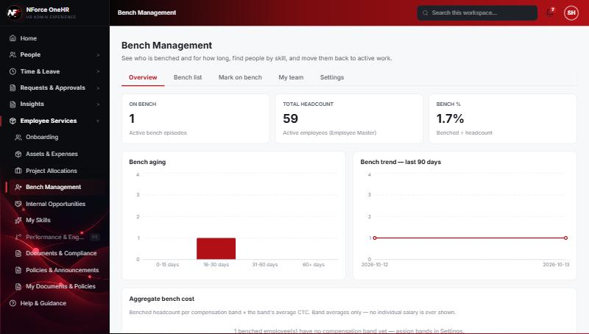
Screenshot 2 - Employee Master - 59 employees
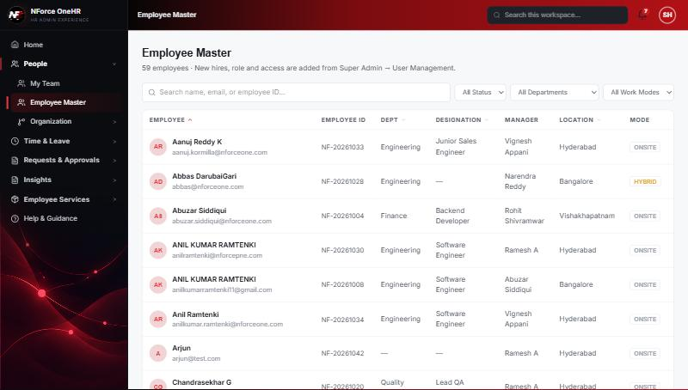

UT-582-02 - Benched headcount and bench % update when employees are benched
Test ID | UT-582-02
Module | Workforce Availability & Bench Management / Dashboard
Class / Method | BenchReportService.dashboard
Scenario | Benched headcount and bench % update when employees are benched
Steps | 1. Mark Chandrasekhar G and Abbas DarubaiGari on bench (Test already was)  2. Reload Overview
Expected Result | On bench = 3, Bench % = 3 / 59 = 5.1%.
Actual Result | 3 on bench, 5.1%. The aging chart shows 2 in 16-30 days and 1 in 31-60 days.
Tested as | HR Admin
Status | Pass
Developer | Abuzar Siddiqui

Screenshot 3 - Dashboard after - 3 on bench, 5.1%
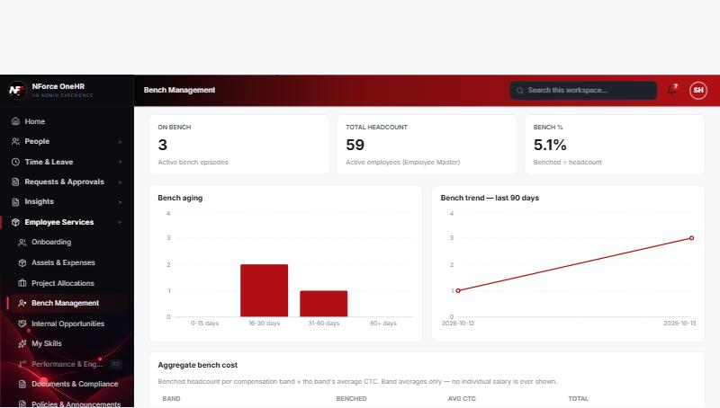

UT-582-03 - 90-day trend is a simple line chart from nightly snapshots (no forecasting)
Test ID | UT-582-03
Module | Workforce Availability & Bench Management / Dashboard
Class / Method | BenchDashboardSnapshot / BenchAgingService.captureSnapshot
Scenario | 90-day trend is a simple line chart from nightly snapshots (no forecasting)
Steps | 1. Open Overview and read the "Bench trend - last 90 days" chart
Expected Result | A line through the stored daily snapshots, ending on today's live value; nothing beyond today.
Actual Result | Two points: 2026-10-12 (snapshot written by the scheduled job, value 1) and 2026-10-13 (live, value 3 after the new entries). No projection. History will fill in as the job runs nightly.
Tested as | HR Admin
Status | Pass
Developer | Abuzar Siddiqui

Screenshot 4 - Trend with the 12-Oct snapshot and today
Screenshot 5 - Trend after more employees were benched

UT-582-04 - Dashboard is not available to Employees or Managers
Test ID | UT-582-04
Module | Workforce Availability & Bench Management / Dashboard
Class / Method | @PreAuthorize on BenchStatusController.dashboard
Scenario | Dashboard is not available to Employees or Managers
Steps | 1. As Employee and as Manager call GET /api/bench-status/dashboard
Expected Result | 403.
Actual Result | 403 for both.
Tested as | Employee, Manager
Status | Pass
Developer | Abuzar Siddiqui
Evidence (recorded response) | Signed in as the Employee (Chandrasekhar G, role EMPLOYEE):  POST /api/bench-status -> 403 Access denied  GET /api/bench-status -> 403 Access denied  GET /api/bench-status/dashboard -> 403 Access denied  GET /api/bench-status/cost -> 403 Access denied  GET /api/bench-status/team -> 403 Access denied  PUT /api/bench-status/aging-config -> 403 Access denied  POST /api/skill-taxonomy -> 403 Access denied  POST /api/opportunities -> 403 Access denied  GET /api/compensation-bands -> 403 Access denied  GET /api/opportunities -> 200 [] (employee was not on bench at the time)

Notes
- Audit History is slow on this remote database: the first load took over a minute and the "Other" filter timed out once (the same query returned in 25 seconds when called directly). Existing behaviour, not caused by the bench changes.
- A request to a route that does not exist for that method (for example DELETE /api/bench-status/{id}) returns a generic 500 from the shared error handler rather than 404/405. Left unchanged because it is shared behaviour; the useful fact is that no delete route exists.
- The company policy-acknowledgement pop-up appears for the Manager and Employee accounts and blocks clicks until dismissed ("Remind Me Later" was used). Unrelated to the bench module.
- QA data left in the shared dev database (all named "QA sample"): 3 skills, 1 compensation band, 1 project, 4 allocations, 2 opportunities, bench history for five employees (all ended), and a "30+ days" notification to the Manager. The Manager's direct report Abbas DarubaiGari and the Employee test account Chandrasekhar G were used as test subjects.

