
NForce-OneHR
Unit Test Case - ONEHR-589 US-A10: Post internal opportunity visible to benched employees
Parent epic: ONEHR-577 - Workforce Availability & Bench Management
Tested: 13 October 2026
Environment: local run - frontend http://localhost:5180, backend http://localhost:8081 (Spring Boot, Java 22), shared dev database. Roles used: HR Admin (hradmin@nforceone.com), Manager (manager@nforceone.com), Employee (emponenforce@nforce.com).
Summary
Test cases | 5 total: 4 passed, 1 passed after a defect was found and fixed, 0 verified by unit test only, 0 not executed

UT-589-01 - A Manager posts an opportunity (role, required skills from the taxonomy, duration)
Test ID | UT-589-01
Module | Workforce Availability & Bench Management / Internal Opportunities
Class / Method | OpportunityController.post -> OpportunityService.post (POST /api/opportunities); BenchOpportunitiesPage
Scenario | A Manager posts an opportunity (role, required skills from the taxonomy, duration)
Steps | 1. Sign in as Manager > Internal Opportunities  2. Enter "QA: Java developer for report automation", 4 weeks, skills Java and SQL  3. Click "Post opportunity"
Expected Result | The opportunity appears as OPEN, posted by the manager, with its skills.
Actual Result | Shown as OPEN, 4 weeks, posted by Narendra Reddy, skills Java and SQL, 0 interested.
Tested as | Manager
Status | Pass
Developer | Abuzar Siddiqui

Screenshot 1 - Manager filling the form
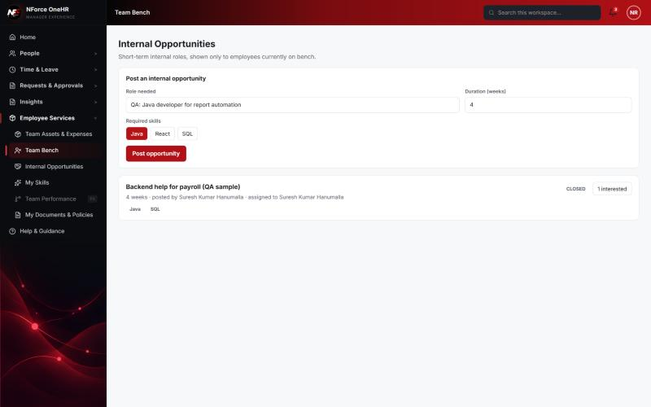
Screenshot 2 - Posted - OPEN
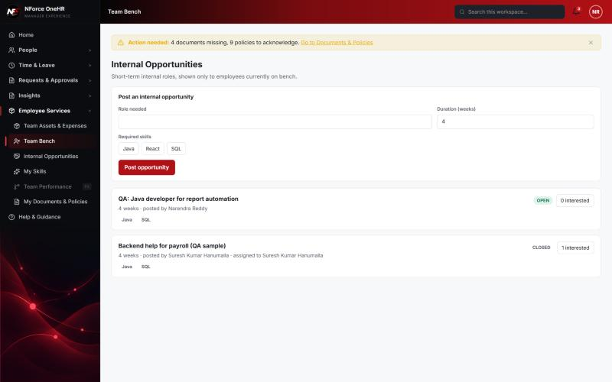

UT-589-02 - A title and at least one skill are required
Test ID | UT-589-02
Module | Workforce Availability & Bench Management / Internal Opportunities
Class / Method | BenchOpportunitiesPage.PostForm
Scenario | A title and at least one skill are required
Steps | 1. Click "Post opportunity" with an empty title
Expected Result | A message; nothing posted.
Actual Result | "Give the opportunity a title" (executed earlier the same day as HR Admin).
Tested as | HR Admin
Status | Pass
Developer | Abuzar Siddiqui

Screenshot 3 - Validation message
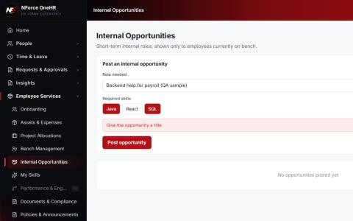

UT-589-03 - Only HR or a Manager can post - an Employee cannot
Test ID | UT-589-03
Module | Workforce Availability & Bench Management / Internal Opportunities
Class / Method | OpportunityService.post (RBAC)
Scenario | Only HR or a Manager can post - an Employee cannot
Steps | 1. As Employee open Internal Opportunities  2. Call POST /api/opportunities
Expected Result | No post form on the page; the API answers 403.
Actual Result | The Employee page has no form (only the list); POST returns 403. An empty or malformed body now returns 400 (was 500 - defect D5).
Tested as | Employee
Status | Pass (after fix D5)
Developer | Abuzar Siddiqui
Evidence (recorded response) | Signed in as the Employee (Chandrasekhar G, role EMPLOYEE):  POST /api/bench-status -> 403 Access denied  GET /api/bench-status -> 403 Access denied  GET /api/bench-status/dashboard -> 403 Access denied  GET /api/bench-status/cost -> 403 Access denied  GET /api/bench-status/team -> 403 Access denied  PUT /api/bench-status/aging-config -> 403 Access denied  POST /api/skill-taxonomy -> 403 Access denied  POST /api/opportunities -> 403 Access denied  GET /api/compensation-bands -> 403 Access denied  GET /api/opportunities -> 200 [] (employee was not on bench at the time)

Screenshot 4 - Employee page - list only, no post form
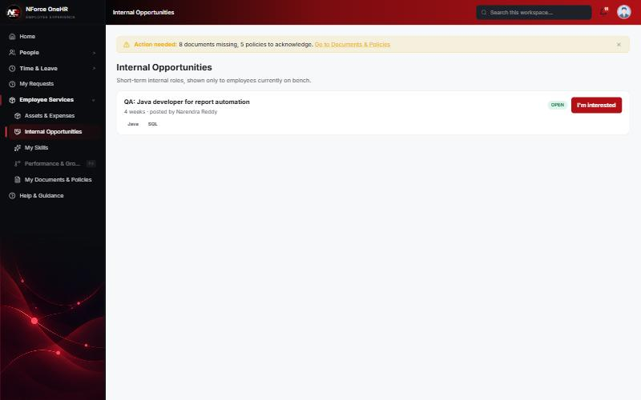

UT-589-04 - Visibility: only employees on bench see OPEN opportunities
Test ID | UT-589-04
Module | Workforce Availability & Bench Management / Internal Opportunities
Class / Method | OpportunityService.list
Scenario | Visibility: only employees on bench see OPEN opportunities
Steps | 1. As the Employee while NOT on bench, call GET /api/opportunities  2. HR marks the Employee on bench  3. As Employee open Internal Opportunities
Expected Result | Not on bench: empty. On bench: only OPEN opportunities (closed ones hidden).
Actual Result | Not on bench: []. On bench: only "QA: Java developer for report automation" (OPEN); the earlier CLOSED opportunity is not listed.
Tested as | Employee
Status | Pass
Developer | Abuzar Siddiqui
Evidence (recorded response) | Signed in as the Employee (Chandrasekhar G, role EMPLOYEE):  POST /api/bench-status -> 403 Access denied  GET /api/bench-status -> 403 Access denied  GET /api/bench-status/dashboard -> 403 Access denied  GET /api/bench-status/cost -> 403 Access denied  GET /api/bench-status/team -> 403 Access denied  PUT /api/bench-status/aging-config -> 403 Access denied  POST /api/skill-taxonomy -> 403 Access denied  POST /api/opportunities -> 403 Access denied  GET /api/compensation-bands -> 403 Access denied  GET /api/opportunities -> 200 [] (employee was not on bench at the time)

Screenshot 5 - Benched employee sees only OPEN opportunities

UT-589-05 - Opportunities have an open / closed state
Test ID | UT-589-05
Module | Workforce Availability & Bench Management / Internal Opportunities
Class / Method | InternalOpportunity.status
Scenario | Opportunities have an open / closed state
Steps | 1. Compare an open and a closed opportunity as HR Admin
Expected Result | Status badges OPEN and CLOSED; closed shows who it was assigned to.
Actual Result | OPEN for the new one; CLOSED "assigned to Chandrasekhar G" after assignment.
Tested as | HR Admin
Status | Pass
Developer | Abuzar Siddiqui

Screenshot 6 - HR view - OPEN with Assign, and CLOSED
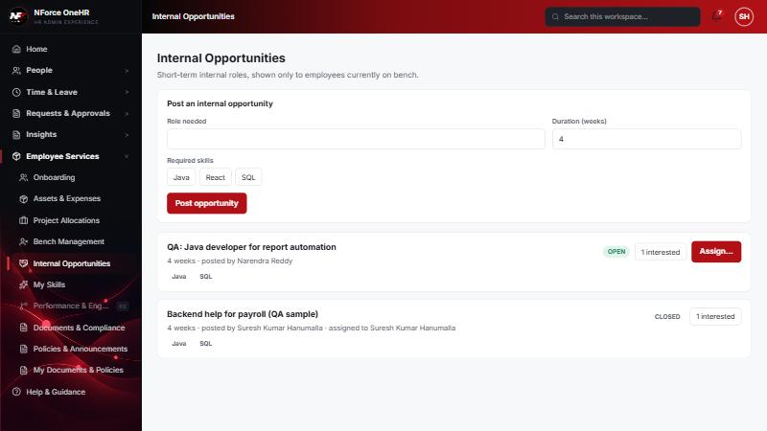

Defects found by this QA run (all fixed and re-tested)
D5 | An invalid enum value (bench reason "VACATION"), an empty body or malformed JSON returned 500 instead of 400 (unreadable bodies were not mapped in GlobalExceptionHandler).  Resolution: Fixed globally with a 400 handler (+ unit test). Re-verified on three endpoints.

Notes
- Audit History is slow on this remote database: the first load took over a minute and the "Other" filter timed out once (the same query returned in 25 seconds when called directly). Existing behaviour, not caused by the bench changes.
- A request to a route that does not exist for that method (for example DELETE /api/bench-status/{id}) returns a generic 500 from the shared error handler rather than 404/405. Left unchanged because it is shared behaviour; the useful fact is that no delete route exists.
- The company policy-acknowledgement pop-up appears for the Manager and Employee accounts and blocks clicks until dismissed ("Remind Me Later" was used). Unrelated to the bench module.
- QA data left in the shared dev database (all named "QA sample"): 3 skills, 1 compensation band, 1 project, 4 allocations, 2 opportunities, bench history for five employees (all ended), and a "30+ days" notification to the Manager. The Manager's direct report Abbas DarubaiGari and the Employee test account Chandrasekhar G were used as test subjects.

