
NForce-OneHR
Unit Test Case - ONEHR-580 US-A01: Mark employee as On Bench with reason code
Parent epic: ONEHR-577 - Workforce Availability & Bench Management
Tested: 13 October 2026
Environment: local run - frontend http://localhost:5180, backend http://localhost:8081 (Spring Boot, Java 22), shared dev database. Roles used: HR Admin (hradmin@nforceone.com), Manager (manager@nforceone.com), Employee (emponenforce@nforce.com).
Summary
Test cases | 7 total: 4 passed, 3 passed after a defect was found and fixed, 0 verified by unit test only, 0 not executed

UT-580-01 - HR Admin opens the Mark on bench form - the reason is a controlled list and the start date defaults to today
Test ID | UT-580-01
Module | Workforce Availability & Bench Management / Bench Status
Class / Method | BenchStatusController.start -> BenchStatusService.start (POST /api/bench-status); MarkBenchSection
Scenario | HR Admin opens the Mark on bench form - the reason is a controlled list and the start date defaults to today
Steps | 1. Sign in as HR Admin and open Employee Services > Bench Management > Mark on bench  2. Look at the Employee, Reason and Start date fields
Expected Result | Reason offers only: Role ended, Project ended, New joiner unallocated, Awaiting onboarding (no free text). Start date is pre-filled with today and is editable.
Actual Result | First run: the start date showed 10/12/2026 although it was already 10/13 for the user - the form computed the date in UTC (defect D1). Fixed to use the local date; re-run shows 10/13/2026. Reason list shows exactly the four codes.
Tested as | HR Admin
Status | Pass (after fix D1)
Developer | Abuzar Siddiqui

Screenshot 1 - Before fix - default start date was yesterday (UTC)
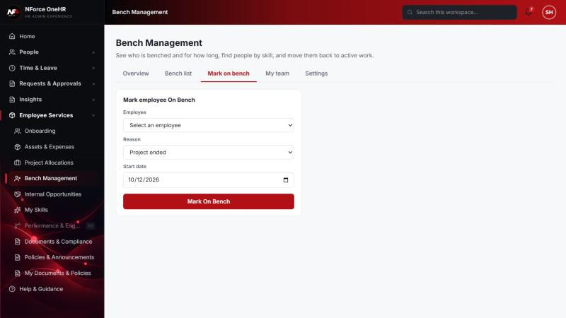
Screenshot 2 - After fix - default start date is today (10/13/2026)
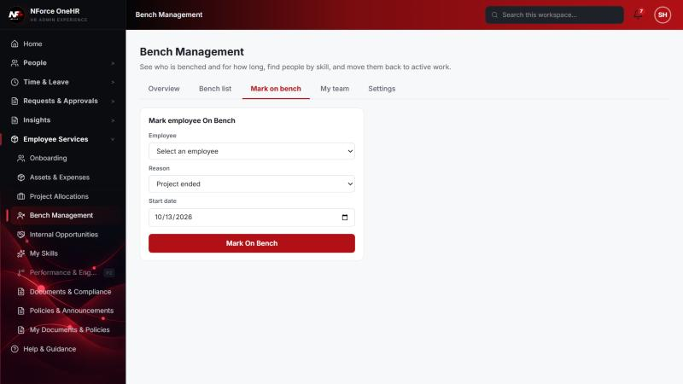

UT-580-02 - Submit the form without choosing an employee
Test ID | UT-580-02
Module | Workforce Availability & Bench Management / Bench Status
Class / Method | MarkBenchSection.submit (client validation)
Scenario | Submit the form without choosing an employee
Steps | 1. Leave Employee as "Select an employee"  2. Click "Mark On Bench"
Expected Result | Nothing is saved; the message "Select an employee" is shown.
Actual Result | Message "Select an employee" shown, no request sent.
Tested as | HR Admin
Status | Pass
Developer | Abuzar Siddiqui

Screenshot 3 - Validation message
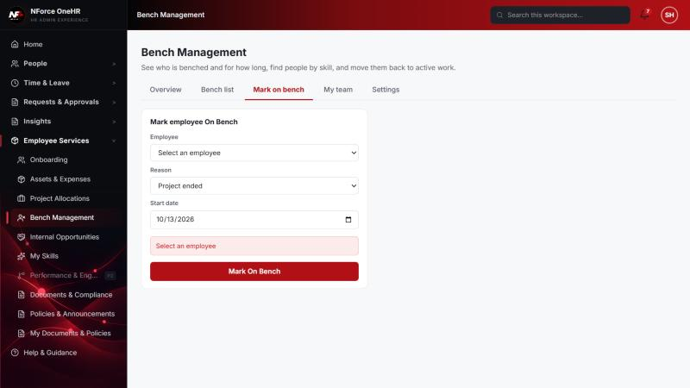

UT-580-03 - Mark an employee on bench with reason "New joiner unallocated" and a back-dated (edited) start date
Test ID | UT-580-03
Module | Workforce Availability & Bench Management / Bench Status
Class / Method | BenchStatusService.start
Scenario | Mark an employee on bench with reason "New joiner unallocated" and a back-dated (edited) start date
Steps | 1. Choose employee Chandrasekhar G  2. Choose reason "New joiner unallocated"  3. Change the start date to 09/13/2026  4. Click "Mark On Bench"
Expected Result | Employee is saved as on bench with the chosen reason and start date, appears in the Bench list with the correct days on bench (30 days on 13 Oct) and an aging bucket.
Actual Result | Saved. The Bench list shows Chandrasekhar G - New joiner unallocated - 30 days - bucket 16-30 days.
Tested as | HR Admin
Status | Pass
Developer | Abuzar Siddiqui

Screenshot 4 - Form filled in with reason and edited start date
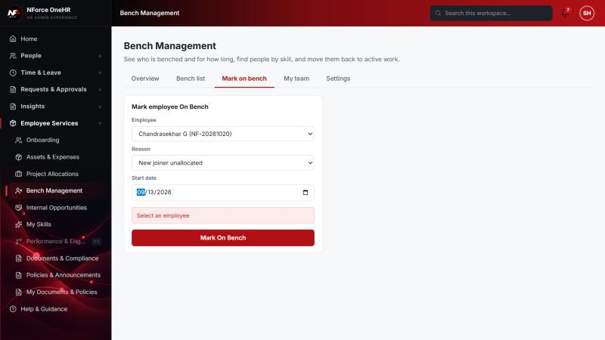
Screenshot 5 - Bench list after marking (Abbas 54d, Chandrasekhar 30d, Test 23d)
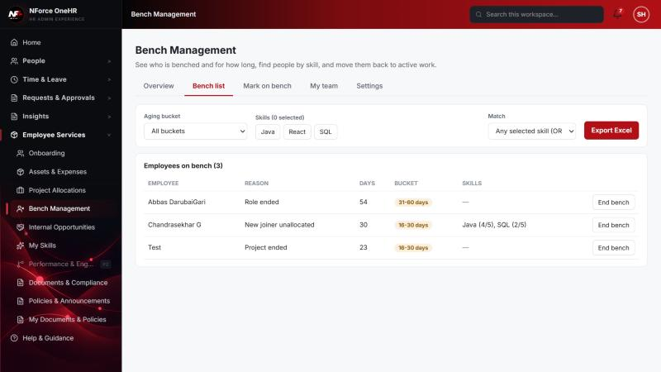

UT-580-04 - Marking an employee who is already on bench is refused
Test ID | UT-580-04
Module | Workforce Availability & Bench Management / Bench Status
Class / Method | BenchStatusService.start
Scenario | Marking an employee who is already on bench is refused
Steps | 1. Mark an employee on bench  2. Select the same employee again and click "Mark On Bench"
Expected Result | The second request is rejected with "Employee is already on bench"; no second episode is created.
Actual Result | Message "Employee is already on bench" shown (executed earlier the same day, before the main QA run).
Tested as | HR Admin
Status | Pass
Developer | Abuzar Siddiqui

Screenshot 6 - Duplicate rejected
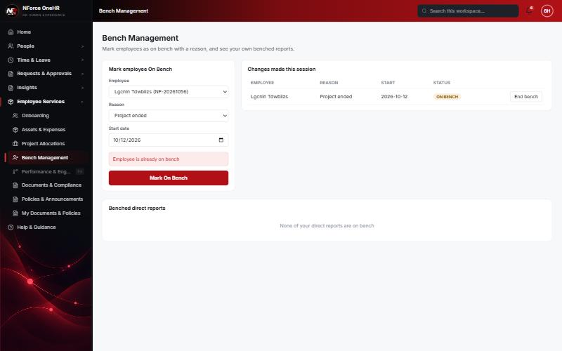

UT-580-05 - The reason is a controlled enum, not free text - values outside the list are refused
Test ID | UT-580-05
Module | Workforce Availability & Bench Management / Bench Status
Class / Method | BenchStatusRequest validation + GlobalExceptionHandler
Scenario | The reason is a controlled enum, not free text - values outside the list are refused
Steps | 1. Send POST /api/bench-status with reasonCode "VACATION"  2. Send it with no reason, no employee, and an unknown employee id
Expected Result | Every invalid request is refused with a 4xx and nothing is stored.
Actual Result | All refused. The first run returned 500 for "VACATION" (defect D5 - unreadable body not mapped); after the fix it returns 400.
Tested as | HR Admin
Status | Pass (after fix D5)
Developer | Abuzar Siddiqui
Evidence (recorded response) | POST /api/bench-status {employeeId, reasonCode: "VACATION"} -> 400 "Request body is missing or invalid" (was 500 before fix D5)  POST /api/bench-status {employeeId} (no reason) -> 400 "Reason is required"  POST /api/bench-status {reasonCode} (no employee) -> 400 "Employee is required"  POST /api/bench-status {employeeId: 0000..., reasonCode: ROLE_ENDED} -> 404 "Employee not found"

UT-580-06 - Every create is written to the audit log
Test ID | UT-580-06
Module | Workforce Availability & Bench Management / Bench Status
Class / Method | AuditService.log (BENCH_STATUS_CHANGE)
Scenario | Every create is written to the audit log
Steps | 1. Mark an employee on bench  2. Open Insights > Audit History (or GET /api/audit-logs?action=BENCH_STATUS_CHANGE)
Expected Result | An entry with action BENCH_STATUS_CHANGE, the actor, the affected employee, and the after-state (no before-state for a create).
Actual Result | Entry present with before = null and after = the new episode. After fix D3 the Audit page shows the employee name ("Test") as the affected user.
Tested as | HR Admin
Status | Pass (after fix D3)
Developer | Abuzar Siddiqui
Evidence (recorded response) | GET /api/audit-logs?action=BENCH_STATUS_CHANGE (as HR Admin) - entry written when Chandrasekhar's bench ended with an allocation:  actor: Suresh Kumar Hanumalla (HR Admin)  before: {"active": true, "endDate": null, "startDate": "2026-09-13", "reasonCode": "NEW_JOINER_UNALLOCATED", "closeReason": null, "allocationId": null}  after : {"active": false, "endDate": "2026-10-13", "startDate": "2026-09-13", "reasonCode": "NEW_JOINER_UNALLOCATED", "closeReason": null, "allocationId": "2ced7334-769b-4f92-b646-8c879f34c4a7"}  Entry written when Abbas was first marked on bench:  before: null  after : {"active": true, "endDate": null, "startDate": "2026-08-20", "reasonCode": "ROLE_ENDED", ...}

Screenshot 7 - Audit History - Bench Status Change, affected user shown by name
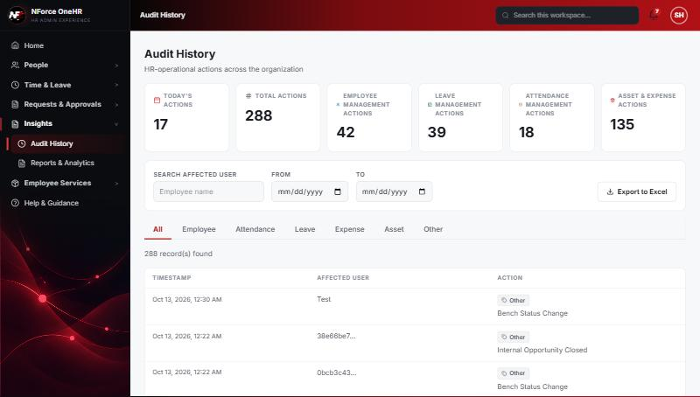

UT-580-07 - Only HR Admin / Super Admin can mark someone on bench
Test ID | UT-580-07
Module | Workforce Availability & Bench Management / Bench Status
Class / Method | @PreAuthorize on BenchStatusController
Scenario | Only HR Admin / Super Admin can mark someone on bench
Steps | 1. Sign in as Employee and as Manager  2. Check the sidebar and call POST /api/bench-status
Expected Result | No HR bench item in the sidebar; the API answers 403.
Actual Result | Employee sidebar has only "Internal Opportunities" and "My Skills"; Manager sidebar has "Team Bench" (read-only). POST returns 403 for both.
Tested as | Employee, Manager
Status | Pass
Developer | Abuzar Siddiqui
Evidence (recorded response) | Signed in as the Employee (Chandrasekhar G, role EMPLOYEE):  POST /api/bench-status -> 403 Access denied  GET /api/bench-status -> 403 Access denied  GET /api/bench-status/dashboard -> 403 Access denied  GET /api/bench-status/cost -> 403 Access denied  GET /api/bench-status/team -> 403 Access denied  PUT /api/bench-status/aging-config -> 403 Access denied  POST /api/skill-taxonomy -> 403 Access denied  POST /api/opportunities -> 403 Access denied  GET /api/compensation-bands -> 403 Access denied  GET /api/opportunities -> 200 [] (employee was not on bench at the time)  Signed in as the Manager (Narendra Reddy, role MANAGER):  POST /api/bench-status -> 403 Access denied  GET /api/bench-status -> 403 Access denied  GET /api/bench-status/dashboard -> 403 Access denied  GET /api/bench-status/cost -> 403 Access denied  GET /api/compensation-bands -> 403 Access denied  PUT /api/bench-status/aging-config -> 403 Access denied  POST /api/opportunities/{id}/close -> 403 Access denied  GET /api/bench-status/team?managerId=<another manager's id> -> 200 [] (the parameter is ignored; only the caller's own reports are ever returned)

Screenshot 8 - Employee sidebar - no bench administration
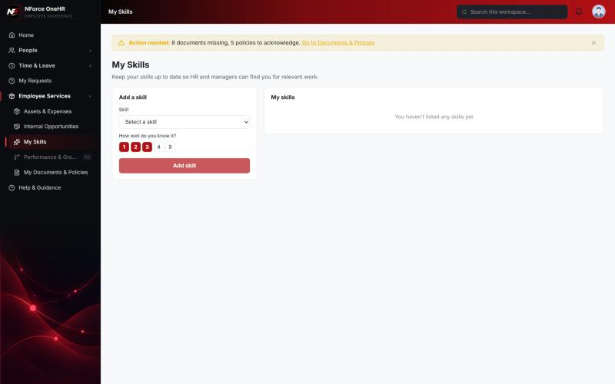
Screenshot 9 - Manager sidebar - Team Bench only
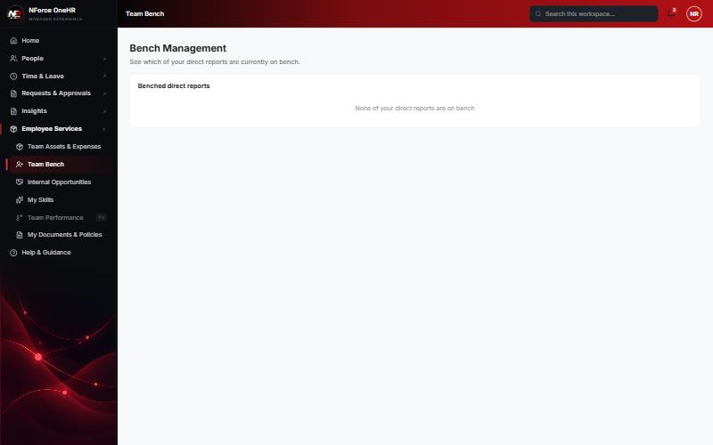

Defects found by this QA run (all fixed and re-tested)
D1 | Default start date was yesterday for users east of UTC (form used toISOString, i.e. UTC). Affected Mark on bench, Assign panel and the export file name.  Resolution: Fixed (todayLocal helper + unit test), re-verified in the browser.
D3 | Audit History showed the bench record id as the "affected user" instead of the employee.  Resolution: Fixed - audit target is now the employee; record ids travel in the audit state. Re-verified.
D5 | An invalid enum value (bench reason "VACATION"), an empty body or malformed JSON returned 500 instead of 400 (unreadable bodies were not mapped in GlobalExceptionHandler).  Resolution: Fixed globally with a 400 handler (+ unit test). Re-verified on three endpoints.

Notes
- Audit History is slow on this remote database: the first load took over a minute and the "Other" filter timed out once (the same query returned in 25 seconds when called directly). Existing behaviour, not caused by the bench changes.
- A request to a route that does not exist for that method (for example DELETE /api/bench-status/{id}) returns a generic 500 from the shared error handler rather than 404/405. Left unchanged because it is shared behaviour; the useful fact is that no delete route exists.
- The company policy-acknowledgement pop-up appears for the Manager and Employee accounts and blocks clicks until dismissed ("Remind Me Later" was used). Unrelated to the bench module.
- QA data left in the shared dev database (all named "QA sample"): 3 skills, 1 compensation band, 1 project, 4 allocations, 2 opportunities, bench history for five employees (all ended), and a "30+ days" notification to the Manager. The Manager's direct report Abbas DarubaiGari and the Employee test account Chandrasekhar G were used as test subjects.

