
NForce-OneHR
Unit Test Case - ONEHR-583 US-A04: Bench aging buckets (0-15 / 16-30 / 31-60 / 60+ days)
Parent epic: ONEHR-577 - Workforce Availability & Bench Management
Tested: 13 October 2026
Environment: local run - frontend http://localhost:5180, backend http://localhost:8081 (Spring Boot, Java 22), shared dev database. Roles used: HR Admin (hradmin@nforceone.com), Manager (manager@nforceone.com), Employee (emponenforce@nforce.com).
Summary
Test cases | 6 total: 6 passed, 0 passed after a defect was found and fixed, 0 verified by unit test only, 0 not executed

UT-583-01 - Each benched employee shows days on bench and the right aging bucket (including the boundary day)
Test ID | UT-583-01
Module | Workforce Availability & Bench Management / Aging
Class / Method | BenchAgingService.resolveBucket; BenchListSection
Scenario | Each benched employee shows days on bench and the right aging bucket (including the boundary day)
Steps | 1. Open Bench list with employees benched for 54, 30 and 23 days
Expected Result | 54 days -> 31-60 days; 30 days -> 16-30 days (boundary stays in the lower bucket); 23 days -> 16-30 days.
Actual Result | Exactly as expected.
Tested as | HR Admin
Status | Pass
Developer | Abuzar Siddiqui

Screenshot 1 - Bench list with buckets
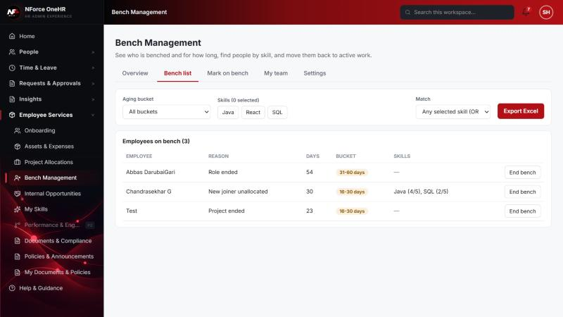

UT-583-02 - Filter the list by bucket
Test ID | UT-583-02
Module | Workforce Availability & Bench Management / Aging
Class / Method | BenchReportService.list (bucket filter)
Scenario | Filter the list by bucket
Steps | 1. Choose "31-60 days" in the Aging bucket filter
Expected Result | Only employees in that bucket.
Actual Result | Only Abbas DarubaiGari (54 days) is listed.
Tested as | HR Admin
Status | Pass
Developer | Abuzar Siddiqui

Screenshot 2 - Filtered to 31-60 days
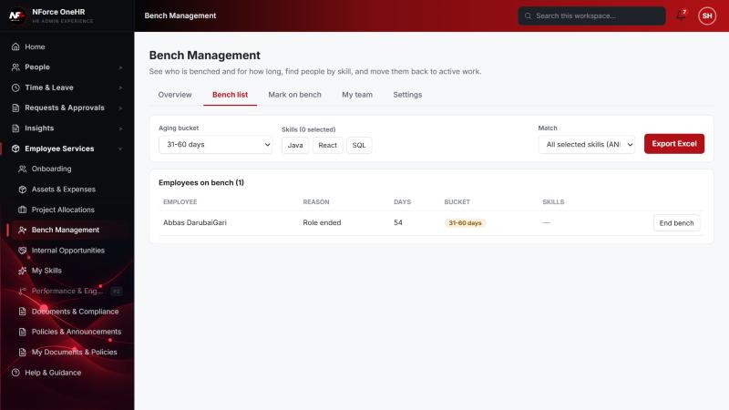

UT-583-03 - HR Admin can view and edit the bucket boundaries
Test ID | UT-583-03
Module | Workforce Availability & Bench Management / Aging
Class / Method | BenchAgingService.getConfig/saveConfig; SettingsSection
Scenario | HR Admin can view and edit the bucket boundaries
Steps | 1. Open Bench Management > Settings
Expected Result | Four buckets with from/to days, an open-ended last bucket, and the notification threshold.
Actual Result | Shown as expected.
Tested as | HR Admin
Status | Pass
Developer | Abuzar Siddiqui

Screenshot 3 - Settings - aging buckets, threshold, skills, bands
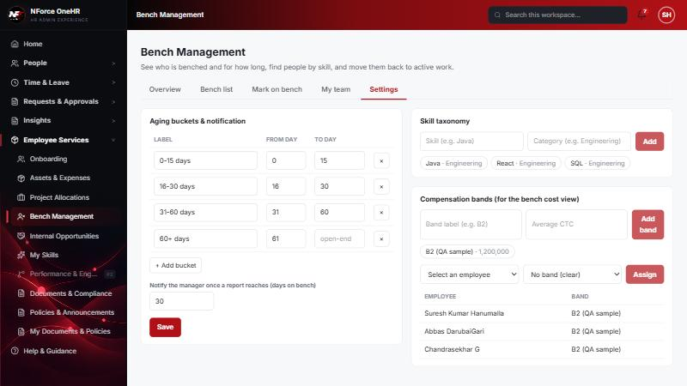

UT-583-04 - Invalid boundaries are rejected (overlap, gap, bad threshold)
Test ID | UT-583-04
Module | Workforce Availability & Bench Management / Aging
Class / Method | BenchAgingService.validateContiguous
Scenario | Invalid boundaries are rejected (overlap, gap, bad threshold)
Steps | 1. Set bucket 1 to end at day 20 while bucket 2 still starts at day 16  2. Click Save  3. Repeat via the API with a gap and with threshold 0
Expected Result | A clear message; nothing saved.
Actual Result | UI: "Buckets must be contiguous: "0-15 days" ends at day 20 but the next one starts at day 16". API gap and threshold 0 are rejected with 400. Configuration unchanged.
Tested as | HR Admin
Status | Pass
Developer | Abuzar Siddiqui
Evidence (recorded response) | PUT /api/bench-status/aging-config with buckets 0-10 and 12-open (gap) -> 400 "Buckets must be contiguous: "a" ends at day 10 but the next one starts at day 12"  PUT /api/bench-status/aging-config with notifyThresholdDays = 0 -> 400 "must be greater than or equal to 1"  GET /api/bench-status/aging-config afterwards -> unchanged: 0-15, 16-30, 31-60, 60+ (open-ended), threshold 30

Screenshot 4 - Overlap rejected
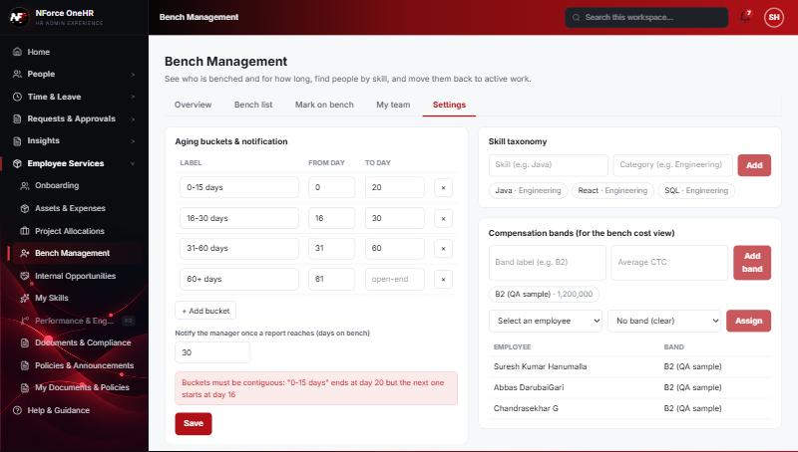

UT-583-05 - A valid change saves and re-buckets everyone immediately
Test ID | UT-583-05
Module | Workforce Availability & Bench Management / Aging
Class / Method | BenchAgingService.saveConfig
Scenario | A valid change saves and re-buckets everyone immediately
Steps | 1. Make bucket 1 end at day 20 and bucket 2 start at day 21  2. Click Save  3. Restore the original boundaries and Save again
Expected Result | "Saved" appears; stored buckets on active episodes are refreshed.
Actual Result | "Saved" shown; defaults restored afterwards and verified through the API.
Tested as | HR Admin
Status | Pass
Developer | Abuzar Siddiqui

Screenshot 5 - Saved confirmation
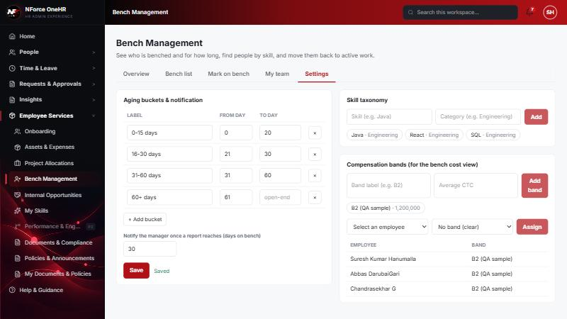

UT-583-06 - Buckets are recomputed by a scheduled job, not on page load
Test ID | UT-583-06
Module | Workforce Availability & Bench Management / Aging
Class / Method | BenchNightlyScheduler / BenchAgingService.recomputeAll
Scenario | Buckets are recomputed by a scheduled job, not on page load
Steps | 1. Start the backend with the job set to run every minute (config only)  2. Watch the log and the dashboard data
Expected Result | The job runs on schedule, refreshes stored buckets, sends threshold notifications and writes the daily snapshot.
Actual Result | The job logged "Bench nightly pass complete" every minute; it produced the 2026-10-12 trend snapshot and the manager notification (see ONEHR-584 and ONEHR-582). Production default is 00:15 daily (configurable with app.bench.nightly.cron).
Tested as | System
Status | Pass
Developer | Abuzar Siddiqui

Notes
- Audit History is slow on this remote database: the first load took over a minute and the "Other" filter timed out once (the same query returned in 25 seconds when called directly). Existing behaviour, not caused by the bench changes.
- A request to a route that does not exist for that method (for example DELETE /api/bench-status/{id}) returns a generic 500 from the shared error handler rather than 404/405. Left unchanged because it is shared behaviour; the useful fact is that no delete route exists.
- The company policy-acknowledgement pop-up appears for the Manager and Employee accounts and blocks clicks until dismissed ("Remind Me Later" was used). Unrelated to the bench module.
- QA data left in the shared dev database (all named "QA sample"): 3 skills, 1 compensation band, 1 project, 4 allocations, 2 opportunities, bench history for five employees (all ended), and a "30+ days" notification to the Manager. The Manager's direct report Abbas DarubaiGari and the Employee test account Chandrasekhar G were used as test subjects.

