
NForce-OneHR
Unit Test Case - ONEHR-584 US-A05: Notify manager when a report crosses 30 days on bench
Parent epic: ONEHR-577 - Workforce Availability & Bench Management
Tested: 13 October 2026
Environment: local run - frontend http://localhost:5180, backend http://localhost:8081 (Spring Boot, Java 22), shared dev database. Roles used: HR Admin (hradmin@nforceone.com), Manager (manager@nforceone.com), Employee (emponenforce@nforce.com).
Summary
Test cases | 4 total: 3 passed, 0 passed after a defect was found and fixed, 1 verified by unit test only, 0 not executed

UT-584-01 - The manager is notified when a direct report is at or over the threshold
Test ID | UT-584-01
Module | Workforce Availability & Bench Management / Notifications
Class / Method | BenchAgingService.notifyThresholdCrossings; NotificationService.send
Scenario | The manager is notified when a direct report is at or over the threshold
Steps | 1. Abbas DarubaiGari (reports to Narendra Reddy) is on bench for 54 days  2. Let the scheduled job run  3. Sign in as the Manager and open Notifications
Expected Result | A "Team member on bench for 30+ days" notification naming the employee and the days.
Actual Result | Notification shown: "Abbas DarubaiGari has been on bench for 54 days."
Tested as | Manager, System
Status | Pass
Developer | Abuzar Siddiqui
Evidence (recorded response) | GET /api/notifications (as the Manager), filtered for bench:  [ type BENCH_THRESHOLD, "Team member on bench for 30+ days", "Abbas DarubaiGari has been on bench for 54 days.", created 2026-10-12T18:36:01Z ]  Checked again at 18:38:56Z, after the job (set to run every minute for this test) had run at least 3 more times: still exactly ONE such notification.

Screenshot 1 - Manager's notifications
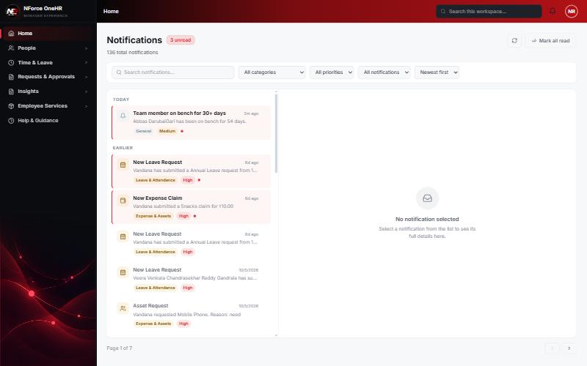

UT-584-02 - One notification per crossing - not repeated every day
Test ID | UT-584-02
Module | Workforce Availability & Bench Management / Notifications
Class / Method | BenchStatus.notifiedAt (dedupe)
Scenario | One notification per crossing - not repeated every day
Steps | 1. Leave the job running (every minute for this test)  2. Count the bench notifications again a few minutes later
Expected Result | Still exactly one.
Actual Result | Exactly one after at least 3 further job runs.
Tested as | Manager
Status | Pass
Developer | Abuzar Siddiqui
Evidence (recorded response) | GET /api/notifications (as the Manager), filtered for bench:  [ type BENCH_THRESHOLD, "Team member on bench for 30+ days", "Abbas DarubaiGari has been on bench for 54 days.", created 2026-10-12T18:36:01Z ]  Checked again at 18:38:56Z, after the job (set to run every minute for this test) had run at least 3 more times: still exactly ONE such notification.

UT-584-03 - The threshold is configurable
Test ID | UT-584-03
Module | Workforce Availability & Bench Management / Notifications
Class / Method | BenchSettings.notifyThresholdDays; SettingsSection
Scenario | The threshold is configurable
Steps | 1. Open Settings and look at "Notify the manager once a report reaches (days on bench)"
Expected Result | An editable field, default 30, stored with the bucket config.
Actual Result | Field shown with 30 and saved together with the buckets. Values below 1 are rejected (400). Behaviour with a threshold other than 30 was covered by unit tests, not run live.
Tested as | HR Admin
Status | Pass (UI + unit test)
Developer | Abuzar Siddiqui

Screenshot 2 - Threshold field in Settings
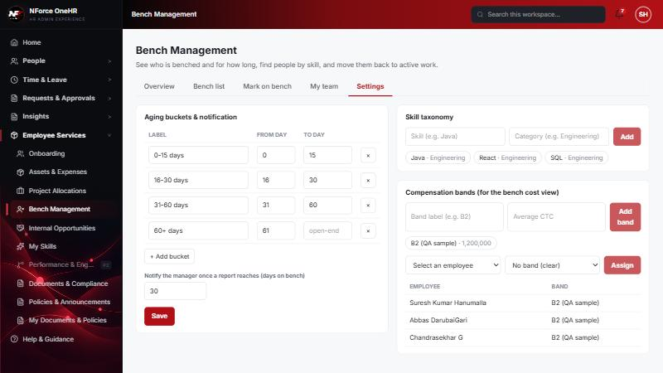

UT-584-04 - No notification before the threshold; retried later when the employee has no manager yet
Test ID | UT-584-04
Module | Workforce Availability & Bench Management / Notifications
Class / Method | BenchAgingServiceTest
Scenario | No notification before the threshold; retried later when the employee has no manager yet
Steps | 1. Unit tests: 29 days, already-notified, and no-manager cases
Expected Result | No notification; no notifiedAt stamp where no manager received it.
Actual Result | Passing unit tests (recomputeAll_doesNotNotifyBeforeTheThreshold, ..._neverNotifiesTheSameCrossingTwice, ..._retriesLaterWhenThereIsNoManagerYet). Not reproduced live because it needed another manager account.
Tested as | -
Status | Pass (unit test only)
Developer | Abuzar Siddiqui

Notes
- Audit History is slow on this remote database: the first load took over a minute and the "Other" filter timed out once (the same query returned in 25 seconds when called directly). Existing behaviour, not caused by the bench changes.
- A request to a route that does not exist for that method (for example DELETE /api/bench-status/{id}) returns a generic 500 from the shared error handler rather than 404/405. Left unchanged because it is shared behaviour; the useful fact is that no delete route exists.
- The company policy-acknowledgement pop-up appears for the Manager and Employee accounts and blocks clicks until dismissed ("Remind Me Later" was used). Unrelated to the bench module.
- QA data left in the shared dev database (all named "QA sample"): 3 skills, 1 compensation band, 1 project, 4 allocations, 2 opportunities, bench history for five employees (all ended), and a "30+ days" notification to the Manager. The Manager's direct report Abbas DarubaiGari and the Employee test account Chandrasekhar G were used as test subjects.

