
NForce-OneHR
Unit Test Case - ONEHR-588 US-A09: Export bench list with skills and aging to Excel
Parent epic: ONEHR-577 - Workforce Availability & Bench Management
Tested: 13 October 2026
Environment: local run - frontend http://localhost:5180, backend http://localhost:8081 (Spring Boot, Java 22), shared dev database. Roles used: HR Admin (hradmin@nforceone.com), Manager (manager@nforceone.com), Employee (emponenforce@nforce.com).
Summary
Test cases | 3 total: 2 passed, 0 passed after a defect was found and fixed, 0 verified by unit test only, 1 not executed

UT-588-01 - Export is offered for the current list and disabled when there is nothing to export
Test ID | UT-588-01
Module | Workforce Availability & Bench Management / Export
Class / Method | BenchListSection (Export Excel button)
Scenario | Export is offered for the current list and disabled when there is nothing to export
Steps | 1. Open the Bench list with rows  2. Apply a filter that returns no rows
Expected Result | "Export Excel" enabled with rows, disabled (greyed) with none.
Actual Result | Enabled with 3 rows; greyed out when the AND search returned nothing.
Tested as | HR Admin
Status | Pass
Developer | Abuzar Siddiqui

Screenshot 1 - Export Excel enabled
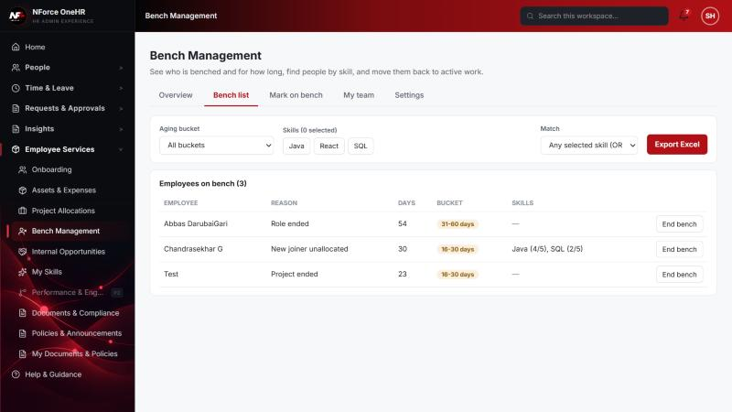
Screenshot 2 - Export Excel disabled (no rows)
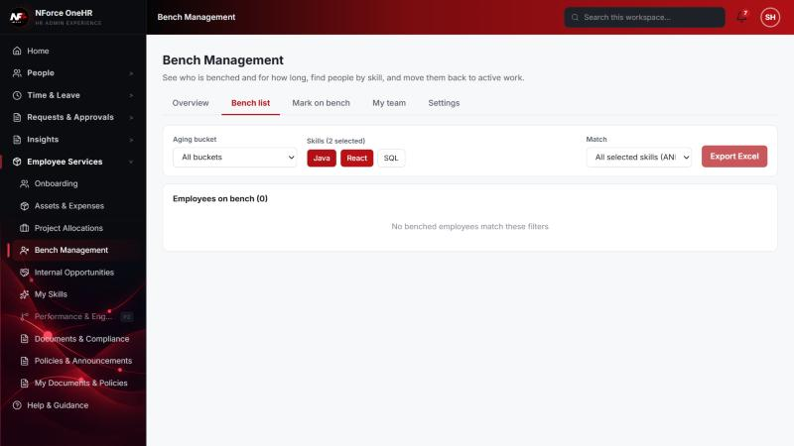

UT-588-02 - The export contains exactly the rows on screen (respects filters) with skills and aging
Test ID | UT-588-02
Module | Workforce Availability & Bench Management / Export
Class / Method | benchExport.toExportRows (benchExport.test.ts)
Scenario | The export contains exactly the rows on screen (respects filters) with skills and aging
Steps | 1. Unit tests for the row mapping: order preserved, skill match shown only when skills were searched, missing bucket blanked, sheet builds
Expected Result | Same rows and order as the filtered list.
Actual Result | 3 passing tests. The export reuses the xlsx library already used by the Audit export (no new dependency).
Tested as | -
Status | Pass (unit test)
Developer | Abuzar Siddiqui

UT-588-03 - The .xlsx file downloads and opens with the right content
Test ID | UT-588-03
Module | Workforce Availability & Bench Management / Export
Class / Method | XLSX.writeFile (browser download)
Scenario | The .xlsx file downloads and opens with the right content
Steps | 1. Click "Export Excel"  2. Open the downloaded bench-list-<date>.xlsx
Expected Result | A workbook with Employee, Reason, Bench start, Days on bench, Aging bucket, Skill match, Skills.
Actual Result | NOT EXECUTED - downloading a file needs the user's explicit permission and none was given for this run. Only the mapping above was verified. (Defect D1 also fixed the file name to use the local date.)
Tested as | HR Admin
Status | Not executed
Developer | Abuzar Siddiqui

Notes
- Audit History is slow on this remote database: the first load took over a minute and the "Other" filter timed out once (the same query returned in 25 seconds when called directly). Existing behaviour, not caused by the bench changes.
- A request to a route that does not exist for that method (for example DELETE /api/bench-status/{id}) returns a generic 500 from the shared error handler rather than 404/405. Left unchanged because it is shared behaviour; the useful fact is that no delete route exists.
- The company policy-acknowledgement pop-up appears for the Manager and Employee accounts and blocks clicks until dismissed ("Remind Me Later" was used). Unrelated to the bench module.
- QA data left in the shared dev database (all named "QA sample"): 3 skills, 1 compensation band, 1 project, 4 allocations, 2 opportunities, bench history for five employees (all ended), and a "30+ days" notification to the Manager. The Manager's direct report Abbas DarubaiGari and the Employee test account Chandrasekhar G were used as test subjects.

