
NForce-OneHR
Unit Test Case - ONEHR-591 US-A12: Close opportunity by assigning employee, creating allocation
Parent epic: ONEHR-577 - Workforce Availability & Bench Management
Tested: 13 October 2026
Environment: local run - frontend http://localhost:5180, backend http://localhost:8081 (Spring Boot, Java 22), shared dev database. Roles used: HR Admin (hradmin@nforceone.com), Manager (manager@nforceone.com), Employee (emponenforce@nforce.com).
Summary
Test cases | 5 total: 2 passed, 3 passed after a defect was found and fixed, 0 verified by unit test only, 0 not executed

UT-591-01 - HR Admin opens Assign - only employees who expressed interest can be chosen
Test ID | UT-591-01
Module | Workforce Availability & Bench Management / Internal Opportunities (Epic A <-> Epic B seam)
Class / Method | OpportunityController.close -> OpportunityService.close (POST /api/opportunities/{id}/close)
Scenario | HR Admin opens Assign - only employees who expressed interest can be chosen
Steps | 1. As HR Admin open Internal Opportunities > Assign... on the open opportunity
Expected Result | Panel lists the interested employee(s), projects, capacity %, start and end dates; start defaults to today.
Actual Result | Panel shows "Chandrasekhar G" as the only choice, plus project, capacity 100, start 10/13/2026.
Tested as | HR Admin
Status | Pass (start date after fix D1)
Developer | Abuzar Siddiqui

Screenshot 1 - Open opportunity with Assign...
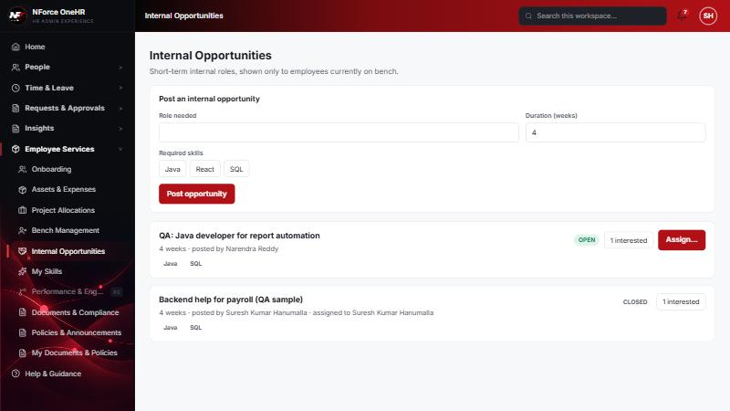

UT-591-02 - A failing step leaves nothing half-done (all-or-nothing)
Test ID | UT-591-02
Module | Workforce Availability & Bench Management / Internal Opportunities (Epic A <-> Epic B seam)
Class / Method | OpportunityService.close (@Transactional)
Scenario | A failing step leaves nothing half-done (all-or-nothing)
Steps | 1. Choose Chandrasekhar G, the QA project, capacity 100, and an END date before the start date  2. Click "Assign & close"  3. Check bench, allocations and the opportunity
Expected Result | An error is shown; the employee stays on bench, no allocation is created, the opportunity stays OPEN, and no audit entry is written.
Actual Result | "End date cannot be before start date" shown. Bench, allocations and opportunity unchanged. No audit entry was written for the failed attempt (this verified fix D4 live).
Tested as | HR Admin
Status | Pass (after fix D4)
Developer | Abuzar Siddiqui
Evidence (recorded response) | After the FAILED assignment attempt (end date before start date):  benched employees : ["Chandrasekhar G", "Test"] (Chandrasekhar still on bench)  Chandrasekhar's allocations on the project: none (no allocation created)  opportunity "QA: Java developer for report automation": OPEN, 1 interested (not closed)  After the SUCCESSFUL attempt:  benched employees : ["Test"] (bench ended)  Chandrasekhar's allocation: Bench QA Project (sample), 100%, 2026-10-13 -> 2026-12-31  opportunity: CLOSED, assigned to Chandrasekhar G  Audit: BENCH_STATUS_CHANGE (before/after with allocationId) and INTERNAL_OPPORTUNITY_CLOSED written once each, at 18:52 UTC.  No audit entry was written for the failed attempt.

Screenshot 2 - Failure message; panel still open
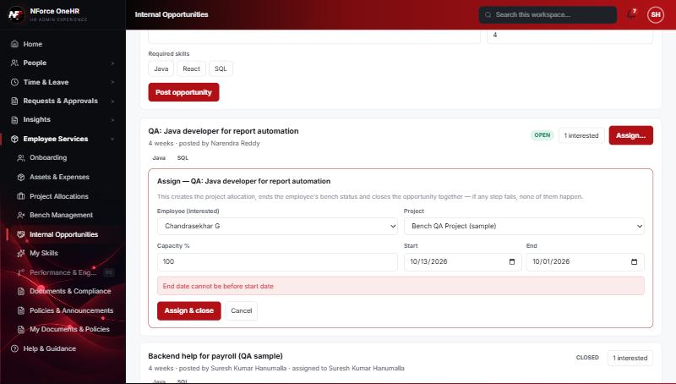

UT-591-03 - A valid assignment creates the allocation, ends the bench and closes the opportunity together
Test ID | UT-591-03
Module | Workforce Availability & Bench Management / Internal Opportunities (Epic A <-> Epic B seam)
Class / Method | OpportunityService.close -> ProjectAllocationService.allocate + BenchStatusService.endForAllocation
Scenario | A valid assignment creates the allocation, ends the bench and closes the opportunity together
Steps | 1. Correct the end date to 12/31/2026  2. Click "Assign & close"
Expected Result | Opportunity CLOSED and assigned; allocation exists; employee no longer on bench.
Actual Result | Opportunity shows CLOSED "assigned to Chandrasekhar G"; allocation 100% 2026-10-13 -> 2026-12-31 created; bench list no longer contains him.
Tested as | HR Admin
Status | Pass
Developer | Abuzar Siddiqui
Evidence (recorded response) | After the FAILED assignment attempt (end date before start date):  benched employees : ["Chandrasekhar G", "Test"] (Chandrasekhar still on bench)  Chandrasekhar's allocations on the project: none (no allocation created)  opportunity "QA: Java developer for report automation": OPEN, 1 interested (not closed)  After the SUCCESSFUL attempt:  benched employees : ["Test"] (bench ended)  Chandrasekhar's allocation: Bench QA Project (sample), 100%, 2026-10-13 -> 2026-12-31  opportunity: CLOSED, assigned to Chandrasekhar G  Audit: BENCH_STATUS_CHANGE (before/after with allocationId) and INTERNAL_OPPORTUNITY_CLOSED written once each, at 18:52 UTC.  No audit entry was written for the failed attempt.

Screenshot 3 - Opportunity closed and assigned
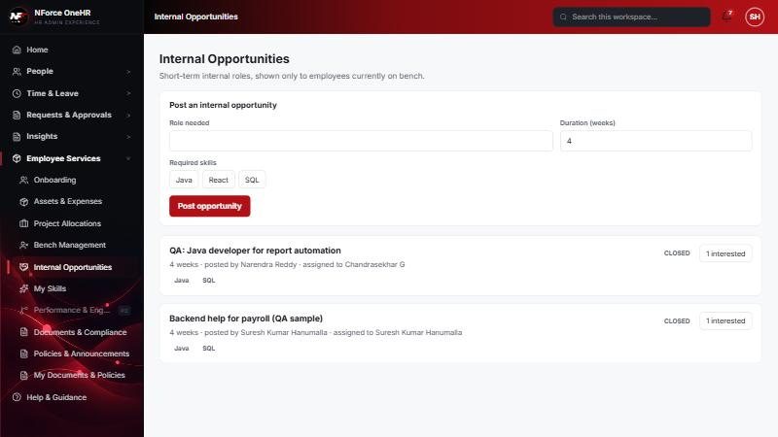

UT-591-04 - One bench-status-change event and one opportunity-closed event are audited, with before/after state
Test ID | UT-591-04
Module | Workforce Availability & Bench Management / Internal Opportunities (Epic A <-> Epic B seam)
Class / Method | AuditService.afterCommit
Scenario | One bench-status-change event and one opportunity-closed event are audited, with before/after state
Steps | 1. Open the audit entries after the successful assignment
Expected Result | One BENCH_STATUS_CHANGE (with allocationId) and one INTERNAL_OPPORTUNITY_CLOSED.
Actual Result | Both present once, written at 18:52 UTC.
Tested as | HR Admin
Status | Pass
Developer | Abuzar Siddiqui
Evidence (recorded response) | GET /api/audit-logs?action=BENCH_STATUS_CHANGE (as HR Admin) - entry written when Chandrasekhar's bench ended with an allocation:  actor: Suresh Kumar Hanumalla (HR Admin)  before: {"active": true, "endDate": null, "startDate": "2026-09-13", "reasonCode": "NEW_JOINER_UNALLOCATED", "closeReason": null, "allocationId": null}  after : {"active": false, "endDate": "2026-10-13", "startDate": "2026-09-13", "reasonCode": "NEW_JOINER_UNALLOCATED", "closeReason": null, "allocationId": "2ced7334-769b-4f92-b646-8c879f34c4a7"}  Entry written when Abbas was first marked on bench:  before: null  after : {"active": true, "endDate": null, "startDate": "2026-08-20", "reasonCode": "ROLE_ENDED", ...}

UT-591-05 - Only HR can close; empty bodies are a client error
Test ID | UT-591-05
Module | Workforce Availability & Bench Management / Internal Opportunities (Epic A <-> Epic B seam)
Class / Method | @PreAuthorize on OpportunityController.close; GlobalExceptionHandler
Scenario | Only HR can close; empty bodies are a client error
Steps | 1. As Employee and Manager call close  2. Call close with an empty body
Expected Result | 403 for non-HR; 400 for an empty body.
Actual Result | 403 / 403; empty body returned 500 on the first run (defect D5) and 400 after the fix.
Tested as | Employee, Manager
Status | Pass (after fix D5)
Developer | Abuzar Siddiqui
Evidence (recorded response) | Employee: POST /api/opportunities/{id}/close (valid body) -> 403 Access denied  Manager : POST /api/opportunities/{id}/close -> 403 Access denied  Empty body (any user): POST /api/opportunities/{id}/close -> 400 "Request body is missing or invalid" (was 500 before fix D5)

Defects found by this QA run (all fixed and re-tested)
D1 | Default start date was yesterday for users east of UTC (form used toISOString, i.e. UTC). Affected Mark on bench, Assign panel and the export file name.  Resolution: Fixed (todayLocal helper + unit test), re-verified in the browser.
D4 | A failed assign-and-close left a false "opportunity closed" audit entry (audit writes commit independently of a rolled-back transaction).  Resolution: Fixed - audit for compound operations is written only after commit (+ unit tests). Re-verified live: no entry for the failed attempt.
D5 | An invalid enum value (bench reason "VACATION"), an empty body or malformed JSON returned 500 instead of 400 (unreadable bodies were not mapped in GlobalExceptionHandler).  Resolution: Fixed globally with a 400 handler (+ unit test). Re-verified on three endpoints.

Notes
- Audit History is slow on this remote database: the first load took over a minute and the "Other" filter timed out once (the same query returned in 25 seconds when called directly). Existing behaviour, not caused by the bench changes.
- A request to a route that does not exist for that method (for example DELETE /api/bench-status/{id}) returns a generic 500 from the shared error handler rather than 404/405. Left unchanged because it is shared behaviour; the useful fact is that no delete route exists.
- The company policy-acknowledgement pop-up appears for the Manager and Employee accounts and blocks clicks until dismissed ("Remind Me Later" was used). Unrelated to the bench module.
- QA data left in the shared dev database (all named "QA sample"): 3 skills, 1 compensation band, 1 project, 4 allocations, 2 opportunities, bench history for five employees (all ended), and a "30+ days" notification to the Manager. The Manager's direct report Abbas DarubaiGari and the Employee test account Chandrasekhar G were used as test subjects.

