
NForce-OneHR
Unit Test Case - ONEHR-586 US-A07: Employee skills inventory with proficiency levels
Parent epic: ONEHR-577 - Workforce Availability & Bench Management
Tested: 13 October 2026
Environment: local run - frontend http://localhost:5180, backend http://localhost:8081 (Spring Boot, Java 22), shared dev database. Roles used: HR Admin (hradmin@nforceone.com), Manager (manager@nforceone.com), Employee (emponenforce@nforce.com).
Summary
Test cases | 8 total: 6 passed, 1 passed after a defect was found and fixed, 1 verified by unit test only, 0 not executed

UT-586-01 - Skills can only be chosen from the managed taxonomy (no free text)
Test ID | UT-586-01
Module | Workforce Availability & Bench Management / Skills
Class / Method | SkillController.taxonomy; SkillService; MySkillsPage
Scenario | Skills can only be chosen from the managed taxonomy (no free text)
Steps | 1. Sign in as Employee and open Employee Services > My Skills  2. Look at the Add a skill dropdown
Expected Result | A dropdown listing only the taxonomy skills (Java, React, SQL); no text box to type a skill.
Actual Result | Dropdown lists exactly Java, React and SQL (Engineering). There is no free-text field.
Tested as | Employee
Status | Pass
Developer | Abuzar Siddiqui

Screenshot 1 - My Skills - empty list, dropdown from taxonomy
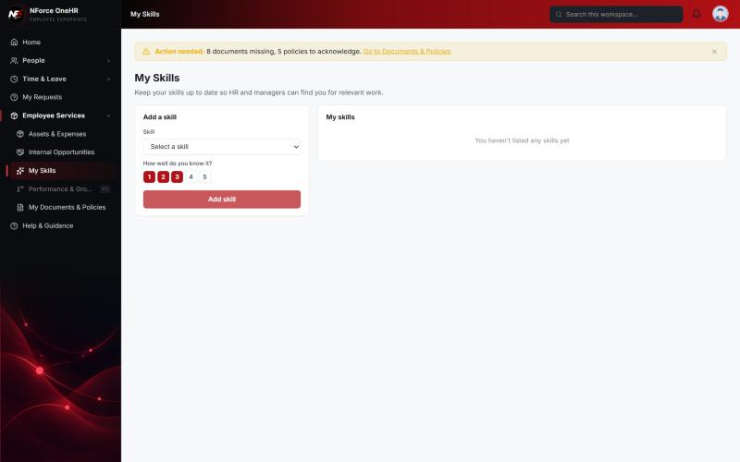

UT-586-02 - Employee self-rates 1-5
Test ID | UT-586-02
Module | Workforce Availability & Bench Management / Skills
Class / Method | SkillService.rateSelf
Scenario | Employee self-rates 1-5
Steps | 1. Select Java, click 4, Add skill  2. Select SQL, click 2, Add skill
Expected Result | Both skills appear with the chosen ratings; manager rating shows "Not rated".
Actual Result | Java 4/5 and SQL 2/5 listed, manager rating "Not rated".
Tested as | Employee
Status | Pass
Developer | Abuzar Siddiqui

Screenshot 2 - Java added
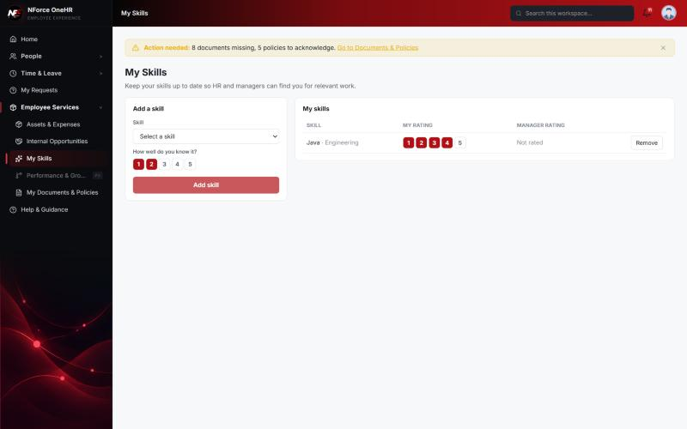
Screenshot 3 - Java 4/5 and SQL 2/5
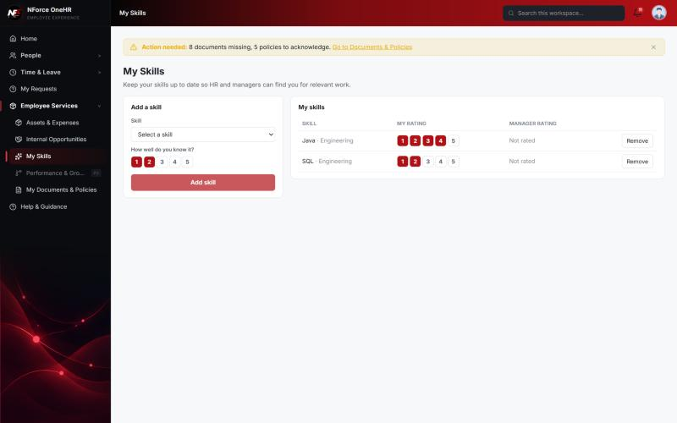

UT-586-03 - Ratings outside 1-5 are rejected
Test ID | UT-586-03
Module | Workforce Availability & Bench Management / Skills
Class / Method | RatingRequest validation
Scenario | Ratings outside 1-5 are rejected
Steps | 1. Send PUT /api/skill-ratings/me with rating 9
Expected Result | 400.
Actual Result | 400 "must be less than or equal to 5".
Tested as | Employee
Status | Pass
Developer | Abuzar Siddiqui
Evidence (recorded response) | Self-rating out of range: PUT /api/skill-ratings/me {"rating": 9} -> 400 "must be less than or equal to 5"  Employee rating own skill as a manager: PUT /api/skill-ratings/{me}/{skill}/manager?rating=5 -> 403 Access denied  Manager of someone else: PUT /api/skill-ratings/{Chandrasekhar}/{Java}/manager?rating=5 (as Manager Narendra Reddy) -> 403 Access denied  HR Admin override: PUT .../manager?rating=5 -> 200  Manager rating out of range (after fix D2): rating=9 -> 400 "Rating must be between 1 and 5"; rating=0 -> 400; rating=4 -> 200

UT-586-04 - HR / manager rating is shown to the employee next to their own rating
Test ID | UT-586-04
Module | Workforce Availability & Bench Management / Skills
Class / Method | SkillService.rateAsManager
Scenario | HR / manager rating is shown to the employee next to their own rating
Steps | 1. As HR Admin, set the manager rating for Chandrasekhar's Java to 5  2. As Employee reload My Skills
Expected Result | Java shows my rating 4 and manager rating 5; SQL still "Not rated".
Actual Result | As expected.
Tested as | HR Admin, Employee
Status | Pass
Developer | Abuzar Siddiqui

Screenshot 4 - Employee sees the manager rating
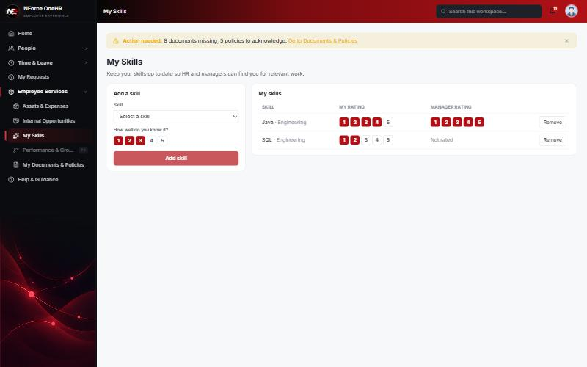

UT-586-05 - Only the employee's manager or HR may rate; an unrelated manager and the employee themselves cannot
Test ID | UT-586-05
Module | Workforce Availability & Bench Management / Skills
Class / Method | SkillService.rateAsManager (RBAC)
Scenario | Only the employee's manager or HR may rate; an unrelated manager and the employee themselves cannot
Steps | 1. As Manager Narendra Reddy, rate Chandrasekhar's Java (not his report)  2. As Employee, rate own skill through the manager endpoint
Expected Result | 403 in both cases.
Actual Result | 403 in both cases.
Tested as | Manager, Employee
Status | Pass
Developer | Abuzar Siddiqui
Evidence (recorded response) | Self-rating out of range: PUT /api/skill-ratings/me {"rating": 9} -> 400 "must be less than or equal to 5"  Employee rating own skill as a manager: PUT /api/skill-ratings/{me}/{skill}/manager?rating=5 -> 403 Access denied  Manager of someone else: PUT /api/skill-ratings/{Chandrasekhar}/{Java}/manager?rating=5 (as Manager Narendra Reddy) -> 403 Access denied  HR Admin override: PUT .../manager?rating=5 -> 200  Manager rating out of range (after fix D2): rating=9 -> 400 "Rating must be between 1 and 5"; rating=0 -> 400; rating=4 -> 200

UT-586-06 - A manager sees their team's skills section for endorsing
Test ID | UT-586-06
Module | Workforce Availability & Bench Management / Skills
Class / Method | SkillService.teamRatings; MySkillsPage
Scenario | A manager sees their team's skills section for endorsing
Steps | 1. Sign in as Manager and open My Skills
Expected Result | "My team's skills" section is present.
Actual Result | Section present; it is empty because none of this manager's direct reports has listed a skill. The positive path (the real manager endorsing their own report) was therefore NOT run live and is covered by the unit test rateAsManager_allowsTheEmployeesManager.
Tested as | Manager
Status | Pass (UI) / positive path unit test only
Developer | Abuzar Siddiqui

Screenshot 5 - Manager My Skills with team section
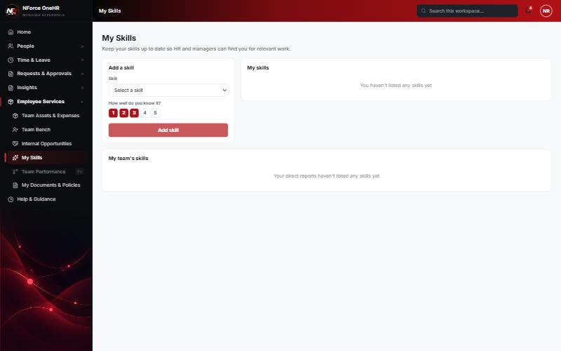

UT-586-07 - A manager rating outside 1-5 is a clean client error
Test ID | UT-586-07
Module | Workforce Availability & Bench Management / Skills
Class / Method | SkillService.rateAsManager (validation)
Scenario | A manager rating outside 1-5 is a clean client error
Steps | 1. As HR Admin, PUT .../manager?rating=9, rating=0, rating=4
Expected Result | 400, 400, 200.
Actual Result | First run returned 500 for 9 (defect D2: validation annotation on a request parameter was not mapped). Fixed in the service; after restart: 400, 400, 200.
Tested as | HR Admin
Status | Pass (after fix D2)
Developer | Abuzar Siddiqui
Evidence (recorded response) | Self-rating out of range: PUT /api/skill-ratings/me {"rating": 9} -> 400 "must be less than or equal to 5"  Employee rating own skill as a manager: PUT /api/skill-ratings/{me}/{skill}/manager?rating=5 -> 403 Access denied  Manager of someone else: PUT /api/skill-ratings/{Chandrasekhar}/{Java}/manager?rating=5 (as Manager Narendra Reddy) -> 403 Access denied  HR Admin override: PUT .../manager?rating=5 -> 200  Manager rating out of range (after fix D2): rating=9 -> 400 "Rating must be between 1 and 5"; rating=0 -> 400; rating=4 -> 200

UT-586-08 - HR Admin manages the taxonomy
Test ID | UT-586-08
Module | Workforce Availability & Bench Management / Skills
Class / Method | SkillController.addSkill; SettingsSection
Scenario | HR Admin manages the taxonomy
Steps | 1. As HR Admin add Java, SQL and React (Engineering) and open Settings
Expected Result | Skills are created and listed; non-HR users get 403.
Actual Result | Three skills created (201) and shown as chips in Settings; Employee POST to the taxonomy returns 403.
Tested as | HR Admin
Status | Pass
Developer | Abuzar Siddiqui
Evidence (recorded response) | Signed in as the Employee (Chandrasekhar G, role EMPLOYEE):  POST /api/bench-status -> 403 Access denied  GET /api/bench-status -> 403 Access denied  GET /api/bench-status/dashboard -> 403 Access denied  GET /api/bench-status/cost -> 403 Access denied  GET /api/bench-status/team -> 403 Access denied  PUT /api/bench-status/aging-config -> 403 Access denied  POST /api/skill-taxonomy -> 403 Access denied  POST /api/opportunities -> 403 Access denied  GET /api/compensation-bands -> 403 Access denied  GET /api/opportunities -> 200 [] (employee was not on bench at the time)

Screenshot 6 - Skill taxonomy in Settings
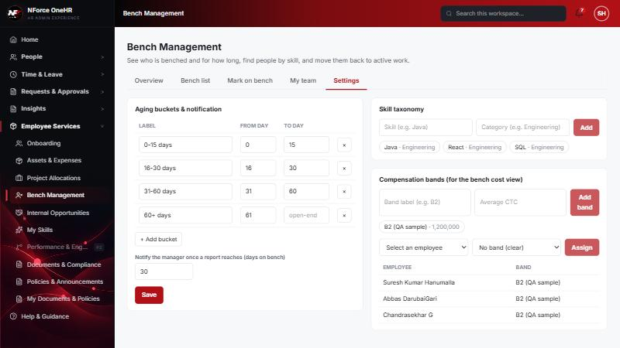

Defects found by this QA run (all fixed and re-tested)
D2 | Manager rating outside 1-5 returned 500 instead of 400 (validation annotation on a request parameter was not mapped).  Resolution: Fixed in SkillService (+ unit test); re-verified: 400, 400, 200.

Notes
- Audit History is slow on this remote database: the first load took over a minute and the "Other" filter timed out once (the same query returned in 25 seconds when called directly). Existing behaviour, not caused by the bench changes.
- A request to a route that does not exist for that method (for example DELETE /api/bench-status/{id}) returns a generic 500 from the shared error handler rather than 404/405. Left unchanged because it is shared behaviour; the useful fact is that no delete route exists.
- The company policy-acknowledgement pop-up appears for the Manager and Employee accounts and blocks clicks until dismissed ("Remind Me Later" was used). Unrelated to the bench module.
- QA data left in the shared dev database (all named "QA sample"): 3 skills, 1 compensation band, 1 project, 4 allocations, 2 opportunities, bench history for five employees (all ended), and a "30+ days" notification to the Manager. The Manager's direct report Abbas DarubaiGari and the Employee test account Chandrasekhar G were used as test subjects.

