
NForce-OneHR
Unit Test Case - ONEHR-587 US-A08: Search benched employees by skill
Parent epic: ONEHR-577 - Workforce Availability & Bench Management
Tested: 13 October 2026
Environment: local run - frontend http://localhost:5180, backend http://localhost:8081 (Spring Boot, Java 22), shared dev database. Roles used: HR Admin (hradmin@nforceone.com), Manager (manager@nforceone.com), Employee (emponenforce@nforce.com).
Summary
Test cases | 5 total: 5 passed, 0 passed after a defect was found and fixed, 0 verified by unit test only, 0 not executed

UT-587-01 - Search by one skill
Test ID | UT-587-01
Module | Workforce Availability & Bench Management / Bench Search
Class / Method | BenchReportService.list (GET /api/bench-status?skillIds=...); BenchListSection
Scenario | Search by one skill
Steps | 1. Bench list > click the "Java" chip
Expected Result | Only benched employees who have Java, with a match score and their skills.
Actual Result | Only Chandrasekhar G: 30 days, bucket 16-30, match 1/1, skills "Java (4/5), SQL (2/5)".
Tested as | HR Admin
Status | Pass
Developer | Abuzar Siddiqui

Screenshot 1 - Java filter
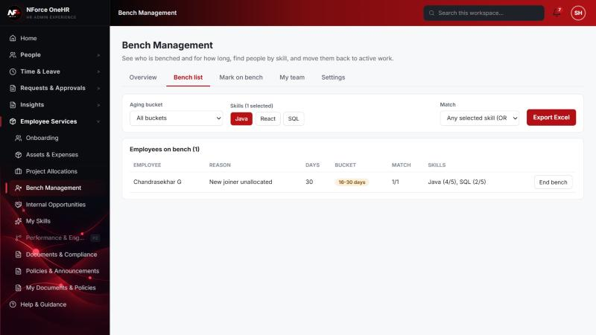

UT-587-02 - Multi-skill search with OR (any selected skill)
Test ID | UT-587-02
Module | Workforce Availability & Bench Management / Bench Search
Class / Method | BenchReportService.list (OR)
Scenario | Multi-skill search with OR (any selected skill)
Steps | 1. Select Java and React  2. Match = "Any selected skill (OR)"
Expected Result | Employees with at least one of the skills; match score shows how many.
Actual Result | Chandrasekhar G with match 1/2.
Tested as | HR Admin
Status | Pass
Developer | Abuzar Siddiqui

Screenshot 2 - OR search
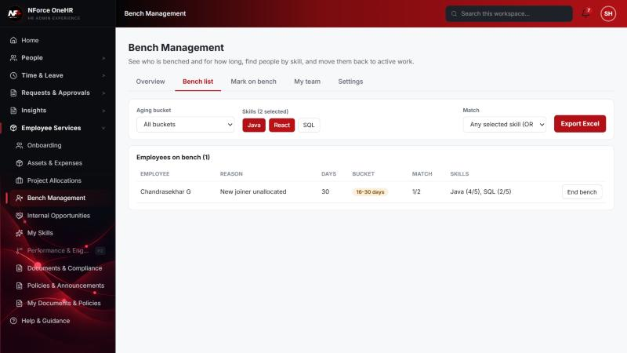

UT-587-03 - Multi-skill search with AND (all selected skills)
Test ID | UT-587-03
Module | Workforce Availability & Bench Management / Bench Search
Class / Method | BenchReportService.list (AND)
Scenario | Multi-skill search with AND (all selected skills)
Steps | 1. Keep Java and React selected  2. Change Match to "All selected skills (AND)"
Expected Result | Only employees with both; nobody on bench has React, so none.
Actual Result | "No benched employees match these filters".
Tested as | HR Admin
Status | Pass
Developer | Abuzar Siddiqui

Screenshot 3 - AND search - no matches
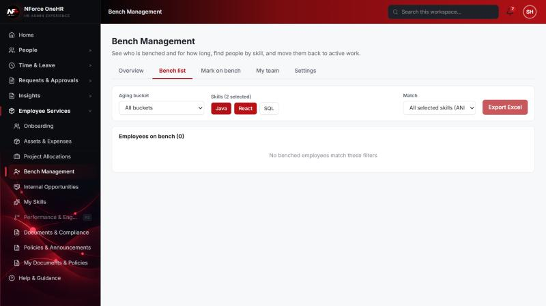

UT-587-04 - Results show bench duration with the skill match, longest-idle first
Test ID | UT-587-04
Module | Workforce Availability & Bench Management / Bench Search
Class / Method | BenchReportService.list (ordering)
Scenario | Results show bench duration with the skill match, longest-idle first
Steps | 1. Clear the filters and read the order of the full list
Expected Result | Sorted by days on bench descending (then match score).
Actual Result | 54, 30, 23 days in that order; the Days and Match columns are side by side.
Tested as | HR Admin
Status | Pass
Developer | Abuzar Siddiqui

Screenshot 4 - Ordered by days on bench
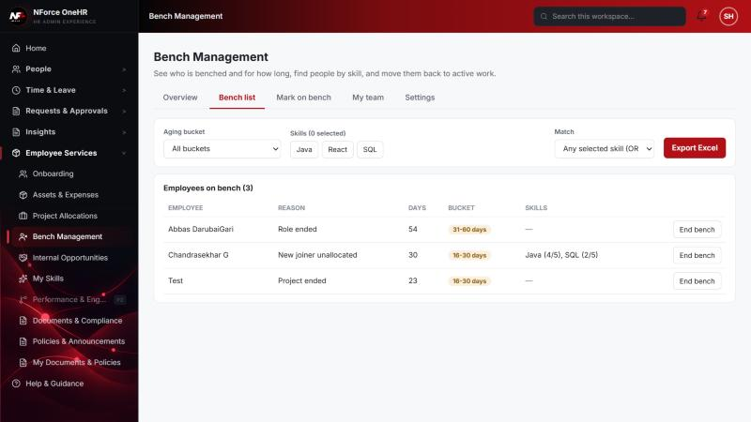

UT-587-05 - Employees and managers cannot search the bench
Test ID | UT-587-05
Module | Workforce Availability & Bench Management / Bench Search
Class / Method | @PreAuthorize on BenchStatusController.list
Scenario | Employees and managers cannot search the bench
Steps | 1. Call GET /api/bench-status as Employee and as Manager
Expected Result | 403.
Actual Result | 403 for both.
Tested as | Employee, Manager
Status | Pass
Developer | Abuzar Siddiqui
Evidence (recorded response) | Signed in as the Employee (Chandrasekhar G, role EMPLOYEE):  POST /api/bench-status -> 403 Access denied  GET /api/bench-status -> 403 Access denied  GET /api/bench-status/dashboard -> 403 Access denied  GET /api/bench-status/cost -> 403 Access denied  GET /api/bench-status/team -> 403 Access denied  PUT /api/bench-status/aging-config -> 403 Access denied  POST /api/skill-taxonomy -> 403 Access denied  POST /api/opportunities -> 403 Access denied  GET /api/compensation-bands -> 403 Access denied  GET /api/opportunities -> 200 [] (employee was not on bench at the time)

Notes
- Audit History is slow on this remote database: the first load took over a minute and the "Other" filter timed out once (the same query returned in 25 seconds when called directly). Existing behaviour, not caused by the bench changes.
- A request to a route that does not exist for that method (for example DELETE /api/bench-status/{id}) returns a generic 500 from the shared error handler rather than 404/405. Left unchanged because it is shared behaviour; the useful fact is that no delete route exists.
- The company policy-acknowledgement pop-up appears for the Manager and Employee accounts and blocks clicks until dismissed ("Remind Me Later" was used). Unrelated to the bench module.
- QA data left in the shared dev database (all named "QA sample"): 3 skills, 1 compensation band, 1 project, 4 allocations, 2 opportunities, bench history for five employees (all ended), and a "30+ days" notification to the Manager. The Manager's direct report Abbas DarubaiGari and the Employee test account Chandrasekhar G were used as test subjects.

