
NForce-OneHR
Unit Test Case - ONEHR-590 US-A11: Express interest in an open internal opportunity
Parent epic: ONEHR-577 - Workforce Availability & Bench Management
Tested: 13 October 2026
Environment: local run - frontend http://localhost:5180, backend http://localhost:8081 (Spring Boot, Java 22), shared dev database. Roles used: HR Admin (hradmin@nforceone.com), Manager (manager@nforceone.com), Employee (emponenforce@nforce.com).
Summary
Test cases | 4 total: 4 passed, 0 passed after a defect was found and fixed, 0 verified by unit test only, 0 not executed

UT-590-01 - A benched employee expresses interest
Test ID | UT-590-01
Module | Workforce Availability & Bench Management / Internal Opportunities
Class / Method | OpportunityController.expressInterest (POST /api/opportunities/{id}/interest)
Scenario | A benched employee expresses interest
Steps | 1. As the benched Employee click "I'm interested"
Expected Result | The button changes to "Interest sent" and is disabled.
Actual Result | Button became "Interest sent" (disabled).
Tested as | Employee
Status | Pass
Developer | Abuzar Siddiqui

Screenshot 1 - Before - "I'm interested"
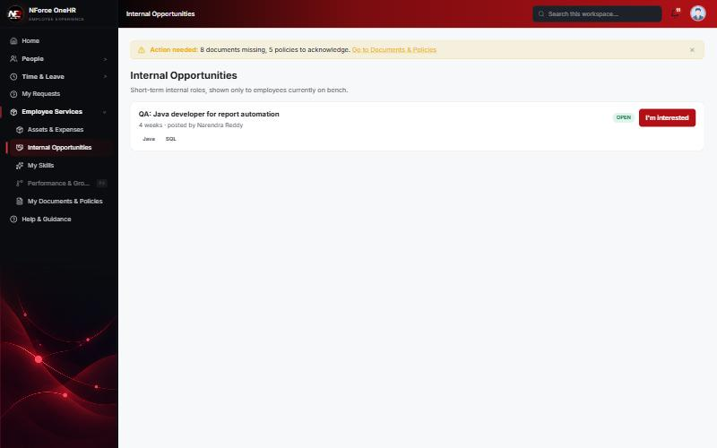
Screenshot 2 - After - "Interest sent"
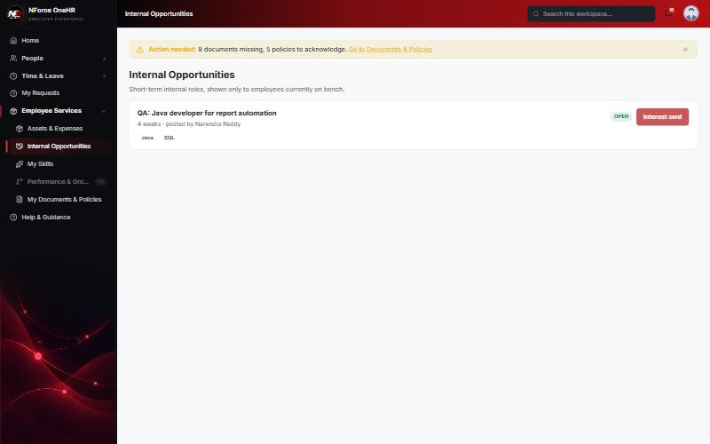

UT-590-02 - Only one active interest per opportunity per employee
Test ID | UT-590-02
Module | Workforce Availability & Bench Management / Internal Opportunities
Class / Method | OpportunityInterest unique (opportunityId, employeeId)
Scenario | Only one active interest per opportunity per employee
Steps | 1. Send the interest request again
Expected Result | Refused.
Actual Result | 409 "You have already expressed interest in this opportunity".
Tested as | Employee
Status | Pass
Developer | Abuzar Siddiqui
Evidence (recorded response) | Signed in as the Employee, already interested:  POST /api/opportunities/{id}/interest -> 409 "You have already expressed interest in this opportunity"  GET /api/opportunities/{id}/interests -> 403 Access denied (employees cannot see who else is interested)  After the employee was assigned and is no longer on bench:  GET /api/opportunities -> 200 [] (opportunities are hidden once not on bench)  POST /api/opportunities/{id}/interest -> 409 "Only employees currently on bench can express interest"

UT-590-03 - The person who posted the opportunity is notified
Test ID | UT-590-03
Module | Workforce Availability & Bench Management / Internal Opportunities
Class / Method | NotificationService.send (OPPORTUNITY_INTEREST)
Scenario | The person who posted the opportunity is notified
Steps | 1. Sign in as the Manager (the poster) and open Notifications
Expected Result | A notification naming the employee and the opportunity.
Actual Result | "Interest in your opportunity - Chandrasekhar G is interested in "QA: Java developer ..."".
Tested as | Manager
Status | Pass
Developer | Abuzar Siddiqui

Screenshot 3 - Poster notified
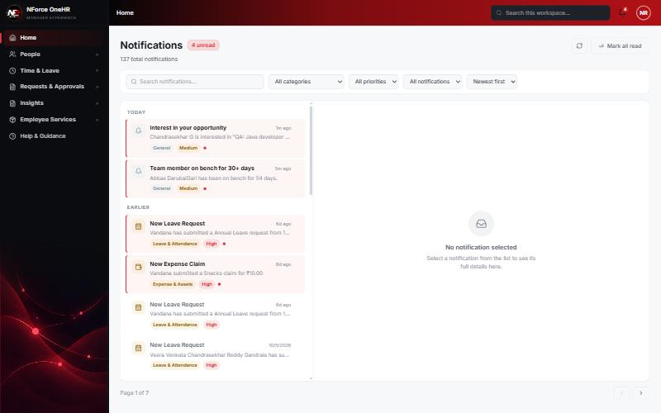

UT-590-04 - An employee who is not on bench cannot express interest; employees cannot see who else is interested
Test ID | UT-590-04
Module | Workforce Availability & Bench Management / Internal Opportunities
Class / Method | OpportunityService.expressInterest
Scenario | An employee who is not on bench cannot express interest; employees cannot see who else is interested
Steps | 1. After the employee is assigned (no longer on bench) request interest again  2. As Employee request the interested list
Expected Result | Refused / 403.
Actual Result | 409 "Only employees currently on bench can express interest"; interested list returns 403.
Tested as | Employee
Status | Pass
Developer | Abuzar Siddiqui
Evidence (recorded response) | Signed in as the Employee, already interested:  POST /api/opportunities/{id}/interest -> 409 "You have already expressed interest in this opportunity"  GET /api/opportunities/{id}/interests -> 403 Access denied (employees cannot see who else is interested)  After the employee was assigned and is no longer on bench:  GET /api/opportunities -> 200 [] (opportunities are hidden once not on bench)  POST /api/opportunities/{id}/interest -> 409 "Only employees currently on bench can express interest"

Notes
- Audit History is slow on this remote database: the first load took over a minute and the "Other" filter timed out once (the same query returned in 25 seconds when called directly). Existing behaviour, not caused by the bench changes.
- A request to a route that does not exist for that method (for example DELETE /api/bench-status/{id}) returns a generic 500 from the shared error handler rather than 404/405. Left unchanged because it is shared behaviour; the useful fact is that no delete route exists.
- The company policy-acknowledgement pop-up appears for the Manager and Employee accounts and blocks clicks until dismissed ("Remind Me Later" was used). Unrelated to the bench module.
- QA data left in the shared dev database (all named "QA sample"): 3 skills, 1 compensation band, 1 project, 4 allocations, 2 opportunities, bench history for five employees (all ended), and a "30+ days" notification to the Manager. The Manager's direct report Abbas DarubaiGari and the Employee test account Chandrasekhar G were used as test subjects.

