
NForce-OneHR
Unit Test Case - ONEHR-592 US-A13: Aggregate bench cost view (banded CTC, no individual salary)
Parent epic: ONEHR-577 - Workforce Availability & Bench Management
Tested: 13 October 2026
Environment: local run - frontend http://localhost:5180, backend http://localhost:8081 (Spring Boot, Java 22), shared dev database. Roles used: HR Admin (hradmin@nforceone.com), Manager (manager@nforceone.com), Employee (emponenforce@nforce.com).
Summary
Test cases | 5 total: 5 passed, 0 passed after a defect was found and fixed, 0 verified by unit test only, 0 not executed

UT-592-01 - HR Admin creates a compensation band and assigns employees to it
Test ID | UT-592-01
Module | Workforce Availability & Bench Management / Cost view
Class / Method | CompensationBandController/Service; SettingsSection
Scenario | HR Admin creates a compensation band and assigns employees to it
Steps | 1. Settings > Compensation bands: add "B2 (QA sample)" with average CTC 1,200,000  2. Assign Abbas DarubaiGari and Chandrasekhar G to B2
Expected Result | The band is listed; assignments table shows employee and band label only.
Actual Result | Band chip "B2 (QA sample) - 1,200,000"; Assignments list shows Suresh Kumar Hanumalla, Abbas DarubaiGari and Chandrasekhar G - B2.
Tested as | HR Admin
Status | Pass
Developer | Abuzar Siddiqui

Screenshot 1 - Band assigned in the UI
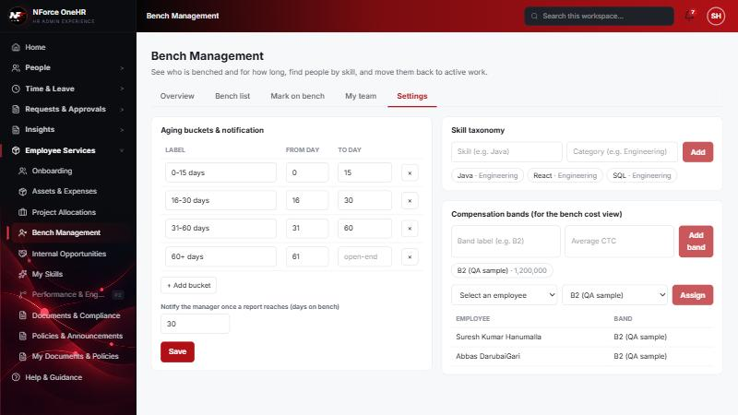
Screenshot 2 - Bands and assignments
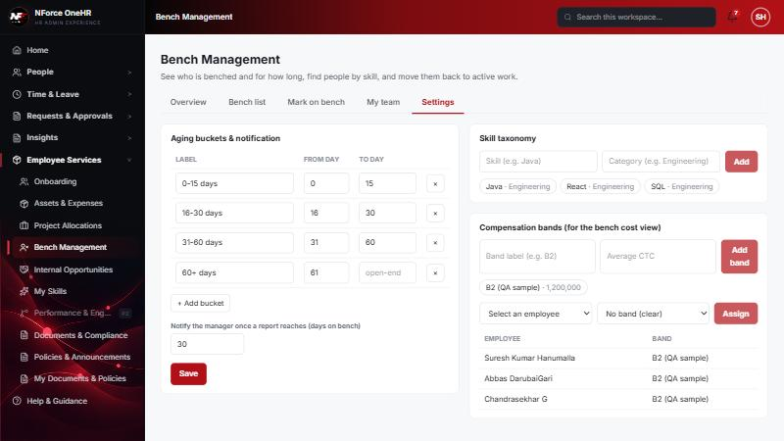

UT-592-02 - Cost = benched headcount per band x the band's average CTC
Test ID | UT-592-02
Module | Workforce Availability & Bench Management / Cost view
Class / Method | BenchReportService.cost (GET /api/bench-status/cost)
Scenario | Cost = benched headcount per band x the band's average CTC
Steps | 1. With Abbas, Chandrasekhar (both B2) and Test (no band) on bench, open Overview > Aggregate bench cost
Expected Result | B2: 2 benched x 1,200,000 = 2,400,000 total.
Actual Result | Row "B2 (QA sample) - 2 - 1,200,000 - 2,400,000"; Total 2,400,000.
Tested as | HR Admin
Status | Pass
Developer | Abuzar Siddiqui
Evidence (recorded response) | GET /api/bench-status/cost (HR Admin):  {"rows":[{"bandLabel":"B2 (QA sample)","benchedCount":2,"avgCtc":1200000.00,"totalCost":2400000.00}],"totalCost":2400000.00,"unbandedCount":1}  -> only band labels, counts and band averages; no employee name, id or individual salary field exists in the response.

Screenshot 3 - Cost view
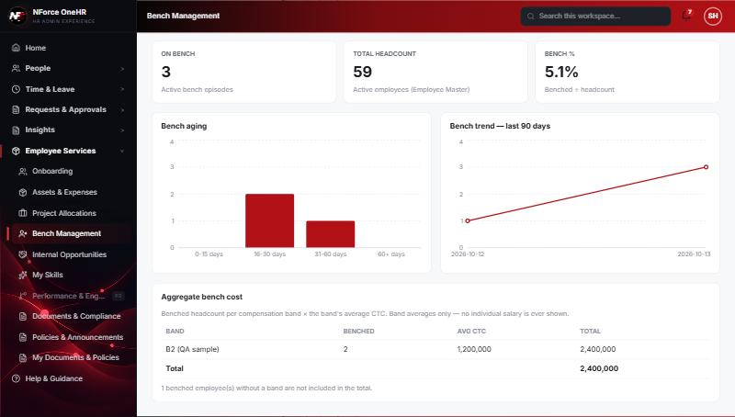

UT-592-03 - Employees without a band are not costed and are flagged
Test ID | UT-592-03
Module | Workforce Availability & Bench Management / Cost view
Class / Method | BenchReportService.cost (unbanded)
Scenario | Employees without a band are not costed and are flagged
Steps | 1. Read the note under the table
Expected Result | A note saying how many benched employees are not included.
Actual Result | "1 benched employee(s) without a band are not included in the total."
Tested as | HR Admin
Status | Pass
Developer | Abuzar Siddiqui

Screenshot 4 - Unbanded note

UT-592-04 - No individual salary or per-employee figure is ever exposed
Test ID | UT-592-04
Module | Workforce Availability & Bench Management / Cost view
Class / Method | BenchCost DTO
Scenario | No individual salary or per-employee figure is ever exposed
Steps | 1. Inspect the cost API response
Expected Result | Only band-level aggregates.
Actual Result | Response has bandLabel, benchedCount, avgCtc, totalCost and unbandedCount only. The bands store a label and an average, never a person's pay; this is not joined to any individual compensation data.
Tested as | HR Admin
Status | Pass
Developer | Abuzar Siddiqui
Evidence (recorded response) | GET /api/bench-status/cost (HR Admin):  {"rows":[{"bandLabel":"B2 (QA sample)","benchedCount":2,"avgCtc":1200000.00,"totalCost":2400000.00}],"totalCost":2400000.00,"unbandedCount":1}  -> only band labels, counts and band averages; no employee name, id or individual salary field exists in the response.

UT-592-05 - Employees and managers cannot see the cost view or the bands
Test ID | UT-592-05
Module | Workforce Availability & Bench Management / Cost view
Class / Method | @PreAuthorize
Scenario | Employees and managers cannot see the cost view or the bands
Steps | 1. Call /api/bench-status/cost and /api/compensation-bands as Employee and Manager
Expected Result | 403.
Actual Result | 403 for both.
Tested as | Employee, Manager
Status | Pass
Developer | Abuzar Siddiqui
Evidence (recorded response) | Signed in as the Employee (Chandrasekhar G, role EMPLOYEE):  POST /api/bench-status -> 403 Access denied  GET /api/bench-status -> 403 Access denied  GET /api/bench-status/dashboard -> 403 Access denied  GET /api/bench-status/cost -> 403 Access denied  GET /api/bench-status/team -> 403 Access denied  PUT /api/bench-status/aging-config -> 403 Access denied  POST /api/skill-taxonomy -> 403 Access denied  POST /api/opportunities -> 403 Access denied  GET /api/compensation-bands -> 403 Access denied  GET /api/opportunities -> 200 [] (employee was not on bench at the time)

Notes
- Audit History is slow on this remote database: the first load took over a minute and the "Other" filter timed out once (the same query returned in 25 seconds when called directly). Existing behaviour, not caused by the bench changes.
- A request to a route that does not exist for that method (for example DELETE /api/bench-status/{id}) returns a generic 500 from the shared error handler rather than 404/405. Left unchanged because it is shared behaviour; the useful fact is that no delete route exists.
- The company policy-acknowledgement pop-up appears for the Manager and Employee accounts and blocks clicks until dismissed ("Remind Me Later" was used). Unrelated to the bench module.
- QA data left in the shared dev database (all named "QA sample"): 3 skills, 1 compensation band, 1 project, 4 allocations, 2 opportunities, bench history for five employees (all ended), and a "30+ days" notification to the Manager. The Manager's direct report Abbas DarubaiGari and the Employee test account Chandrasekhar G were used as test subjects.

