
NForce-OneHR
Unit Test Case - ONEHR-593 US-A14: Audit log for all bench status changes
Parent epic: ONEHR-577 - Workforce Availability & Bench Management
Tested: 13 October 2026
Environment: local run - frontend http://localhost:5180, backend http://localhost:8081 (Spring Boot, Java 22), shared dev database. Roles used: HR Admin (hradmin@nforceone.com), Manager (manager@nforceone.com), Employee (emponenforce@nforce.com).
Summary
Test cases | 5 total: 2 passed, 2 passed after a defect was found and fixed, 0 verified by unit test only, 1 not executed

UT-593-01 - Marking and ending bench both write to the existing audit log with before/after state
Test ID | UT-593-01
Module | Workforce Availability & Bench Management / Audit
Class / Method | BenchStatusService.start/close -> AuditService.log
Scenario | Marking and ending bench both write to the existing audit log with before/after state
Steps | 1. Mark Abbas on bench, then end his bench with an allocation  2. Read GET /api/audit-logs?action=BENCH_STATUS_CHANGE
Expected Result | Two entries: create (before null, after active) and end (before active, after ended with endDate and allocationId).
Actual Result | Both present with the expected JSON.
Tested as | HR Admin
Status | Pass
Developer | Abuzar Siddiqui
Evidence (recorded response) | GET /api/audit-logs?action=BENCH_STATUS_CHANGE (as HR Admin) - entry written when Chandrasekhar's bench ended with an allocation:  actor: Suresh Kumar Hanumalla (HR Admin)  before: {"active": true, "endDate": null, "startDate": "2026-09-13", "reasonCode": "NEW_JOINER_UNALLOCATED", "closeReason": null, "allocationId": null}  after : {"active": false, "endDate": "2026-10-13", "startDate": "2026-09-13", "reasonCode": "NEW_JOINER_UNALLOCATED", "closeReason": null, "allocationId": "2ced7334-769b-4f92-b646-8c879f34c4a7"}  Entry written when Abbas was first marked on bench:  before: null  after : {"active": true, "endDate": null, "startDate": "2026-08-20", "reasonCode": "ROLE_ENDED", ...}

UT-593-02 - Entries appear on the existing Audit History page with the affected employee
Test ID | UT-593-02
Module | Workforce Availability & Bench Management / Audit
Class / Method | AuditActionCategory (HR_OPERATIONAL) / Audit History page
Scenario | Entries appear on the existing Audit History page with the affected employee
Steps | 1. Open Insights > Audit History
Expected Result | "Bench Status Change" / "Internal Opportunity Closed" rows with the employee name in "Affected user".
Actual Result | First run showed raw ids (defect D3: the bench record id was used as the target). Fixed so the target is the employee; the new row shows "Test".
Tested as | HR Admin
Status | Pass (after fix D3)
Developer | Abuzar Siddiqui

Screenshot 1 - Before fix - affected user shown as ids
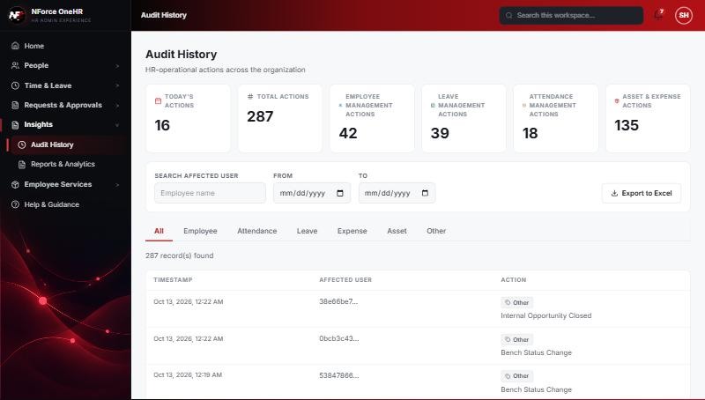
Screenshot 2 - After fix - "Test" shown
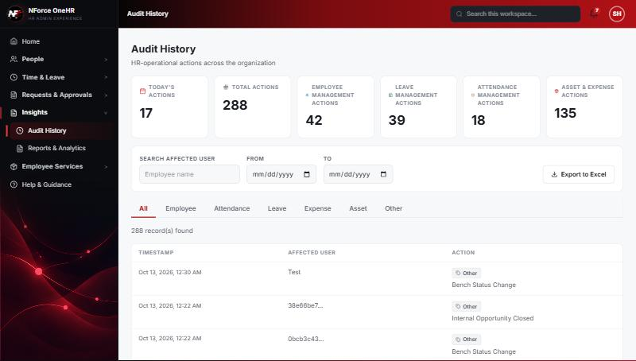

UT-593-03 - A failed compound operation leaves no audit entry
Test ID | UT-593-03
Module | Workforce Availability & Bench Management / Audit
Class / Method | AuditService.afterCommit
Scenario | A failed compound operation leaves no audit entry
Steps | 1. Attempt the invalid assignment (end before start)  2. Look for new audit rows
Expected Result | No new entries.
Actual Result | None written. (The first run before fix D4 had left a false "opportunity closed" entry; the older entry remains in the log.)
Tested as | HR Admin
Status | Pass (after fix D4)
Developer | Abuzar Siddiqui
Evidence (recorded response) | After the FAILED assignment attempt (end date before start date):  benched employees : ["Chandrasekhar G", "Test"] (Chandrasekhar still on bench)  Chandrasekhar's allocations on the project: none (no allocation created)  opportunity "QA: Java developer for report automation": OPEN, 1 interested (not closed)  After the SUCCESSFUL attempt:  benched employees : ["Test"] (bench ended)  Chandrasekhar's allocation: Bench QA Project (sample), 100%, 2026-10-13 -> 2026-12-31  opportunity: CLOSED, assigned to Chandrasekhar G  Audit: BENCH_STATUS_CHANGE (before/after with allocationId) and INTERNAL_OPPORTUNITY_CLOSED written once each, at 18:52 UTC.  No audit entry was written for the failed attempt.

UT-593-04 - Reuses the existing audit mechanism
Test ID | UT-593-04
Module | Workforce Availability & Bench Management / Audit
Class / Method | AuditLog (no new mechanism)
Scenario | Reuses the existing audit mechanism
Steps | 1. Compare with other HR actions in Audit History
Expected Result | Same table, API, page and categories; no bench-specific audit store.
Actual Result | Confirmed: entries are ordinary audit_log rows shown on the same page, in the "Other" group.
Tested as | HR Admin
Status | Pass
Developer | Abuzar Siddiqui

Screenshot 3 - Same Audit History page

UT-593-05 - Super Admin sees bench entries
Test ID | UT-593-05
Module | Workforce Availability & Bench Management / Audit
Class / Method | Super Admin audit view
Scenario | Super Admin sees bench entries
Steps | 1. Sign in as Super Admin and open Audit & Security
Expected Result | Entries visible.
Actual Result | NOT EXECUTED - no Super Admin login was provided. The entries are classified HR_OPERATIONAL, which both HR Admin and Super Admin can see.
Tested as | Super Admin
Status | Not executed
Developer | Abuzar Siddiqui

Defects found by this QA run (all fixed and re-tested)
D3 | Audit History showed the bench record id as the "affected user" instead of the employee.  Resolution: Fixed - audit target is now the employee; record ids travel in the audit state. Re-verified.
D4 | A failed assign-and-close left a false "opportunity closed" audit entry (audit writes commit independently of a rolled-back transaction).  Resolution: Fixed - audit for compound operations is written only after commit (+ unit tests). Re-verified live: no entry for the failed attempt.

Notes
- Audit History is slow on this remote database: the first load took over a minute and the "Other" filter timed out once (the same query returned in 25 seconds when called directly). Existing behaviour, not caused by the bench changes.
- A request to a route that does not exist for that method (for example DELETE /api/bench-status/{id}) returns a generic 500 from the shared error handler rather than 404/405. Left unchanged because it is shared behaviour; the useful fact is that no delete route exists.
- The company policy-acknowledgement pop-up appears for the Manager and Employee accounts and blocks clicks until dismissed ("Remind Me Later" was used). Unrelated to the bench module.
- QA data left in the shared dev database (all named "QA sample"): 3 skills, 1 compensation band, 1 project, 4 allocations, 2 opportunities, bench history for five employees (all ended), and a "30+ days" notification to the Manager. The Manager's direct report Abbas DarubaiGari and the Employee test account Chandrasekhar G were used as test subjects.

