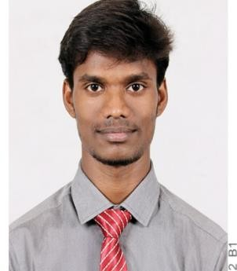**VIGNESH ARVIN .G**

**Summary**

Specializing in Web application development and performance optimization with 2.6 years of experience in Java, Spring Boot, Angular 2+, HTML, and CSS. My main interest is in web development and regular contribution to system enhancement.

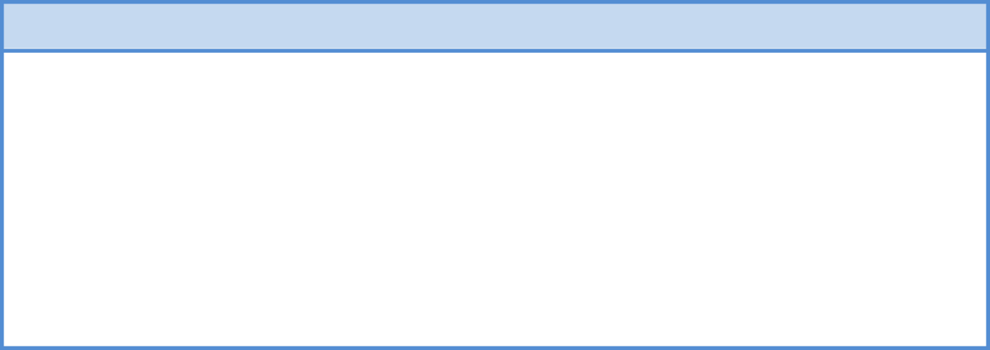

**Education**

**2015 – 19 Kumaraguru College of Technology, Coimbatore.**

Anna University Affiliated.

B.E. Electrical and Electronics Engineering

**2014 – 15 Sri Vidya Mandir Higher Secondary School**, Palacode.

HSC

**2013**

**D.D.C.S.M.Matriculation School,** Palacode. SSLC

\



**Technical Skills & Certification**

**Programming :** Java, C Basics, Angular 2+, MongoDB, SQL  
**Tools :** Jmeter, JProfiler, VisualVM

**Framework :** Angular & Spring Boot, Hibernate

**Certification :** Completed a Udemy course on Full Stack: Angular and Java Spring Boot

**Certificate URL :** <https://www.udemy.com/certificate/UC-94a14df6-4e51-4a97-a6c3-30bf51fd64ca/>

\



|  |  |  |
| --- | --- | --- |
| **Work Experience**  **Cognizant Technology Solutions:** From May 28, 2019 to June 14, 2021(2 Years),   * *Programmer Analyst* specializing in Resilience & Reliability Engineering. * Developed Web Application using Angular 7 and Spring Boot framework (FSD). * Developed Jmeter Script for Web Applications. Ability to Design, Develop and Execute automated Performance/load Test for Web Applications with Jmeter script. * Ability to debug code and make modifications as per requirement and solved Performance related issues in application with better understanding of Performance metrics like GC, Heap dump & Thread dump.   **Netcracker:** From Jun 17, 2021 to still working,   * *Software Engineer* specializing in full stack development, implementing enhancements, additional feature development dev tasks.   **Personal Details** | | |
| EMAIL-ID | : | [arvin.vignesh@gmail.com](mailto:arvin.vignesh@gmail.com) |
| MOBILE NUMBER | : | +91 9600914154 |
| LANGUAGES | : | Tamil, English. |
| DATE OF BIRTH | : | 19/10/1997 |
| ADDRESS | : | 3/396, Sugar Mill, Palacode, Dharmapuri, Tamil Nadu |
|  |  | Pin : 636 808 |
|  |  |  |

**Declaration:** I hereby declare that the above-mentioned information are true to the best of my knowledge and I bear the responsibility for the correctness of the above-mentioned particulars.

**Place**: Chennai **Signature**

**Date**: (VIGNESH ARVIN.G)