IT ASSET TRACKER
AssetSphere — Comprehensive Technical & Functional Documentation
Version 1.0 | July 2026

Prepared for: Internal Review

Table of Contents
1. Project Overview
2. Technology Stack
3. System Architecture
4. Project Structure
5. Authentication & Authorisation
6. Database Design
7. Backend API – Modules & Endpoints
8. Frontend – Pages & Screens
9. Role-Based Access Control (RBAC)
10. Application Flow Walkthrough
11. SAP BTP Deployment
12. Environment Variables
13. Testing
14. Demo Credentials
15. Screenshots

1. Project Overview
IT Asset Tracker (branded as "AssetSphere") is a full-stack enterprise web application designed to centralise the lifecycle management of all IT hardware and software assets within an organisation. It supports real-time inventory tracking, role-based access control, asset assignment, and service history recording.

Key capabilities:
- Maintain a complete, searchable inventory of IT assets (laptops, monitors, peripherals, software licences, etc.)
- Assign assets to employees and track who holds what equipment at any point in time
- Log and review maintenance / service records for each asset
- Manage asset categories to organise the inventory
- Role-based dashboards tailored to Admin, Asset Manager, and User personas
- Dual authentication support: local JWT (development/mock mode) and SAP XSUAA (production / BTP mode)
- Ready for cloud deployment on SAP Business Technology Platform (BTP) via Cloud Foundry

Application Name: AssetSphere / IT Asset Tracker
Development Type: Full-stack Web Application
Backend Tests: 6 / 6 passed
Build Status: Production build completed successfully

2. Technology Stack

2.1 Frontend
Technology | Version | Purpose
React | 18.3.1 | UI component library
Vite | 7.x | Build tool & dev server
React Router DOM | 6.21.1 | Client-side routing & protected routes
Axios | 1.7.3 | HTTP client for API calls
Vanilla CSS | Custom | Styling & responsive layout (styles.css)

2.2 Backend
Technology | Version | Purpose
Node.js | 18+ (ESM) | JavaScript runtime
Express.js | 4.21.2 | REST API framework
jsonwebtoken | 9.0.2 | JWT creation & verification
bcryptjs | 2.4.3 | Password hashing
@sap/xssec | 4.13.3 | SAP XSUAA token validation
pg (node-postgres) | 8.5.0 | PostgreSQL client
express-validator | 7.0.1 | Request input validation
helmet | 8.1.1 | HTTP security headers
cors | 2.8.5 | Cross-Origin Resource Sharing
morgan | 1.10.1 | HTTP request logging
dotenv | 16.4.1 | Environment variable management
nodemon | 3.1.1 | Dev auto-restart

2.3 Database
Technology | Purpose
PostgreSQL | Primary relational database (production)
In-memory Mock Repository | Local development / mock mode (no DB required)

2.4 Cloud & Infrastructure
Technology | Purpose
SAP Business Technology Platform (BTP) | Cloud deployment target
Cloud Foundry (CF) | Container orchestration & app push
SAP XSUAA | Enterprise identity & OAuth 2.0 authorisation server
SAP Application Router (@sap/approuter) | Central entry point & route dispatcher

3. System Architecture
The application follows a classic three-tier web architecture with an additional SAP Application Router layer when deployed to BTP.

3.1 Architecture Overview
Layer | Component | Responsibility
Presentation | React (Vite SPA) | User interface, routing, role-based views
API Gateway | SAP App Router (BTP only) | Route proxy, XSUAA authentication enforcement
Application | Express.js REST API | Business logic, validation, JWT/XSUAA auth
Data | PostgreSQL | Persistent storage of assets, users, maintenance records

3.2 Request Flow (Production – SAP BTP)
Browser → App Router → XSUAA Token Validation → Express API → PostgreSQL → Response

3.3 Request Flow (Local / Mock Mode)
Browser → React Dev Server → Express API (JWT) → Mock Repository (in-memory) → Response

4. Project Structure

4.1 Top-level
IT_ASSET_TRACKER/
├── Client/ # React + Vite frontend
├── Server/ # Express.js REST API
├── AppRouter/ # SAP Application Router (BTP gateway)
└── README.md

4.2 Client (Frontend)
Client/src/
├── main.jsx # React root mount
├── App.jsx # Root component with Router
├── styles.css # Global CSS design system
├── context/
│ └── AuthContext.jsx # Auth state (login/logout/user)
├── routes/
│ └── AppRoutes.jsx # Route definitions & guards
├── layouts/
│ └── MainLayout.jsx # Sidebar + topbar shell
├── pages/
│ ├── LoginPage.jsx
│ ├── DashboardPage.jsx
│ ├── AssetsPage.jsx
│ ├── MyAssetsPage.jsx
│ ├── CategoriesPage.jsx
│ └── MaintenancePage.jsx
└── components/
├── AssetForm.jsx
└── CategoryForm.jsx

4.3 Server (Backend)
Server/src/
├── server.js # Startup, DB init, port binding
├── app.js # Express app, middleware, route mounting
├── config/env.js # Environment variable loader
├── routes/
│ ├── authRoutes.js
│ ├── assetRoutes.js
│ ├── categoryRoutes.js
│ ├── maintenanceRoutes.js
│ └── healthRoutes.js
├── controllers/ # Request handlers
├── models/ # DB query functions
├── services/ # Business logic (assetService)
├── middleware/
│ ├── authMiddleware.js # JWT + XSUAA token verification
│ ├── authorizeMiddleware.js # Permission checks
│ ├── validateMiddleware.js # express-validator error handler
│ └── errorHandler.js
├── db/
│ ├── schema.sql # Table definitions
│ ├── seed.js # Demo data seeding
│ ├── init.js # Schema initialisation
│ ├── pool.js # pg connection pool
│ ├── mockData.js # In-memory seed data
│ └── mockRepository.js # In-memory DB operations
└── utils/
├── permissions.js # RBAC permission matrix
└── asyncHandler.js # Async error wrapper

5. Authentication & Authorisation

5.1 Dual Authentication Modes
The backend supports two authentication strategies, selected via the AUTH_MODE environment variable:
Mode | AUTH_MODE value | When to use | Token type
Mock / JWT | mock | Local development, testing | HS256 JWT (8 h expiry)
SAP XSUAA | xsuaa | SAP BTP production deployment | OAuth 2.0 Bearer token issued by XSUAA

5.2 JWT Login Flow (Mock Mode)
- User submits username + password via the Login page
- POST /auth/login → authController.login()
- bcryptjs verifies the password hash from the DB (or mock store)
- jsonwebtoken signs a token with { sub, username, role } and 8 h expiry
- Token stored in localStorage under the key "it-asset-token"
- All subsequent API calls send Authorization: Bearer <token> header
- authMiddleware.js decodes & verifies the token on every protected request

5.3 XSUAA Flow (Production)
- User is redirected to the SAP Identity Provider via the App Router
- XSUAA issues an OAuth Bearer token after successful login
- App Router forwards the token in the Authorization header to the Express API
- @sap/xssec creates a SecurityContext and extracts scopes & user details
- Role is derived from token scopes (administrator → admin, assetmanager → asset_manager)
- If the user does not exist locally, a shadow record is auto-created in PostgreSQL

6. Database Design

6.1 Entity Relationship Summary
The PostgreSQL database consists of four core tables:
Table | Description | Primary Key
users | Application users with roles | id (SERIAL)
categories | Asset classification groups | id (SERIAL)
assets | Physical/virtual IT assets | id (SERIAL)
maintenance_history | Service records for assets | id (SERIAL)

6.2 Table: users
Column | Type | Constraints | Description
id | SERIAL | PRIMARY KEY | Auto-increment identifier
username | VARCHAR(100) | NOT NULL, UNIQUE | Login username
email | VARCHAR(255) | NOT NULL, UNIQUE | Email address
password_hash | VARCHAR(255) | NOT NULL | bcrypt hashed password
role | VARCHAR(50) | DEFAULT 'user' | user | asset_manager | admin
is_active | BOOLEAN | DEFAULT TRUE | Account status
created_at | TIMESTAMPTZ | DEFAULT NOW() | Record creation time
updated_at | TIMESTAMPTZ | DEFAULT NOW() | Last update time

6.3 Table: categories
Column | Type | Description
id | SERIAL | Primary key
name | VARCHAR(100) UNIQUE | Category name (e.g. Laptop, Monitor)
description | TEXT | Optional description
is_active | BOOLEAN | Soft-delete flag

6.4 Table: assets
Column | Type | Description
id | SERIAL | Primary key
asset_id | VARCHAR(50) UNIQUE | Business asset serial / tag number
name | VARCHAR(200) | Human-readable asset name
description | TEXT | Optional notes
category_id | INT → categories.id | FK to categories
purchase_date | DATE | Date of acquisition
purchase_cost | NUMERIC(12,2) | Purchase price
status | VARCHAR(50) | Available | Assigned | Maintenance | Lost | Damaged | Retired | Disposed
assigned_to | INT → users.id | FK to the assigned user (nullable)
location | VARCHAR(200) | Physical location of the asset

6.5 Table: maintenance_history
Column | Type | Description
id | SERIAL | Primary key
asset_id | INT → assets.id | FK to asset
performed_by | INT → users.id | User who logged the maintenance
maintenance_type | VARCHAR(100) | Type of service (e.g. Screen Replacement)
description | TEXT | Details of work performed
cost | NUMERIC(12,2) | Repair cost
technician | VARCHAR(200) | Technician name or service vendor
completion_date | DATE | Date the service was completed
remarks | TEXT | Additional notes or final remarks
performed_at | TIMESTAMPTZ | Timestamp of log entry

6.6 Indexes
- idx_assets_status — speeds up status-based filtering
- idx_assets_category_id — speeds up category join
- idx_assets_assigned_to — speeds up user-based asset lookup
- idx_maintenance_asset_id — speeds up maintenance history by asset

7. Backend API – Modules & Endpoints

7.1 API Base URL
Development: http://localhost:4000
Production (BTP): https://it-asset-tracker-api.cfapps.us10-003.hana.ondemand.com

7.2 Authentication Endpoints (/auth)
Method | Endpoint | Access | Description
POST | /auth/login | Public (mock mode only) | Authenticate user, return JWT
POST | /auth/register | Public (mock mode only) | Register new user (role: user)
GET | /auth/me | Authenticated | Return currently authenticated user
GET | /auth/users | asset_manager, admin | List all users (for assignment dropdown)

7.3 Asset Endpoints (/assets)
Method | Endpoint | Permission | Description
GET | /assets | view_assets | List all assets; supports ?status=, ?categoryId=, ?search= filters
GET | /assets/:id | view_assets | Get a single asset by database ID
POST | /assets | create_asset | Register a new asset
PUT | /assets/:id | edit_asset | Update asset details or status
DELETE | /assets/:id | edit_asset | Delete an asset record
POST | /assets/:id/assign | assign_asset | Assign asset to a user
GET | /assets/me/assets | view_my_assets | Get assets assigned to the current user

7.4 Category Endpoints (/categories)
Method | Endpoint | Permission | Description
GET | /categories | view_assets | List all categories
GET | /categories/:id | view_assets | Get a single category
POST | /categories | manage_categories | Create a new category (Admin)
PUT | /categories/:id | manage_categories | Update a category (Admin)
DELETE | /categories/:id | manage_categories | Delete a category (Admin)

7.5 Maintenance Endpoints (/maintenance)
Method | Endpoint | Permission | Description
GET | /maintenance | view_assets | List all maintenance records
POST | /maintenance | add_maintenance | Log a new maintenance event

7.6 Health Endpoint
Method | Endpoint | Description
GET | /health | Returns 200 OK with status message — used for liveness probes on BTP

7.7 Standard Response Format
{ "success": true, "data": <payload> } // Success
{ "success": false, "message": "<error text>" } // Error

8. Frontend – Pages & Screens

8.1 Login Page (/login)
The entry point of the application, accessible without authentication.

Features:
- Split-panel layout: branding/feature banner on the left, form card on the right
- Toggle between Sign In and Register modes
- Animated floating icons (💻 🔒 📦 📊) in the banner panel
- Demo credential hints shown in mock mode
- Loading spinner on form submission
- Error display on invalid credentials

Login Page
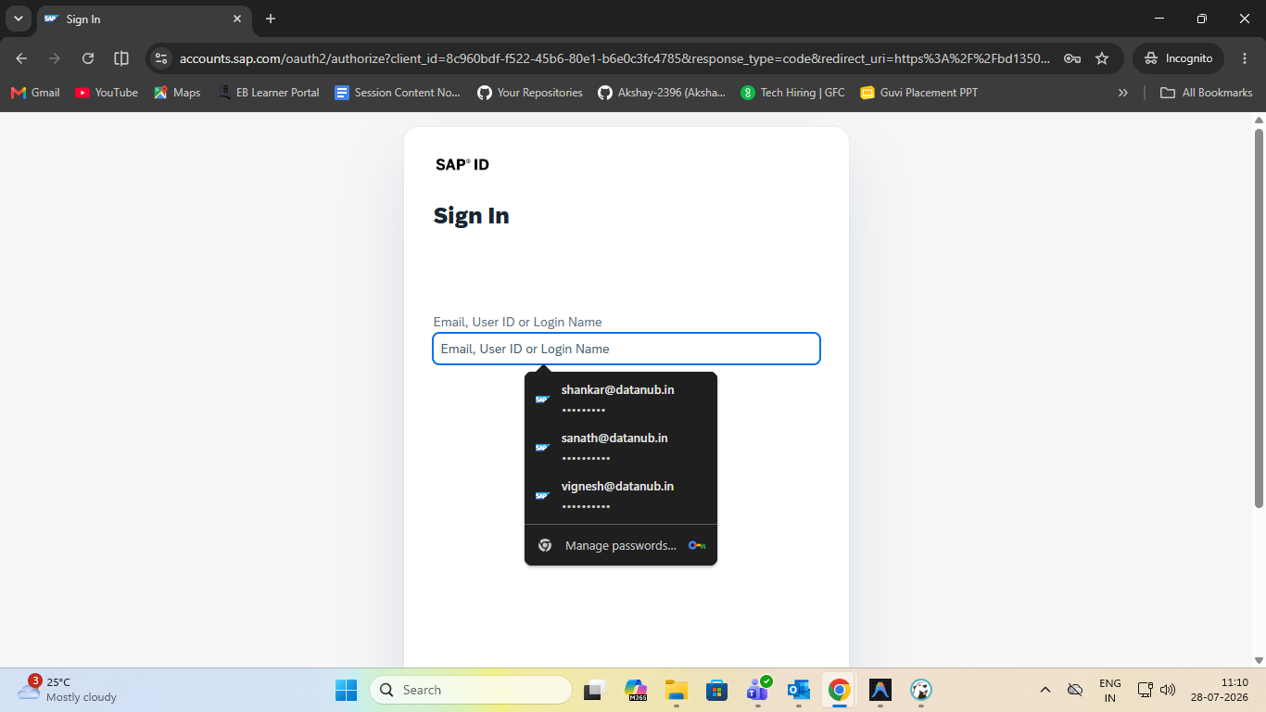

8.2 Dashboard Page (/)
The home screen after login, personalised by the user's role.

Admin view includes:
- KPI cards: Total Assets, Available Inventory, Total Capital Cost, In Maintenance
- Trend sparkline graphs on each KPI card

Asset Manager view includes:
- KPI cards: Serials Tracked, Assigned Units (with utilisation %), Pending Service

User view includes:
- My Assigned Assets status, Platform Security status

Shared sections (all roles):
- Asset Status Allocation panel with animated progress bars (Available / Assigned / In Service / Retired)
- Recently Registered Serials table with Asset ID, Name, Category, Cost, Status, Location

Dashboard Page – Admin View
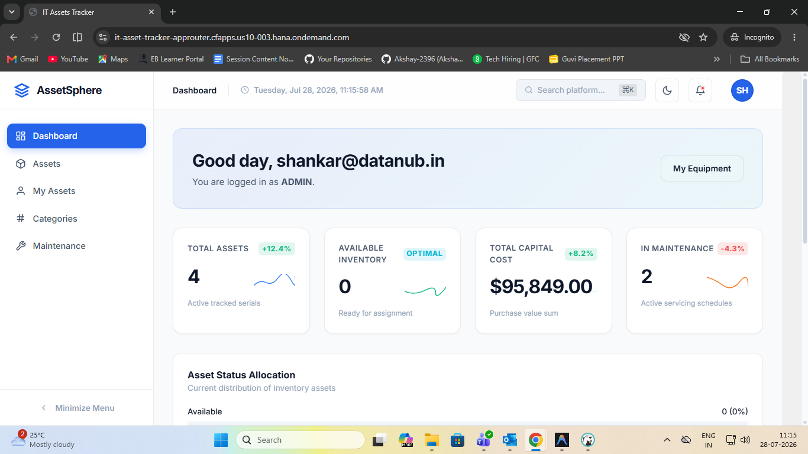

Dashboard Page – Asset Manager View 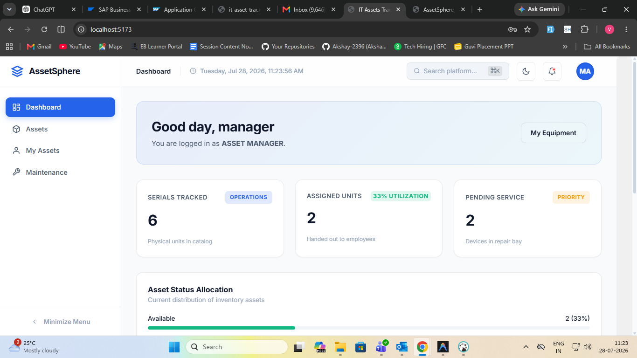

Dashboard Page – User View
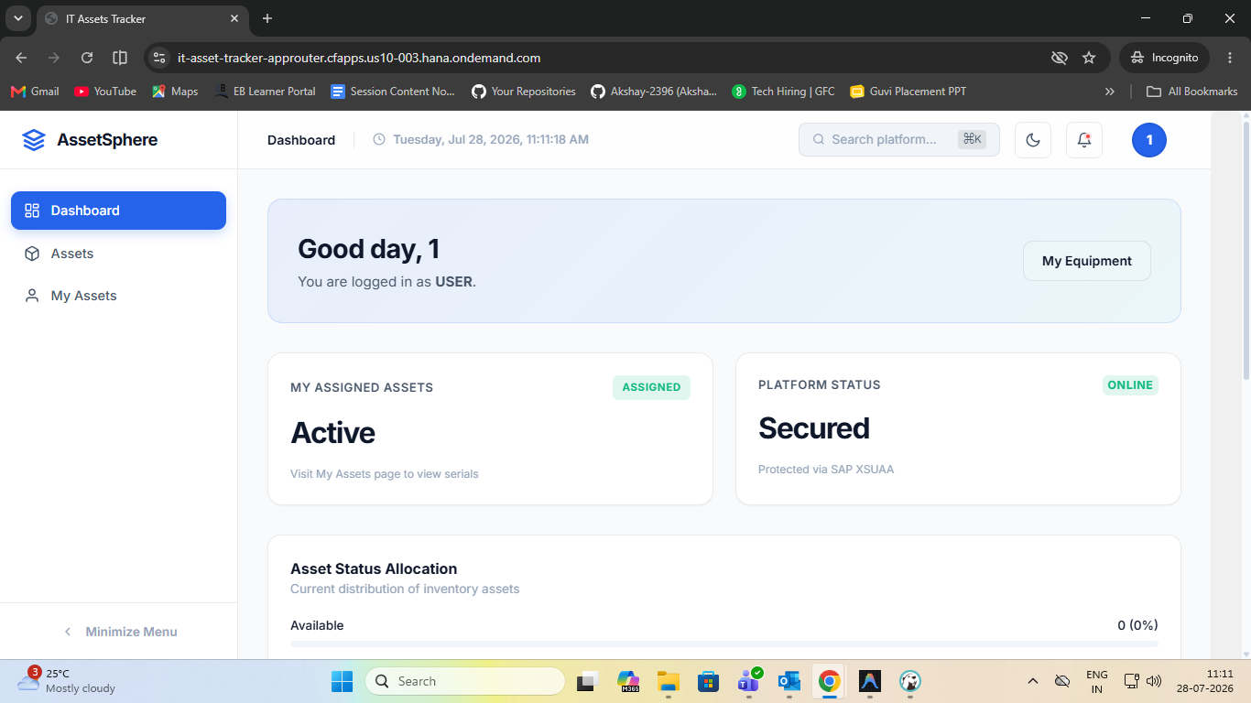

8.3 Assets Page (/assets)
Full asset inventory listing with inline CRUD and workflow actions.

Features:
- Search bar (filters by Asset ID, Name, Description, Location)
- Status dropdown filter (All / Available / Assigned / Maintenance / Lost / Damaged / Retired / Disposed)
- Asset cards showing: Asset ID badge, Name, Description, Category, Assigned To, Location, Purchase Cost, Status badge
- Register Asset button (Admin / Asset Manager only)
- Edit button → opens AssetForm modal
- Assign button (Available assets only) → opens Assign Modal with user dropdown
- Unassign button (Assigned assets) → sets status back to Available
- Service button → opens Maintenance Log Modal
- Delete button with confirmation prompt

Assets Page – Asset Grid View
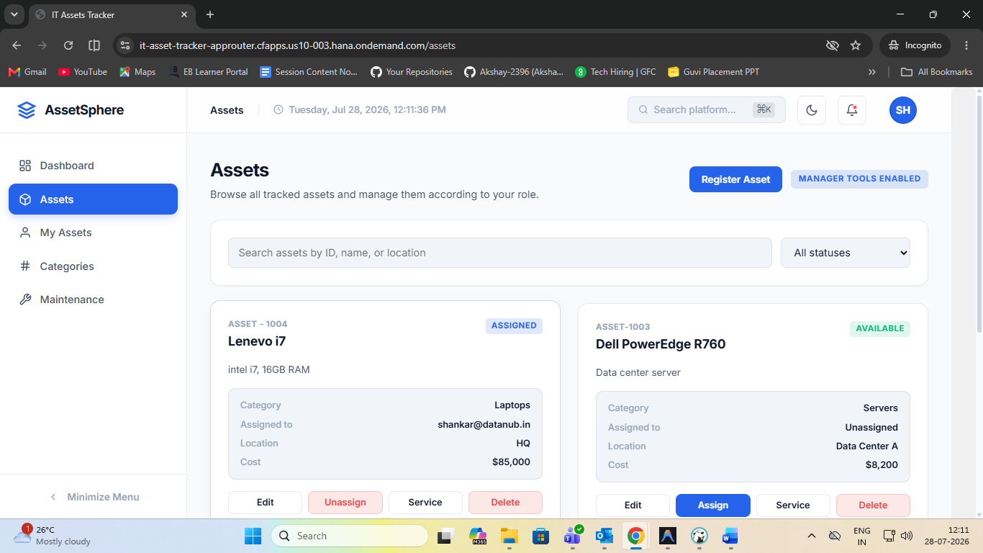

Assets Page – Register / Edit Asset Form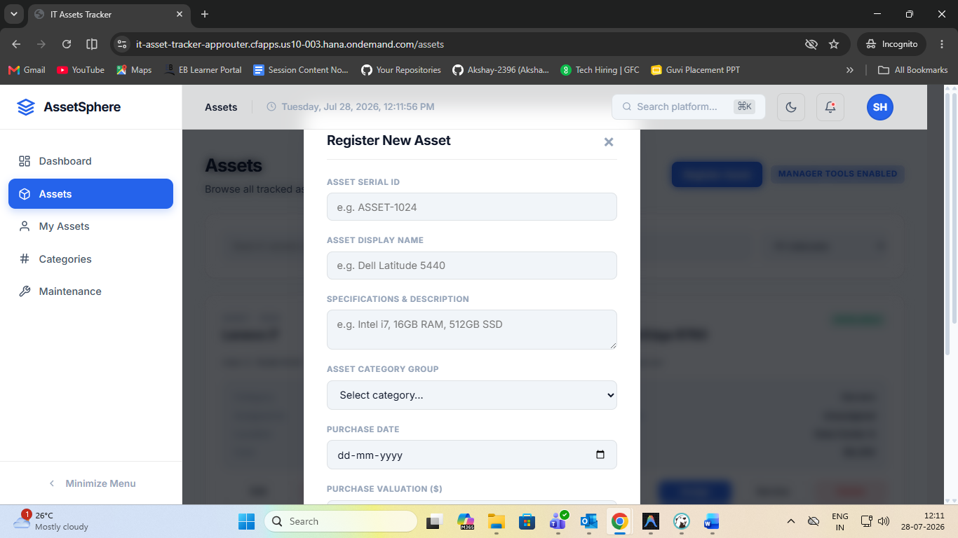

Assets Page – Assign Asset Modal
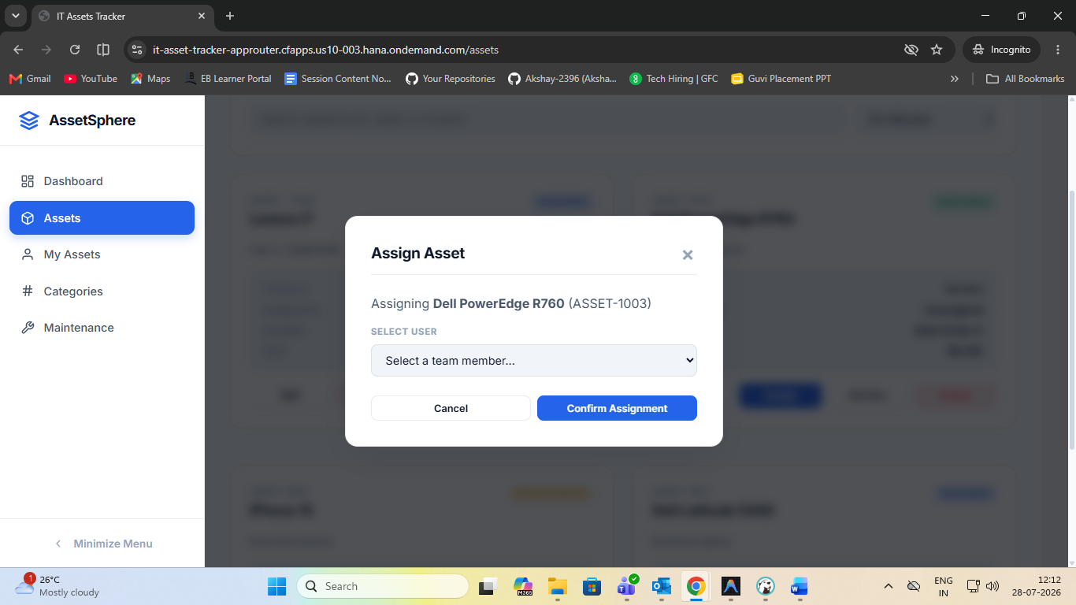

Assets Page – Log Maintenance Modal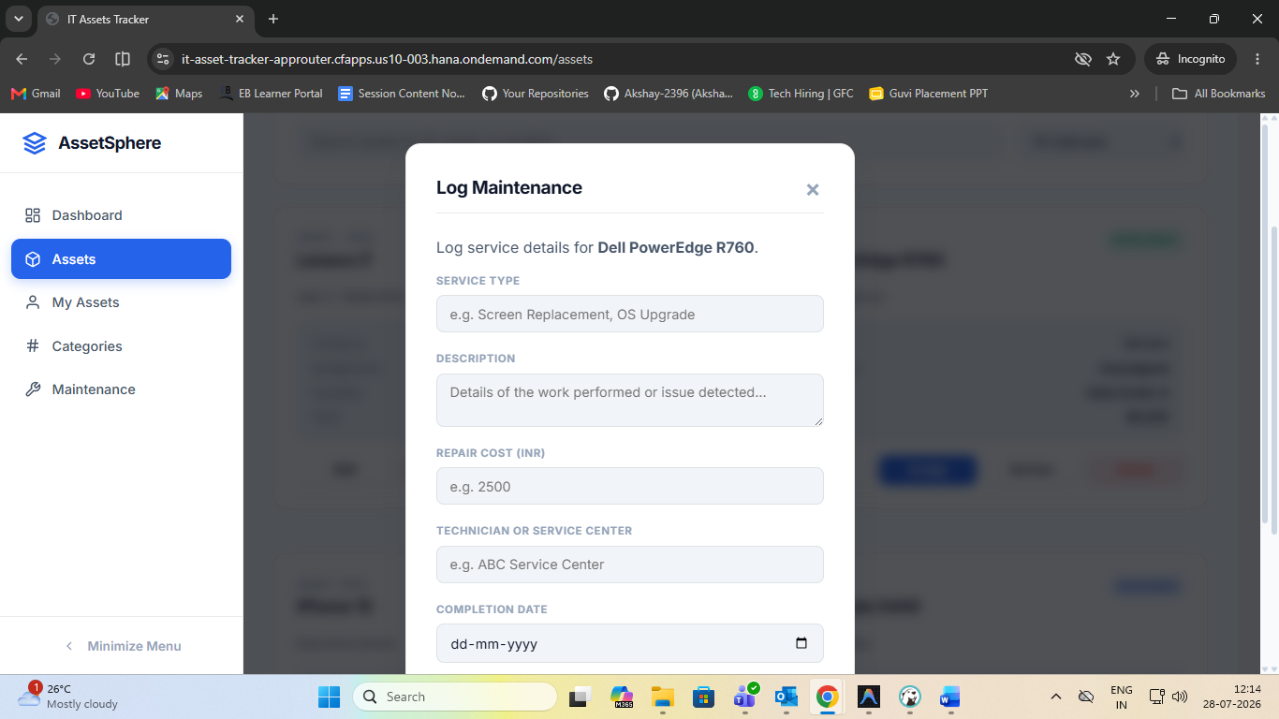

8.4 My Assets Page (/my-assets)
Displays only the assets currently assigned to the logged-in user. Available to all roles.

My Assets Page
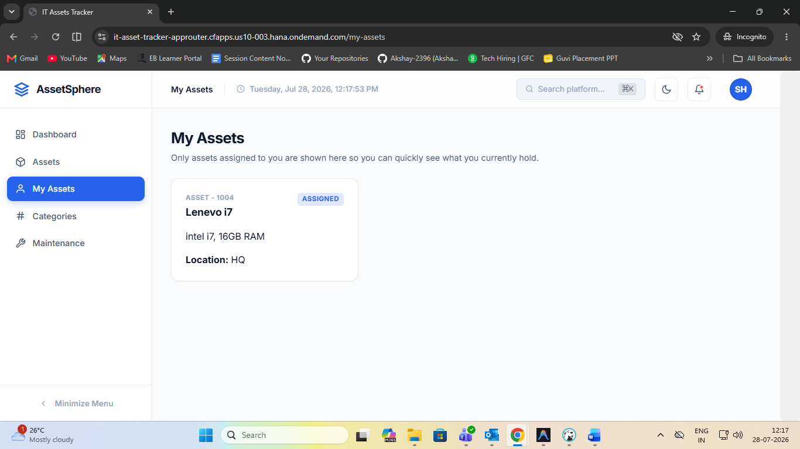

8.5 Categories Page (/categories) — Admin Only
Manage the taxonomy of asset types used throughout the system.

Features:
- Grid of category cards showing: Name, Description, Active/Inactive status badge
- Inline Edit and Delete buttons per card
- CategoryForm component for creating or editing a category

Categories Page 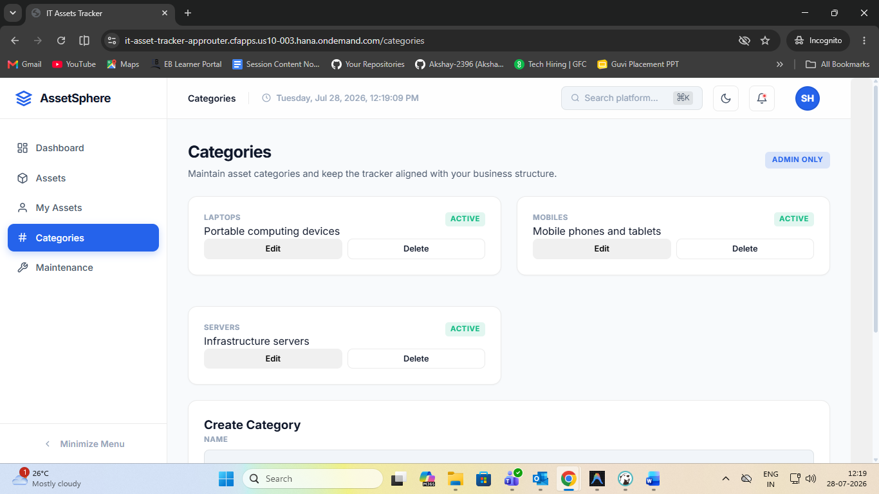

8.6 Maintenance Records Page (/maintenance) — Admin & Asset Manager
View a log of all maintenance events across all assets.

Features:
- Cards per maintenance record: Asset ID, Maintenance Type, Performed By, Service Date, Completion Date, Cost, Technician/Vendor, Description, Remarks
- Computed status badge: "Completed" (if completion_date ≤ today) or "In Service"

Maintenance Records Page
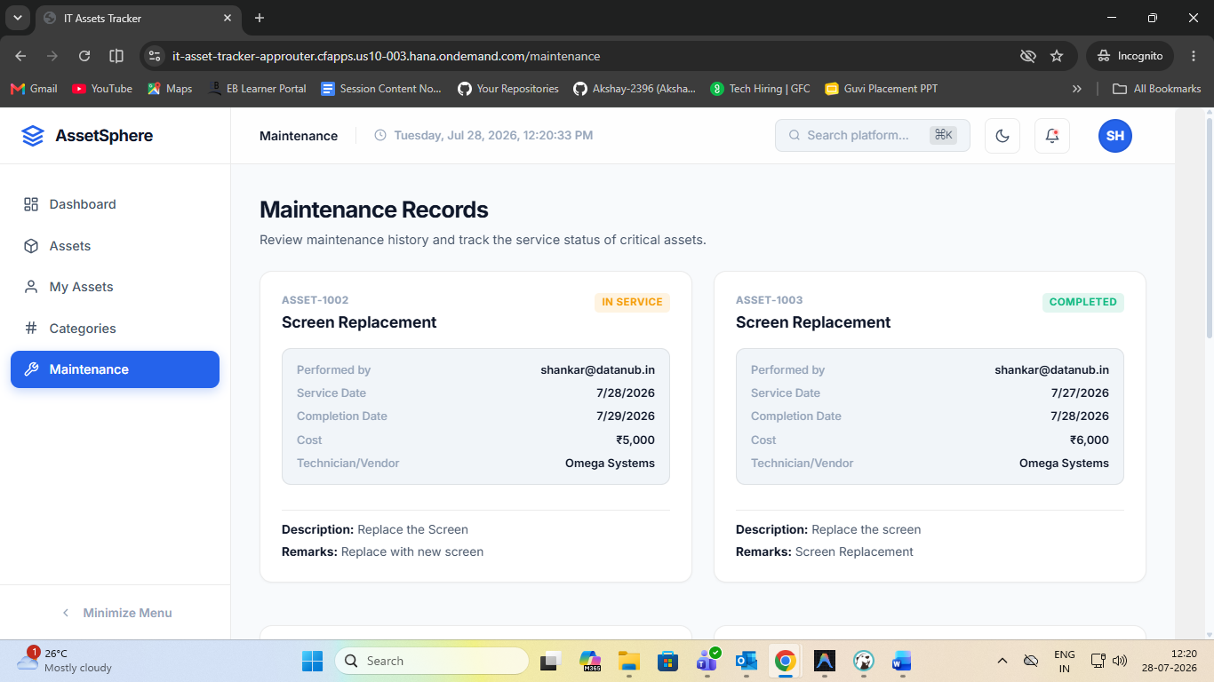

9. Role-Based Access Control (RBAC)

9.1 Roles
Role | Description | Hierarchy Level
user | Standard employee – can view assets and see their own assignments | 1 (lowest)
asset_manager | IT staff – can manage assets, assign, and log maintenance | 2
admin | Full system access including categories and all management functions | 3 (highest)

9.2 Permission Matrix
Permission | user | asset_manager | admin
view_assets | ✔ | ✔ | ✔
filter_assets | ✔ | ✔ | ✔
view_my_assets | ✔ | ✔ | ✔
create_asset | ✘ | ✔ | ✔
edit_asset | ✘ | ✔ | ✔
assign_asset | ✘ | ✔ | ✔
change_asset_status | ✘ | ✔ | ✔
add_maintenance | ✘ | ✔ | ✔
manage_categories | ✘ | ✘ | ✔
system_configuration | ✘ | ✘ | ✔

9.3 Route-Level Guards
Route | Allowed Roles
/login | Public (unauthenticated)
/ (Dashboard) | All authenticated users
/assets | user, asset_manager, admin
/my-assets | user, asset_manager, admin
/categories | admin only
/maintenance | asset_manager, admin

10. Application Flow Walkthrough

10.1 User Authentication Flow
Step 1:
User navigates to the application URL. React Router checks AuthContext; no token found → redirect to /login.

Step 2:
User enters credentials and submits the form.

Step 3:
POST /auth/login → server verifies password hash → signs JWT → returns token + user object.

Step 4:
AuthContext.login() stores the token in localStorage, sets user state → React Router redirects to /.

Step 5:
DashboardPage loads; calls GET /assets with Authorization header → renders role-personalised KPI view.

10.2 Asset Registration Flow (Asset Manager / Admin)
- Navigate to /assets → click "Register Asset"
- AssetForm modal opens with fields: Asset ID, Name, Description, Category, Purchase Date, Cost, Status, Assigned To, Location
- On submit: POST /assets (with validation) → asset saved → grid refreshes

10.3 Asset Assignment Flow
- On the Assets page, locate an asset with status = Available
- Click "Assign" → Assign Asset modal opens with a dropdown of all users
- Select a user → "Confirm Assignment" → POST /assets/:id/assign { user_id }
- Server calls assetService.assignAsset() which updates status to Assigned and sets assigned_to
- Asset card updates immediately after the grid reloads

10.4 Maintenance Logging Flow
- On the Assets page, click "Service" on an asset not already retired/in-maintenance
- Maintenance modal opens: Service Type, Description, Cost, Technician, Completion Date, Remarks
- On submit: POST /maintenance → record stored in maintenance_history table
- Navigate to /maintenance to view the full service log

10.5 Category Management Flow (Admin only)
- Navigate to /categories
- Existing categories displayed as cards
- Create: CategoryForm at the bottom of the page → POST /categories
- Edit: click Edit on a card → form pre-fills → PUT /categories/:id
- Delete: click Delete → DELETE /categories/:id (blocked if assets reference this category)

11. SAP BTP Deployment

11.1 Components Deployed
Component | CF App Name | Manifest
Express API | it-asset-tracker-api | Server/manifest.yml
React Frontend | it-asset-tracker-client | Client/manifest.yml
Application Router | it-asset-tracker-approuter | AppRouter/manifest.yml

11.2 AppRouter Routing Rules (xs-app.json)
Source Pattern | Target / LocalDir | Auth Type | Purpose
^/api/(.*)$ | backend (Express) | xsuaa | Proxy API calls to Express backend
^/assets/(.*)$ | public/ | xsuaa | Serve static assets (images, icons)
^/(.*)$ | public/index.html | xsuaa | SPA fallback – all routes serve index.html

11.3 Deployment Steps (Summary)
- 1. cf login and target your BTP org/space
- 2. Create XSUAA service instance: cf create-service xsuaa application it-asset-tracker-xsuaa
- 3. Build the frontend with the production backend URL (VITE_API_URL)
- 4. cf push the Express API, React client, and AppRouter using their respective manifest.yml files
- 5. Bind the XSUAA service to the API and the AppRouter
- 6. Set environment variables: JWT_SECRET, AUTH_MODE=xsuaa, NODE_ENV=production
- 7. Optionally bind a PostgreSQL service instance for cloud database
- 8. cf restage the API
- 9. Access the application via the AppRouter URL and verify login and RBAC

12. Environment Variables

12.1 Server (.env)
Variable | Default / Example | Description
PORT | 4000 | Port the Express server listens on
NODE_ENV | development | Environment (development / production)
AUTH_MODE | mock | Authentication mode: mock or xsuaa
JWT_SECRET | <strong-random-string> | Secret used to sign/verify JWTs
DB_HOST | localhost | PostgreSQL host
DB_PORT | 5432 | PostgreSQL port
DB_NAME | it_asset_tracker | Database name
DB_USER | postgres | Database user
DB_PASSWORD | <password> | Database password
VCAP_SERVICES | (auto-injected by BTP) | SAP service bindings in JSON (XSUAA, PostgreSQL)

12.2 Client (.env)
Variable | Example | Description
VITE_API_URL | http://localhost:4000 | Base URL for API calls (dev: direct, prod: /api via approuter)

13. Testing

13.1 Backend Tests
Framework: Node.js built-in test runner (node:test)
Test command: npm test (from Server/)
Results: 6 / 6 tests passing

13.2 Test Coverage Areas
- Health endpoint returns 200 OK
- Asset listing returns success payload
- Authentication: valid credentials return token
- Authentication: invalid credentials return 401
- Protected endpoint rejected without token
- Asset creation validation (missing required fields returns 400)

13.3 Frontend Build Verification
Command: npm run build (from Client/)
Result: Vite production build completed successfully — dist/ directory generated.

14. Demo Credentials (Mock / Development Mode)
Username | Password | Role | Access Level
admin | Admin123! | admin | Full access – all pages, all CRUD operations
manager | Manager123! | asset_manager | Asset & maintenance management, no categories
user | User123! | user | View assets, view own assigned assets only

Note: These credentials are seeded automatically by Server/src/db/seed.js when the server starts in mock mode. Do not use these in production.

15. Screenshots
Paste application screenshots in the placeholders below. Use Windows Snipping Tool (Win+Shift+S) or the browser DevTools to capture each screen at 1280×800 or higher resolution.

15.1 Login Page
Login Page – Full Screen


15.2 Dashboard – Admin
Dashboard Page – Admin (KPI Cards + Status Panel + Recent Assets Table)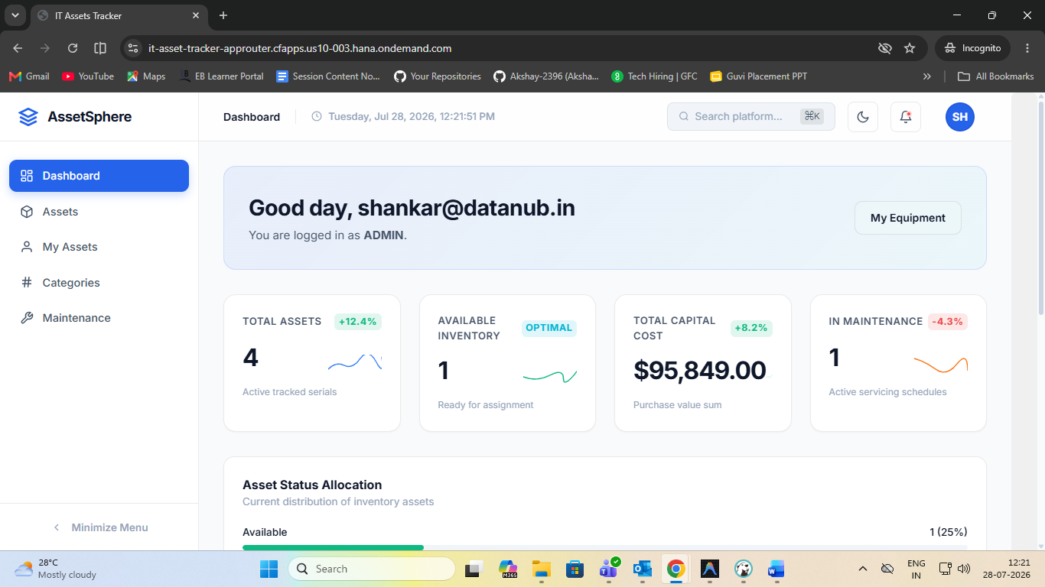

15.3 Dashboard – Asset Manager
Dashboard Page – Asset Manager View


15.4 Dashboard – User
Dashboard Page – Standard User View


15.5 Assets Page
Assets Page – Grid View (Status Badges Visible)
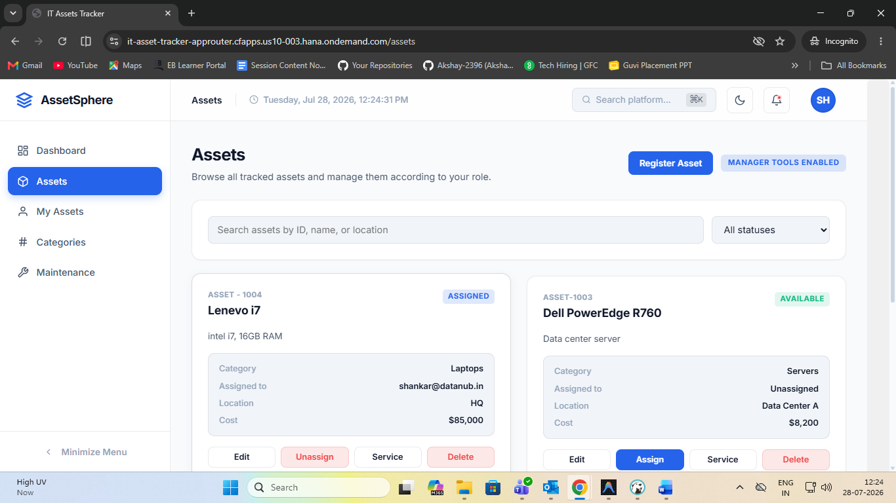

15.6 Register / Edit Asset Form
Assets Page – Register Asset Form Modal
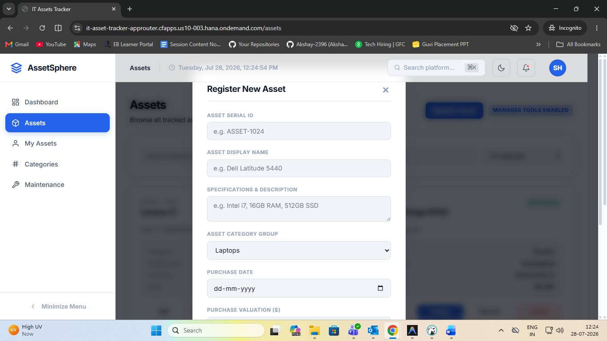

15.7 Assign Asset Modal
Assets Page – Assign Asset to User Modal 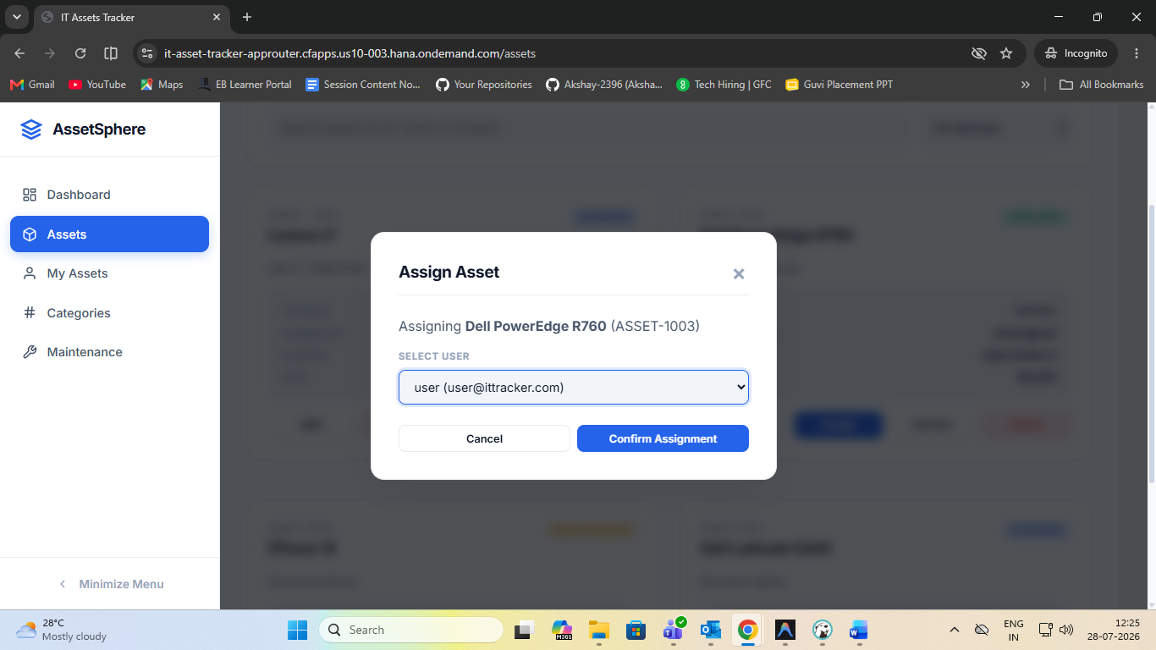

15.8 Log Maintenance Modal
Assets Page – Log Maintenance / Service Modal 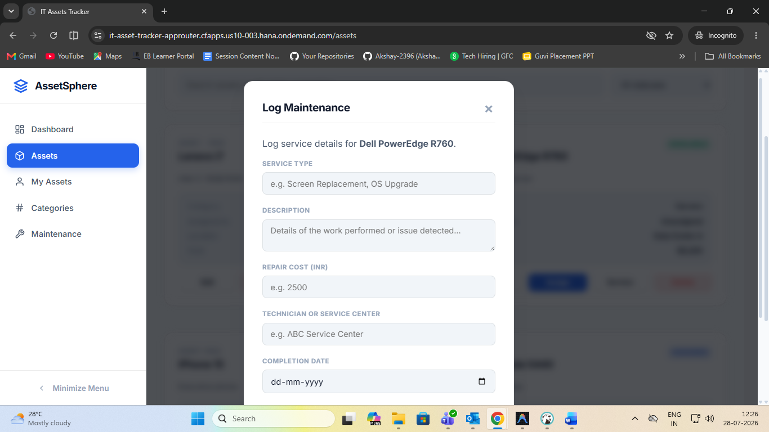

15.9 My Assets Page
My Assets Page – Current User Assignment
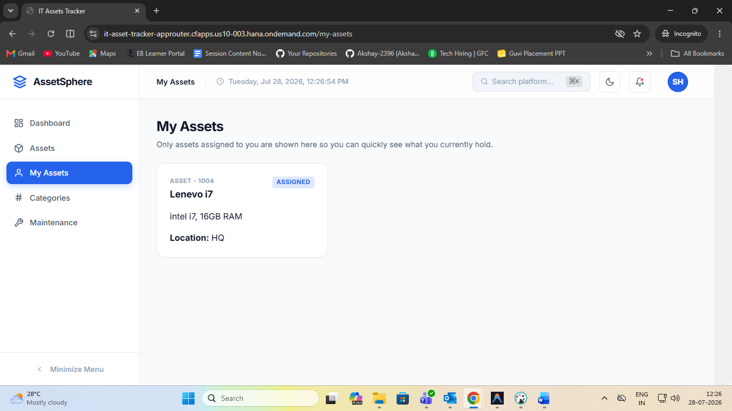

15.10 Categories Page
Categories Page – Admin View with Category Cards
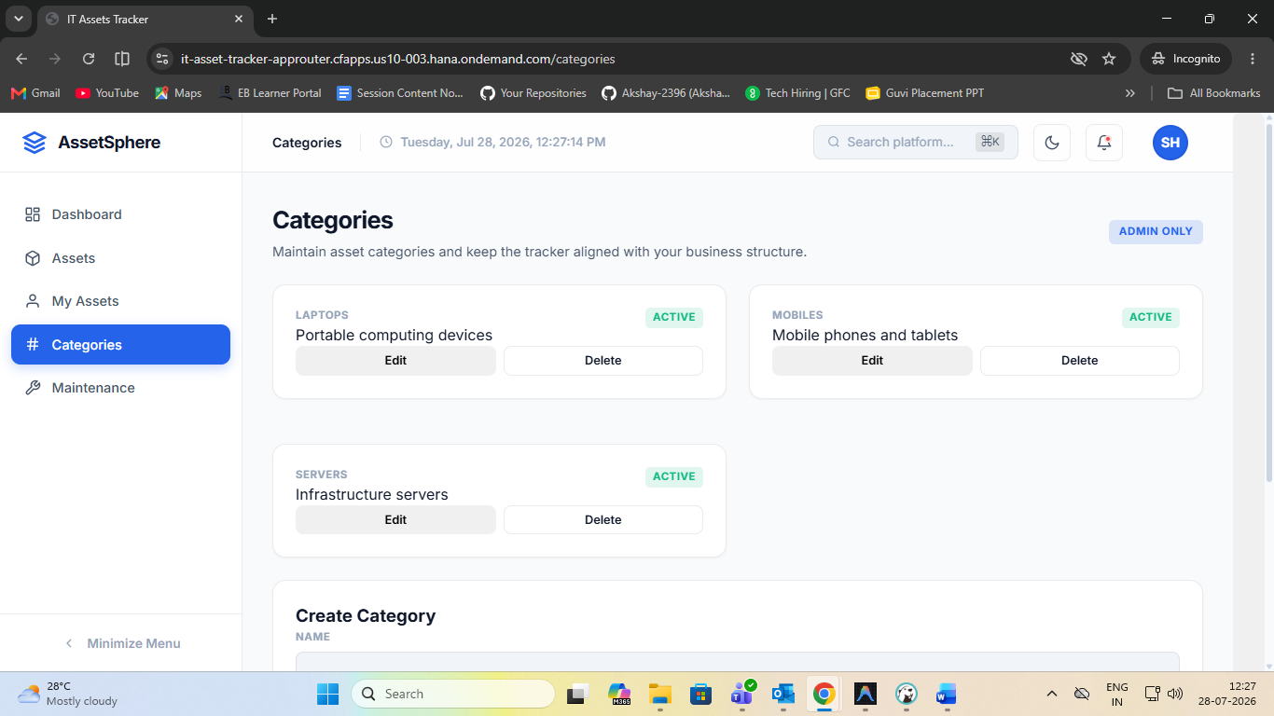

15.11 Maintenance Records Page
Maintenance Records Page – Service Log Cards 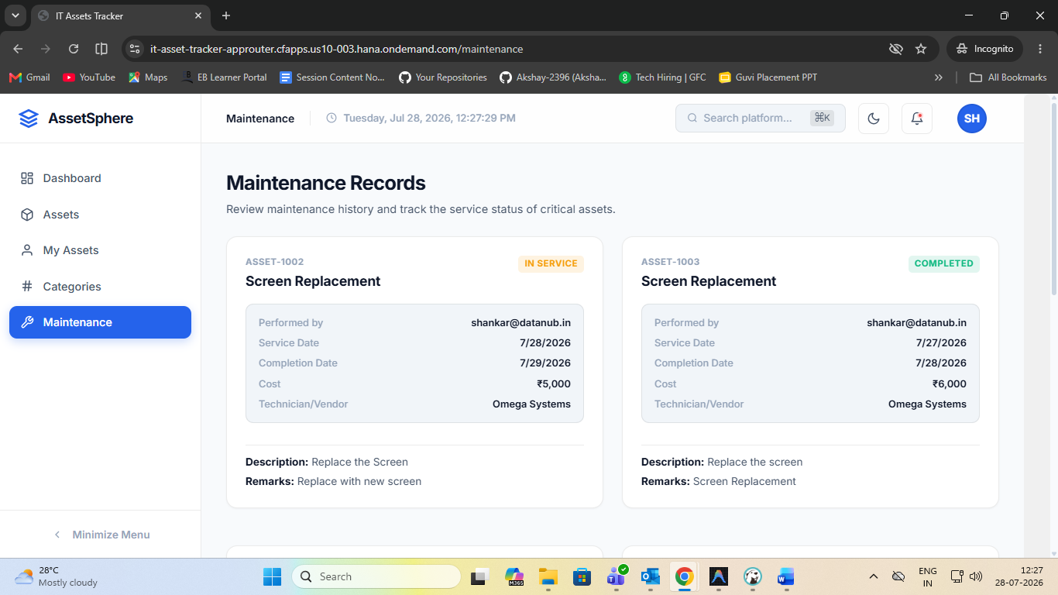

— End of Document —

