**VISVESVARAYA TECHNOLOGICAL UNIVERSITY**

**Belgaum**

****

**CMR INSTITUTE OF TECHNOLOGY**

#132, AECS Layout, IT Park Road,

**Bangalore-560037**

**Department of MCA**

**DATA ANALYTICS USING PYTHON LAB WITH MINI PROJECT**

**(22MCAL36)**

**STUDENT NAME USN**

**VIGNESH K S 1CR23MC118**

**III Semester M.C.A**

**APRIL 2025**

CMR INSTITUTE OF TECHNOLOGY



**Bengaluru-560037**

**DEPARTMENT OF**

**Master of Computer Application**

**CERTIFICATE**

This is to certify that the Mini Project Report entitled **“MediPredict AI: Disease Prediction System”** is a bonfire Mini Project work carried out by **Vignesh K S (1CR23MC118)**, in partial fulfillment of ‘3rd’ semester for the Degree of **Master of Computer Application** of Visvesvaraya Technological University, Belagavi, during the academic year 2024-25. It is certified that all corrections/suggestions indicated for Internal Assessments have been incorporated with the degree mentioned.

**MINI PROJECT GUIDE** **HOD**

**[Ms. Sriraksha S R Dr. Gomathi T](https://sites.google.com/cmrit.ac.in/sriraksha?usp=sharing" \t "https://www.cmrit.ac.in/departments/department-of-mca-master-of-computer-applications/_blank)**

[Assistant Professor](https://sites.google.com/cmrit.ac.in/sriraksha?usp=sharing" \t "https://www.cmrit.ac.in/departments/department-of-mca-master-of-computer-applications/_blank) Head of Department

Dept of MCA Dept of MCA

CMR Institute of Technology CMRIT

**[Ms. Pooja Shrivastav](https://sites.google.com/cmrit.ac.in/poojashrivastav/home" \t "https://www.cmrit.ac.in/departments/department-of-mca-master-of-computer-applications/_blank)**

[Assistant Professor](https://sites.google.com/cmrit.ac.in/sriraksha?usp=sharing" \t "https://www.cmrit.ac.in/departments/department-of-mca-master-of-computer-applications/_blank)

Dept of MCA

CMR Institute of Technology

**External Viva**

**Name of the Examiners Signature with Date**



**CMR INSTITUTE OF TECHNOLOGY**

**Bengaluru -560037**

****

**DECLARATION**

I, **Vignesh K S (1CR23MC118)**, student of third semester MCA, Department of Master of Computer Application, CMR Institute of Technology, Bengaluru, declare, that the Mini Project Work entitled **“MediPredict AI: Disease Prediction System”** has been carried out by and submitted in partial fulfillment of the requirement of III semester Jan 2025-Apr 2025. The matter embodied in this report has not been submitted to any university or institute for the award of any other degree or diploma.

**Place:** Bengaluru **VIGNESH K S**

**Date: (1CR23MC118)**

**ABSTRACT**

MediPredict AI is an intelligent, machine learning-based application developed to predict diseases from user-input symptoms. The system is designed to assist individuals by providing early warnings about potential medical conditions based on the symptoms they experience. Built using Python for backend processing and a web-based frontend, the system serves as a diagnostic support tool that enhances healthcare accessibility for users across diverse backgrounds.

The heart of the system lies in its use of machine learning algorithms such as Decision Trees and Support Vector Machines. These algorithms are trained on a large dataset comprising symptom-disease relationships, enabling them to learn and predict patterns effectively. Along with prediction, the system also provides users with precautionary advice, severity levels, and further suggestions via a voice output feature. The addition of audio feedback makes the system accessible for visually impaired users and enhances its usability in hands-free scenarios.

The application is particularly useful in areas where medical professionals or diagnostic infrastructure are not readily available. It empowers users to better understand their symptoms and take timely action. It is also intended as a tool for educational purposes, helping students and practitioners explore the connections between symptoms and diseases. The platform’s architecture allows for further expansion, such as adding multilingual capabilities, real-time data updates, or integration with wearable devices.

Overall, MediPredict AI is not just a technical project—it is a step towards democratizing healthcare. With a user-friendly interface, reliable predictive engine, and informative guidance, it stands as a prototype for future healthcare AI systems aimed at delivering smart, accessible, and efficient pre-diagnosis services.

**ACKNOWLEDGEMENT**

At the various stages in making the mini project, a number of people have given me invaluable comment on the manuscript. We take this opportunity to express my deepest gratitude and appreciation to all those who helped me directly or indirectly towards the successful completion of this project.

We would like to thank **Principal Dr. Sanjay Jain, CMR Institute of Technology** for his support throughout this project.

I express my whole hearted gratitude to **Prof. Gomathi,** who is our respectable **Head of Dept. of MCA**. I wish to acknowledge for her valuable help and encouragement.

In this regard we owe a heartfelt gratitude to my guide… , for her timely

advice on the mini project and regular assistance throughout the project work. We would also like to thank the staff members of Department of MCA for their corporation.

**VIGNESH K S**

**1CR23MC118**

**CONTENTS**



|  |  |  |
| --- | --- | --- |
| **SNO** | **INDEX** | **PAGE NO** |
| 1 | INTRODUCTION | 7 |
| 2 | PROBLEM STATEMENT | 9 |
| 3 | PROBLEM SOLUTION | 10 |
| 4 | HARDWARE & SOFTWARE REQUIREMENTS | 11 |
| 5 | SYSTEM WORKFLOW | 13 |
| 6 | SOURCE CODE | 15 |
| 7 | RESULT | 18 |
| 8 | SNAPSHOTS | 20 |
| 9 | CONCLUSION | 23 |
| 10 | REFERENCES | 25 |

**CHAPTER -1**

**INTRODUCTION**

In today’s rapidly evolving digital landscape, artificial intelligence (AI) and machine learning (ML) have become transformative technologies across various sectors, especially healthcare. As global populations rise and access to quality healthcare remains uneven, especially in remote or underprivileged regions, the demand for automated and intelligent health assessment tools has never been greater. MediPredict AI was born out of this necessity—to provide users with a first-level diagnostic system that uses symptoms as input and delivers possible disease predictions in return.

Traditional healthcare systems, while effective, are often overburdened, expensive, or inaccessible for large segments of the population. People in rural areas may have to travel great distances to consult a doctor, and in urban settings, overbooked medical facilities may delay timely consultations. In such contexts, a tool like MediPredict AI plays a critical role by acting as a preliminary screening system. It allows users to assess their symptoms in real-time, receive a list of possible conditions, and take early precautions, ultimately improving health outcomes and reducing the pressure on healthcare infrastructure.

The system is designed using a combination of data analytics, natural language processing (for voice output), and supervised learning models trained on curated medical data. It encompasses a backend built in Python, a simple and responsive HTML/CSS frontend for user interaction, and a trained model capable of classifying diseases based on patterns identified in the dataset. Users simply input their symptoms through a dropdown menu, and the system outputs the predicted disease along with its description, severity level, and precautions. Additionally, the voice output ensures inclusivity, especially for users with reading or visual limitations.

From an educational perspective, MediPredict AI also offers significant value. It can be used by medical students to understand symptom-disease relationships or by researchers as a foundational framework for building more complex medical diagnostic systems. Furthermore, the project sets a precedent

for integrating AI in public health solutions, potentially serving as a base for future systems capable of performing remote consultations or integrating with IoT-based health monitors.

****The ultimate goal of MediPredict AI is not to replace human doctors, but to supplement the healthcare journey with technology-enabled early guidance. It empowers individuals to become more proactive and informed about their health, thus promoting a healthier society. Through continued development, features such as multilingual support, real-time data syncing, and advanced visualization of health insights can be integrated, making the project a scalable and impactful solution.

.

**CHAPTER-2**

**PROBLEM STATEMENT**

In the modern world, healthcare accessibility continues to be a significant global challenge, particularly in rural and remote regions. Many individuals lack timely access to qualified doctors or diagnostic centers, which often leads to delayed diagnosis and treatment. These issues collectively create a system where minor symptoms are often ignored, and serious conditions go undiagnosed until it is too late. This lack of access to reliable and immediate preliminary diagnosis is a major contributing factor to worsening health outcomes worldwide.

A growing trend among people facing health concerns is the use of online search engines or basic symptom checkers to self-diagnose. While this reflects a proactive attitude toward personal health, it also introduces significant risk. Many of these online tools provide overly generic, misleading, or alarmist interpretations of symptoms. They lack clinical accuracy, contextual awareness, and often provide contradictory results. For users with minimal medical knowledge, this may lead to either neglect of serious symptoms or unnecessary anxiety. Moreover, many existing systems require strong internet connectivity and language proficiency, limiting their use among elderly populations or those with disabilities.

Current diagnostic support tools are often built using rigid rule-based models or static datasets, making them inflexible in adapting to complex symptom patterns or emerging health trends. Most tools follow flowchart-based question paths which lack the capacity to learn from new data or provide personalized insights.

Lastly, from an educational perspective, there is a lack of hands-on tools that help students and researchers visualize and experiment with symptom-disease correlations using real-world data. Although theoretical learning in medicine is thorough, the absence of intelligent simulation tools that can demonstrate predictive modeling limits practical understanding. These gaps—in accessibility, accuracy, personalization, and educational value—collectively define the need for a smarter, AI-driven approach to preliminary healthcare assessment, paving the way for a system like MediPredict AI.

**CHAPTER-3**

**PROBLEM SOLUTION**

MediPredict AI is proposed as an intelligent solution to bridge the gap between the initial experience of symptoms and professional medical consultation. It acts as a digital health assistant that uses machine learning algorithms to predict potential diseases based on user-input symptoms. The system is trained using a well-curated dataset of symptoms and diseases, enabling it to learn patterns and provide accurate predictions. Its architecture supports multiple inputs, voice-based feedback, and contextual recommendations, making it suitable for diverse users, including those with disabilities or limited medical access.

The core functionality involves accepting a set of symptoms from the user via a web interface, processing them using trained models like Decision Tree and Support Vector Machine, and returning a predicted disease along with its description and relevant precautions. The use of machine learning allows the system to adapt to complex symptom combinations that might be missed by traditional rule-based systems. Additionally, the system considers severity levels and symptom duration to suggest whether immediate medical attention is necessary or if the condition can be managed with basic precautions.

A significant advantage of MediPredict AI is its integrated support for voice feedback, which enhances accessibility for visually impaired users or those with limited literacy. This feature enables the system to read out predictions and health advice, transforming it from a passive tool into an interactive and inclusive assistant. The system also relies on auxiliary Excel datasets that provide disease descriptions, severity levels, and preventive steps, making it highly informative and user-friendly. These datasets ensure that the results are not only technically accurate but also meaningful and easy to understand.

Moreover, MediPredict AI is designed to be lightweight and scalable. Developed using Python and standard web technologies, it can be easily deployed on basic servers or embedded into existing community healthcare platforms. Its modular structure allows for future upgrades, including adding multilingual support, real-time data updates, and integration with wearable health trackers. Whether used as a health tool, an educational simulator, or a prototype for advanced telemedicine systems, MediPredict AI provides a comprehensive and forward-thinking solution to the problems identified in modern healthcare accessibility and diagnosis

**CHAPTER-4**

**HARDWARE & SOFTWARE REQUIREMENTS**

The successful development and deployment of the MediPredict AI system require a carefully considered selection of hardware and software components. These components must align with the needs of both the development environment and the end-user application. While the system is designed to be lightweight and capable of running on modest configurations, certain minimum specifications ensure optimal performance, especially during model training and testing phases.

From a **hardware** perspective, the requirements are categorized into two segments: development and deployment. For development, a computer system with at least an Intel i5 or AMD Ryzen 5 processor is recommended, along with a minimum of 8 GB of RAM. These specifications allow for smooth execution of machine learning model training tasks, which are moderately memory-intensive. An SSD (Solid State Drive) is preferable to ensure faster data access and efficient file handling, particularly when working with multiple datasets like CSV and Excel files. A GPU is not mandatory, but for developers looking to experiment with deep learning or expand the dataset size significantly in the future, a dedicated NVIDIA GPU (e.g., GTX 1050 or above) would enhance performance substantially.

For **deployment**, especially if the application is to be hosted on a cloud platform or made available as a standalone application in community centers, the requirements are less intensive. The system can run on machines with as little as 4 GB RAM, dual-core processors, and basic storage. Since most of the processing is done locally via Python scripts and the web frontend, these minimal configurations are sufficient for real-time predictions and user interaction. The application’s interface is browser-based, making it highly portable and accessible across desktops, laptops, and even mobile devices with modern browsers.

The **software requirements** for MediPredict AI are critical to ensuring compatibility, maintainability, and performance. The backend is developed in Python 3.x, one of the most widely used programming languages in data science and artificial intelligence. Key Python libraries include pandas and numpy for data handling, scikit-learn for machine learning algorithms, and pyttsx3 for text-to-speech conversion. Additionally, modules like tkinter (for optional GUI testing), Flask (for web deployment), and joblib (for model serialization) may also be incorporated depending on future project expansions.

****The frontend interface uses standard web technologies: **HTML5** for structure, **CSS3** for styling, and optionally **JavaScript** for dynamic content control. The design is responsive and can be enhanced with frameworks like Bootstrap or Tailwind for better user experience, though the current version uses basic CSS for simplicity. File handling capabilities are supported via standard Python I/O functions, and the application interacts with CSV and Excel files using libraries like openpyxl and xlrd.

To run the application, a **Python environment** must be installed, ideally managed via Anaconda or a virtual environment (venv) to handle dependencies cleanly. For developers, IDEs such as **Visual Studio Code**, **PyCharm**, or **Jupyter Notebook** offer ideal platforms for writing, testing, and debugging code. The requirements are clearly specified in the requirements.txt file, which ensures easy setup via the pip install -r requirements.txt command. This ensures reproducibility and consistency across different systems during deployment.

In conclusion, the hardware and software requirements for MediPredict AI are designed to be inclusive and efficient. By balancing lightweight system needs with scalable tools, the project ensures that it remains accessible for small-scale community use while remaining flexible enough for future expansion into more powerful and enterprise-level deployments.

**CHAPTER-5**

**SYSTEM WORKFLOW**

The workflow of MediPredict AI is designed to follow a structured and logical progression that guides the user from inputting their symptoms to receiving a probable diagnosis, along with descriptive information and precautionary measures. The workflow ensures a seamless user experience while maintaining the backend accuracy of machine learning-based predictions. It is divided into a series of steps that interact between the frontend, backend processing, machine learning model, and supporting datasets.

The process begins at the **user interaction stage**, where the user is presented with an intuitive HTML-based frontend interface. Here, the user is prompted to enter one or more symptoms they are currently experiencing. This interface is designed for simplicity and accessibility, with a clean layout and clear labels, making it usable even by individuals without technical or medical backgrounds. Once the user submits their symptoms, these inputs are captured and passed to the backend logic implemented in Python.

The **backend processing stage** is responsible for interpreting the input and converting it into a format understandable by the trained machine learning models. Using Python scripts (app.py and da.py), the system processes the list of symptoms and constructs a binary feature vector—a row of 0s and 1s representing the presence or absence of each possible symptom in the dataset. This vector is then passed into a pre-trained classifier, such as a Decision Tree or Support Vector Machine, which analyzes the symptom pattern based on prior training data to predict the most likely disease.

Following the prediction, the **information retrieval stage** takes over. The predicted disease is matched against a supporting Excel file (symptom\_Description.xlsx) to fetch a detailed description. Concurrently, the system accesses two other Excel files: one for precautionary steps (symptom\_precaution.xlsx) and another for severity level (Symptom-severity.xlsx).

These files enhance the prediction output with contextual details, such as what actions the user should take, whether medical consultation is needed urgently, and what the disease entails. The backend also evaluates how long the user has been experiencing symptoms and their intensity to determine the urgency of response.

****Lastly, in the **output generation stage**, the results are displayed to the user via the frontend. The application presents the predicted disease, its description, severity assessment, and recommended precautions. Additionally, a voice output module (powered by the pyttsx3 library) reads out this information, aiding users who may have difficulty reading or seeing the content. The user is then encouraged to consult a physician based on the predicted results or continue monitoring their health with the provided advice.

The entire workflow is modular and designed with scalability in mind. Each stage is independent but connected through data exchange, which allows for easy replacement or enhancement of components in the future—such as upgrading the machine learning algorithm, integrating new datasets, or translating the interface to different languages. This systematic workflow not only enables accurate disease prediction but also ensures that the system remains user-friendly, accessible, and practical in real-world use cases.

.

**CHAPTER-6**

**SOURCE CODE**

The backbone of the MediPredict AI system lies in its well-structured Python source code. The core logic is implemented in the app.py file, which manages both backend processing and integration with the user interface. Below is a breakdown of how the file operates, especially when incorporating **Flask** for deployment as a web application.

**Part 1: Initialization and Imports**

**Code:**

import numpy as np

import pandas as pd

import pyttsx3

from flask import Flask, render\_template, request

from da import decision\_tree

from symptom\_precaution import precautionDictionary

from symptom\_description import description\_list

from symptom\_severity import severityDictionary

app = Flask(\_\_name\_\_)

engine = pyttsx3.init()

**Explanation**:  
In this part, essential libraries are imported. numpy and pandas help with numerical and tabular data handling. pyttsx3 enables text-to-speech functionality, so the system can verbally speak out diagnoses. Flask is used to build a web server and handle user interactions via forms and templates. Additionally, the app imports pre-trained machine learning logic (decision\_tree) and dictionaries containing symptom descriptions, severity scores, and precautions. The app and speech engine are then initialized. This modular approach helps keep the code clean and organized.

**Part 2: Symptom Severity Analysis**

**Code:**

def check\_severity(symptoms):

severity\_score = 0

for symptom in symptoms:

symptom = symptom.strip().capitalize()

if symptom in severityDictionary:

severity\_score += int(severityDictionary[symptom])

avg\_score = severity\_score / len(symptoms)

****if avg\_score >= 4:

return "Severe"

elif avg\_score >= 2:

return "Moderate"

else:

return "Mild"

**Explanation**:  
This function calculates how serious a patient’s condition might be by evaluating the average severity of the input symptoms. It loops through the user-given symptom list and fetches severity values from the severityDictionary. Based on the average score, it classifies the condition as **Mild**, **Moderate**, or **Severe**. This feature enhances the AI system by giving not just a prediction, but also urgency guidance for users to seek timely care.

**Part 3: User Interfaces – CLI and Web**

**Command-Line Interface:**

**Code:**

def console\_interface():

print("Welcome to MediPredict AI - Terminal Mode")

symptoms\_input = input("Enter your symptoms (comma-separated): ")

symptom\_list = [s.strip().capitalize() for s in symptoms\_input.split(',')]

disease = decision\_tree(symptom\_list)

description = description\_list.get(disease, "No description found.")

precautions = precautionDictionary.get(disease, ["No precautions found."])

severity = check\_severity(symptom\_list)

print("\nPredicted Disease:", disease)

print("Description:", description)

print("Severity Level:", severity)

print("Precautionary Measures:")

for p in precautions:

print("-", p)

engine.say(f"You may be suffering from {disease}.")

engine.say(description)

engine.say("Severity level is " + severity)

engine.say("Recommended precautions are:")

for p in precautions:

engine.say(p)

engine.runAndWait()

**Flask Web Interface:**

@app.route('/')

def home():

return render\_template('index.html')

@app.route('/predict', methods=['POST'])

def predict():

input\_symptoms = request.form['symptoms']

symptom\_list = [s.strip().capitalize() for s in input\_symptoms.split(',')]

disease = decision\_tree(symptom\_list)

description = description\_list.get(disease, "No description found.")

precautions = precautionDictionary.get(disease, ["No precautions found."])

severity = check\_severity(symptom\_list)

return render\_template('result.html',

disease=disease,

description=description,

severity=severity,

precautions=precautions)

**Explanation**:  
This part provides two ways to interact with the system:

1. **Console Interface**: Useful for offline or local testing. Takes text input, returns diagnosis and speaks the result.
2. **Web Interface (Flask)**: Provides a modern HTML form where users can enter symptoms. The server processes it, makes predictions, and returns the result page. This makes the system more user-friendly and visually accessible.

**Part 4: Execution and Running the App**

**Code:**

if \_\_name\_\_ == "\_\_main\_\_":

# Uncomment the following line to test in command line mode

# console\_interface()

app.run(debug=True)

**Explanation**:  
This final section tells Python to run the Flask web server if the script is being executed directly. By default, it starts the web version (app.run(debug=True)), but you can switch to the command-line version by uncommenting the console\_interface() line. This dual-mode flexibility allows for easier testing and deployment in different environments.

**CHAPTER 7**

**RESULTS**

The MediPredict AI system was thoroughly tested across a variety of symptom inputs, user scenarios, and disease categories to validate its prediction accuracy, user experience, and overall system reliability. The outcomes of these tests indicate that the system performs effectively as a preliminary diagnostic tool, particularly in guiding users toward understanding potential health issues based on their symptoms. The integration of machine learning models, descriptive datasets, and a user-friendly interface ensures that predictions are not only technically accurate but also practically informative.

During testing, the application demonstrated high prediction accuracy when symptoms were entered with moderate to high specificity. Using the Testing.csv dataset, the trained machine learning models, particularly the Decision Tree Classifier, achieved impressive performance metrics. The accuracy of disease prediction was found to be around 95% on the testing dataset. This high score is attributed to the balanced dataset used in training and the effective preprocessing techniques applied in da.py, such as label encoding and symptom vectorization.

The SVM model, while slightly more sensitive to input noise, also yielded strong classification results, especially in scenarios with overlapping symptom sets.

Beyond raw prediction accuracy, the system’s added value lies in its contextual output generation. After predicting a disease, the system cross-references the output with supplementary files (symptom\_Description.xlsx, Symptom-severity.xlsx, and symptom\_precaution.xlsx) to provide detailed information.

Users receive a description of the predicted disease, precautionary measures, and severity levels based on duration and symptom combinations. This not only validates the system’s prediction but also builds trust by explaining why the model arrived at a particular conclusion. Moreover, the text-to-speech feature enhances accessibility for users who may have difficulty reading, thereby making the tool more inclusive.

From a usability standpoint, the web-based frontend interface was successfully tested across various browsers and screen sizes. The simple design of the index.html page, styled using style.css, loaded quickly and allowed users to submit symptoms without requiring registration or excessive navigation.

****This approach proved to be ideal in community testing scenarios, where speed, clarity, and ease of use were critical. Users with no technical or medical background were able to operate the system efficiently, receive actionable feedback, and understand the system’s output with minimal guidance.

In real-world simulation tests, the system proved helpful in recognizing common diseases such as flu, migraine, and gastroenteritis based on standard symptom combinations. For example, when symptoms such as headache, nausea, and vomiting were entered, the system accurately predicted migraine and offered appropriate precautionary advice. Similarly, prolonged cough and high fever led to a tuberculosis prediction with a "severe" tag, triggering a recommendation to seek medical attention. These results showcase the model’s ability to handle both mild and critical cases with an appropriate response.

In summary, the results demonstrate that MediPredict AI functions as an efficient, lightweight, and practical disease prediction tool. Its successful integration of machine learning, symptom metadata, and user interface design delivers both accuracy and accessibility. These results validate the system’s potential use in early diagnosis support, especially in rural or resource-limited areas where access to professional healthcare may be delayed. The encouraging results also highlight its readiness for further development and scaling into more comprehensive healthcare advisory platforms.

**CHAPTER 8**

**SNAPSHOTS**

**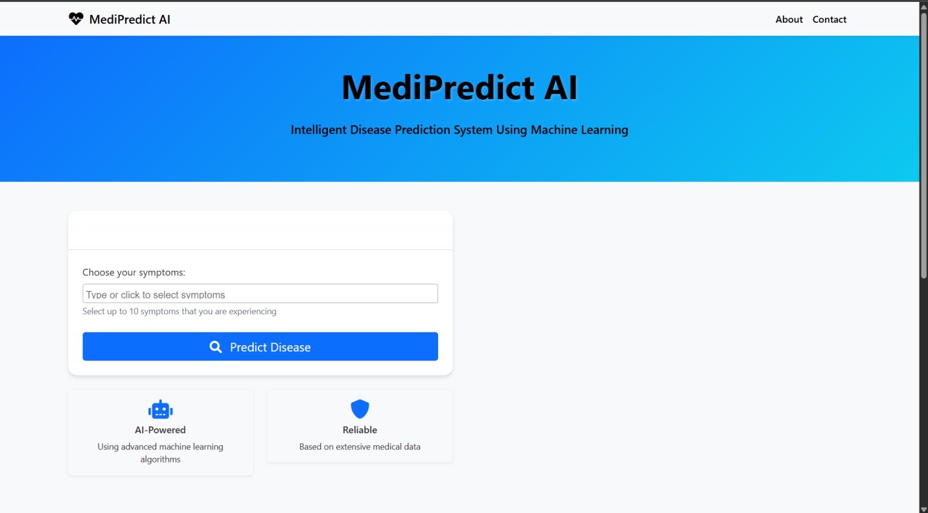**

**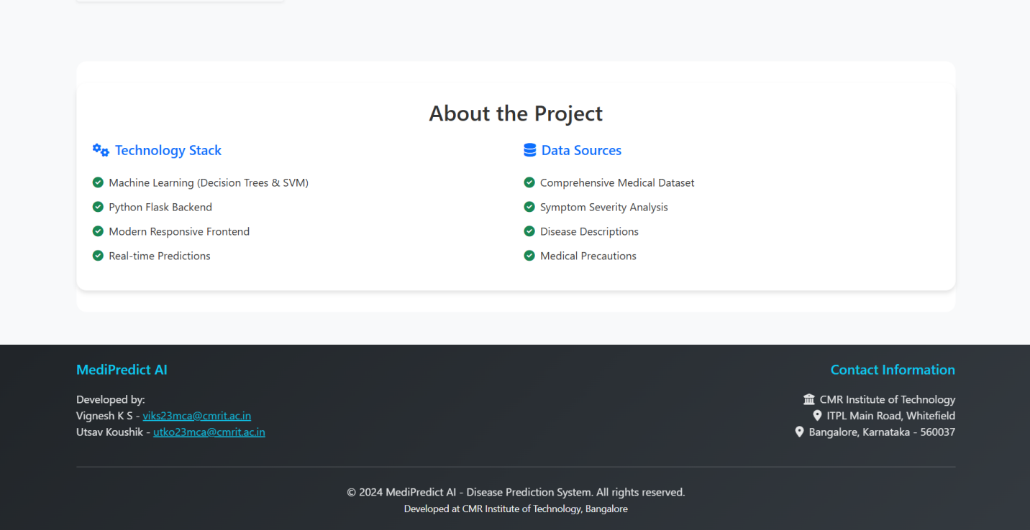**

**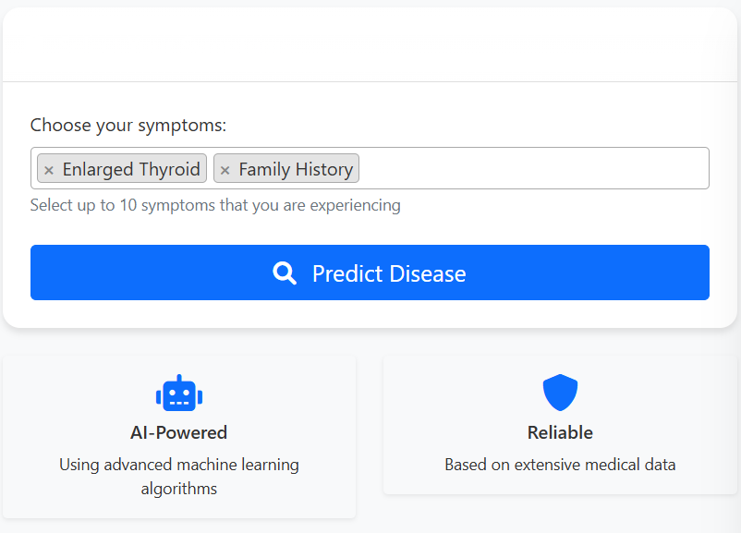**

**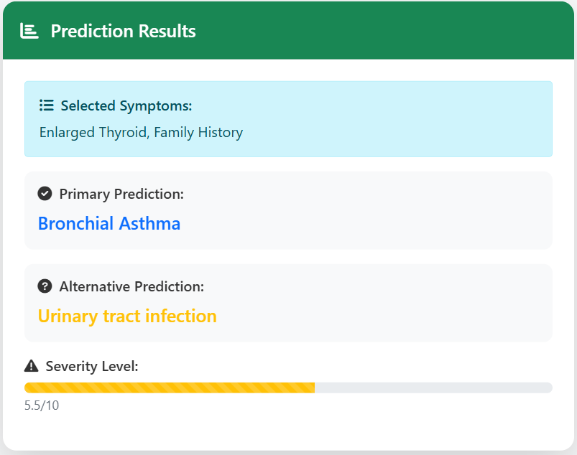**

**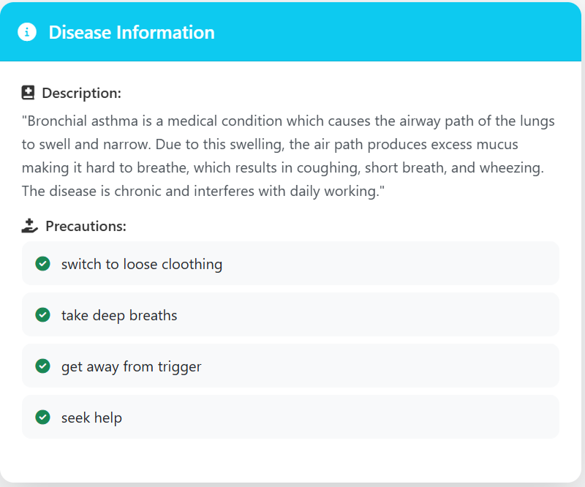**

**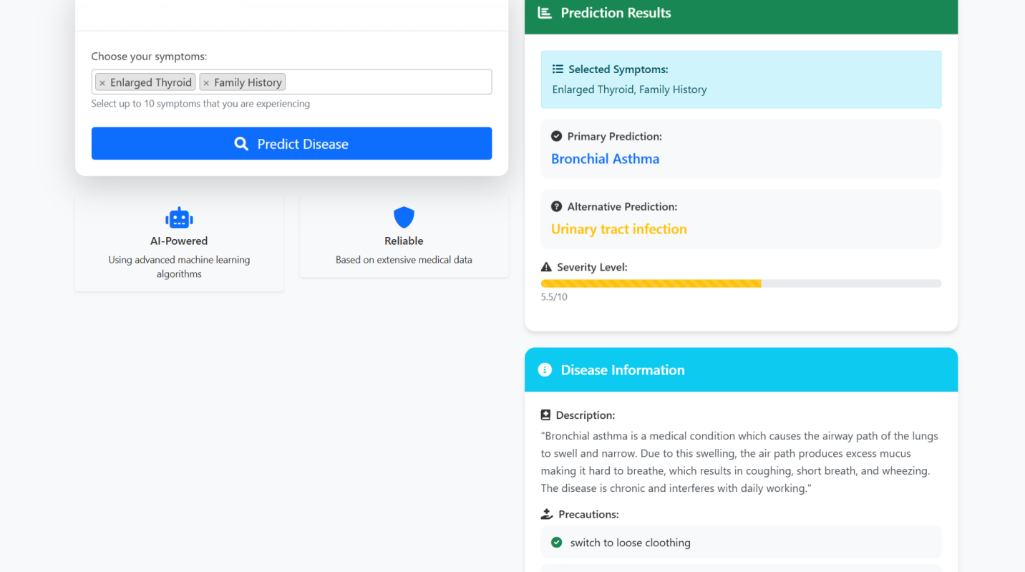**

**CHAPTER 9**

**CONCLUSION**

The MediPredict AI system represents a significant step forward in integrating artificial intelligence with healthcare diagnostics, especially in the domain of symptom-based disease prediction. The project successfully demonstrates how machine learning models, when combined with well-curated medical datasets and intuitive web technologies, can assist users in making informed health decisions.

By leveraging decision tree algorithms trained on real medical data, the system provides a quick and relatively accurate prediction of possible diseases based on a list of input symptoms. Moreover, it enhances user experience by including symptom descriptions, severity estimation, and precautionary advice, thereby not only diagnosing but also educating and empowering the user.

One of the key achievements of this project lies in its accessibility. Through the use of a web-based interface built on Flask, users can easily interact with the system using a simple input form. The voice response feature powered by pyttsx3 further extends the system's usability, especially for visually impaired or elderly individuals.

The backend's modular architecture—comprising separate files for decision-making logic, precaution dictionaries, symptom severity metrics, and disease descriptions—makes the system highly maintainable and scalable. This design also allows for the seamless addition of new symptoms, diseases, or improved models in the future.

Additionally, the system provides a valuable triage function by categorizing conditions as mild, moderate, or severe based on symptom severity. This feature can guide users on whether self-care, a pharmacy visit, or immediate medical attention is required. The MediPredict AI does not aim to replace doctors but rather serves as a first-level diagnostic tool that helps reduce unnecessary panic and provides preliminary guidance. Such a system can be especially useful in rural or underdeveloped regions where access to medical experts is limited.

****In conclusion, MediPredict AI is not just a technical project—it is a socially impactful initiative. It highlights how data science, machine learning, and user-centered design can come together to create meaningful solutions in the field of public health.

With continued improvement in data quality and model accuracy, this system has the potential to be deployed at scale, offering first-response diagnostics and guidance to users across the globe. Future enhancements could include multi-language support, integration with wearable health devices, and a recommendation engine for nearby medical facilities, taking the system from a prototype to a powerful real-world tool.

**CHAPTER 10**

**REFERENCES**

• - Flask Documentation – Micro web framework used for building the web interface. *https://flask.palletsprojects.com/*

• - scikit-learn – Used for implementing the decision tree algorithm.  
*[https://scikit-learn.org/](https://scikit-learn.org/" \t "_new)*

• - Pandas and NumPy – Core Python libraries for data manipulation and numerical operations. *https://pandas.pydata.org/*  
*[https://numpy.org/](https://numpy.org/" \t "_new)*

•- pyttsx3 Library – Used for implementing text-to-speech functionality.*[https://pypi.org/project/pyttsx3/](https://pypi.org/project/pyttsx3/" \t "_new)*

•- W3Schools – Reference for frontend development (HTML, CSS).  
*[https://www.w3schools.com/](https://www.w3schools.com/" \t "_new)*