2023_27_CSE_ST_EASY_FA_Q12

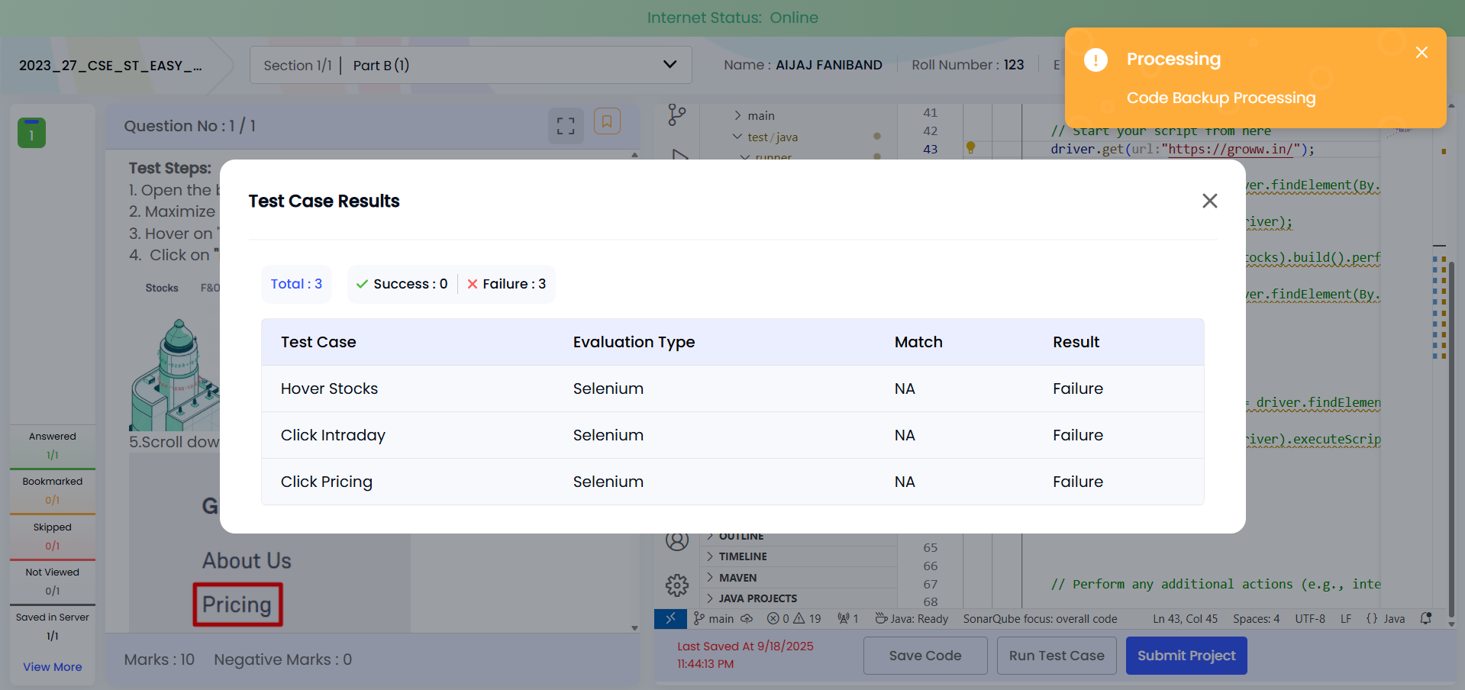

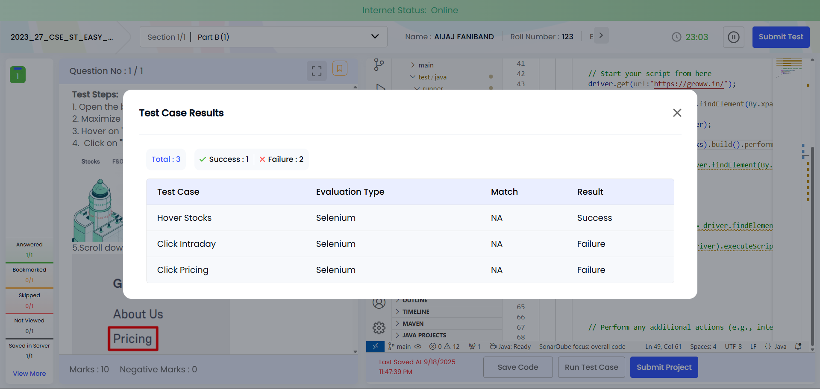

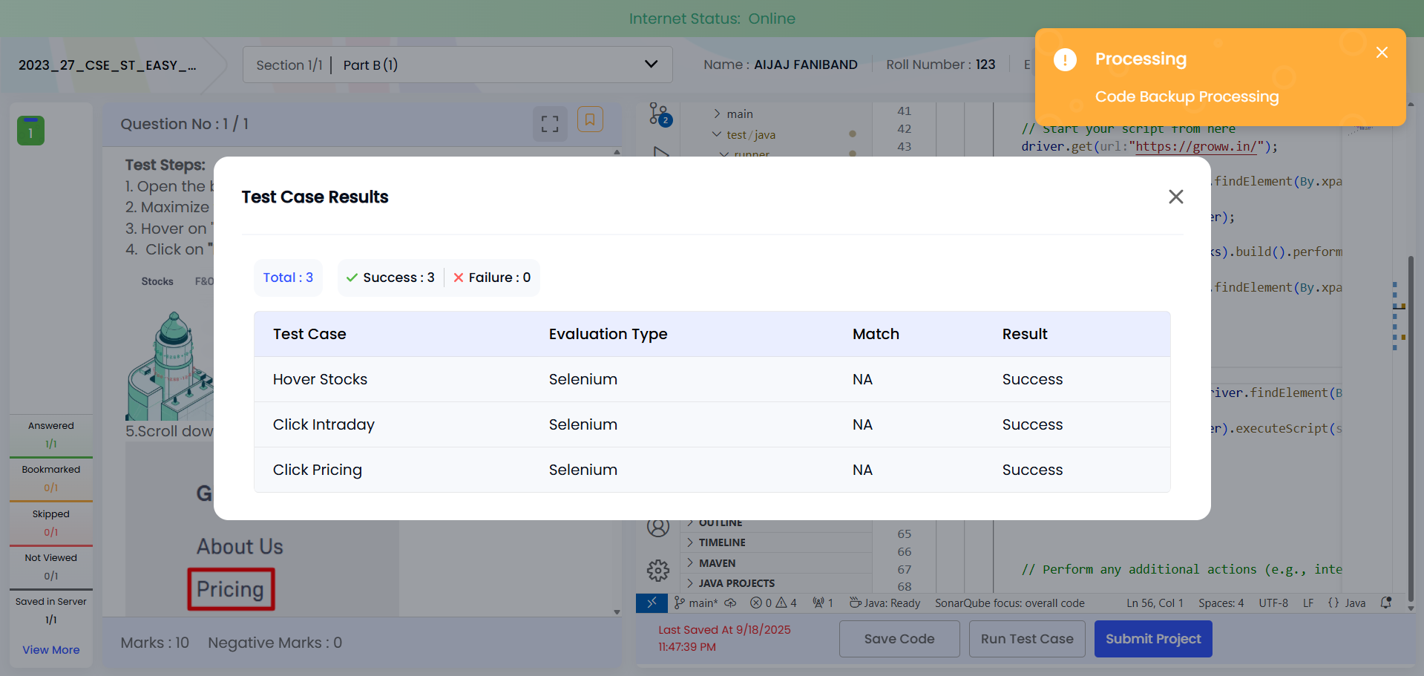

package runner;

import java.net.MalformedURLException;
import java.net.URL;

import org.openqa.selenium.By;
import org.openqa.selenium.JavascriptExecutor;
import org.openqa.selenium.WebDriver;
import org.openqa.selenium.WebElement;
import org.openqa.selenium.chrome.ChromeOptions;
import org.openqa.selenium.interactions.Actions;
import org.openqa.selenium.remote.RemoteWebDriver;
import org.openqa.selenium.support.events.EventFiringDecorator;
import org.openqa.selenium.support.events.WebDriverListener;
import org.testng.annotations.Test;
import utils.EventHandler;

public class TestSample {

public static WebDriver driver;

Actions actions;

@Test
public void testMain() throws InterruptedException {
try {
driver = new RemoteWebDriver(new URL("http://localhost:4444"), new ChromeOptions());

// Maximize the browser window
driver.manage().window().maximize();

// Add the implicit wait
driver.manage().timeouts().implicitlyWait(java.time.Duration.ofSeconds(10));

// Add the page load timeout
driver.manage().timeouts().pageLoadTimeout(java.time.Duration.ofSeconds(10));

// Initialize the event listener
WebDriverListener listener = new EventHandler();
driver = new EventFiringDecorator<>(listener).decorate(driver);

// Start your script from here
driver.get("https://groww.in/");

WebElement stocks = driver.findElement(By.xpath("//span[text()='Stocks']"));

actions = new Actions(driver);

actions.moveToElement(stocks).build().perform();

WebElement intday = driver.findElement(By.xpath("//div[text()='Intraday']"));

intday.click();

Thread.sleep(5000);

WebElement pricingLink = driver.findElement(By.xpath("//a[@class='contentPrimary footerTopSection_productLinks__RO4GI'][normalize-space()='Pricing']"));

((JavascriptExecutor) driver).executeScript("window.scroll(0,2500)", pricingLink);

Thread.sleep(5000);

pricingLink.click();

// Perform any additional actions (e.g., interacting with elements)

} catch (MalformedURLException e) {
e.printStackTrace();
} finally {
if (driver != null) {
driver.quit();
}
}
}
}

2023_27_CSE_ST_EASY_FA_Q15

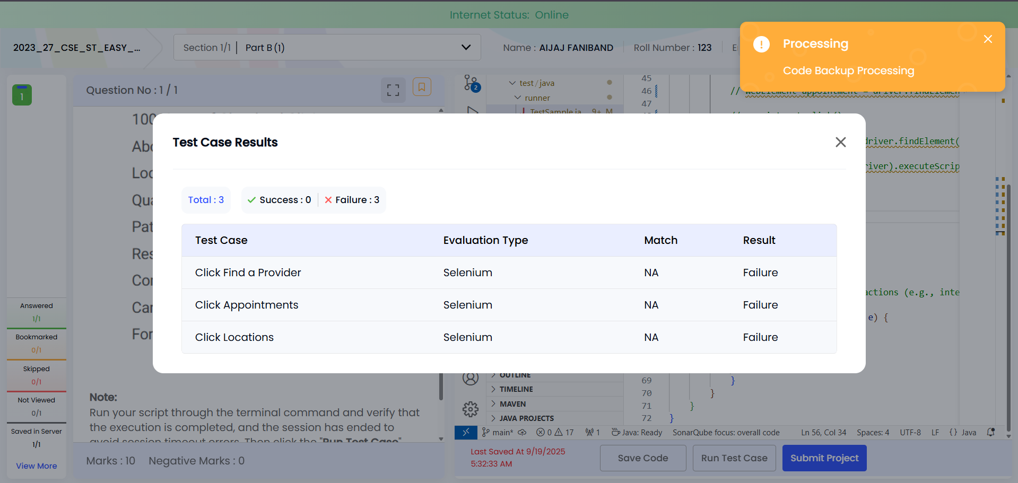

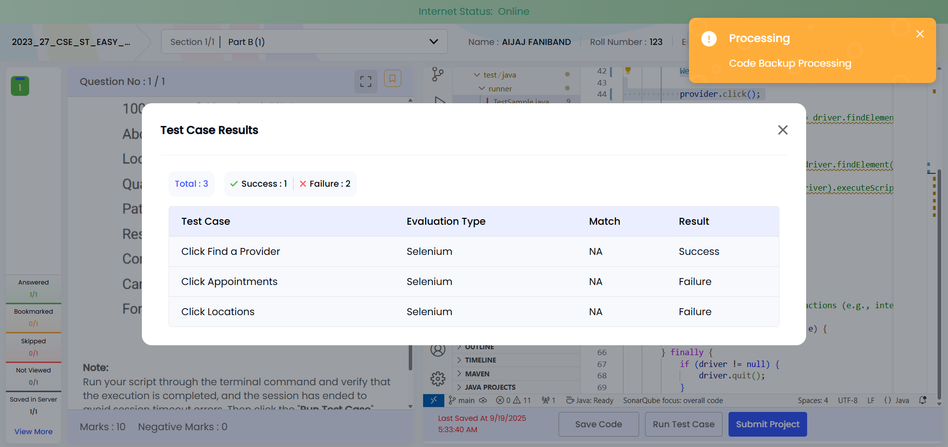

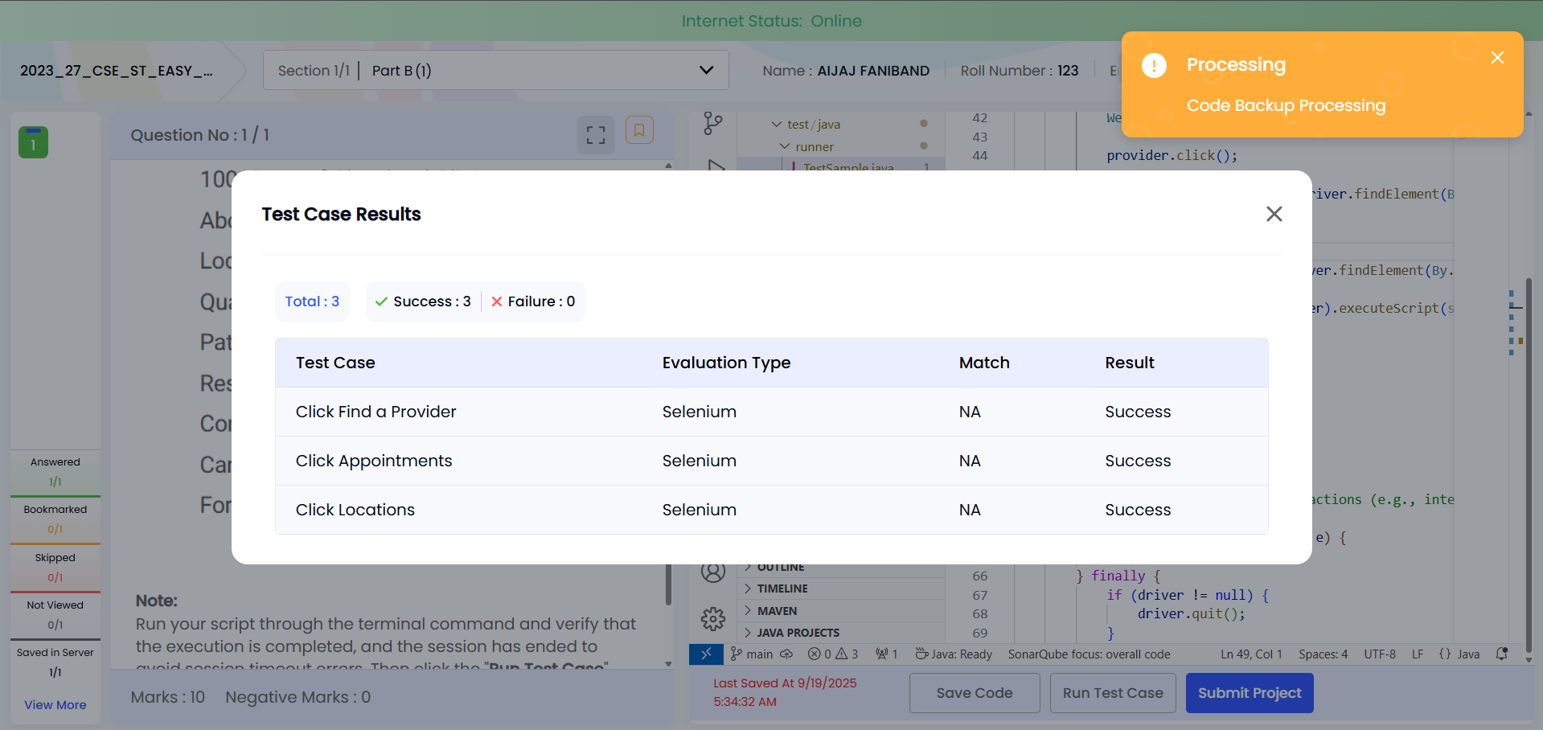

package runner;

import java.net.MalformedURLException;
import java.net.URL;

import org.openqa.selenium.By;
import org.openqa.selenium.JavascriptExecutor;
import org.openqa.selenium.WebDriver;
import org.openqa.selenium.WebElement;
import org.openqa.selenium.chrome.ChromeOptions;
import org.openqa.selenium.remote.RemoteWebDriver;
import org.openqa.selenium.support.events.EventFiringDecorator;
import org.openqa.selenium.support.events.WebDriverListener;
import org.testng.annotations.Test;
import utils.EventHandler;

public class TestSample {

public static WebDriver driver;

@Test
public void testMain() throws InterruptedException {
try {
driver = new RemoteWebDriver(new URL("http://localhost:4444"), new ChromeOptions());

// Maximize the browser window
driver.manage().window().maximize();

// Add the implicit wait
driver.manage().timeouts().implicitlyWait(java.time.Duration.ofSeconds(10));

// Add the page load timeout
driver.manage().timeouts().pageLoadTimeout(java.time.Duration.ofSeconds(10));

// Initialize the event listener
WebDriverListener listener = new EventHandler();
driver = new EventFiringDecorator<>(listener).decorate(driver);

// Start your script from here
driver.get("https://my.clevelandclinic.org/");

WebElement provider = driver.findElement(By.xpath("//a[contains(@class,'nav--secondary__link')][normalize-space()='Find a Provider']"));

provider.click();

WebElement appointment = driver.findElement(By.xpath("//a[@aria-label='Appointments']"));

appointment.click();

WebElement locations = driver.findElement(By.xpath("//a[normalize-space()='Locations']"));

((JavascriptExecutor) driver).executeScript("window.scroll(0,4000)", locations);

Thread.sleep(5000);

locations.click();

// Perform any additional actions (e.g., interacting with elements)

} catch (MalformedURLException e) {
e.printStackTrace();
} finally {
if (driver != null) {
driver.quit();
}
}
}
}

