2023_27_CSE_ST_CAT 2_Easy_4

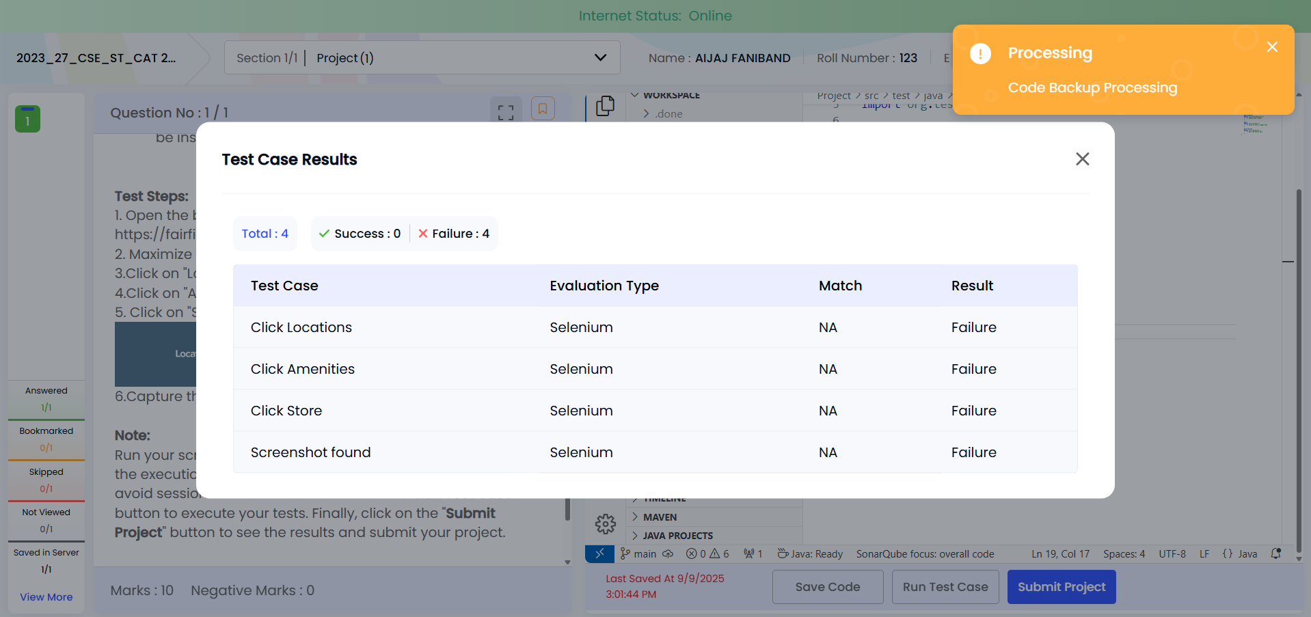

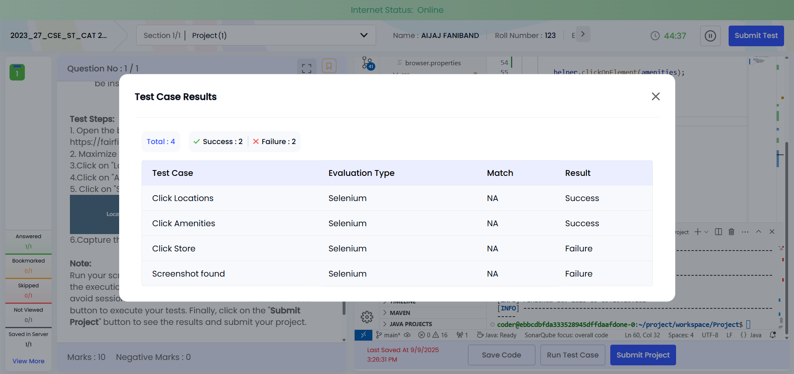

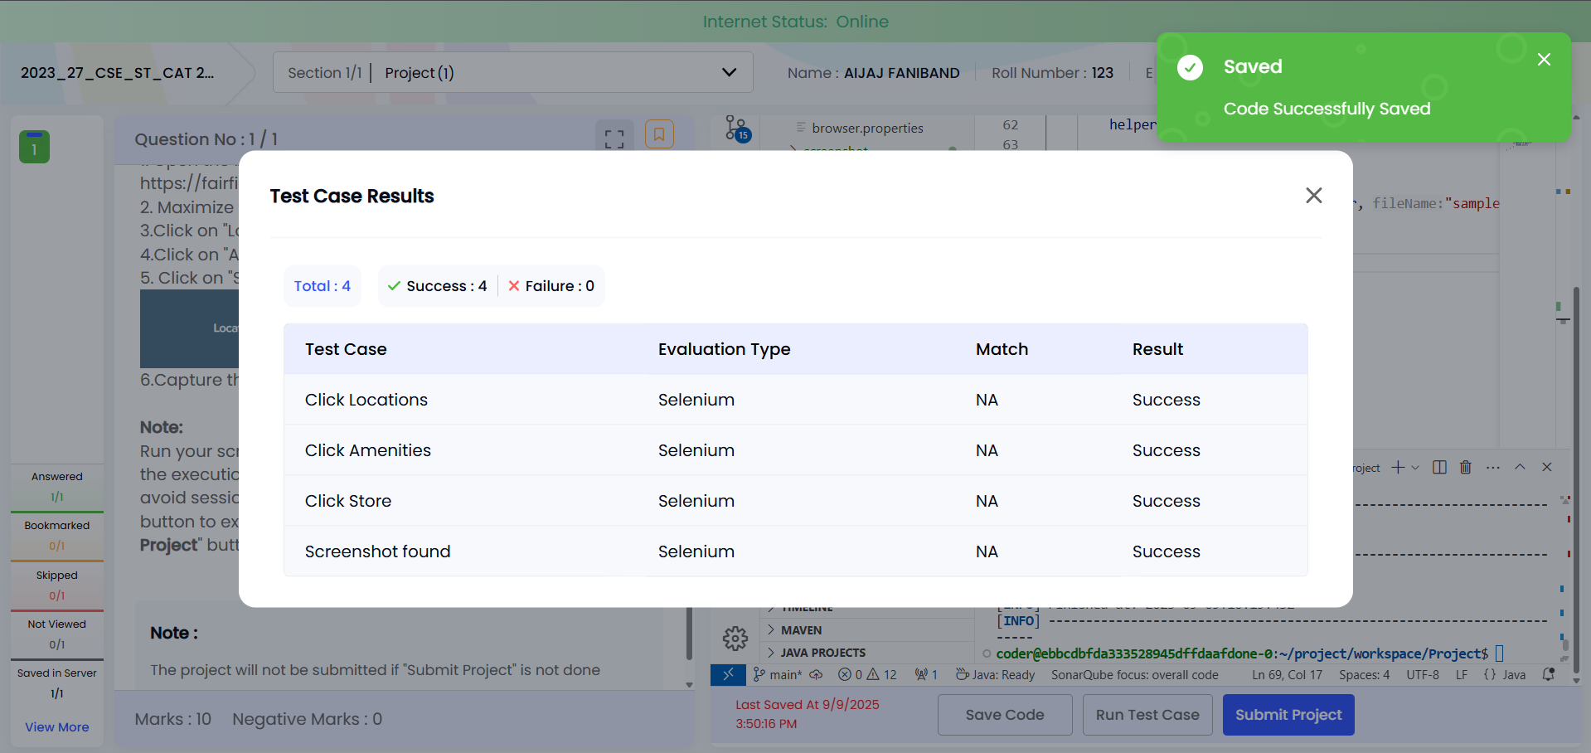

package runner;

import java.io.IOException;

import org.openqa.selenium.By;
import org.openqa.selenium.WebDriver;
import org.openqa.selenium.WebElement;
import org.testng.annotations.AfterMethod;
import org.testng.annotations.BeforeMethod;
import org.testng.annotations.Test;

import utils.Base;
import utils.Screenshot;
import utils.WebDriverHelper;

public class TestSample extends Base{

WebDriverHelper helper;

@BeforeMethod
public void launchBrowser() {
// launch your browser

try {
openBrowser();

helper = new WebDriverHelper(driver);
} catch (Exception e) {

e.printStackTrace();
}

}

@Test
public void testOne() throws InterruptedException, IOException {
// write or call ur pages here

By location = By.xpath("//a[text()='Locations']");

helper.waitForElementToBeVisible(location,10);

helper.clickOnElement(location);

By amenities = By.xpath("//a[text()='Amenities']");

helper.waitForElementToBeVisible(amenities,10);

helper.clickOnElement(amenities);

By store = By.xpath("//a[text()='Store']");

helper.waitForElementToBeVisible(store,10);

helper.clickOnElement(store);

Screenshot.getScreenShot(driver, "sample");
}

@AfterMethod
public void tearDown() {
// quit the driver here
if (driver != null) {
driver.quit();
}
}
}

2023_27_CSE_ST_CAT 2_Easy_5
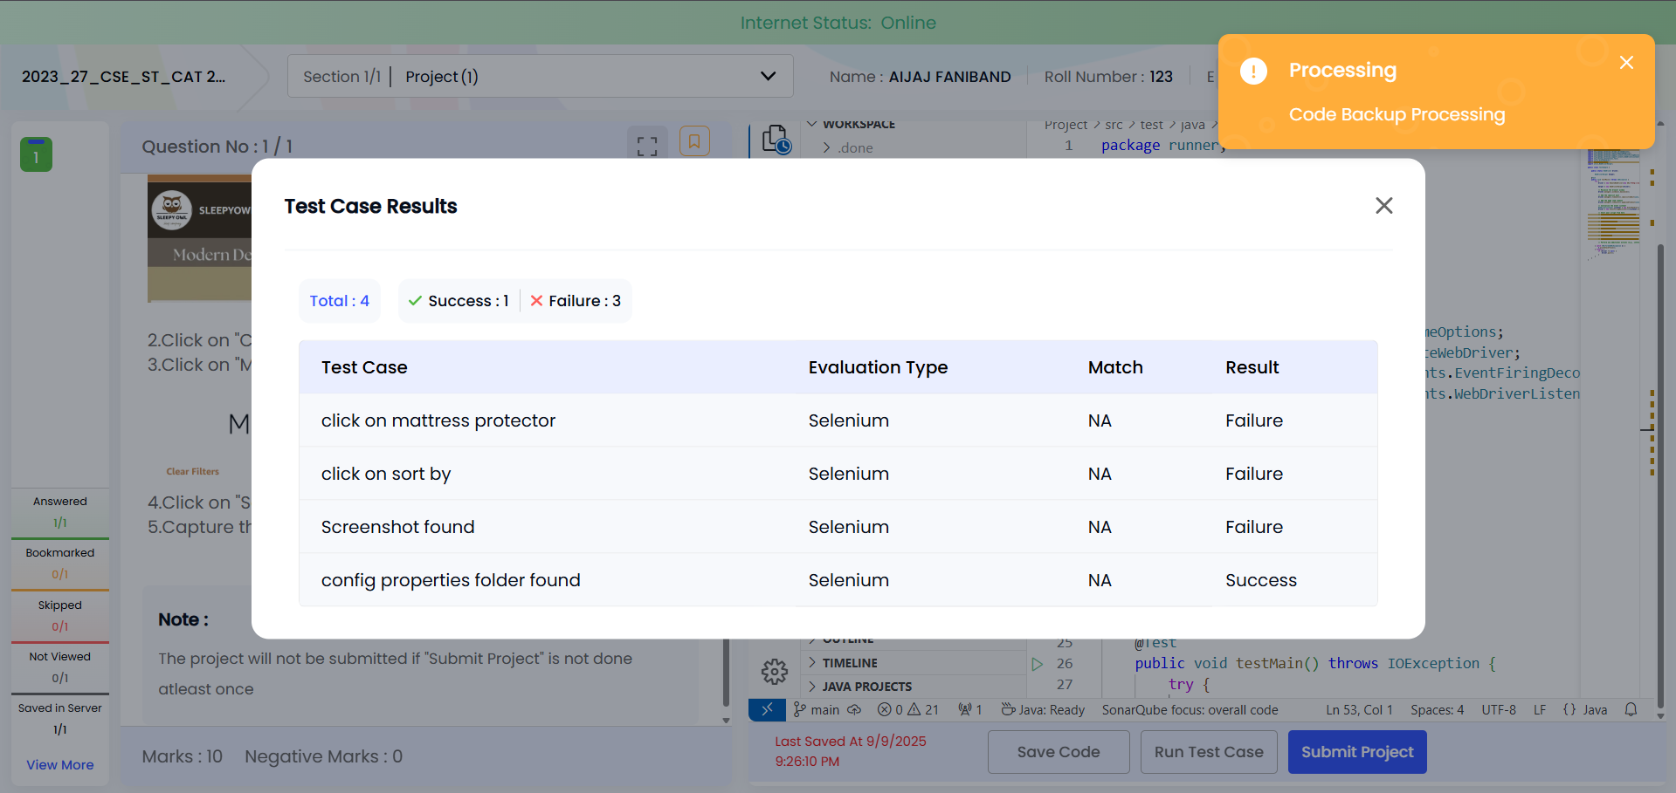

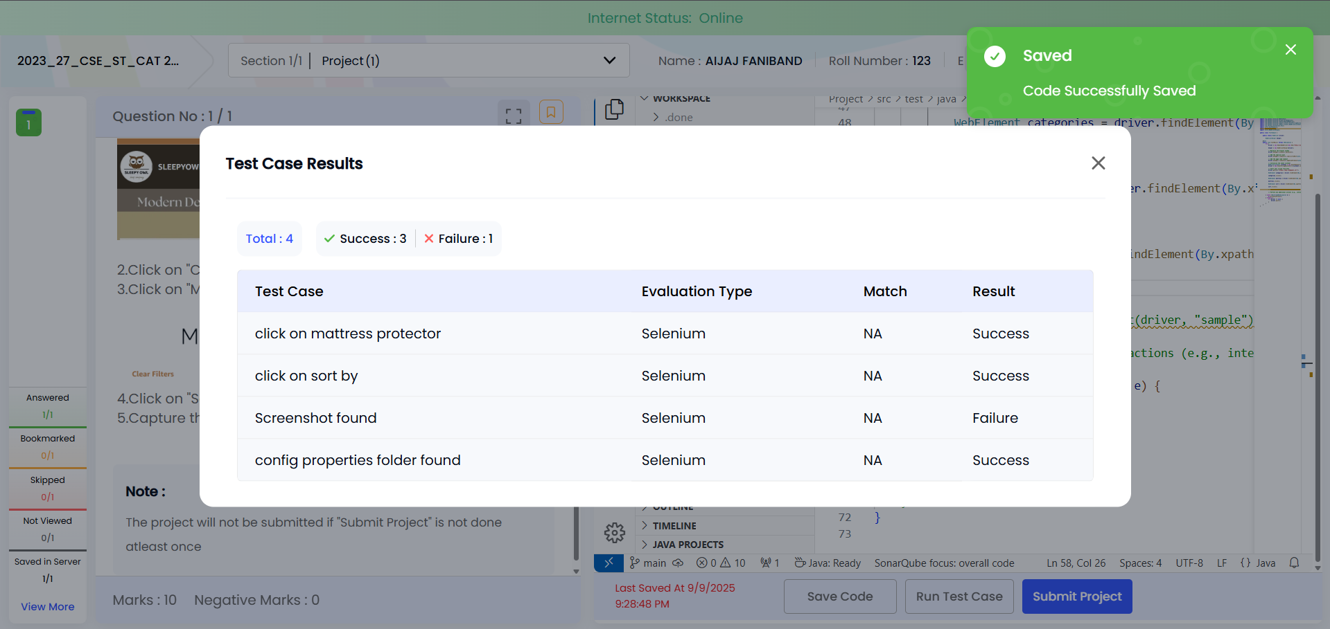

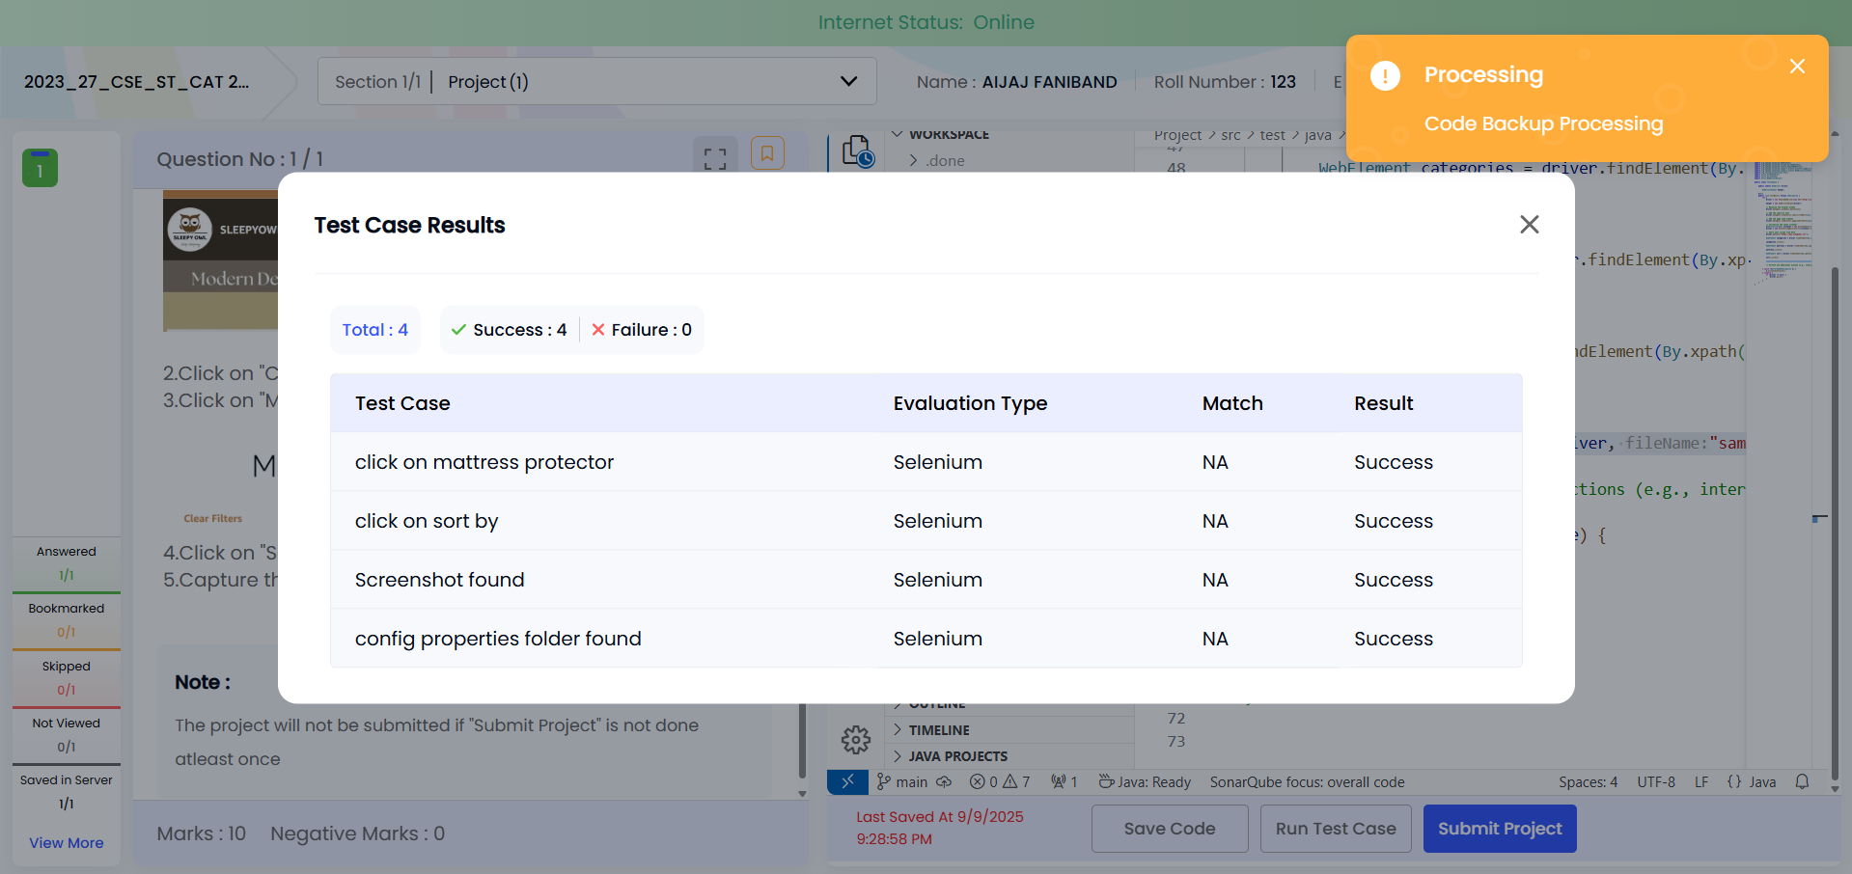

package runner;

import java.io.IOException;
import java.net.MalformedURLException;
import java.net.URL;

import org.openqa.selenium.By;
import org.openqa.selenium.WebDriver;
import org.openqa.selenium.WebElement;
import org.openqa.selenium.chrome.ChromeOptions;
import org.openqa.selenium.remote.RemoteWebDriver;
import org.openqa.selenium.support.events.EventFiringDecorator;
import org.openqa.selenium.support.events.WebDriverListener;
import org.testng.annotations.Test;
import utils.EventHandler;
import utils.Screenshot;
import utils.WebDriverHelper;

public class TestSample {

public static WebDriver driver;

WebDriverHelper helper;

@Test
public void testMain() throws IOException {
try {
driver = new RemoteWebDriver(new URL("http://localhost:4444"), new ChromeOptions());

helper = new WebDriverHelper(driver);

// Maximize the browser window
driver.manage().window().maximize();

// Add the implicit wait
driver.manage().timeouts().implicitlyWait(java.time.Duration.ofSeconds(10));

// Add the page load timeout
driver.manage().timeouts().pageLoadTimeout(java.time.Duration.ofSeconds(10));

// Initialize the event listener
WebDriverListener listener = new EventHandler();
driver = new EventFiringDecorator<>(listener).decorate(driver);

// Start your script from here
driver.get("https://www.sleepyowl.in/");

WebElement categories = driver.findElement(By.xpath("//div[normalize-space()='Categories']"));

categories.click();

WebElement mattress = driver.findElement(By.xpath("//p[@class='css-1bgph81'][normalize-space()='Mattress Protector']"));

mattress.click();

WebElement sort = driver.findElement(By.xpath("//p[normalize-space()='Sort By']"));

sort.click();

Screenshot.getScreenShot(driver, "sample");

// Perform any additional actions (e.g., interacting with elements)

} catch (MalformedURLException e) {
e.printStackTrace();
} finally {
if (driver != null) {
driver.quit();
}
}
}
}

2023_27_CSE_ST_CAT 2_Easy_6
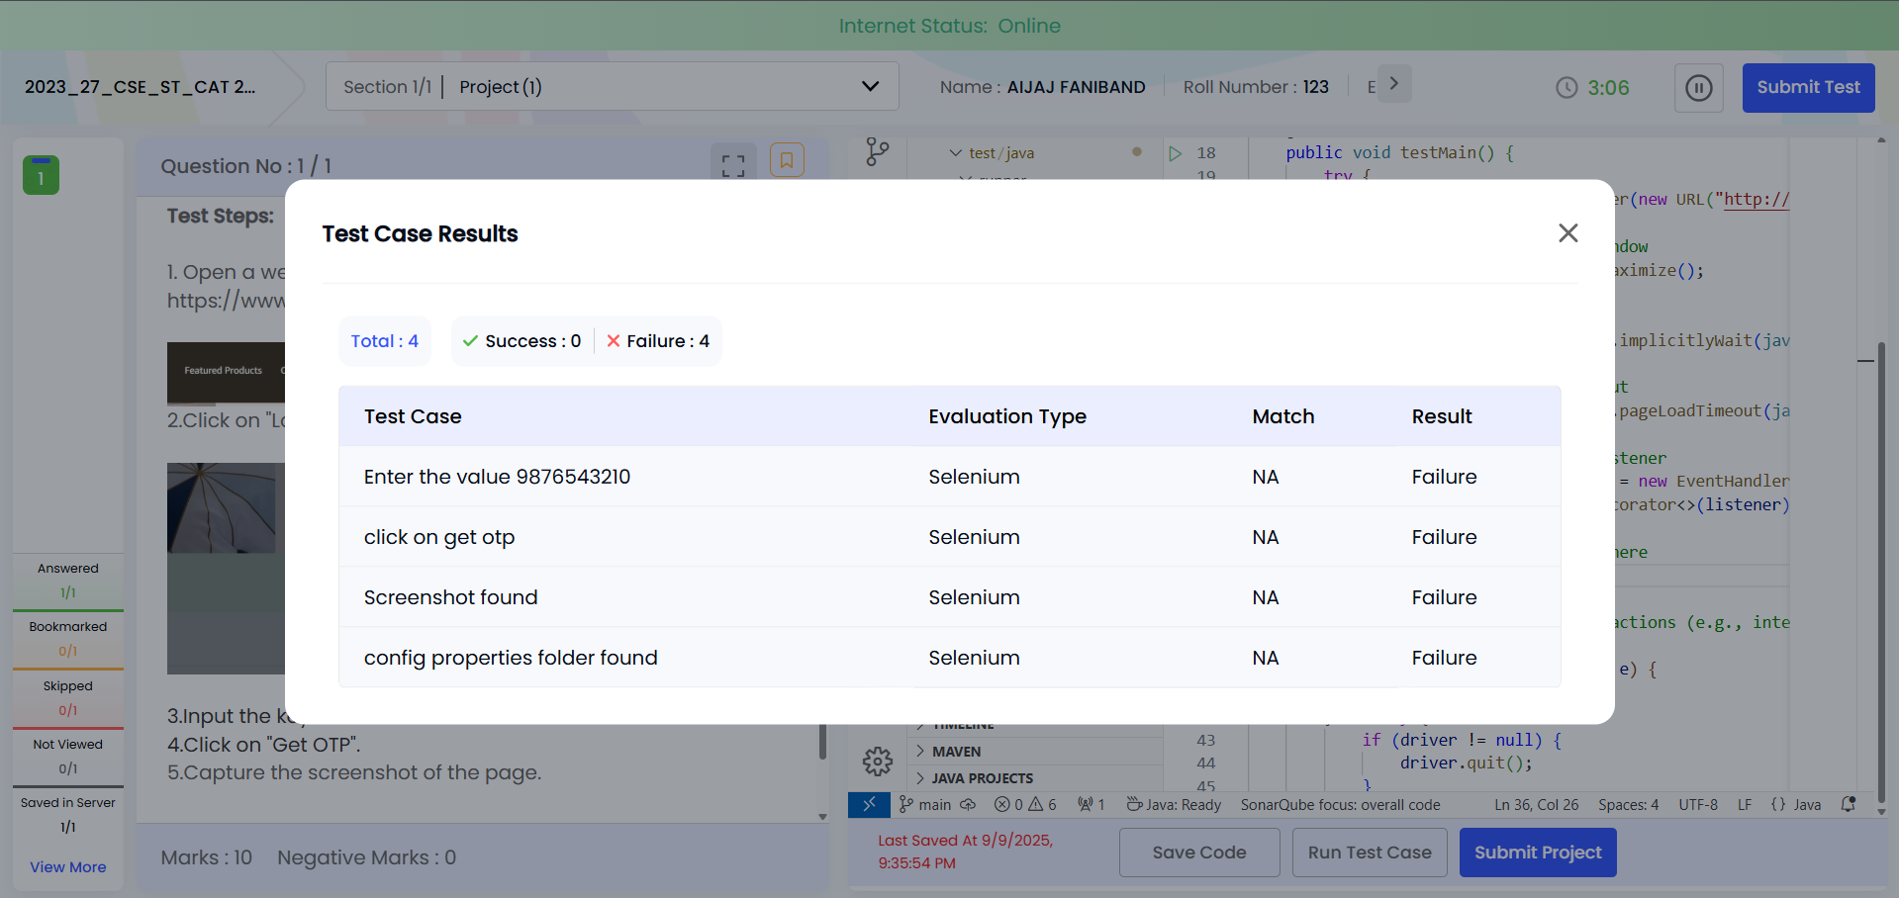

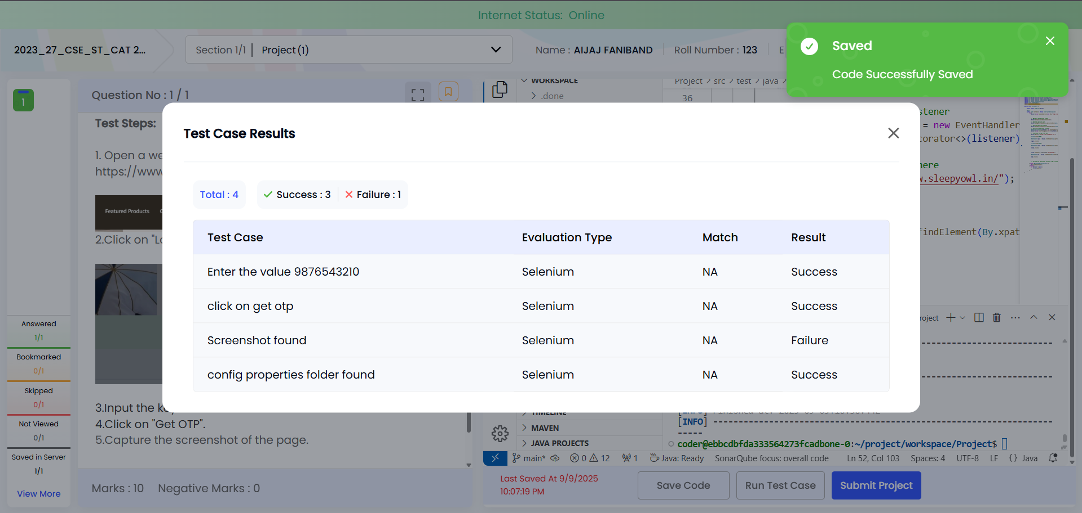

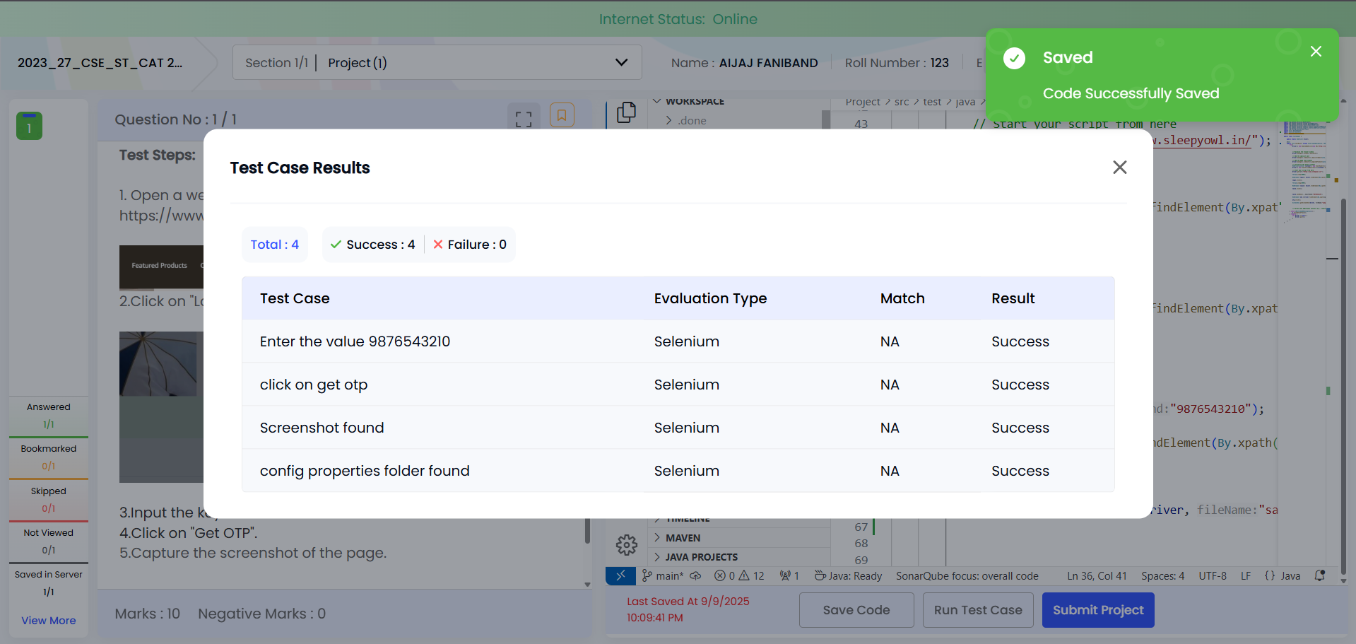

package runner;

import java.io.IOException;
import java.net.MalformedURLException;
import java.net.URL;

import org.openqa.selenium.By;
import org.openqa.selenium.WebDriver;
import org.openqa.selenium.WebElement;
import org.openqa.selenium.chrome.ChromeOptions;
import org.openqa.selenium.remote.RemoteWebDriver;
import org.openqa.selenium.support.events.EventFiringDecorator;
import org.openqa.selenium.support.events.WebDriverListener;
import org.testng.annotations.Test;
import utils.EventHandler;
import utils.Screenshot;
import utils.WebDriverHelper;

public class TestSample {

public static WebDriver driver;

@Test
public void testMain() throws InterruptedException, IOException {
try {
driver = new RemoteWebDriver(new URL("http://localhost:4444"), new ChromeOptions());

// Maximize the browser window
driver.manage().window().maximize();

// Add the implicit wait
driver.manage().timeouts().implicitlyWait(java.time.Duration.ofSeconds(10));

// Add the page load timeout
driver.manage().timeouts().pageLoadTimeout(java.time.Duration.ofSeconds(10));

// Initialize the event listener
WebDriverListener listener = new EventHandler();
driver = new EventFiringDecorator<>(listener).decorate(driver);

// Start your script from here
driver.get("https://www.sleepyowl.in/");

Thread.sleep(5000);

WebElement login = driver.findElement(By.xpath("//p[text()='Login']"));

login.click();

Thread.sleep(6000);

WebElement value = driver.findElement(By.xpath("//input[@placeholder='Enter Phone Number']"));

value.click();

value.sendKeys("9876543210");

WebElement otp = driver.findElement(By.xpath("//button[text()='Get OTP']"));

otp.click();

Screenshot.getScreenShot(driver, "sample");

// Perform any additional actions (e.g., interacting with elements)

} catch (MalformedURLException e) {
e.printStackTrace();
} finally {
if (driver != null) {
driver.quit();
}
}
}
}

