Use Case No:13
Jenkins Availability Monitoring and Alerting on AWS EC2
Problem Statement:
Ensure Jenkins service running on an EC2 instance is continuously monitored for downtime and restarts, generate reports for audit, and trigger automated alerts using AWS services.
Trigger Condition:
Jenkins service goes DOWN or restarts unexpectedly.
Workflow:
- Install Jenkins on EC2:
- Deploy Jenkins using package manager and enable systemd service.

- Monitor Jenkins Status:
- Use a bash script scheduled via cron to check systemctl is-active jenkins.
- Log events (UP/DOWN) with timestamps in /var/log/jenkins_monitor.log.

- Generate Report:
- Parse log file to count downtime and uptime occurrences

- Configure AWS Alerts:
- Enable CloudWatch Agent to monitor Jenkins process or custom metric.
- Create CloudWatch Alarm for Jenkins DOWN or restart events.
- Attach SNS Topic for email/SMS notifications.

Expected Outcome:
- Jenkins downtime and restart events tracked automatically.
- Alerts triggered instantly when Jenkins goes down or restarts.

Step 1: Creating EC2 Instance and installing Jenkins using Cloud Formation:
Procedure:
- Create a Cloud Formation yaml file and store it in local system.
  - Details about EC2 Instance type and AMI Image ID.
  - Details about the Inbound and Outbound rule.
  - Details about the application and installation instructions.
- Create a Key-Pair and download the private key.
- Cloud Formation Console Create Stack Upload the template cloud formation yaml file.
- Give the Stack name and Key-Pair name which we created. Create Stack.
- Instance created with all the configuration which we mentioned in the yaml file.
- Open browser and <EC2_Public_IP>:8080. Jenkins Interface will open.
- Result: EC2 Instance created, and Jenkins installed, and Jenkins server is Up.

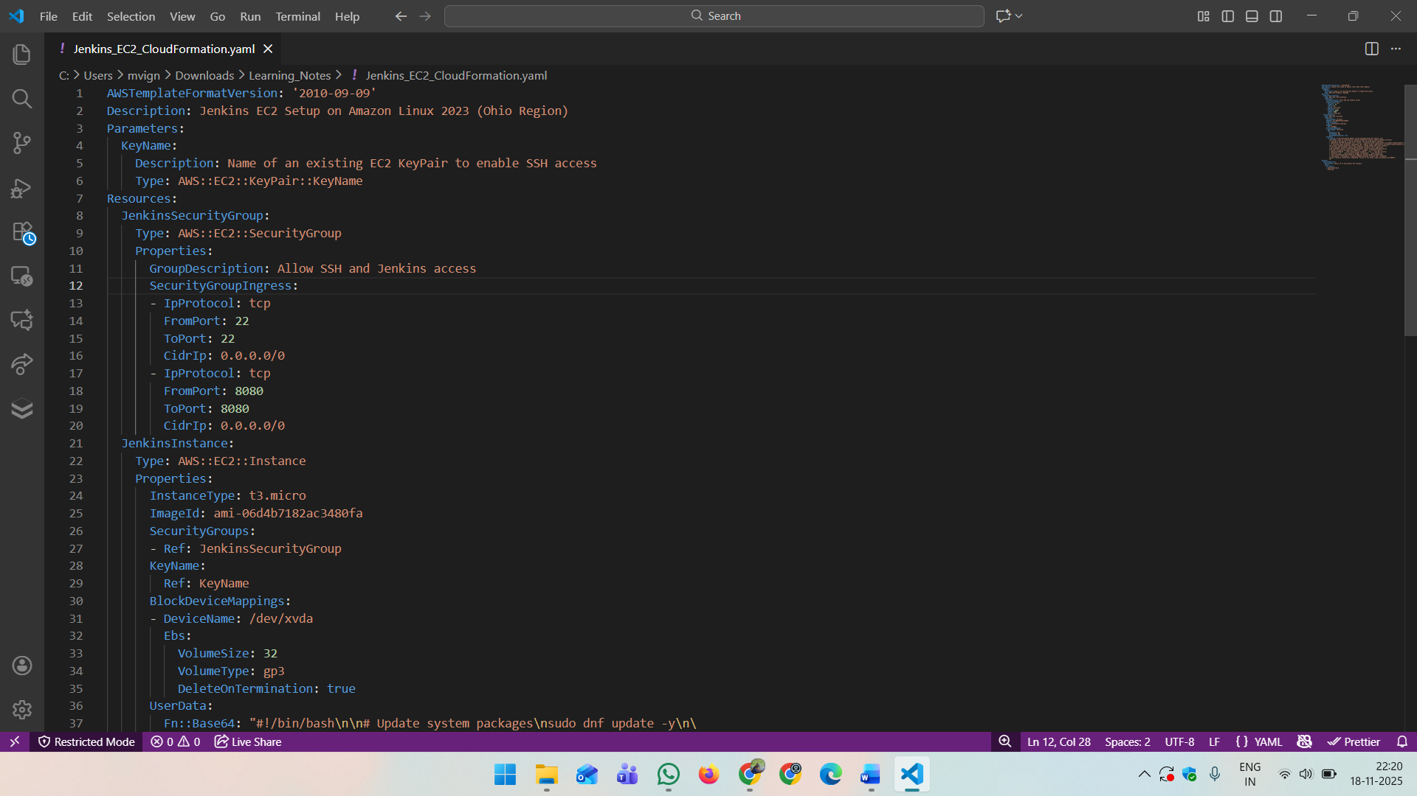

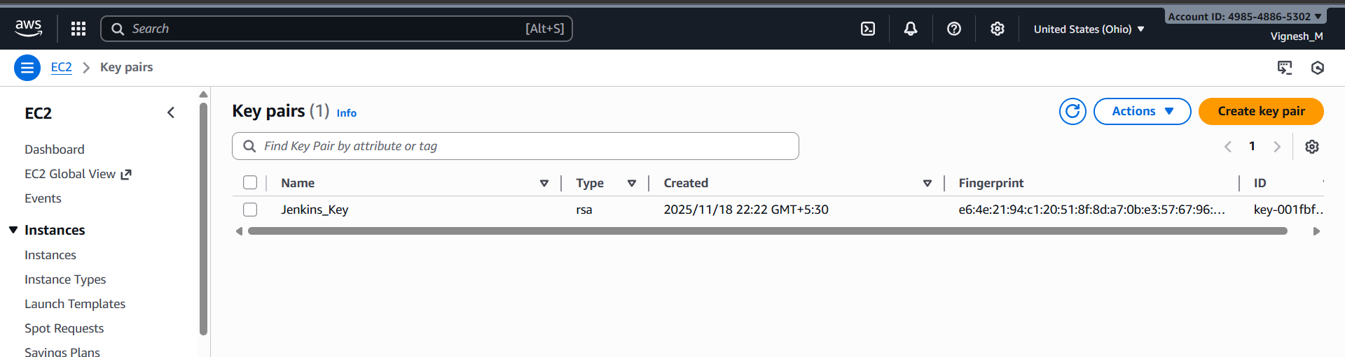

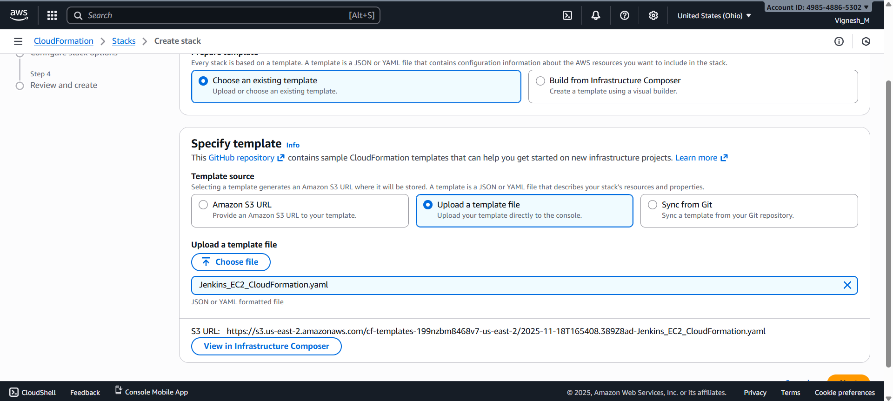

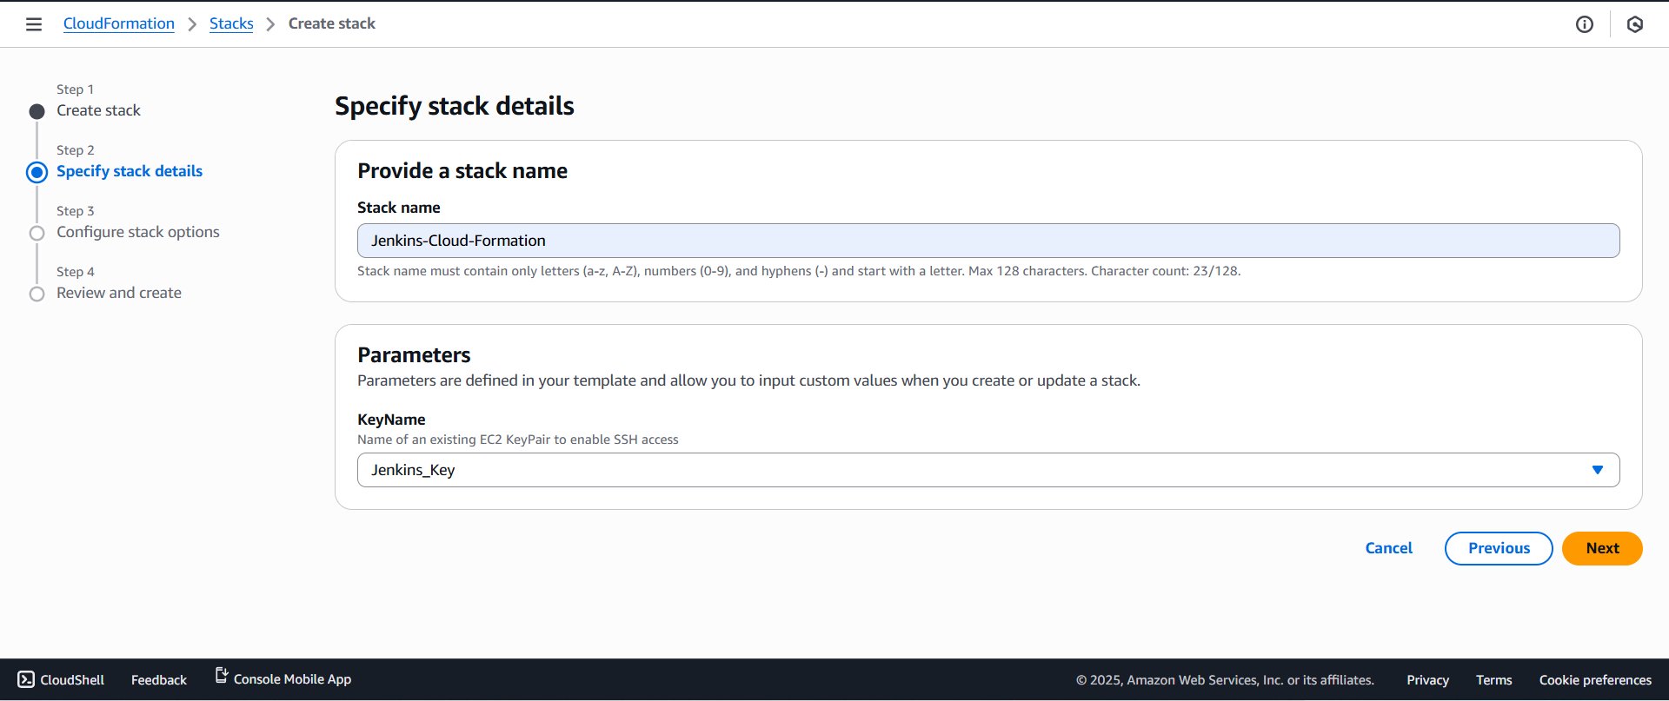

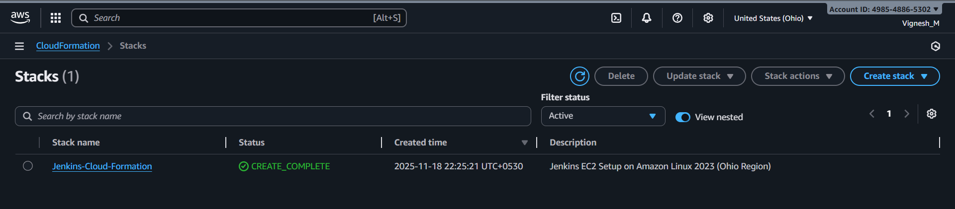
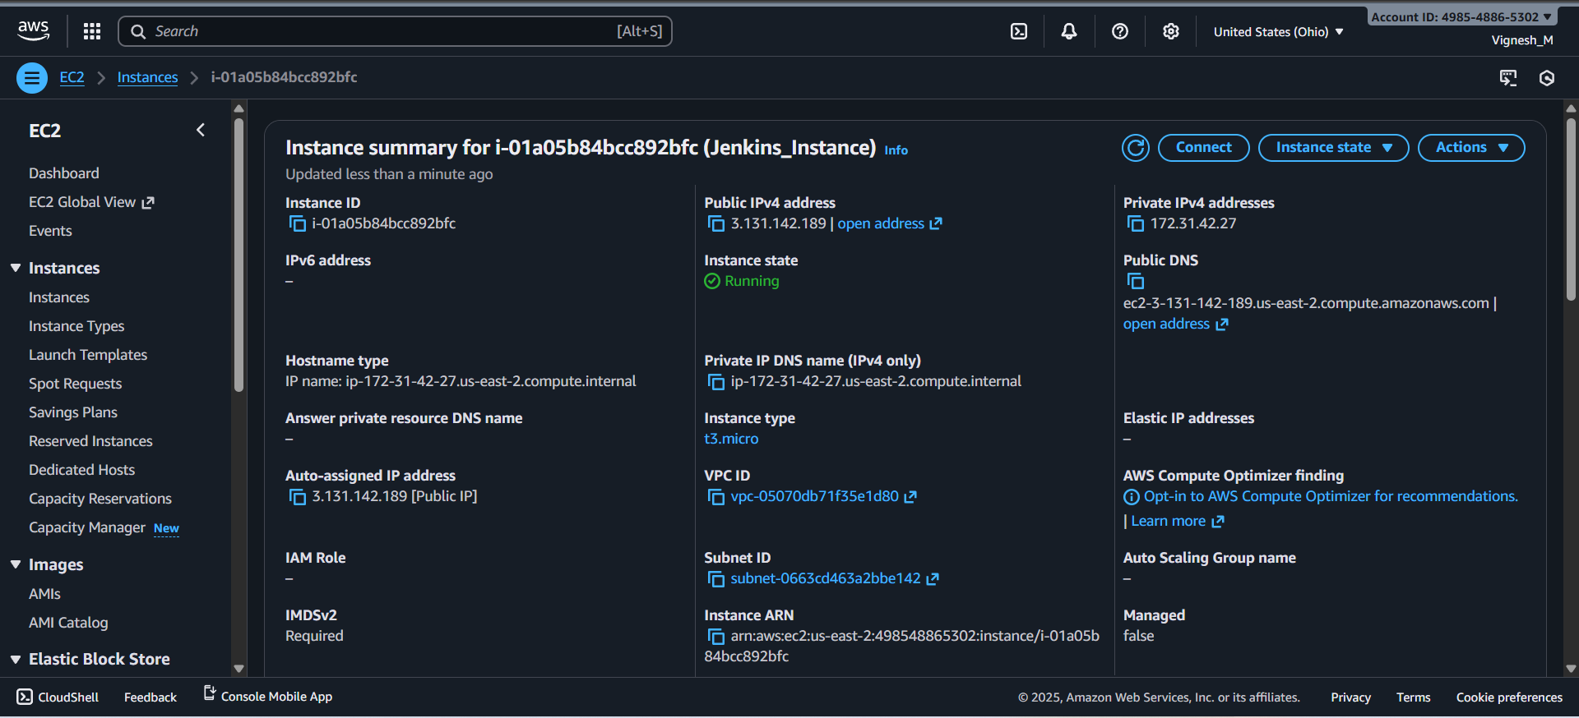
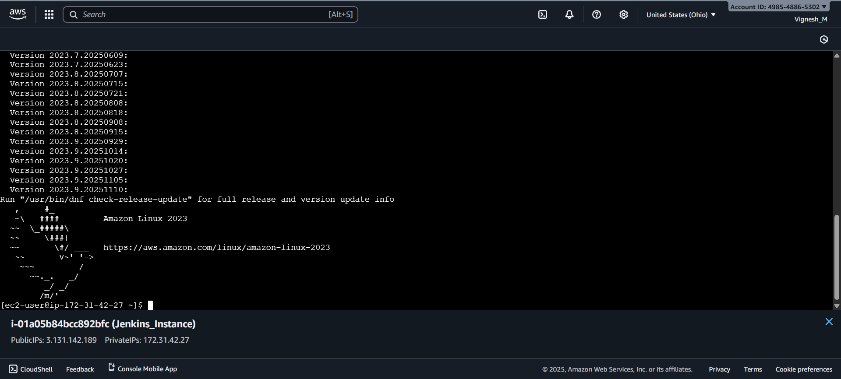
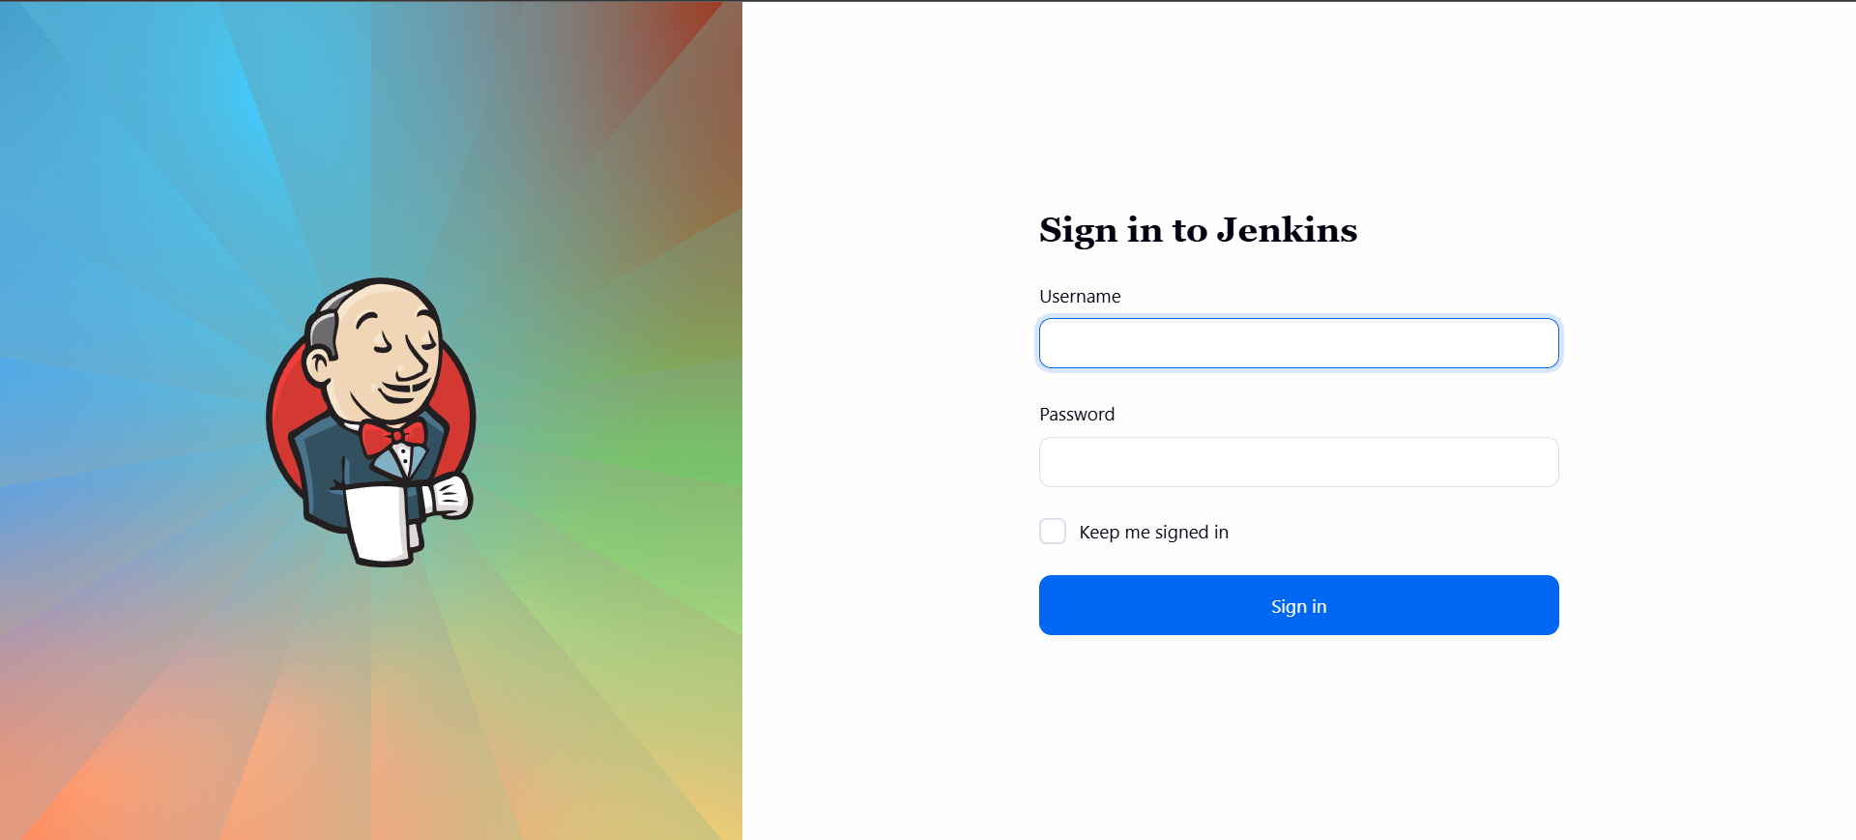

Step 2: Create Shell Script file in /usr/local/bin location:
Procedure:
- Inside EC2 terminal create jenkins_monitor.sh and Jenkins_monitor_report.sh in /usr/local/bin location.
- Change the permission of the file and make it executable.
  - sudo chmod +x <File_Name>
- Install crontab for cronjob scheduling if it is not there.
  - Command 1: sudo yum install cronie -y
  - Command 2: sudo systemctl enable crond
  - Command 3: sudo systemctl start crond
  - Command 4: sudo systemctl status crond
- Set the cronjob for executing the Jenkins_monitor.sh script every minute to check the Jenkins status.
  - sudo crontab -e
  - sudo crontab -l
- For every one minute the cronjob will run and the log will store in /var/log/Jenkins_monitor.sh
- If we run the jenkins_monitor_report.sh, it will parse the log file and show the number of occurrences of UP, DOWN and RESTART and last 10 log events.
- Result:
  - Jenkins_monitor.sh and Jenkins_monitor_report.sh file create.
  - Cronjob set successfully for Jenkins_monitor.sh.
  - /var/log/Jenkins_monitor.log file created and log are fetching correctly.
  - jenkins_monitor_report.sh is executing and report is generations correctly.
Jenkins_monitor.sh code:
#!/usr/bin/env bash
export TZ="Asia/Kolkata"
LOG="/var/log/jenkins_monitor.log"
STATE="/var/run/jenkins_monitor.state"
# Local IST timestamp
timestamp() { date +"%Y-%m-%dT%H:%M:%S%z"; }
mkdir -p "$(dirname "$LOG")"
touch "$LOG"
chmod 644 "$LOG"
active=$(systemctl is-active jenkins 2>/dev/null || echo "unknown")
pid=$(pgrep -f "jenkins.war" | head -n1 || true)
prev_active=""
prev_pid=""
if [ -f "$STATE" ]; then
read -r prev_active prev_pid < "$STATE" || true
fi
if [ "$active" != "$prev_active" ]; then
echo "$(timestamp) STATUS_CHANGE $active prev=$prev_active" >> "$LOG"
fi
if [ -n "$prev_pid" ] && [ -n "$pid" ] && [ "$pid" != "$prev_pid" ]; then
echo "$(timestamp) RESTART detected new_pid=$pid old_pid=$prev_pid" >> "$LOG"
fi
if [ -z "$prev_pid" ] && [ -n "$pid" ] && [ "$active" = "active" ]; then
echo "$(timestamp) START detected pid=$pid" >> "$LOG"
fi
if [ "$active" != "active" ]; then
echo "$(timestamp) DOWN state=$active" >> "$LOG"
fi
echo "$active $pid" > "$STATE"

Jenkins_monitor_report.sh code:
#!/usr/bin/env bash
LOG="/var/log/jenkins_monitor.log"
echo "Jenkins Monitor Report"
echo "Generated: $(date -u +"%Y-%m-%dT%H:%M:%SZ")"
echo
echo "Total DOWN occurrences: $(grep -c "DOWN state" "$LOG" 2>/dev/null || echo 0)"
echo "Total START occurrences: $(grep -c "START detected" "$LOG" 2>/dev/null || echo 0)"
echo "Total RESTART occurrences: $(grep -c "RESTART detected" "$LOG" 2>/dev/null || echo 0)"
echo
echo "Last 10 events:"
tail -n 10 "$LOG"

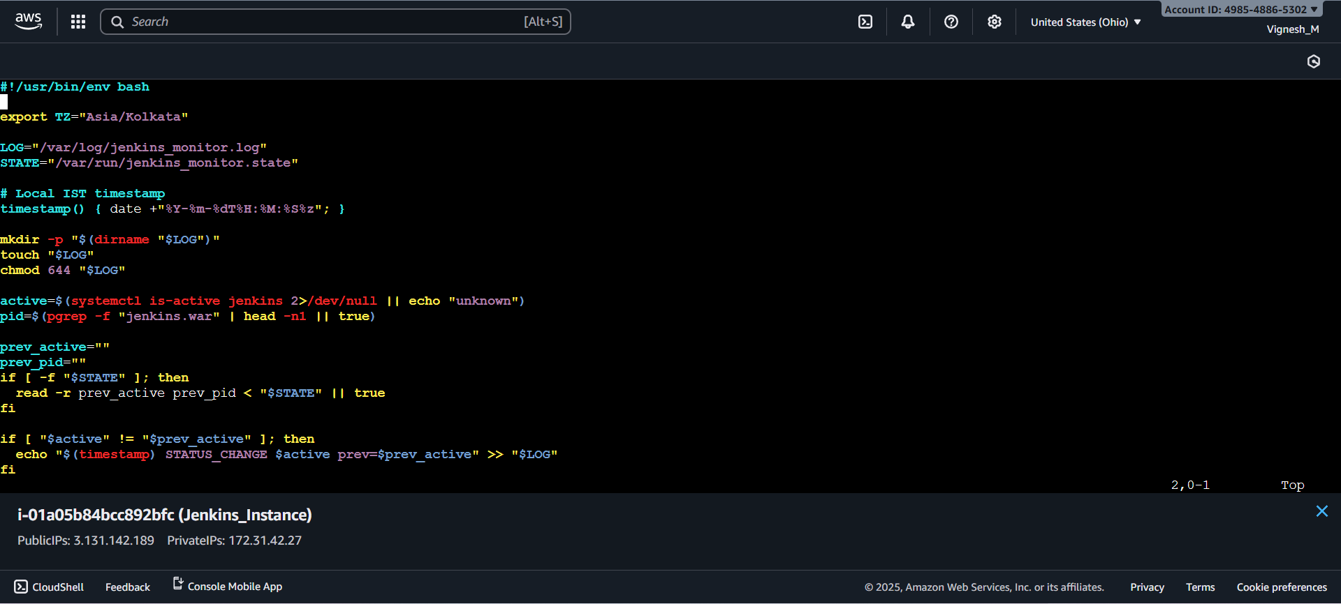
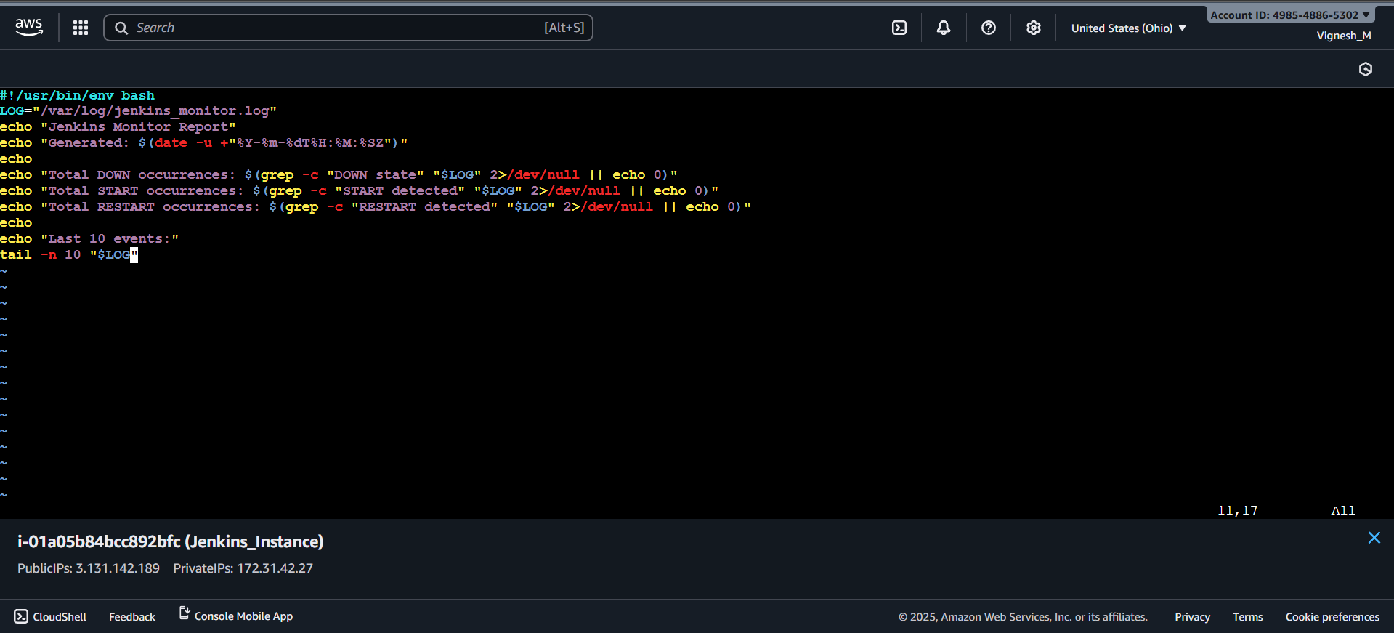
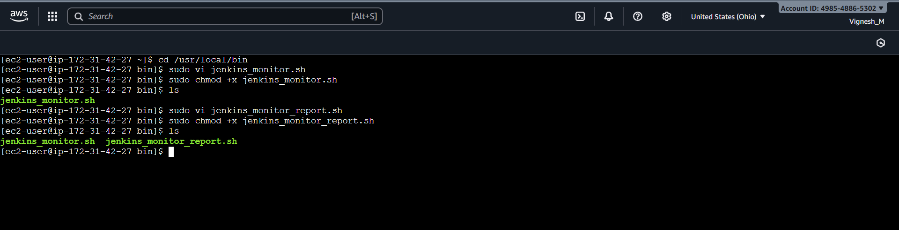

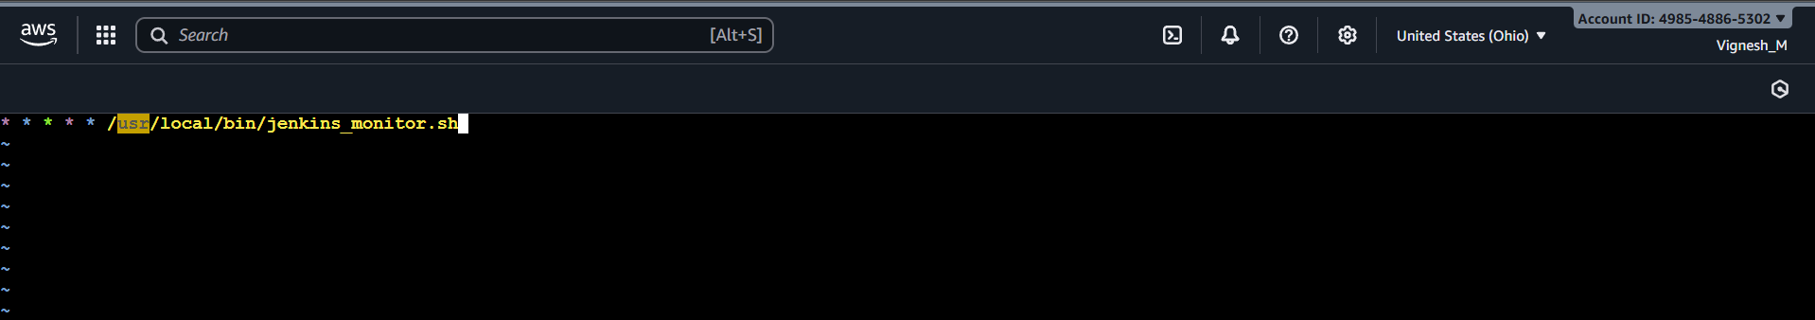

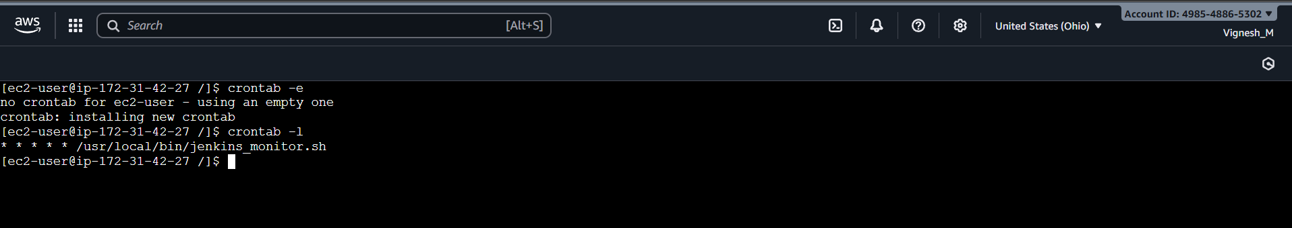

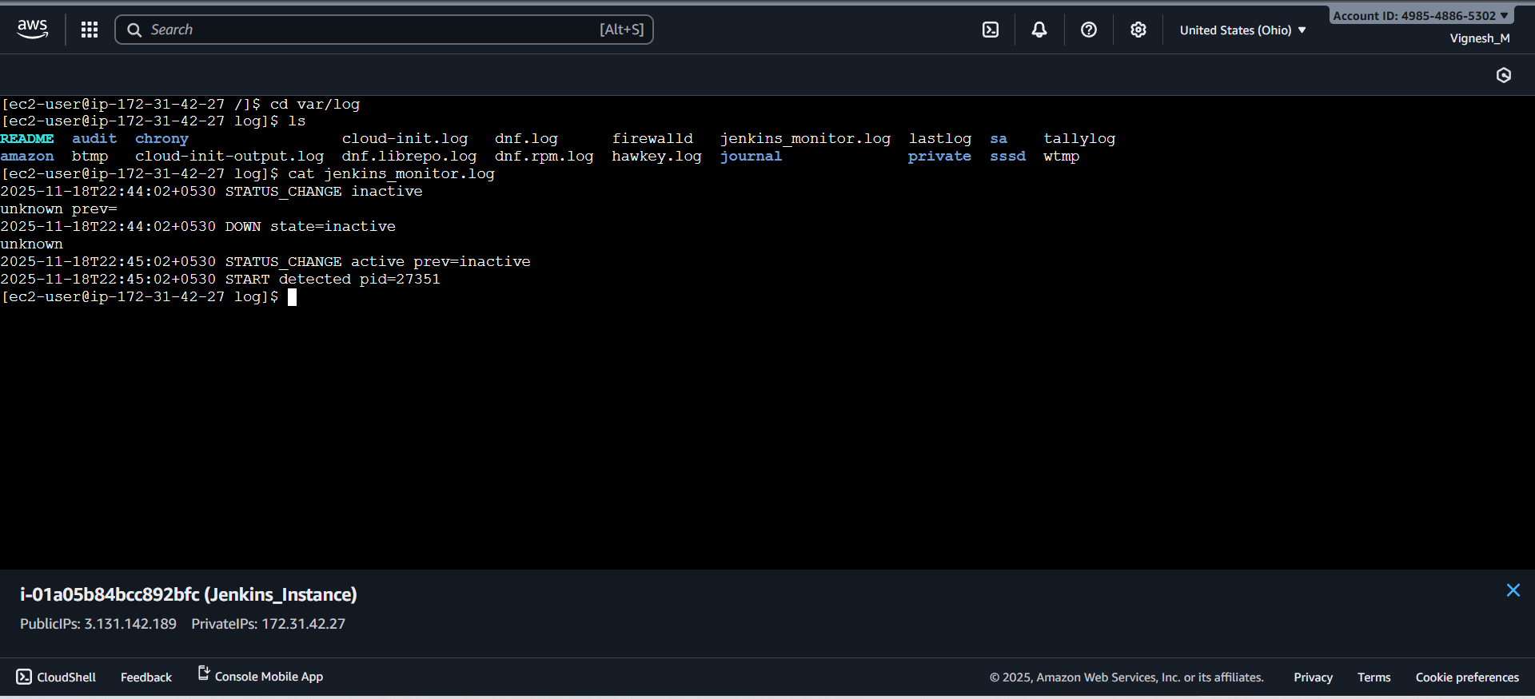

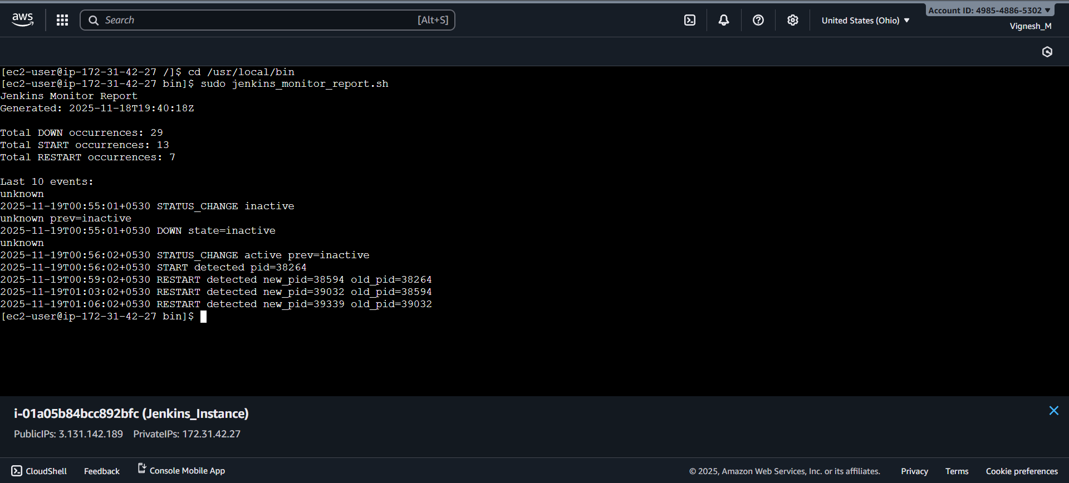
Step 3: Install and Configure the CloudWatch Agent:
Procedure:
- Create a role and attach it to EC2 instances for configuring the cloud watch agent in the EC2 instance.
  - Policy 1: AmazonSSMManagedInstanceCore
  - Policy 2: CloudWatchServerPolicy
  - Role Name: EC2CloudWatchAgentRole
- Attach the create role to the EC2 instance.
- Install the cloud watch agent and configure that with our EC2 Instance.
  - Command 1: sudo yum install amazon-cloudwatch-agent -y
  - Command 2: sudo /opt/aws/amazon-cloudwatch-agent/bin/amazon-cloudwatch-agent-config-wizard
  - Command 3: sudo /opt/aws/amazon-cloudwatch-agent/bin/amazon-cloudwatch-agent-ctl -a fetch-config -m ec2 -c file:/opt/aws/amazon-cloudwatch-agent/bin/config.json
  - Command 4: sudo /opt/aws/amazon-cloudwatch-agent/bin/amazon-cloudwatch-agent-ctl -a start
  - Command 5: sudo /opt/aws/amazon-cloudwatch-agent/bin/amazon-cloudwatch-agent-ctl -a status
- After executing the commands, config file will create, and it will have all the metrics and log file details which we are going to monitor.
- Result:
  - Role assigned to EC2 instance.
  - Cloud watch agent installed and configured in EC2 instance successfully.
  - Jenkins_monitor.log file log fetch by cloud watch agent and send it to cloud watch console correctly.

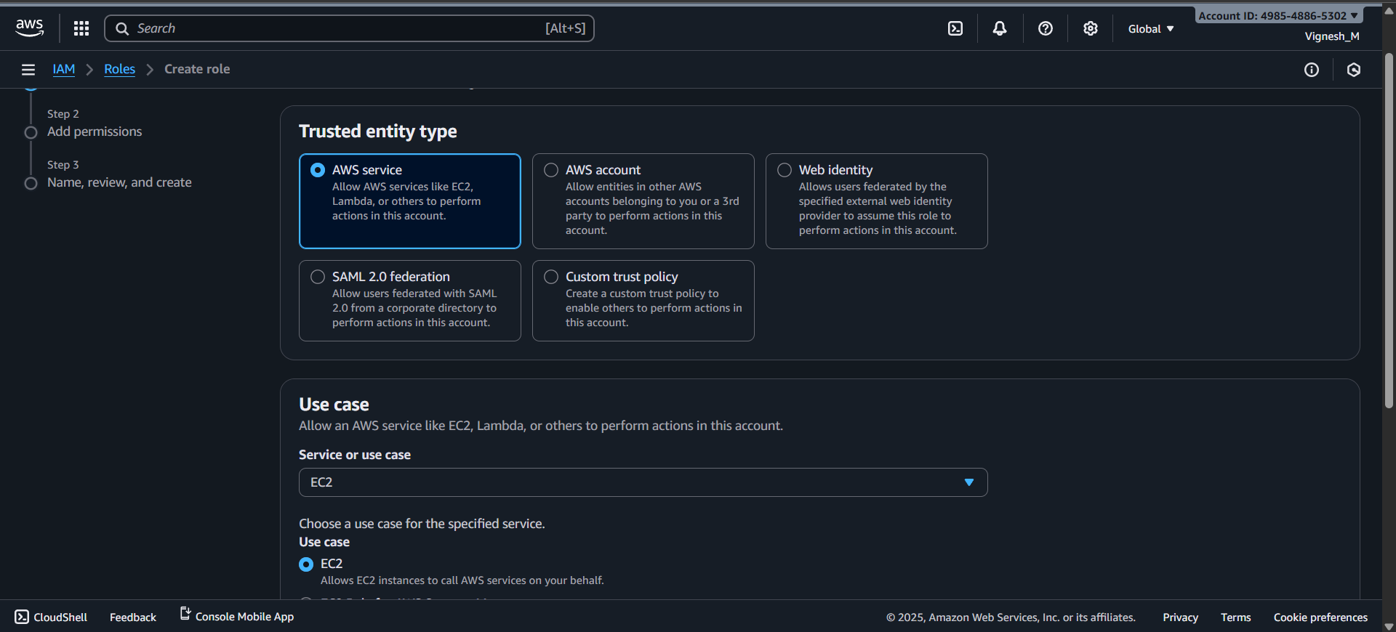

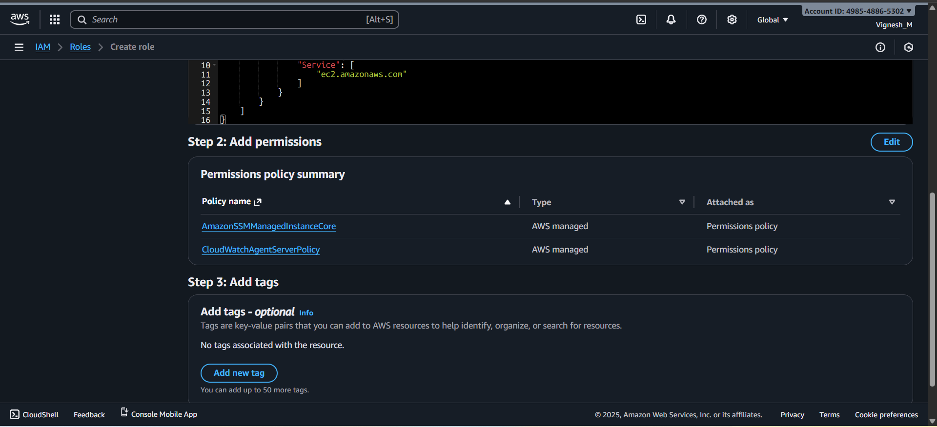

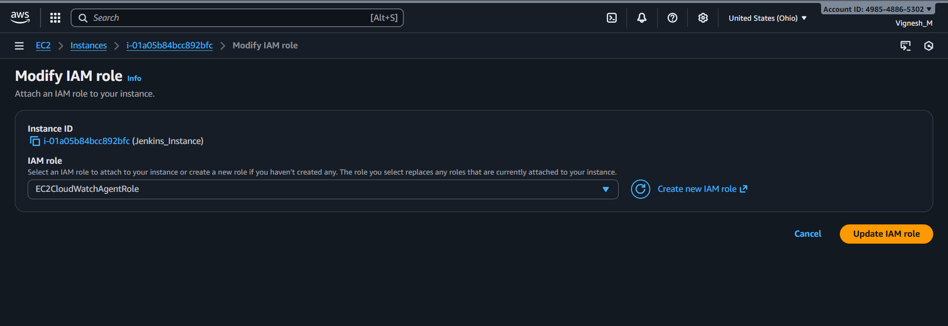

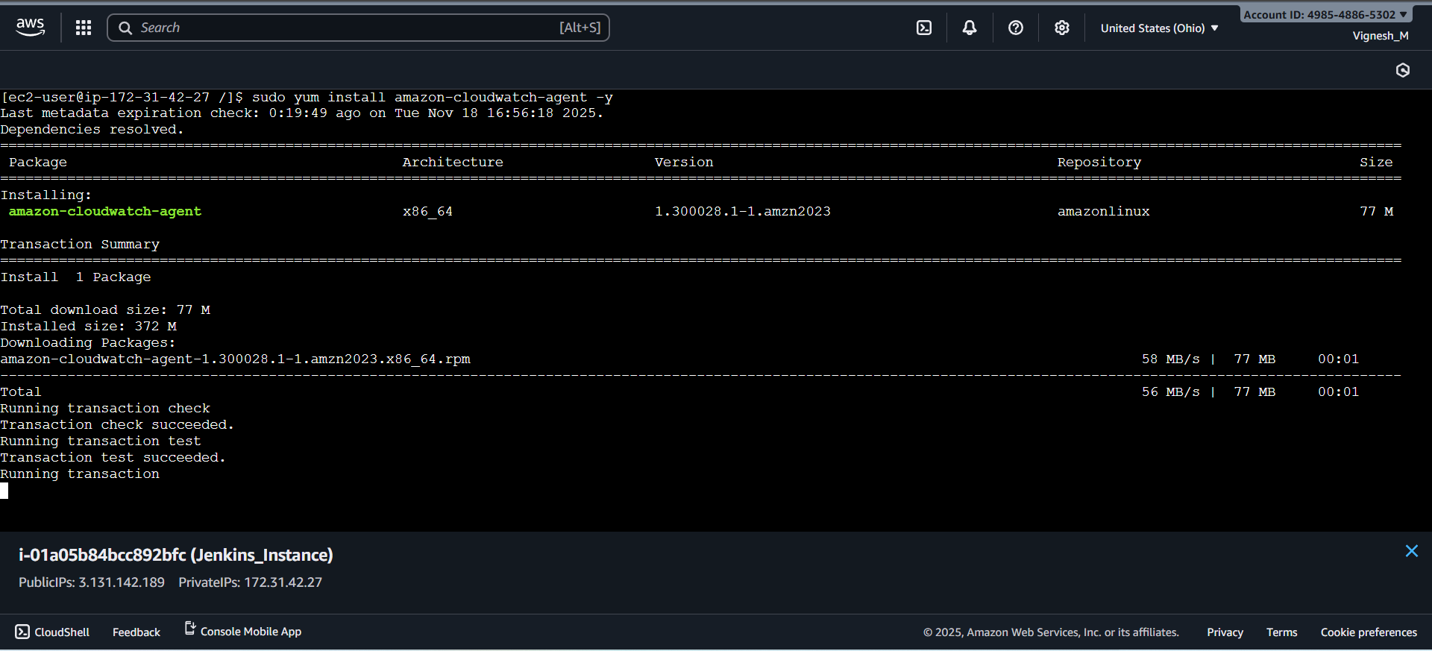

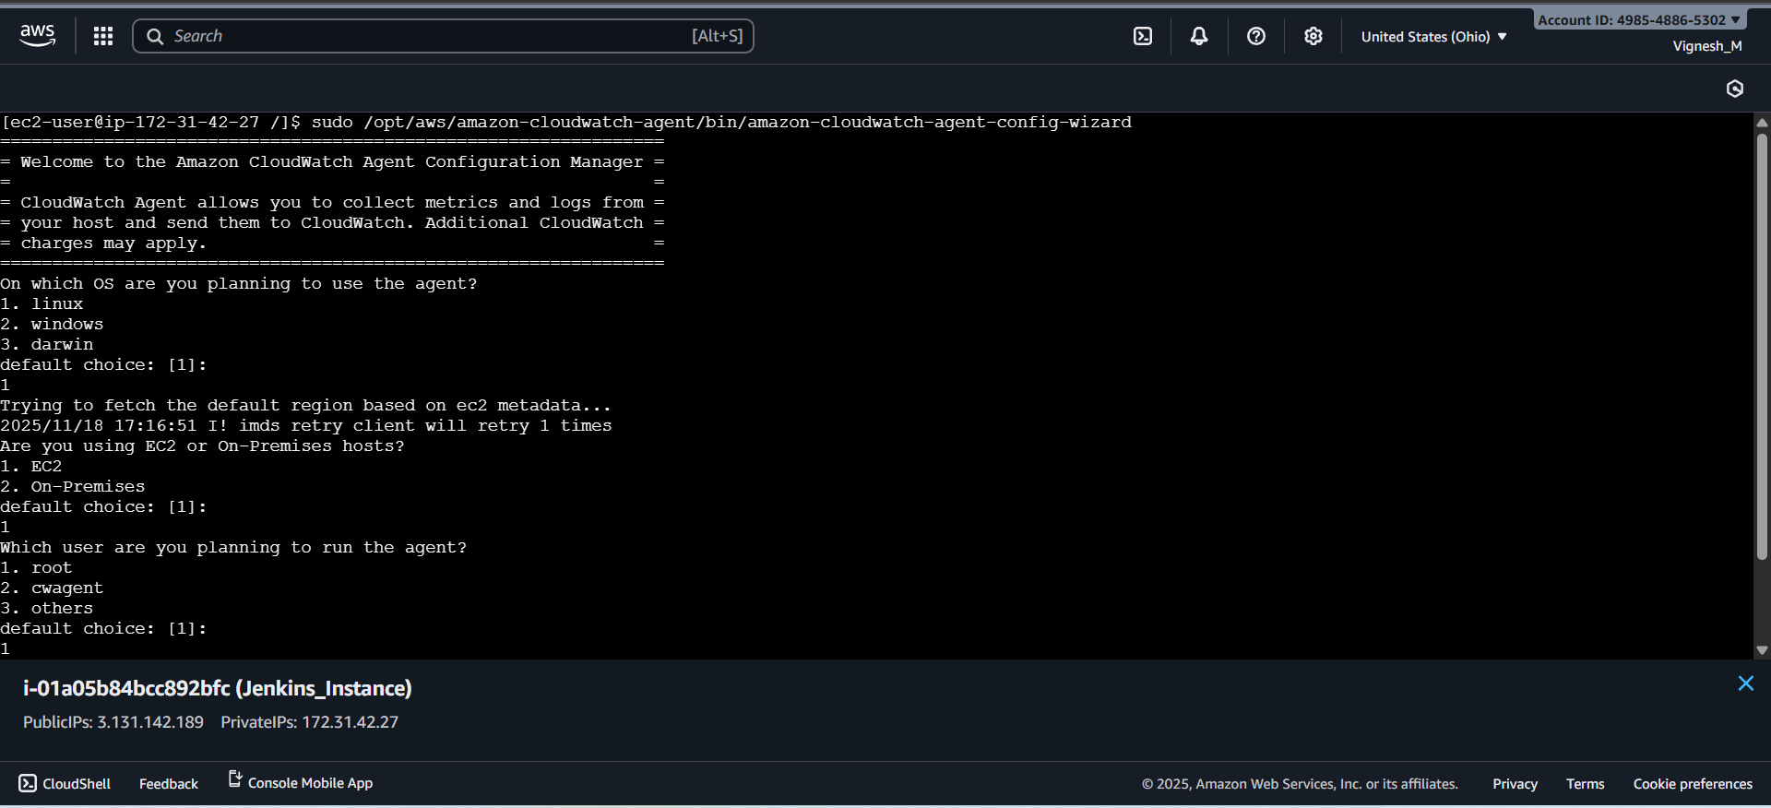

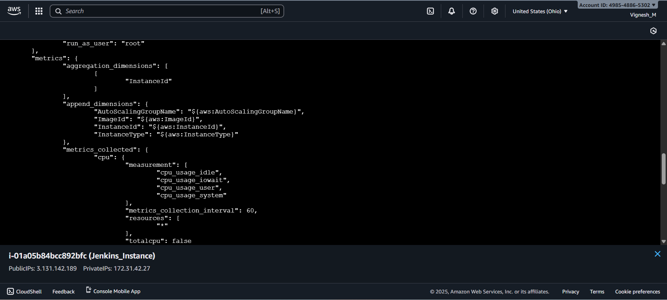

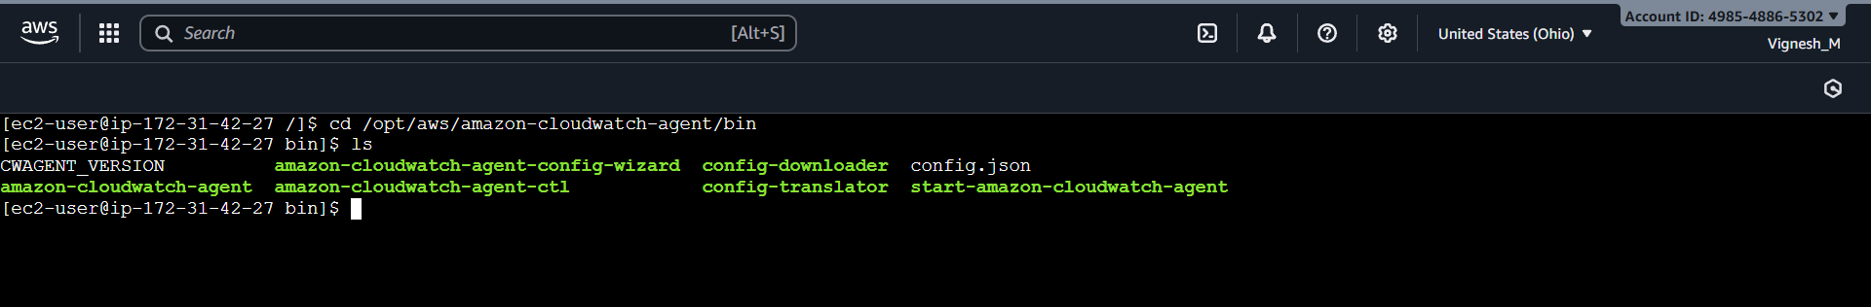

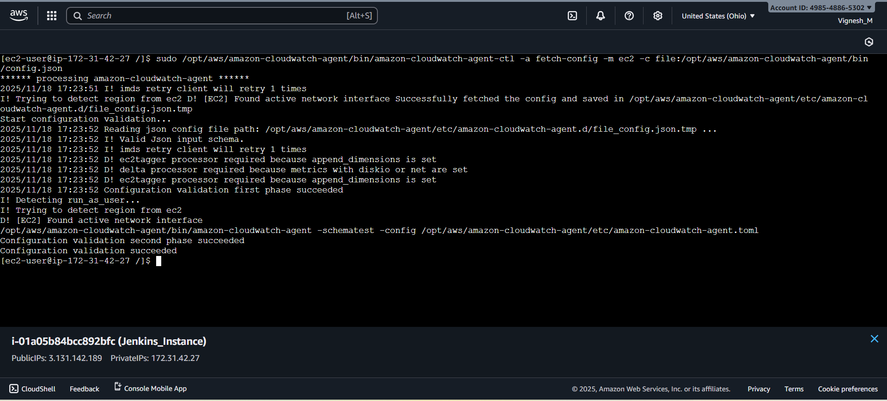

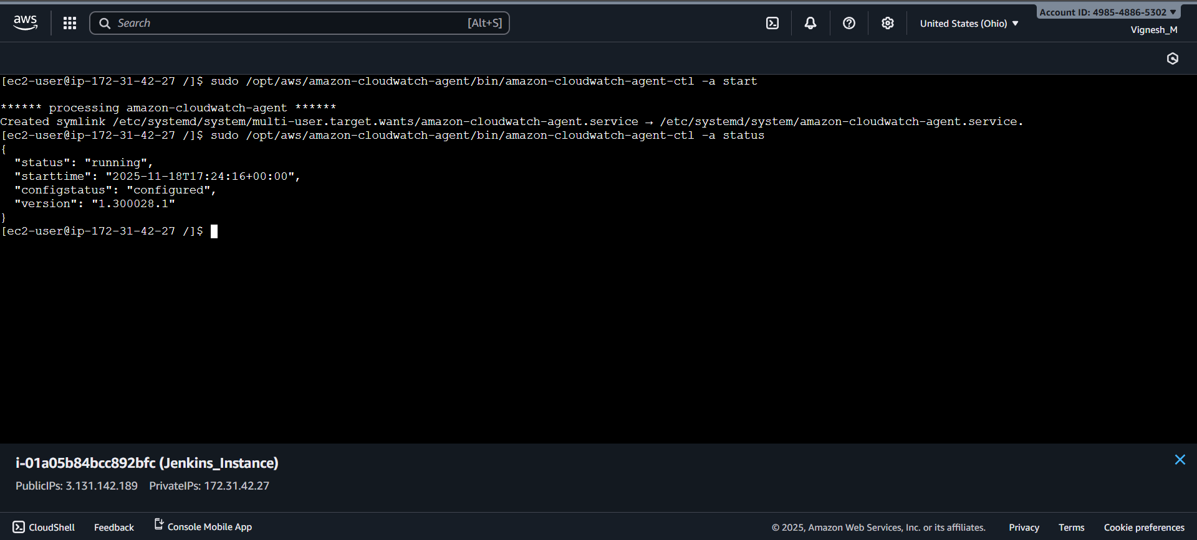

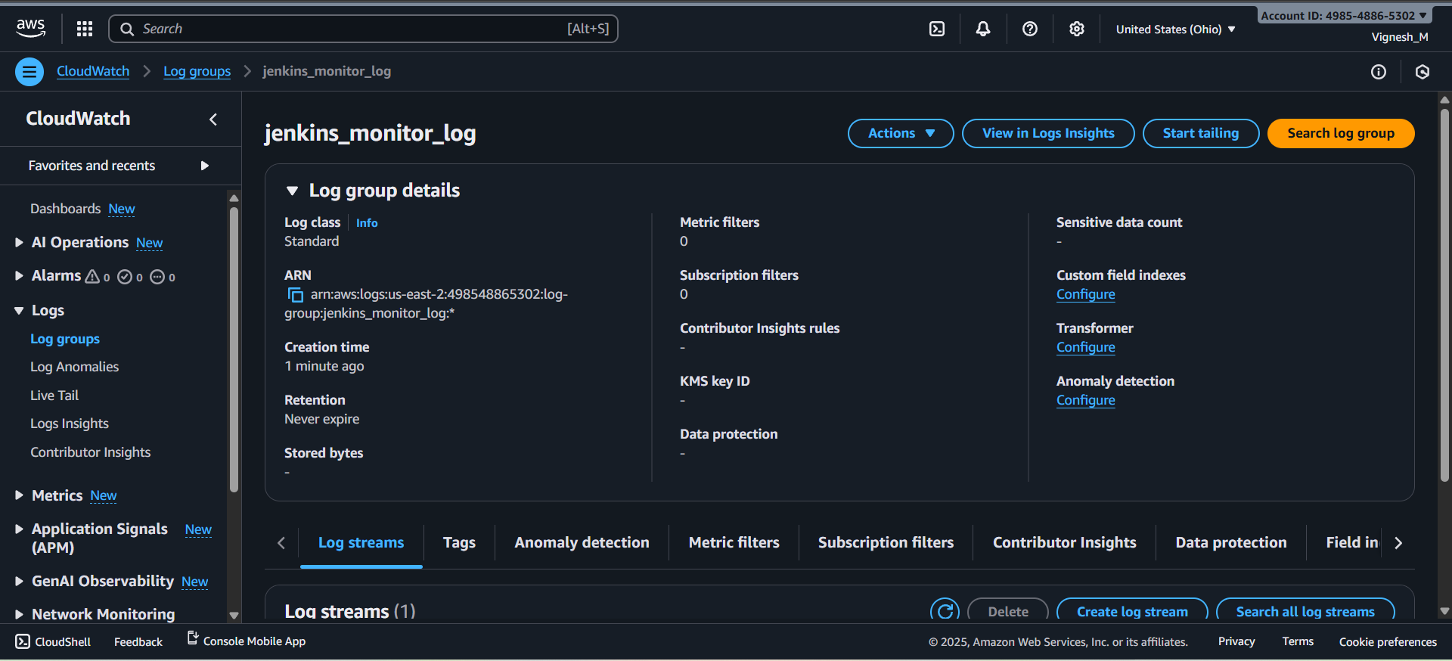

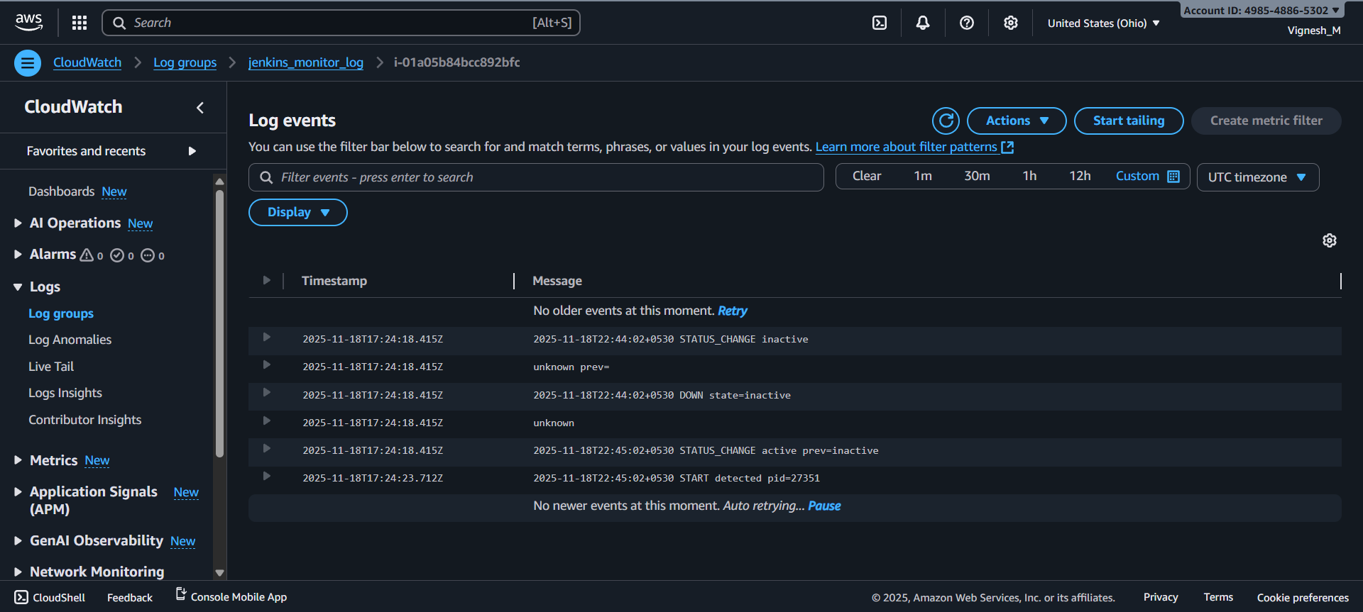

Step 4: Create Metric Filter for Jenkins Down and Restart Events:
Procedure:
- Create a custom metric filter to create alarm for Jenkins down and restart events.
  - Log Groups <Monitorign_Log_Name> Create metric filter Create metric Enter metric details Create metric.
- Metric for Jenkins Up Events:
  - Filter Pattern: START
  - Filter Name: Jenkins_Up_Event
  - Metric Namespace: Jenkins_Monitoring
  - Metric Name: Jenkins Status
  - Metric Value: 1
  - Default Value: 0
- Metric for Jenkins Restart Events:
  - Filter Pattern: RESTART detected
  - Filter Name: Jenkins_Restart_Event
  - Metric Namespace: Jenkins_Monitoring
  - Metric Name: Jenkins Restart
  - Metric Value: 1
- Result: Metric for Jenkins down and Jenkins restart event created successfully.

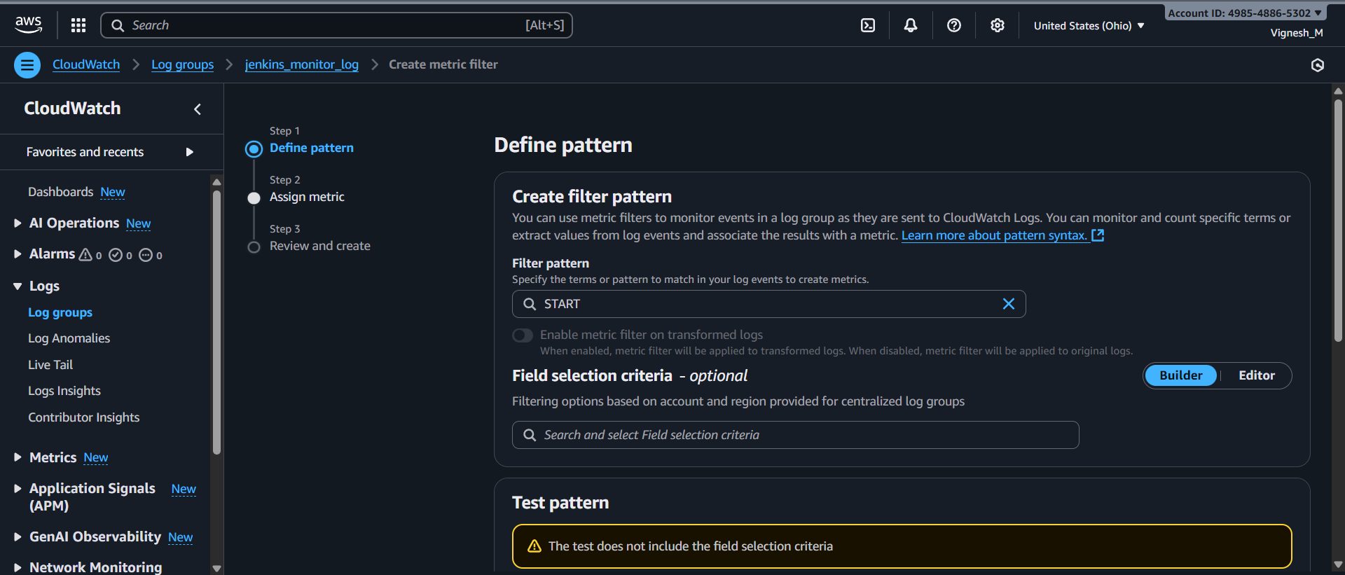

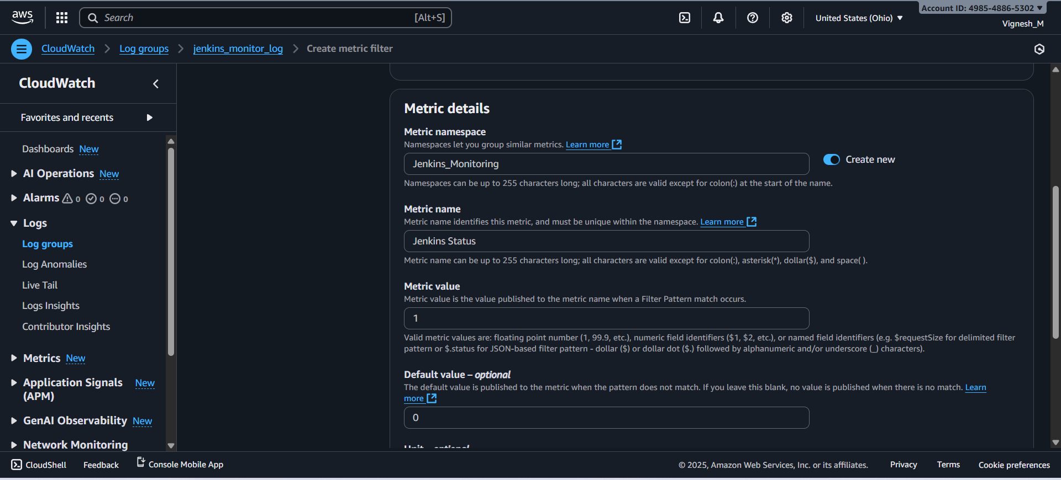

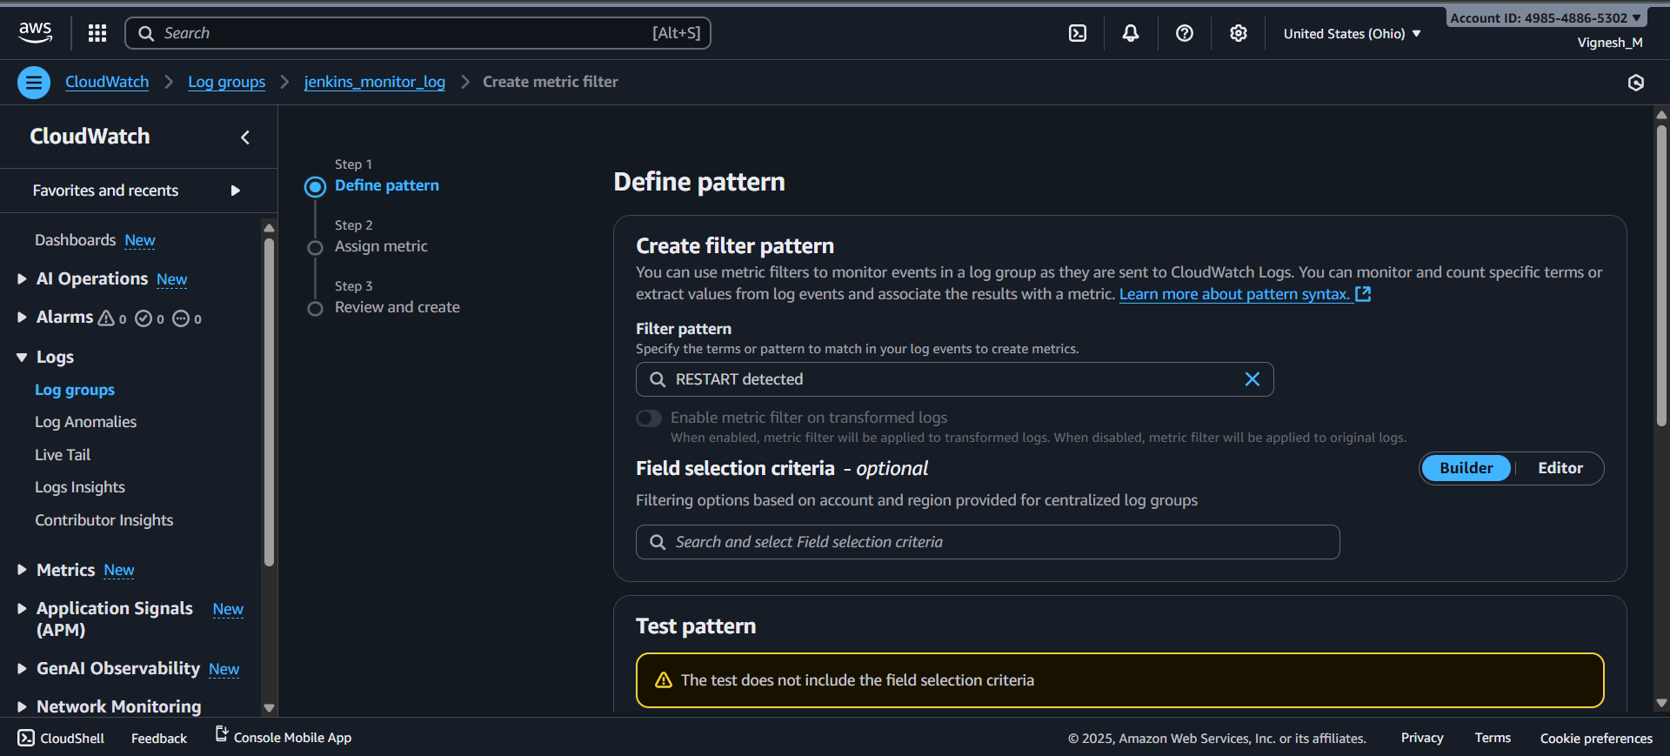

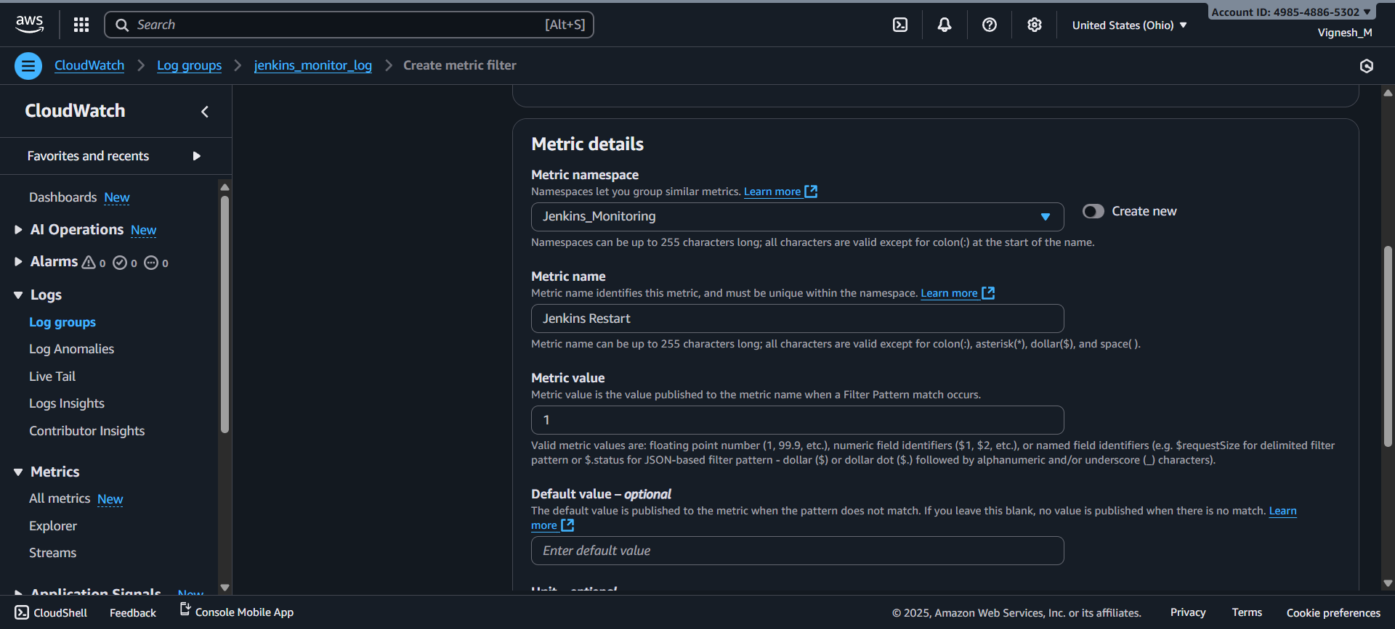

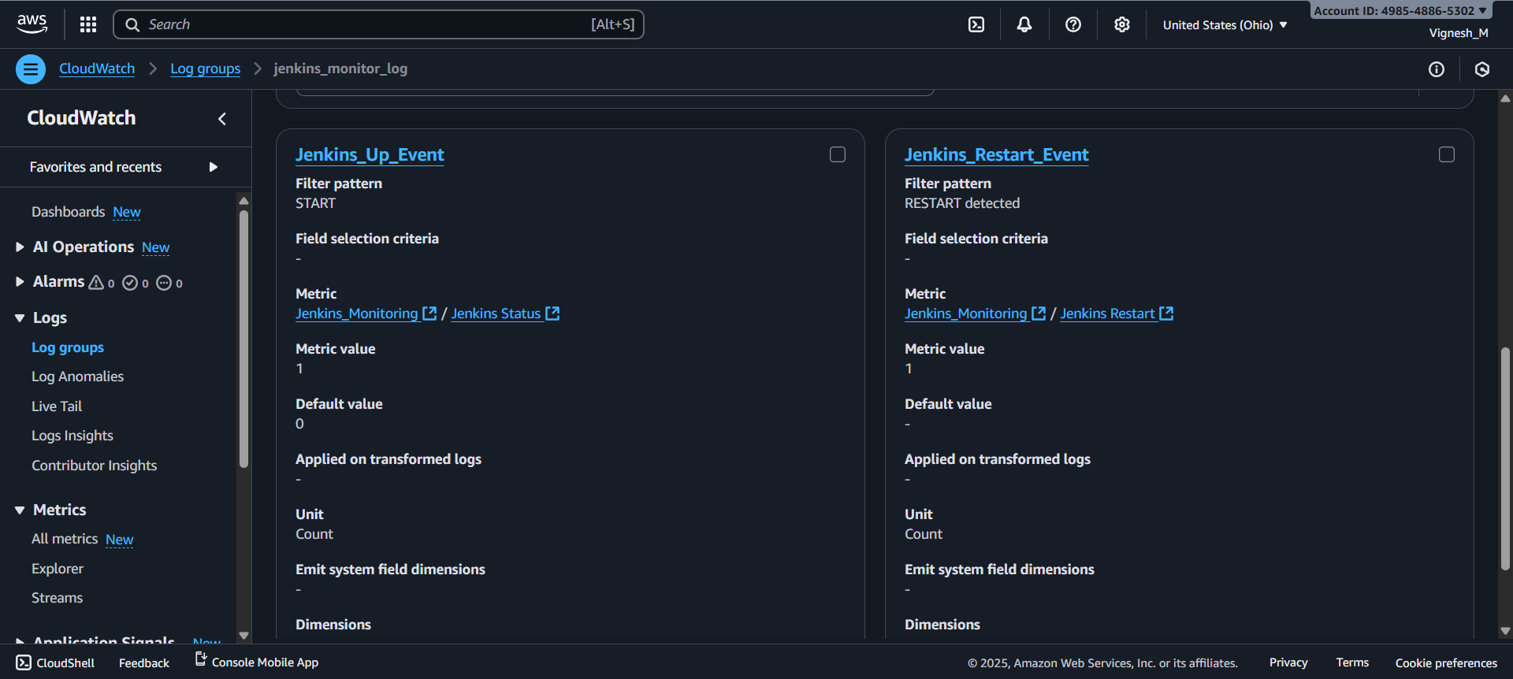

Step 5: Create SNS Topics for Jenkins Alerts:
Procedure:
- Create a SNS topics and subscriptions for Jenkins Alerts
  - Amazon SNS Create Alert <Alert_Name> Create Subscription Enter Topic ARN Protocol (Email) Enter mail ID. create Subscription Verify the email address.
- SNS for Jenkins Up Events Alert:
  - Topic Name: Jenkins_Status_Alert
  - Topic ARN: ARN_Jenkins_Status_Alert (Automatically fetch)
  - Protocol: Email
  - Email Id: Vignesh.ajith17@gmail.com
- SNS for Jenkins Restart Events Alert:
  - Topic Name: Jenkins_Restart_Alert
  - Topic ARN: ARN_Jenkins_Restart_Alert (Automatically fetch)
  - Protocol: Email
  - Email Id: Vignesh.ajith17@gmail.com
- Verification link will be sent to email. Verify it.
- Result: SNS alert for Jenkins Down and Jenkins Restart events created successfully.

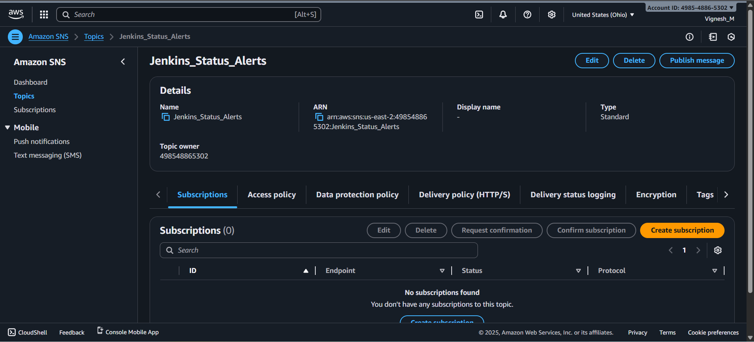
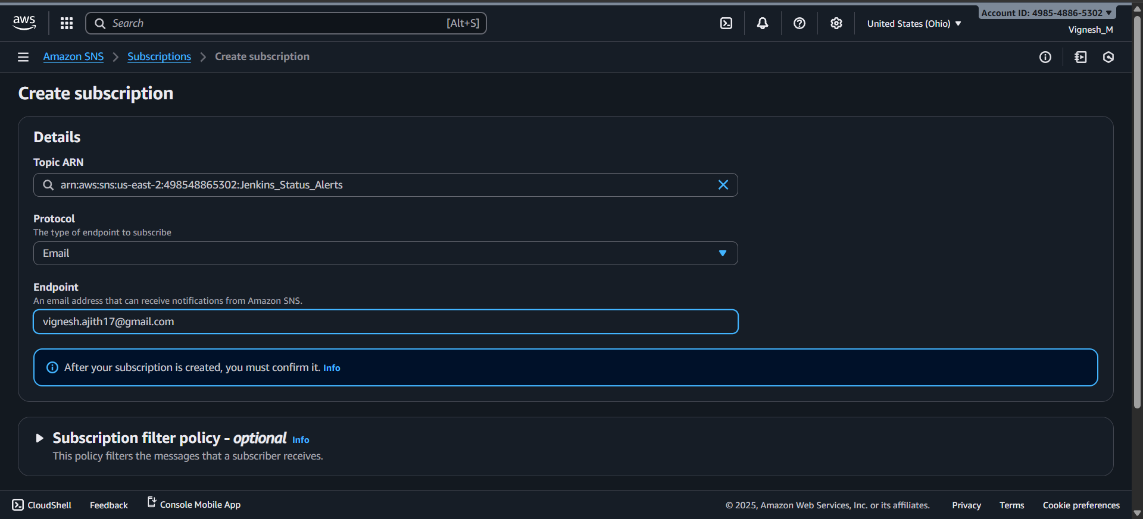
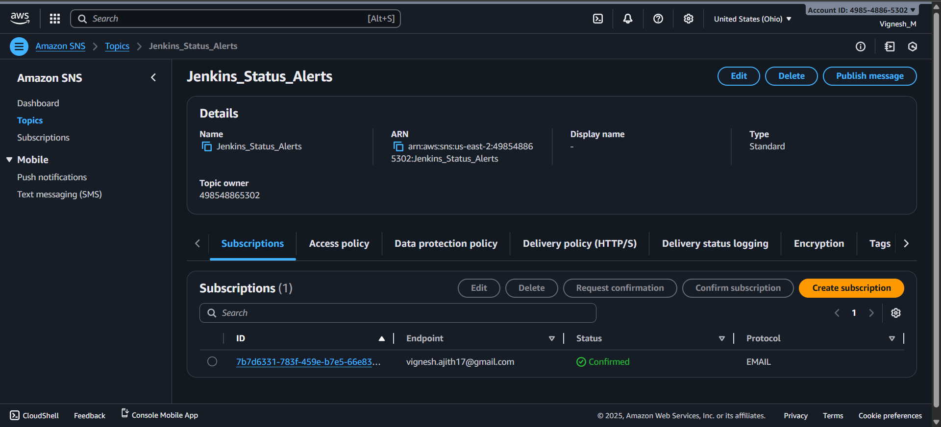

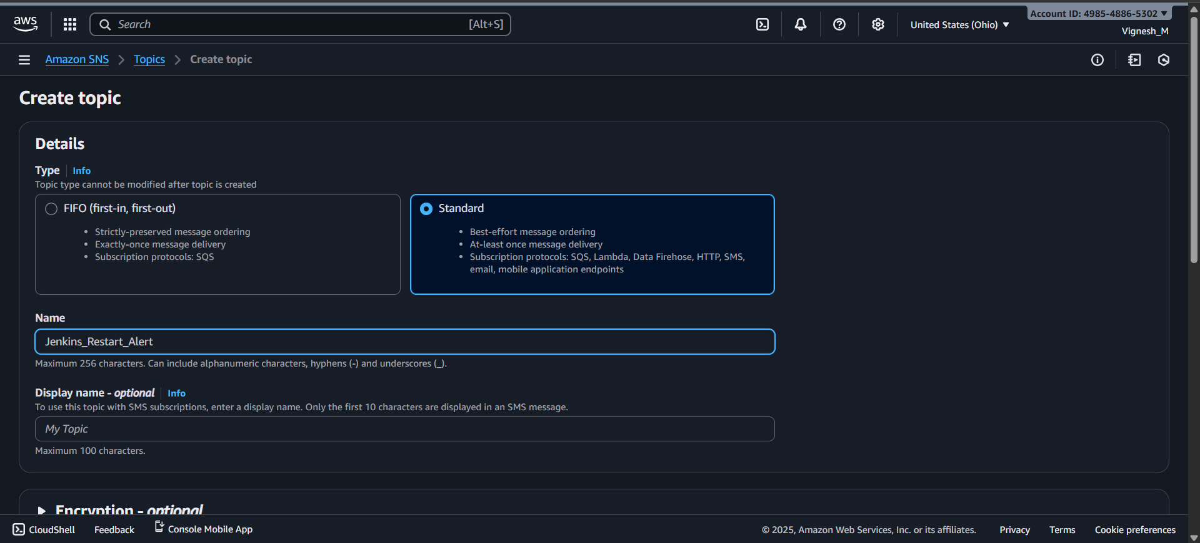

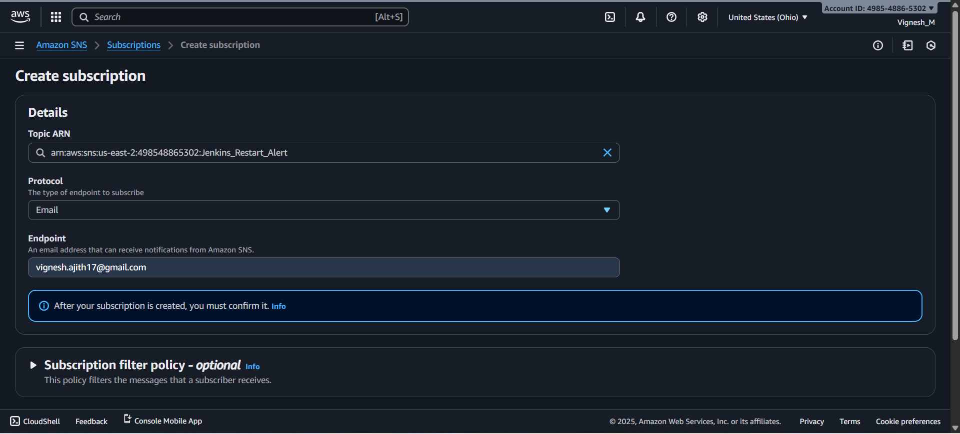

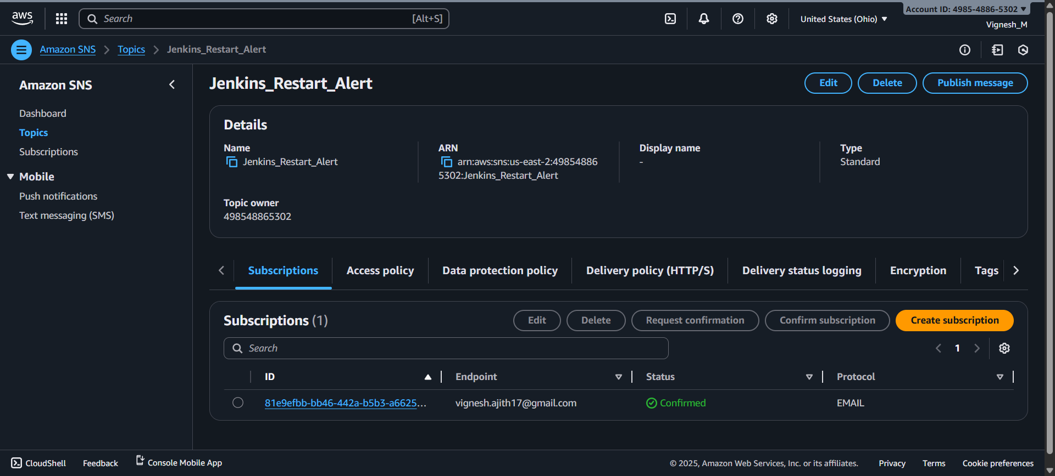

Step 6: Create CloudWatch Alarms for Jenkins Down and Restart Events:
Procedure:
- Create an alarm for Jenkins Down and Jenkins Restart Events.
  - Amazon cloud watch Create Alaram Select namespace Select namespace Select metrics Set Statistics and Period select threshold type Select Jenkins status is Set threshold value Set Additional configuration Select SNS Topic Finally Create Alarm
- Alarm for Jenkins Down Events:
  - Metric Namespace: Jenkins_Monitoring
  - Metric Name: Jenkins Status
  - Statistics: Sum
  - Periods: 10 Seconds
  - Threshold Type: Static
  - Jenkins Status is: Lower
  - Threshold Value: 0.5
  - Missing Data Treatment: Treat missing data as ignore (maintain the alarm state)
  - Alarm State Tigger: In Alarm
  - Select SNS Topic: Jenkins_Status_Alerts
- Alarm for Jenkins Restart Events:
  - Metric Namespace: Jenkins_Monitoring
  - Metric Name: Jenkins Restart
  - Statistics: Sum
  - Periods: 10 Seconds
  - Threshold Type: Static
  - Jenkins Status is: Greater/Equal
  - Threshold Value: 1
  - Missing Data Treatment: Treat missing data as good (not breaching threshold)
  - Alarm State Tigger: In Alarm
  - Select SNS Topic: Jenkins_Restart_Alerts
- Create a Dashboard with all the necessary metrics and alarms.
- Result:
  - Alarm for Jenkins Down and Jenkins Restart was created successfully.
  - Dashboard created with necessary metrics and alarms.
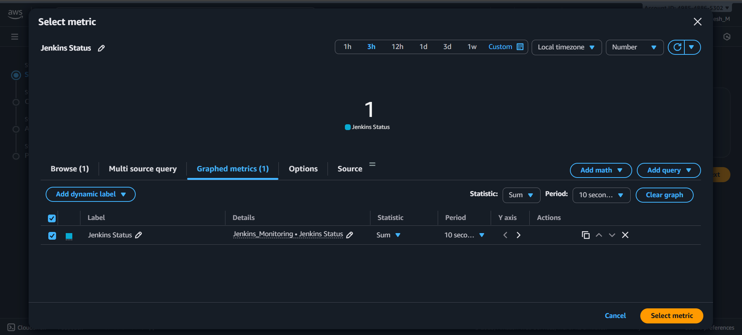
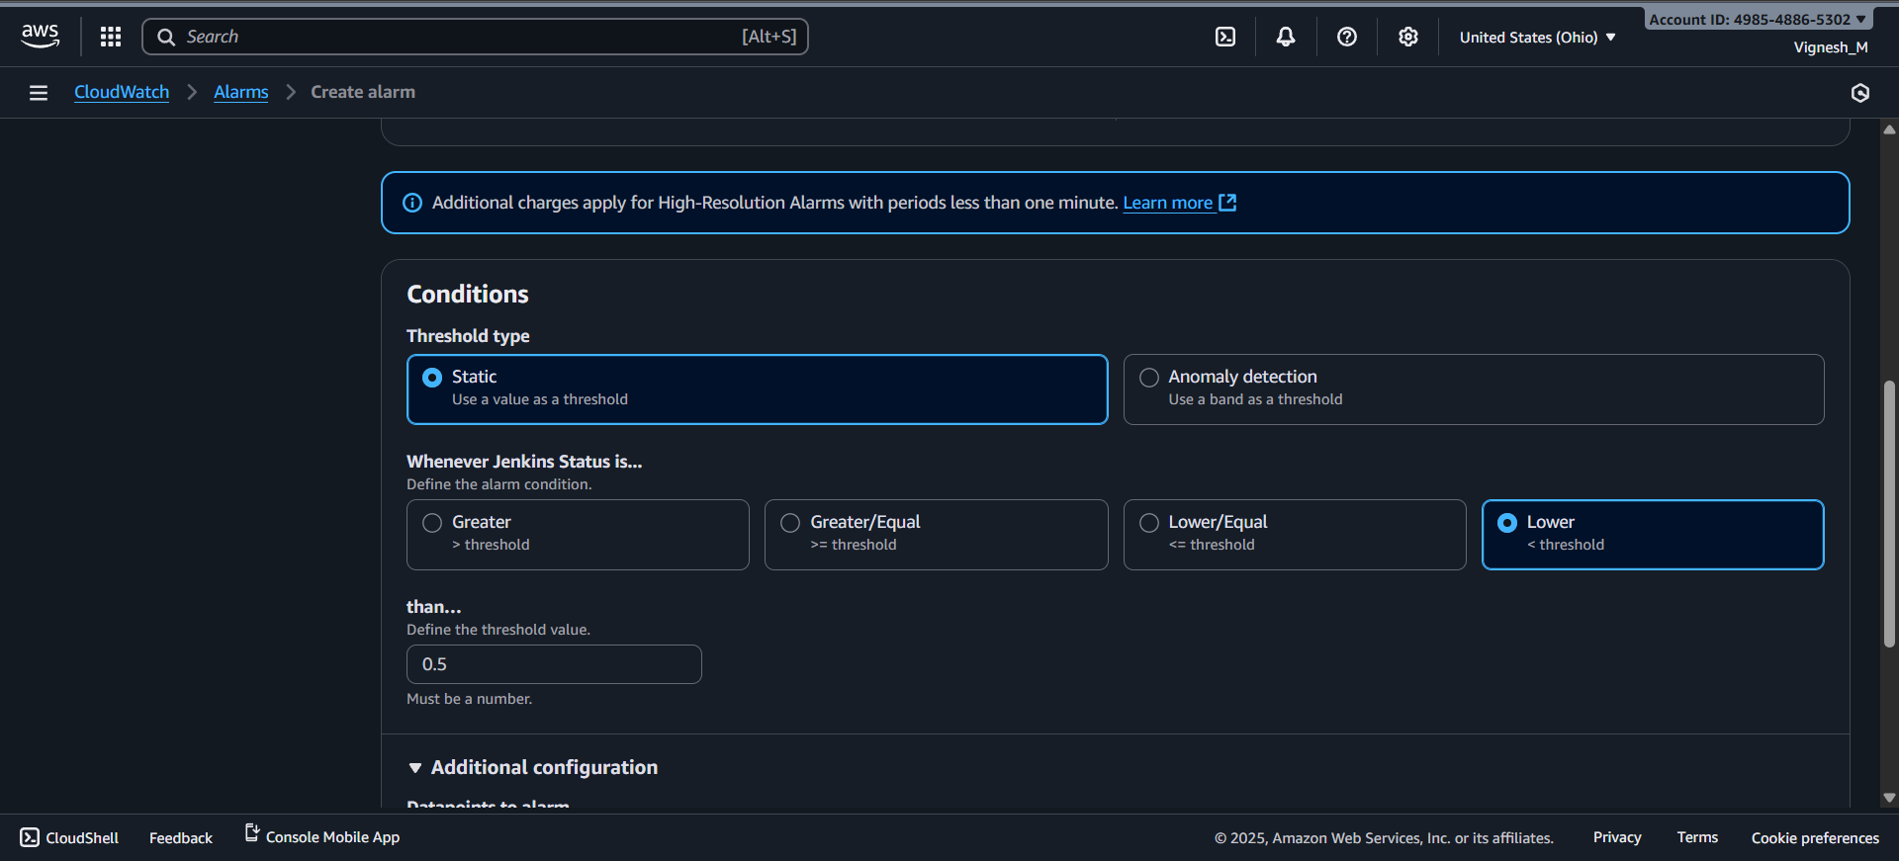
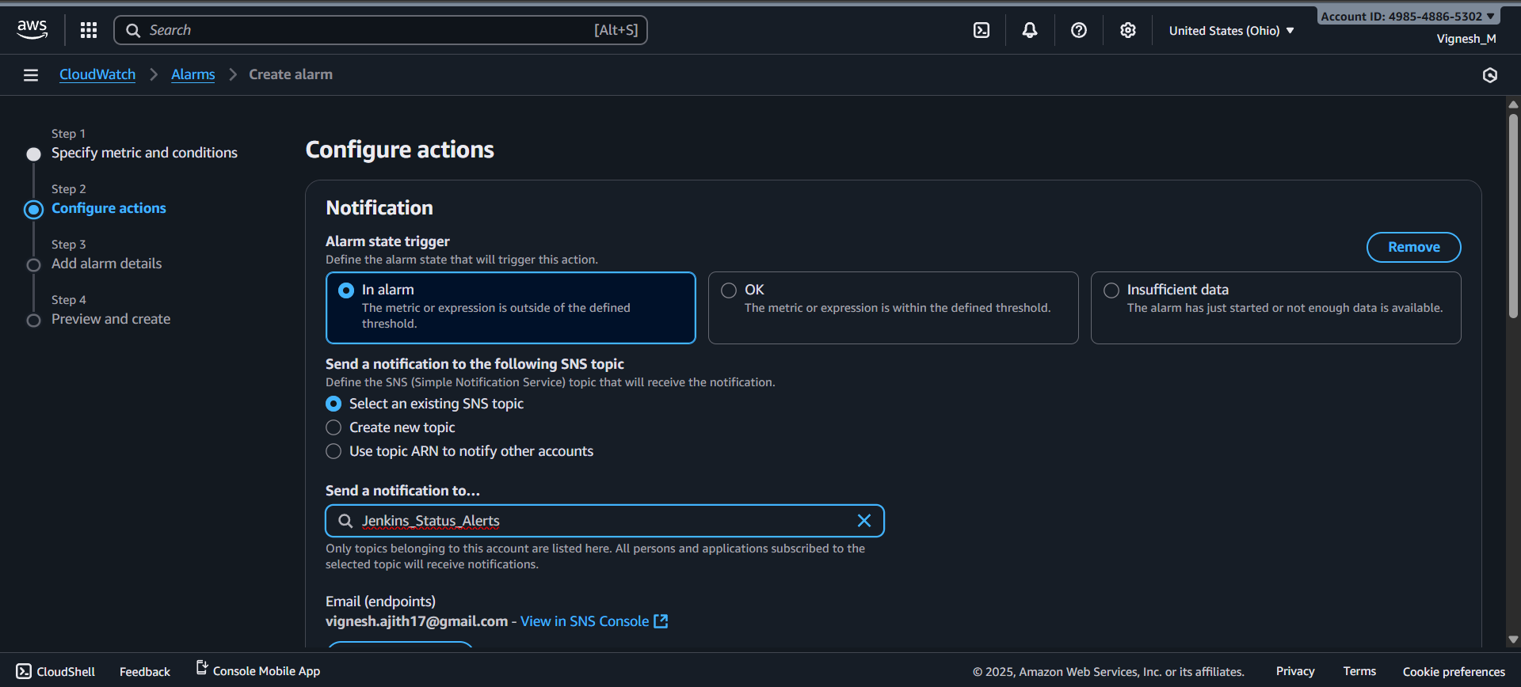
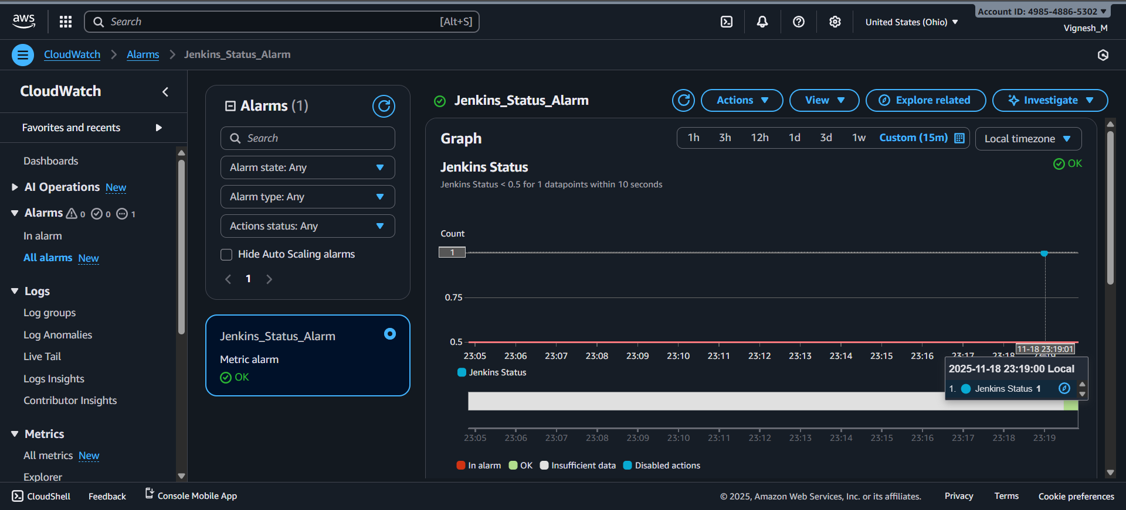
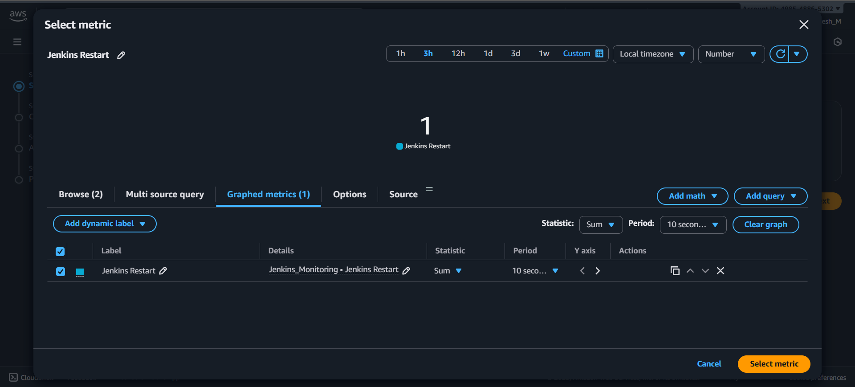
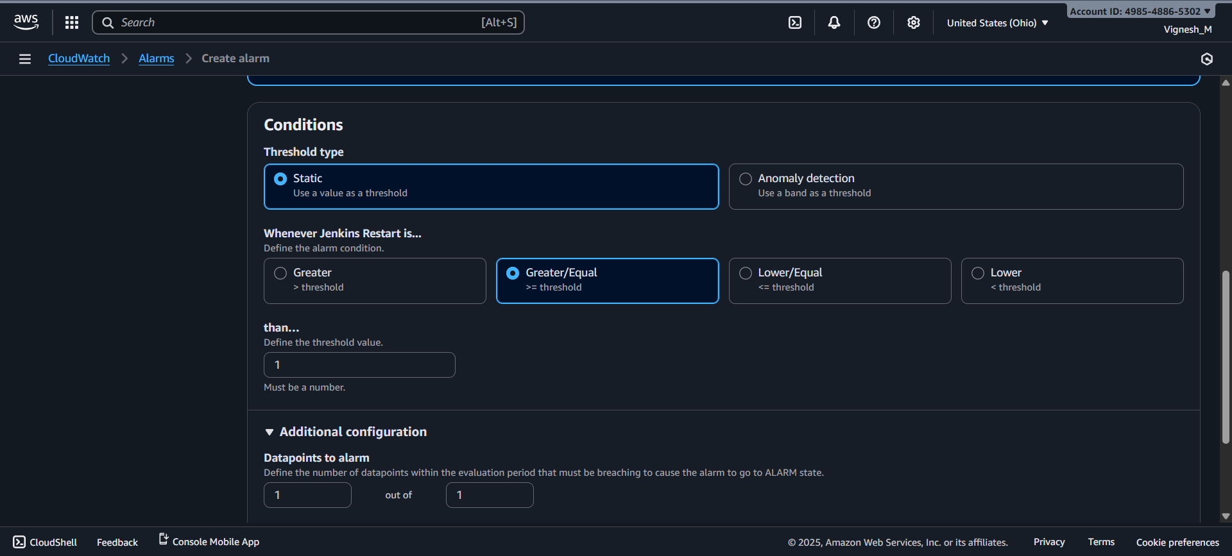
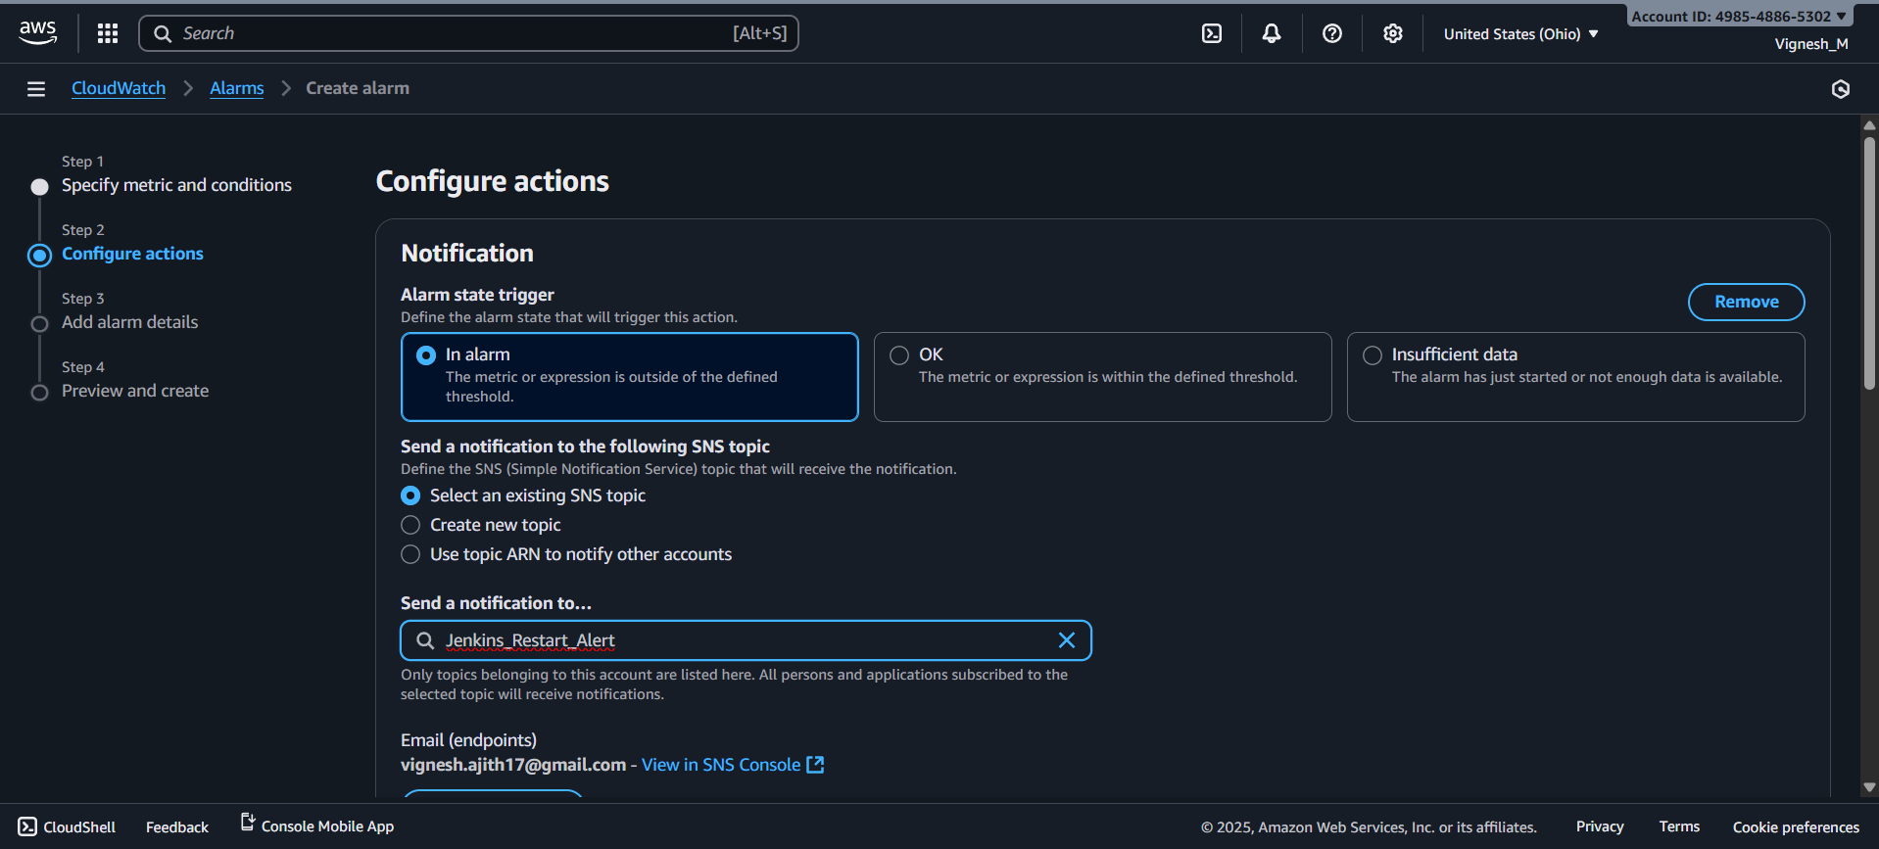
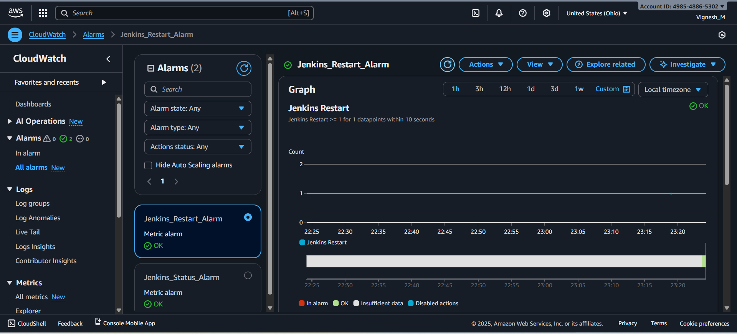
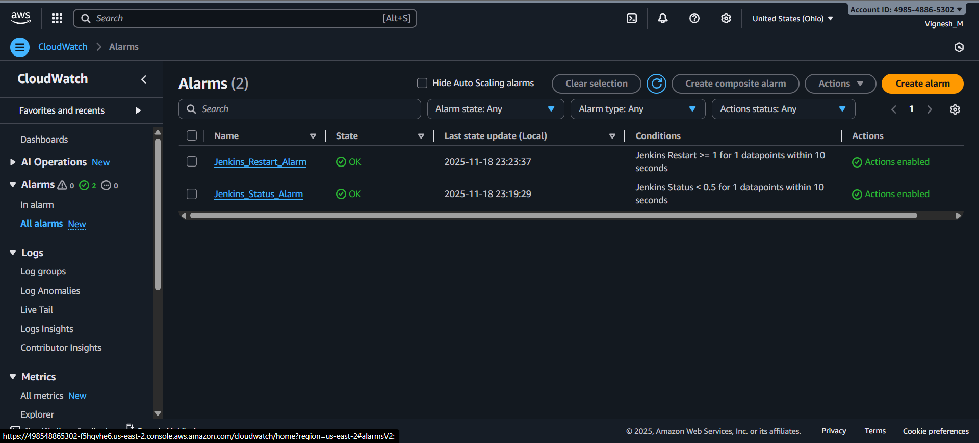
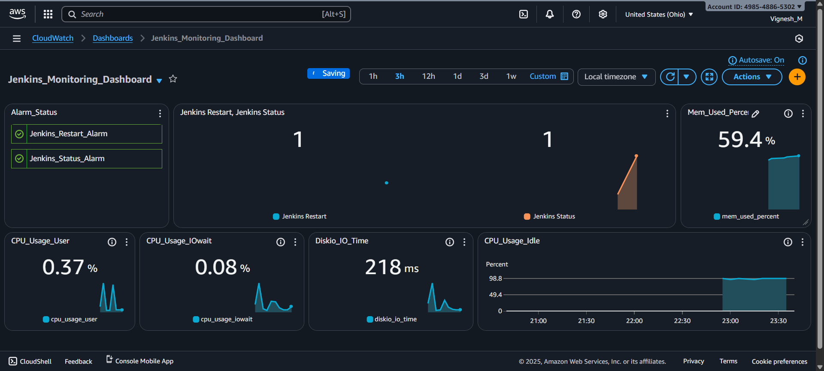

Step 7: Test Alarm Trigger by Manually Shutting Down Jenkins Server:
Procedure:
- In EC2 console check the Jenkins status and down the Jenkins server.
  - Command 1: sudo systemctl status jenkins
  - Command 2: sudo systemctl stop Jenkins
- After stopping the Jenkins, the web interface will go down.
- After one minute the cronjob will tigger and log will be sent to Jenkins_monitor.log
- Cloud watch agent will fetch that log and send it to the cloud watch console.
- After log comes to cloud watch, after sometimes Jenkins Status metric will goes to 0.
- Jenkins_Status_Alarm get triggered immediately and we will receive the Email notification
through SNS.
- Result:
  - Jenkins server went down and Web interface not able to access.
  - Cronjob triggered and log was fetched by the cloud watch agent correctly.
  - Jenkins Status metrics changed, and Jenkins_Status_Alarm triggered successfully.
  - Jenkins Alert was sent to Email through SNS correctly.

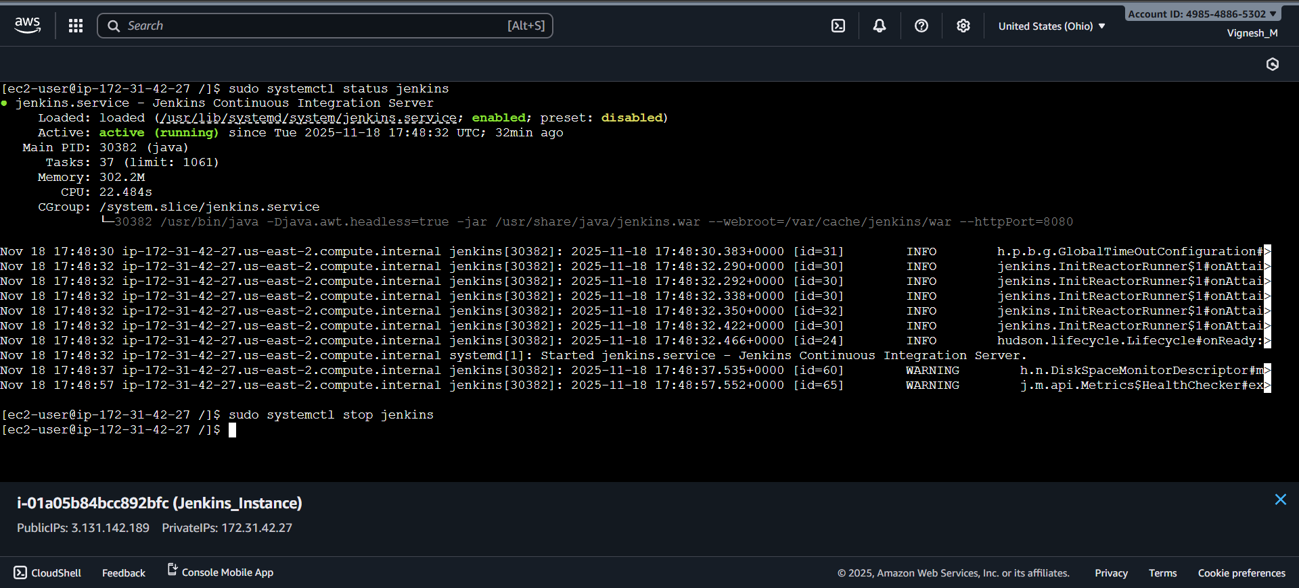

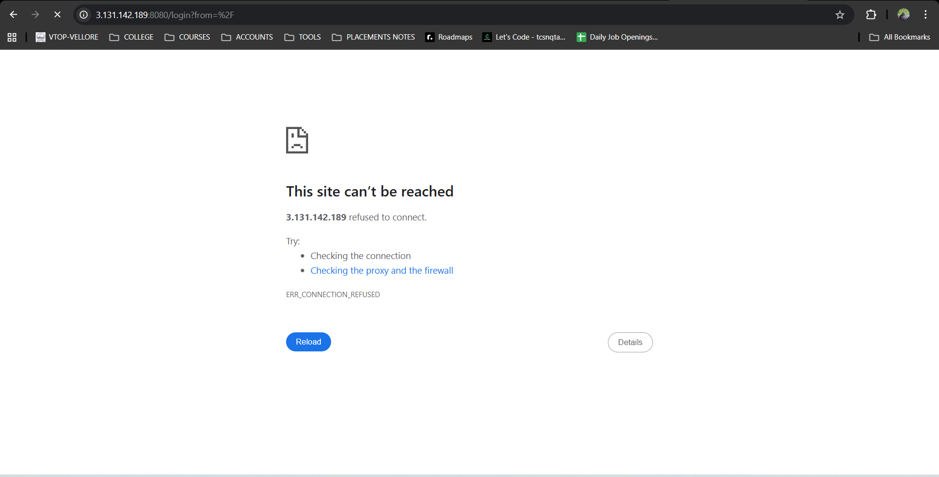

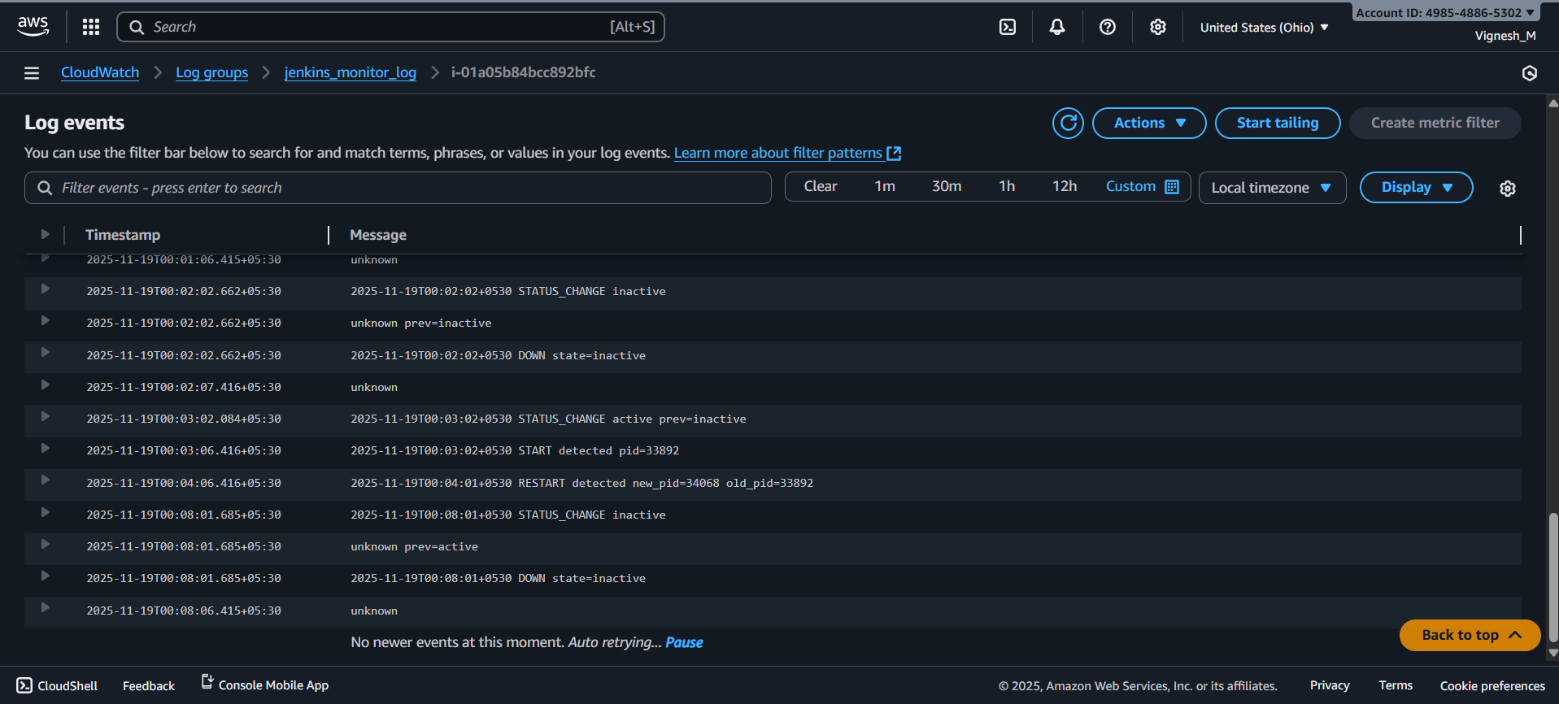
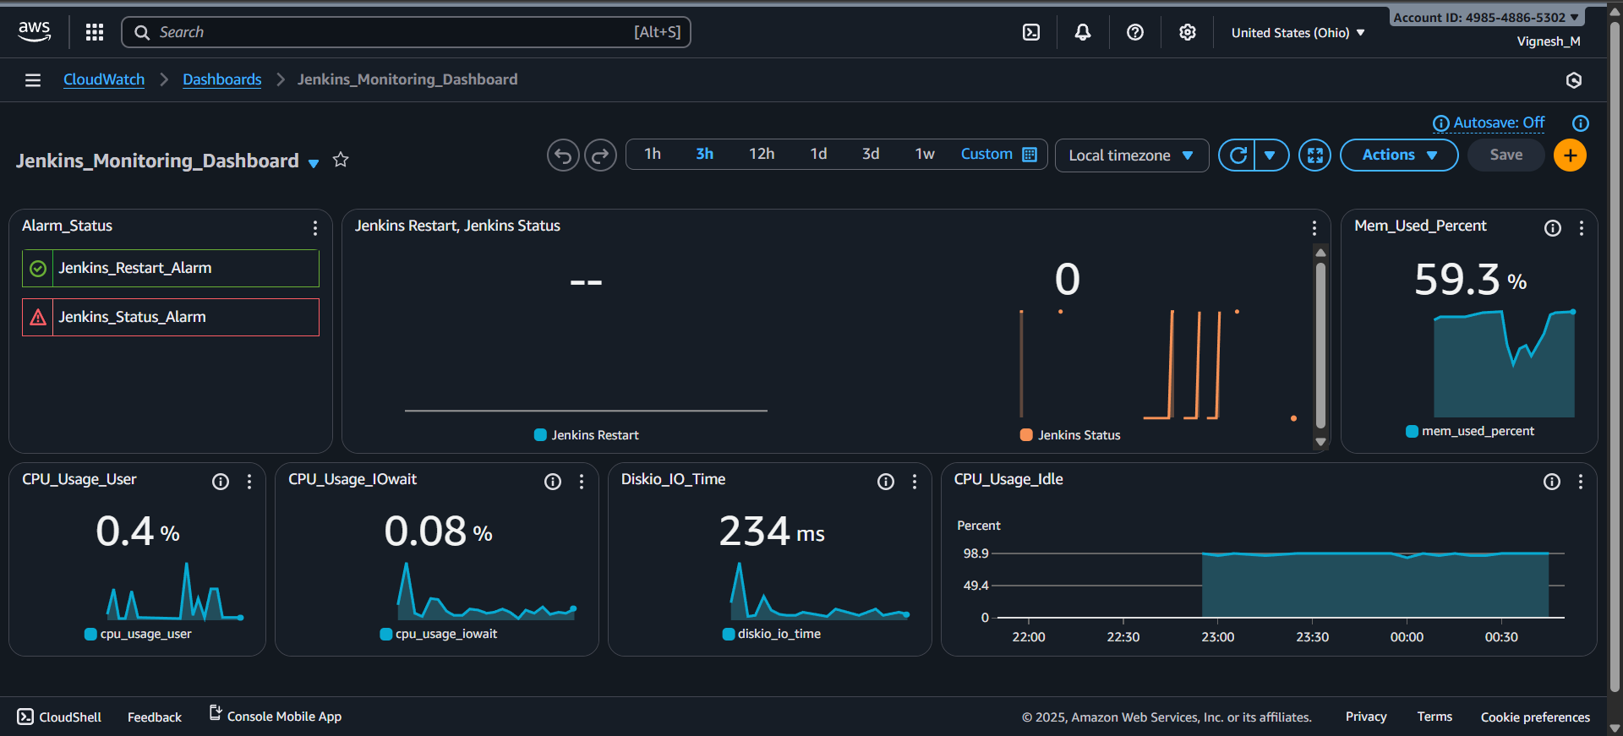
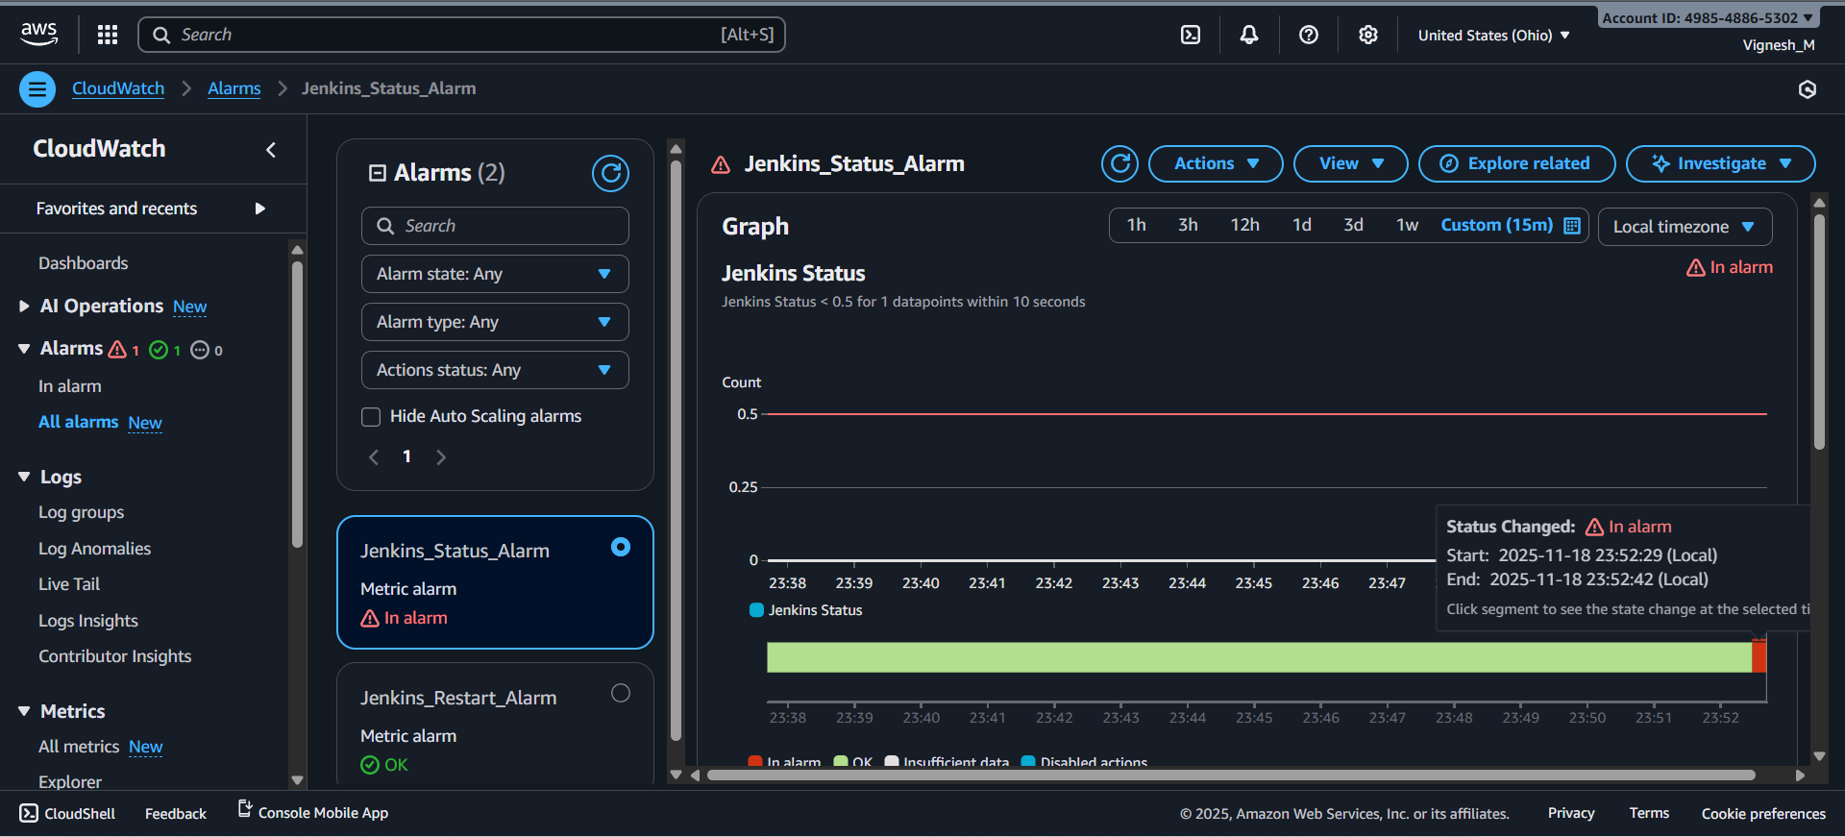
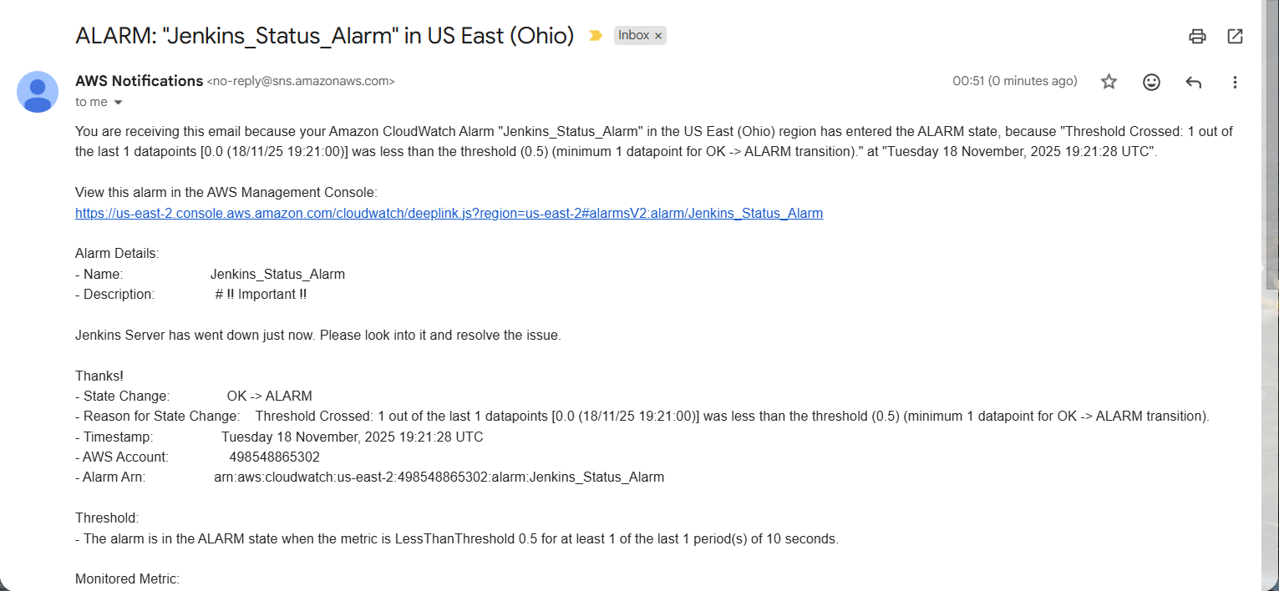
Step 8: Test Alarm Status by Manually Starting Jenkins Server:
Procedure:
- In EC2 console check the Jenkins status and up the Jenkins server.
  - Command 1: sudo systemctl status jenkins
  - Command 2: sudo systemctl Up Jenkins
- After Starting the Jenkins, the web interface will go work.
- After one minute the cronjob will tigger and log will be sent to Jenkins_monitor.log
- Cloud watch agent will fetch that log and send it to the cloud watch console.
- After log comes to cloud watch, after sometimes Jenkins Status metric will goes to 1.
- Jenkins_Status_Alarm get triggered immediately and it will go back to OK state.
- Result:
  - Jenkins server Started and Web interface came and able to access.
  - Cronjob triggered and log was fetched by the cloud watch agent correctly.
  - Jenkins Status metrics changed, and Jenkins_Status_Alarm triggered successfully.
  - Jenkins_Status_Alarm went back to OK state.


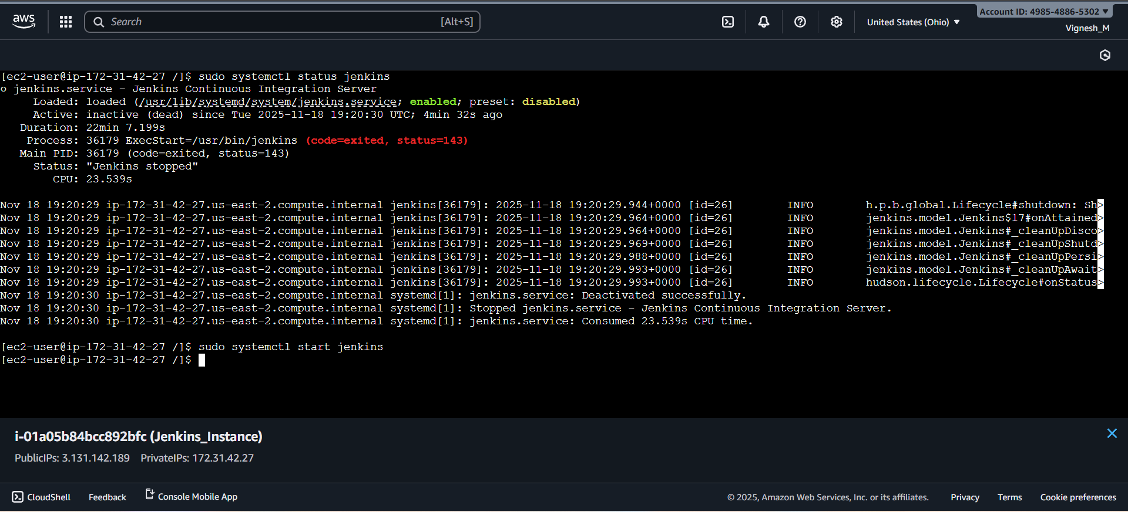
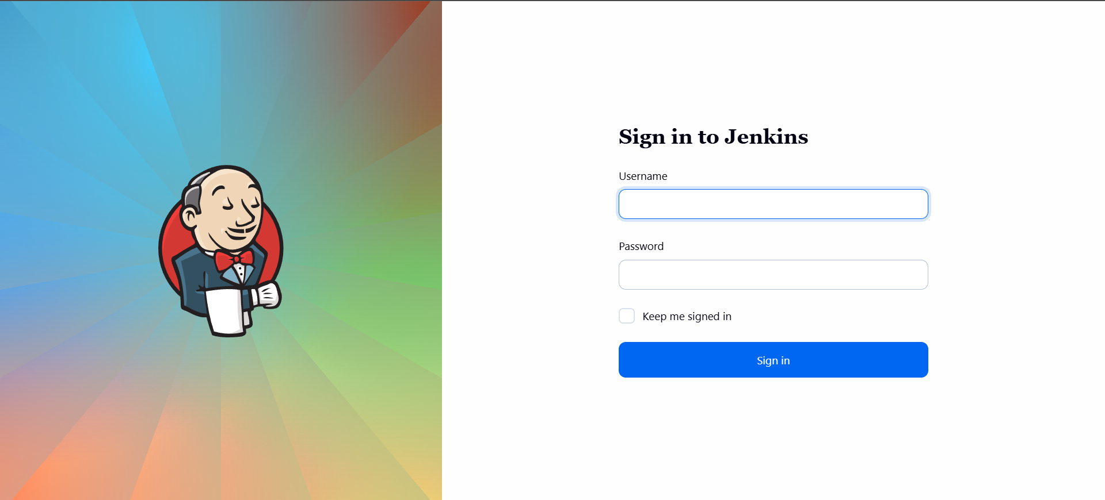
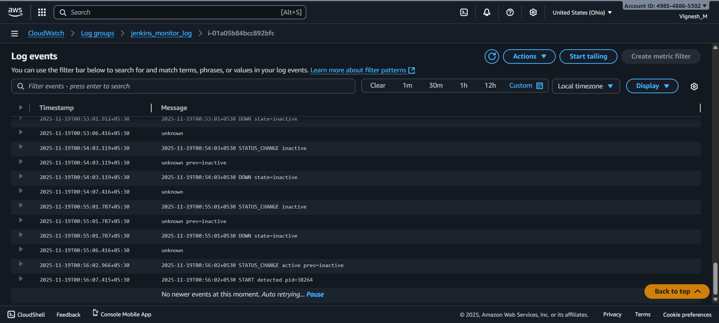

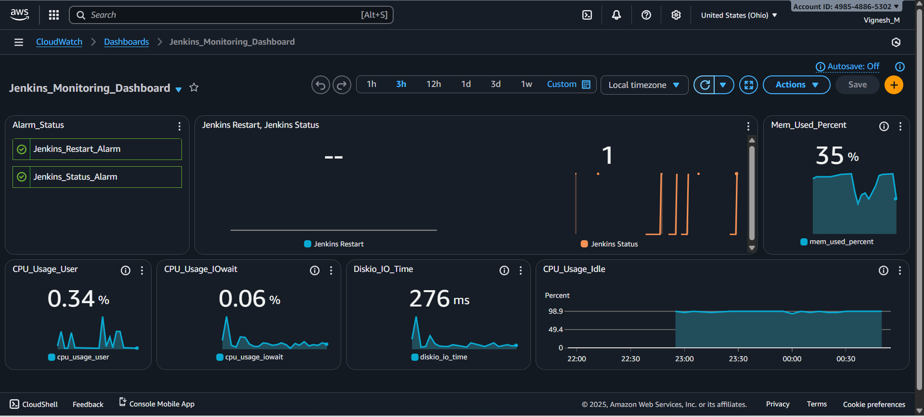

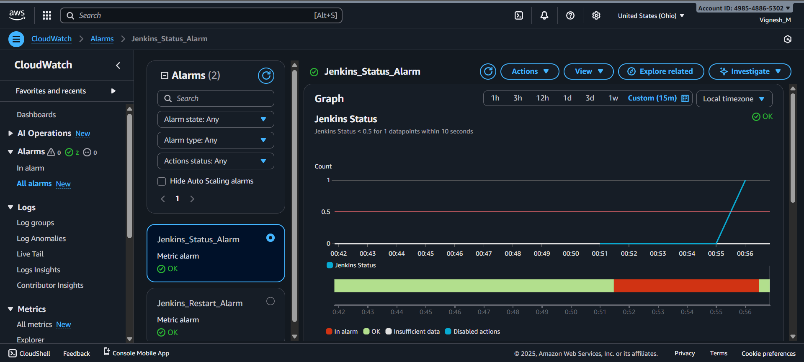

Step 9: Test Alarm Tigger by Manually Restarting Jenkins Server:
Procedure:
- In EC2 console check the Jenkins status and restart the Jenkins server.
  - Command 1: sudo systemctl status jenkins
  - Command 2: sudo systemctl restart Jenkins
- After restarting the Jenkins, after some time the web interface will go work.
- After one minute the cronjob will tigger and log will be sent to Jenkins_monitor.log
- Cloud watch agent will fetch that log and send it to the cloud watch console.
- After log comes to cloud watch, after sometimes Jenkins Restart metric will goes to 1.
- Jenkins_Restart_Alarm get triggered immediately and it will go to In Alarm state.
- We will receive the Jenkins_Restart_Alarm alert through Email by SNS.
- After 3 Evaluation periods (1 minute), if we did not receive any restart log then the Jenkins_Restart_Alarm will automatically go back to OK state.
- Result:
  - Jenkins server Restarted and Web interface came and able to access.
  - Cronjob triggered and log was fetched by the cloud watch agent correctly.
  - Jenkins Restart metrics changed, and Jenkins_Restart_Alarm triggered successfully.
  - Jenkins Restart Alert was sent to Email through SNS correctly.
  - After completion of evaluation periods, Jenkins_Restart_Alarm state went back to OK state successfully.


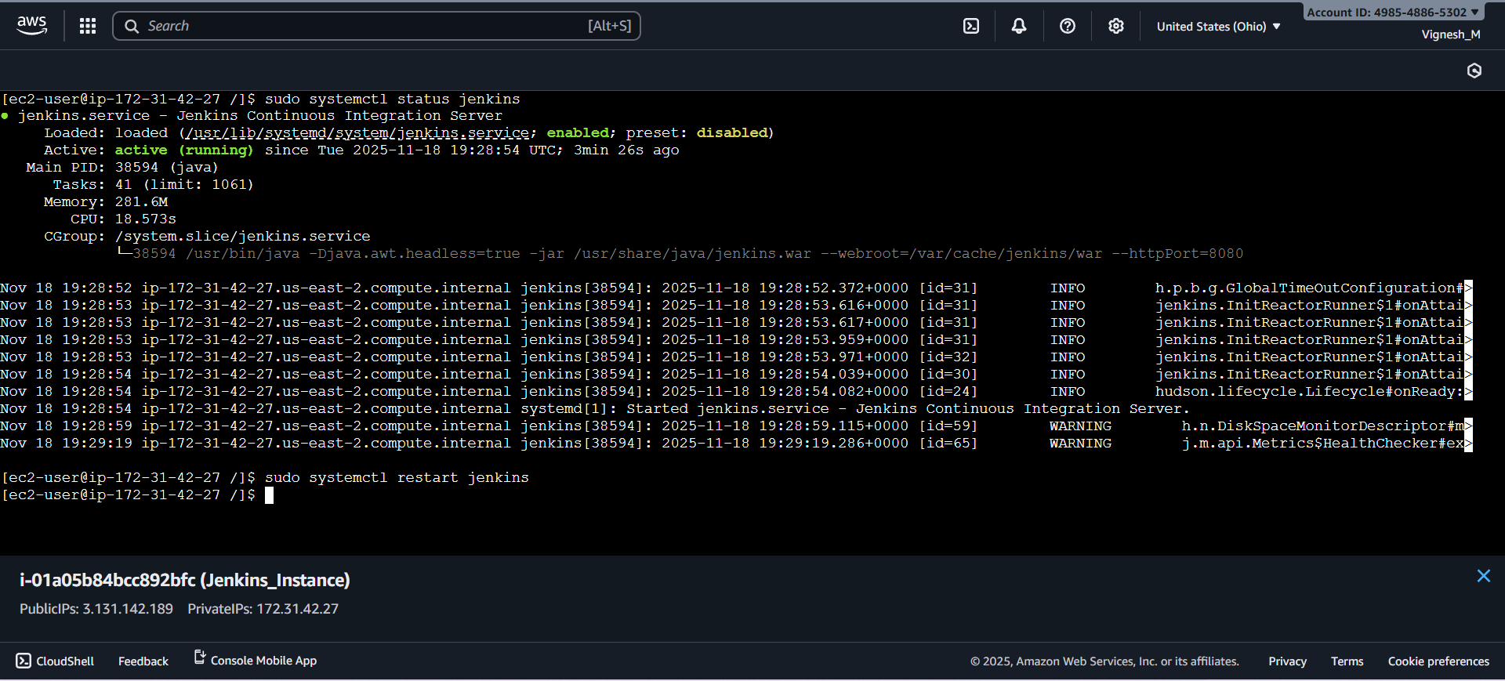
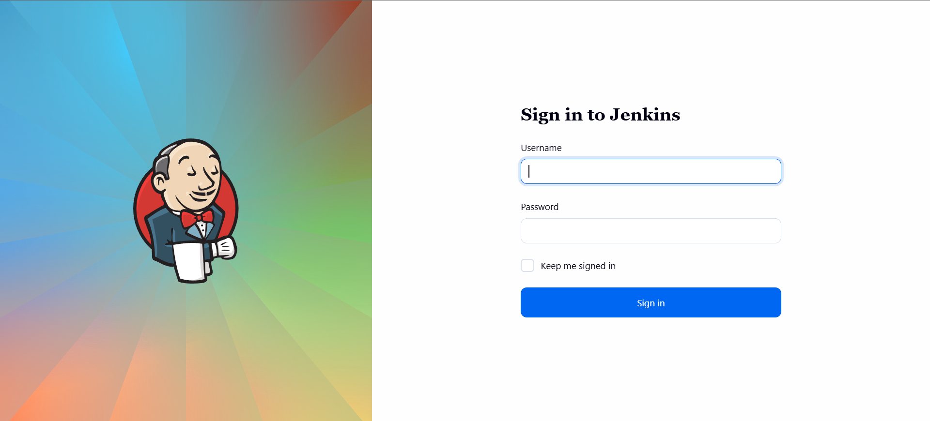
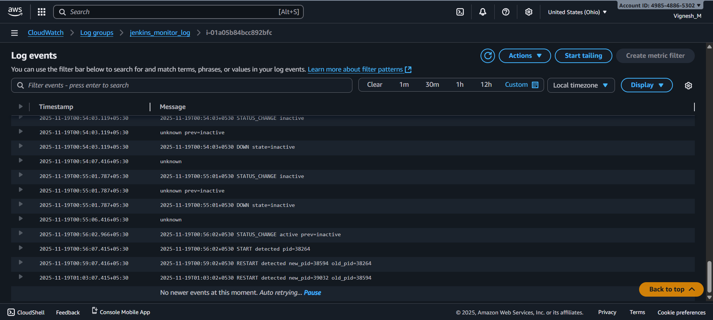
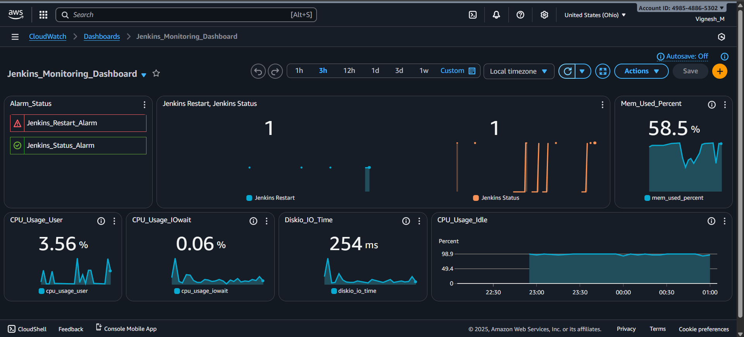
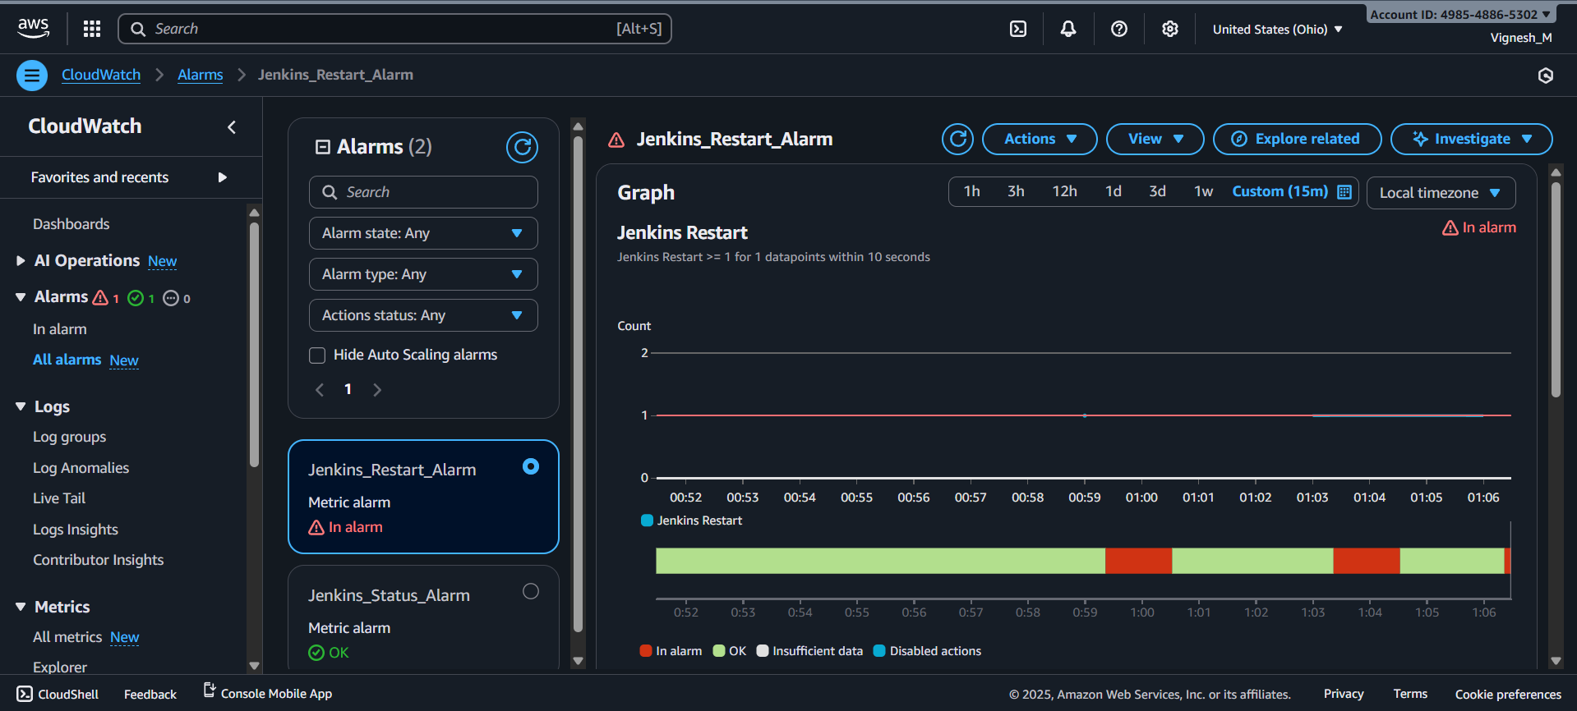
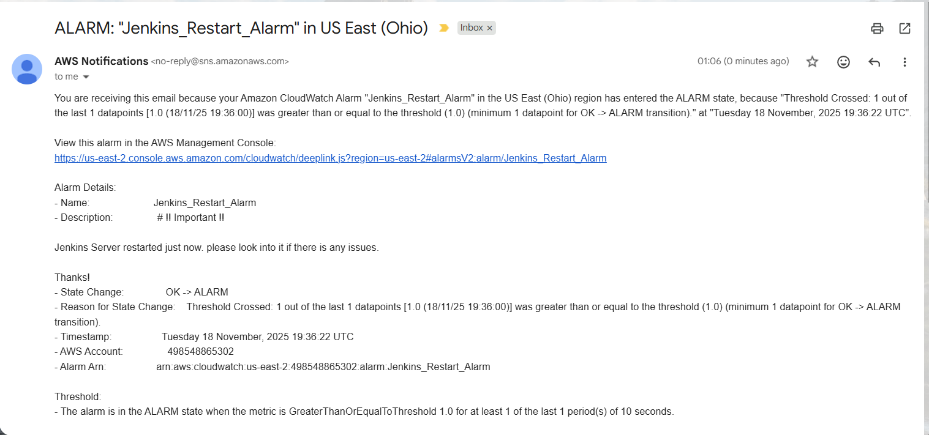

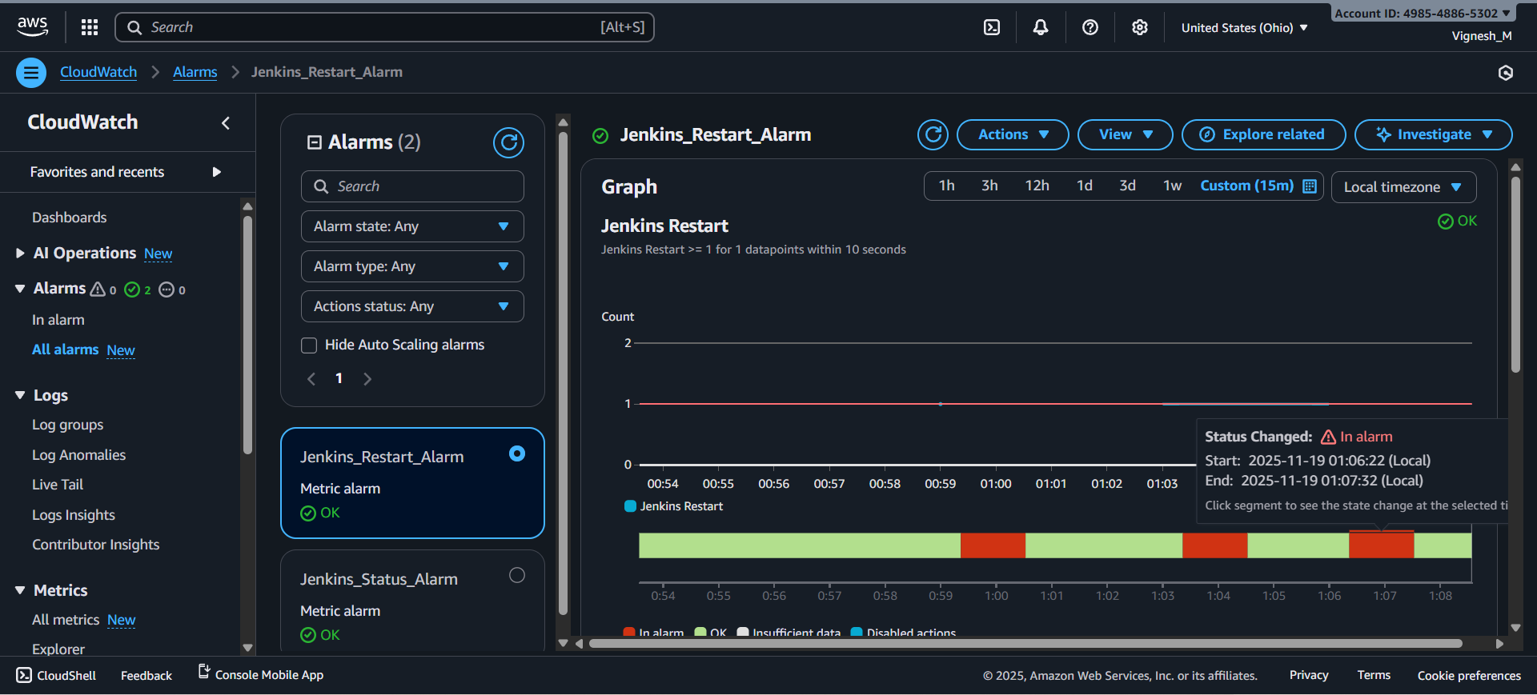

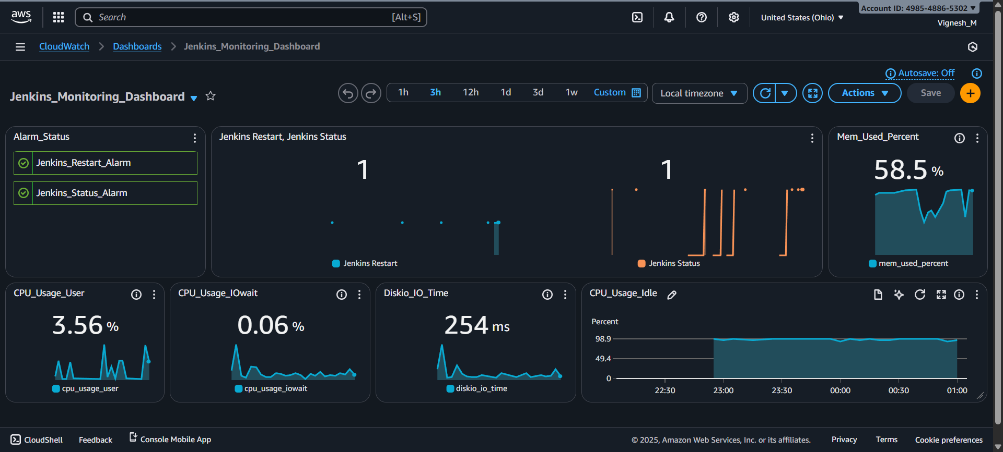

Step 10: Run jenkins_monitor_report.sh to Generate Final Alert Report:
Procedure:
- Now everything was successfully installed and configured to monitor the Jenkins status (Up, Down, Restart)
- Now we want the final report of number of occurrences of Jenkins Up, Jenkins Down and Jenkins restart. For that we have created a script (Jenkins_monitor_report.sh) and we are going to run that script now.
  - Command: sudo /usr/local/bin/Jenkins_monitor_report.sh
- After running that script we will get the final report.
- Result:
  - jenkins_monitor_report.sh script file was created successfully.
  - jenkins_monitor_report.sh file was executed, and report was generated successfully.



Final Use Case Outcome:
- Continuous Service Uptime Verification: Automated monitoring is in place, verifying the real-time operational status of the Jenkins service running on the EC2 instance, ensuring immediate detection of any Downtime or unexpected restarts.
- Instant Alerting on Failure: CloudWatch Alarms are configured to trigger automatically based on the monitored Jenkins status metric, initiating near-instantaneous notifications via the configured SNS Topic (Email/SMS) when the service goes DOWN or restarts.
- Auditable and Traceable Event Logging: A structured, timestamped log file is maintained on the EC2 instance, creating an unalterable record of all Jenkins UP and DOWN events, which is periodically parsed to generate reports for audit and compliance.
- Comprehensive Operational Reporting: The system provides the capability to generate detailed downtime/uptime reports by parsing the log data. This helps operational teams quantify the frequency and duration of service interruptions, supporting RCA and SLA verification.
- Enhanced System Reliability: The combination of monitoring, logging, and instant alerting has significantly reduced Mean Time To Detect (MTTD) service failures, enable a faster response and contribute to overall increased reliability and availability of the critical Jenkins CI/CD platform.

