**Usability** :

1. Instead of labels for “**View photo here**” and “**View signature here**”, it should have been hyperlinks, so that user will be able to add photo and signature with ease.

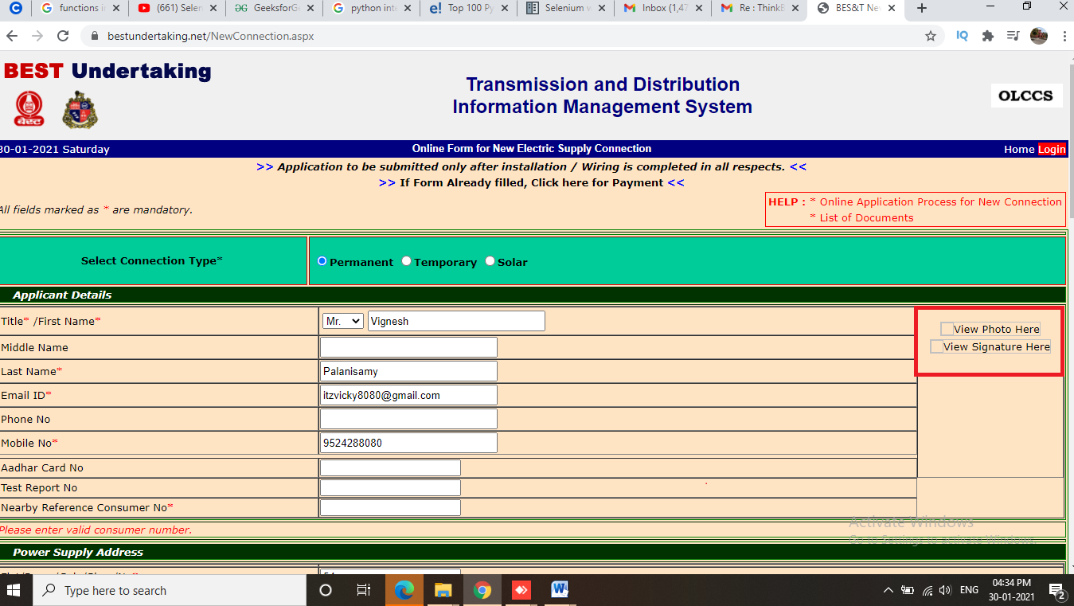

1. The fields like **Type of Premise, Category of Premise** and **Languages** should have been given in dropdown, so that in future, it will be easy to add many more values in those list instead of radio buttons.

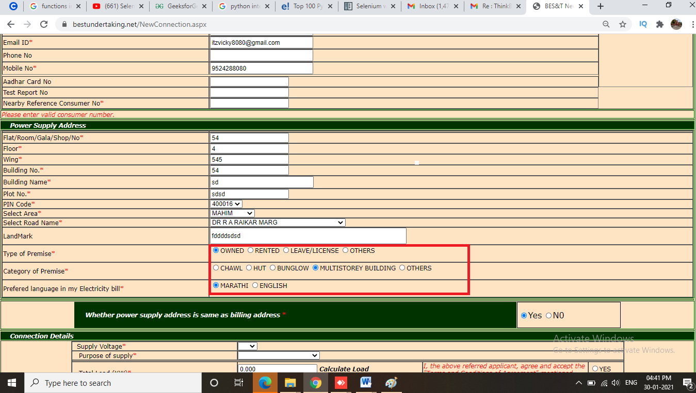

1. Instead of having 2 buttons for 2 functions **choose file** and **upload**, it should have been a single button which will work for both choosing and uploading the file in a single click

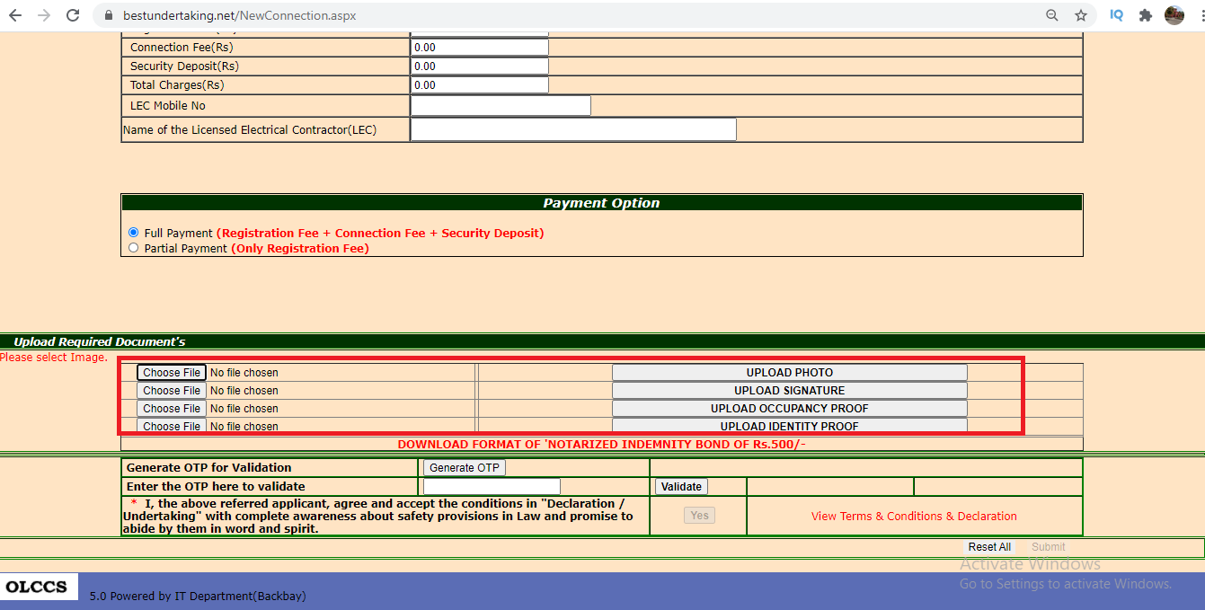

1. There should have been an additional mobile number field for emergency purposes when the primary number is not in use.

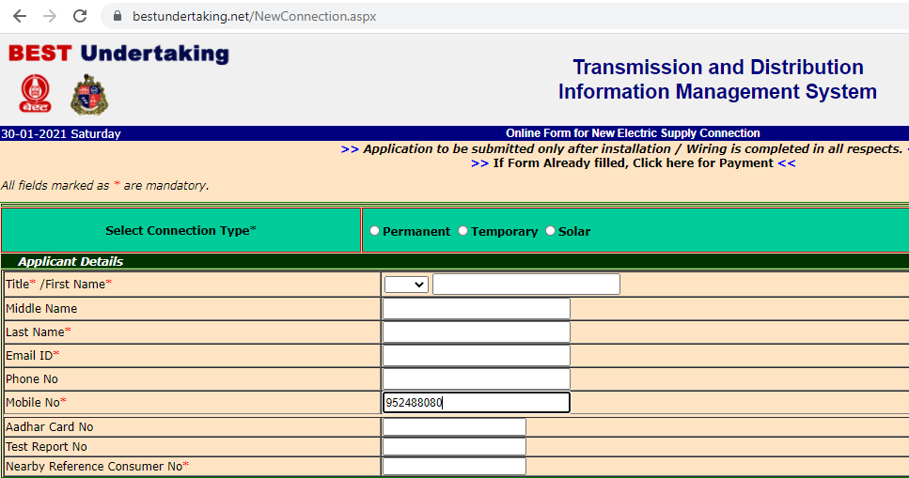

**Functionality :**

1. When clicking on submit button, for First Name filed, if its empty, its showing “Required” twice. It should have been showed only once at that particular field.

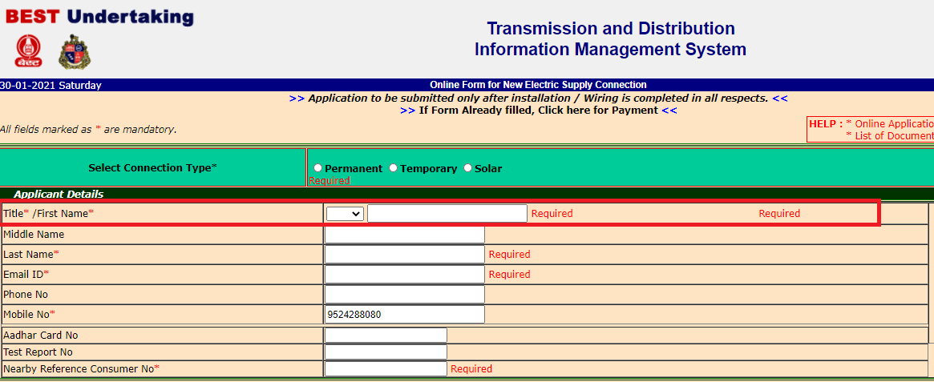

1. Entering OTP field should have been made mandatory :

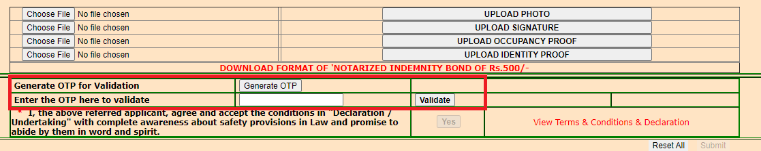

1. Even without entering OTP, simply while clicking on Validate button, the YES button in the decalaration is getting enabled.

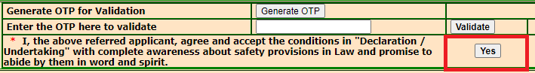

1. Instead of YES button at declaration part, it should have been a check box which has to be checked as part of declaration which will be more user friendly.



**UI Suggestions :**

1. Title of the page is not center aligned :

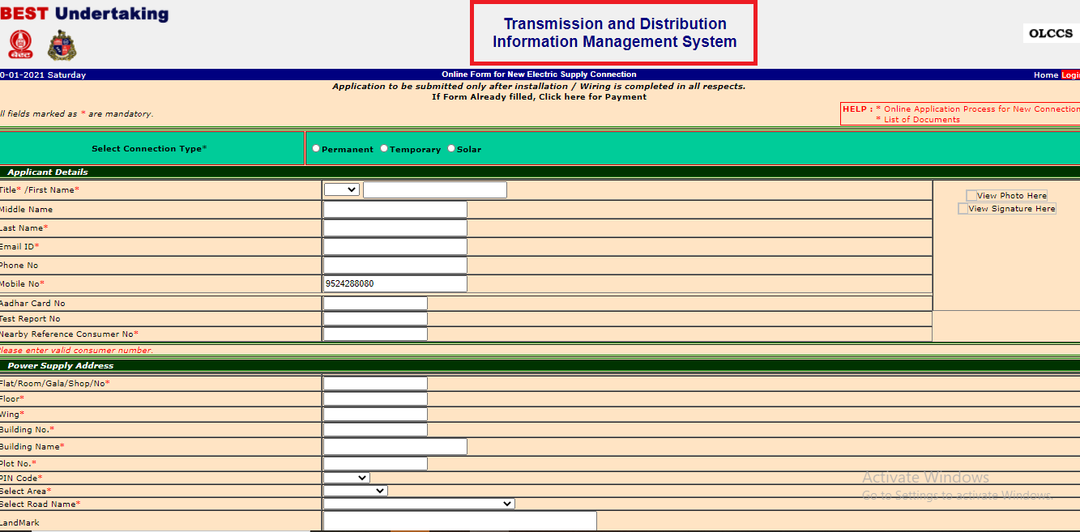

1. More empty cells are seen in between fields at many places in the page :



1. Logos were completely blurred, proper PNG formats should have been added :



1. It should have been **Documents** instead of **Document’s** and **Payment Options** instead of **Payment Option**

