

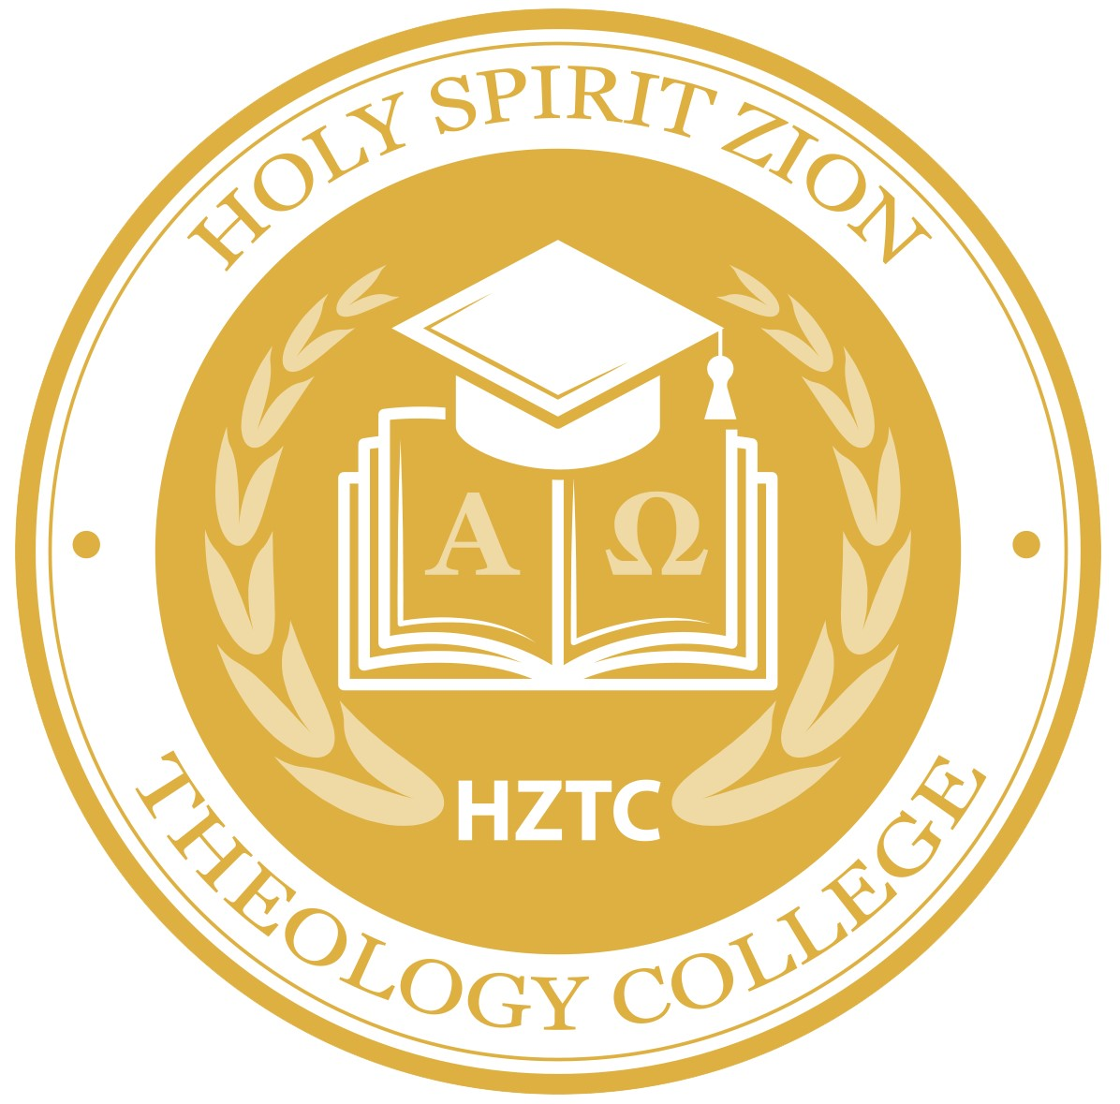**HOLY SPIRIT ZION THEOLOGY COLLEGE**

No. {{id}}

Having successfully completed the studies in the Theology of the Bible-emphasis on

the book of Revelation, Ministerial Training and Ordination as per guidance and inspiration

of God The Father, Jesus The Son and The Holy Spirit.

{{alias}}. __**{{name}}** _ is Awarded the Degree of

***Certificate of the Theology of the Bible***

***- Emphasis on the book of Revelation***

Together with all the Rights, Privileges and honours thereto pertaining in testimony

thereof we the faculty and the board of Directors of New Heaven and New Earth

HOLY SPIRIT ZION THEOLOGY COLLEGE Bible Seminary India Program have Issued

**this Degree Duly Signed Under the Seal of Our Ministries on the ________October 6th, 2023___________**

**Chancellor** **The Head of College Principal The board of director**

