**ASSIGNMENT 12.2 :**

**Question : Create a flume agent that streams data from Twitter and stores it in the HDFS cluster.**

**STEP 1: To create a directory using ‘ mkdir ‘ command.**

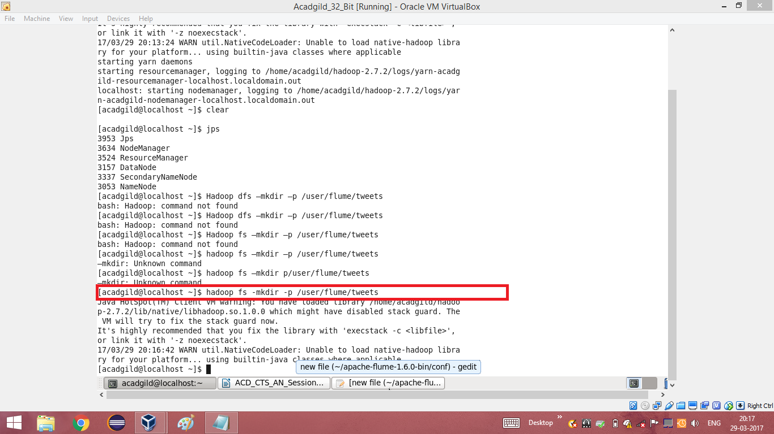

**STEP 2:**

**To Edit the configuration file with the generated key, consumerSecret, accessToken and accessTokenSecret.**

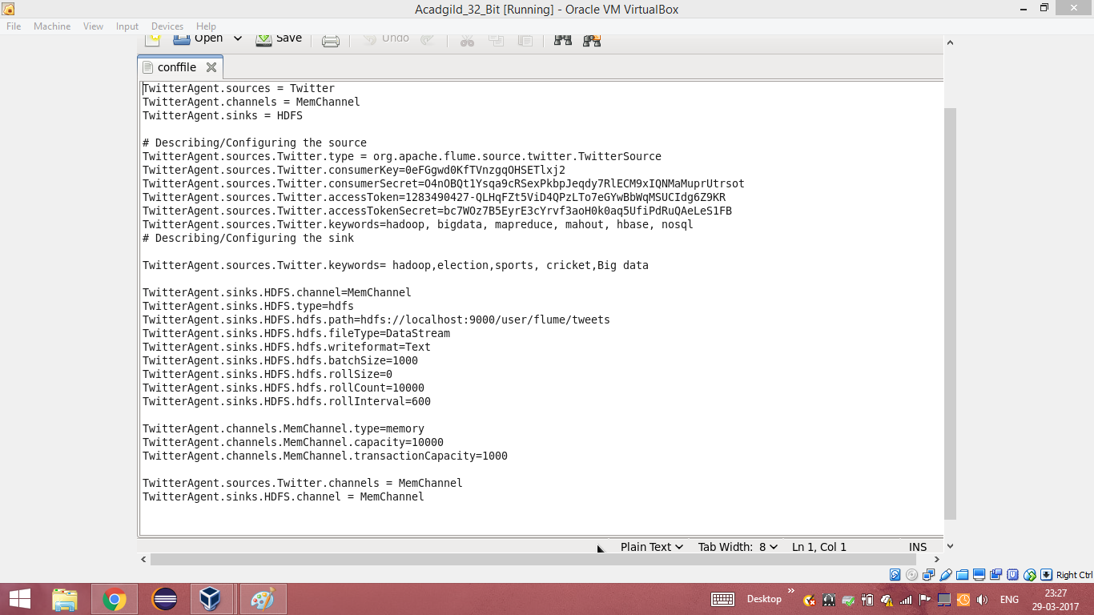

**STEP 3: Running flume**

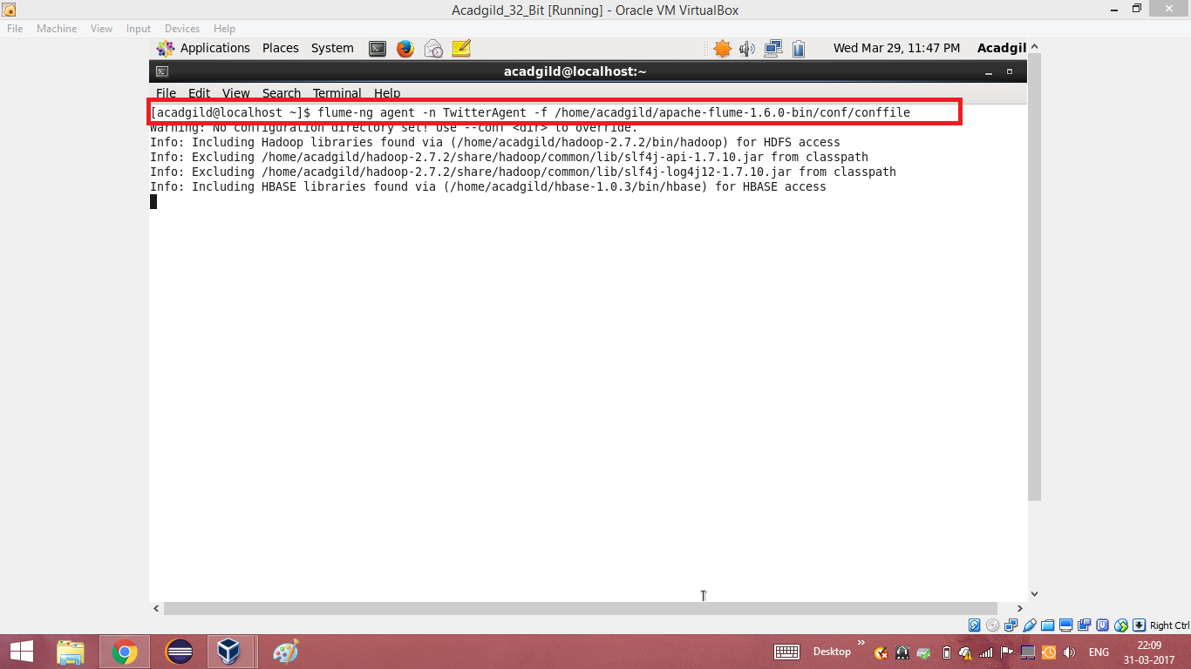

**STEP 4: Listing the contents of the tweets folder**

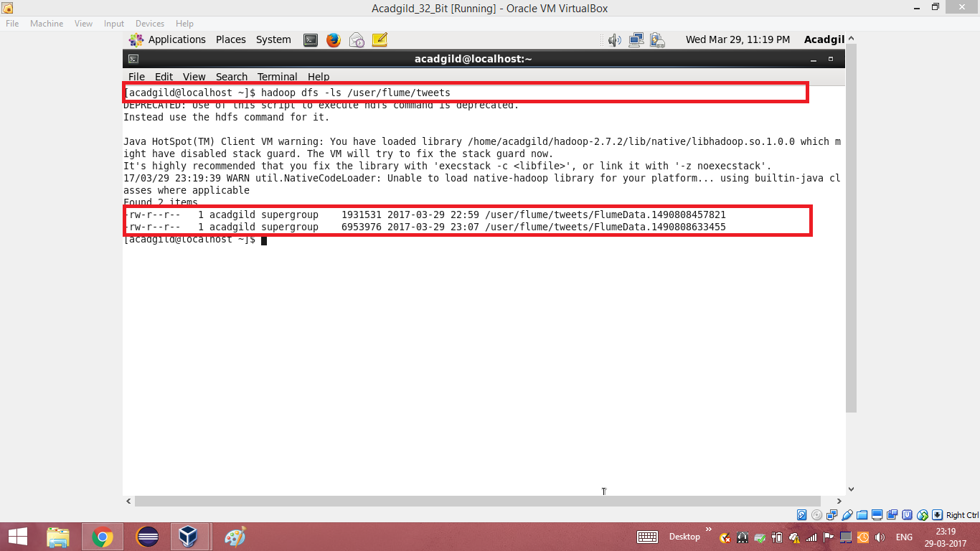

**STEP 5:Reading the extracted data from twitter using cat command**

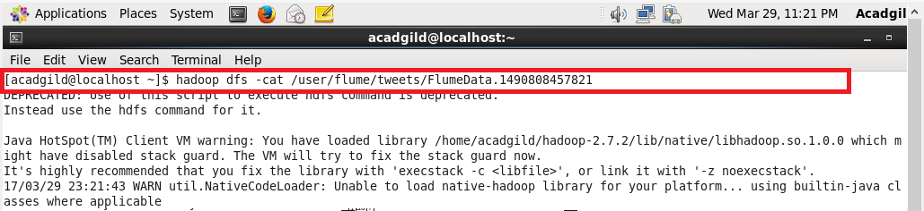

**STEP 6: Extracted data from twitter**

