**ASSIGNMENT-15.1:**

Perform wordcount operation in local mode (In windows environment). Share the code, explain the execution steps, and attach the output screenshot.

DRIVER CLASS:

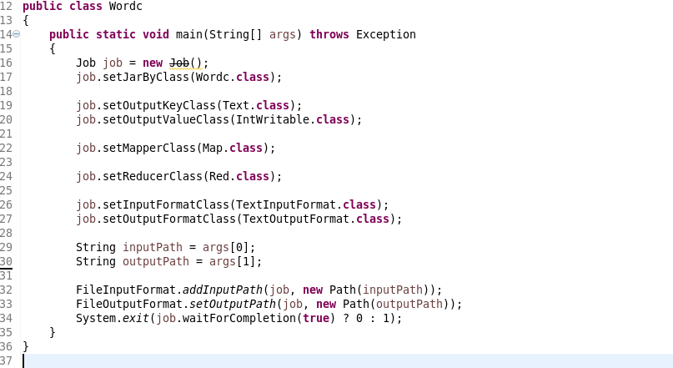

MAPPER CLASS:

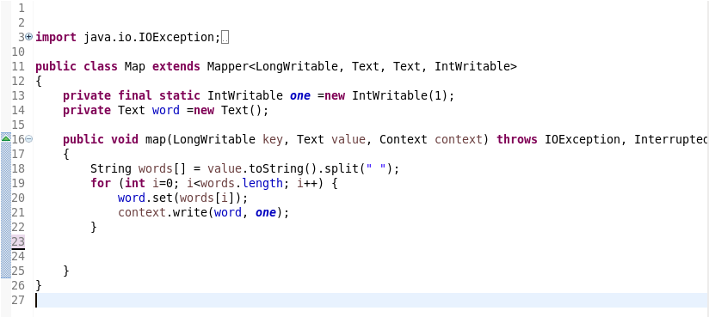

REDUCER CLASS:

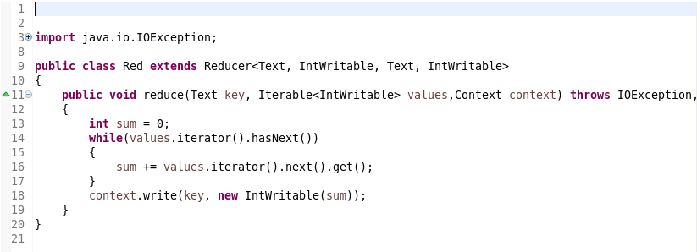

RUNNING THE PROGRAM AS JAVA APPLICATIONS:

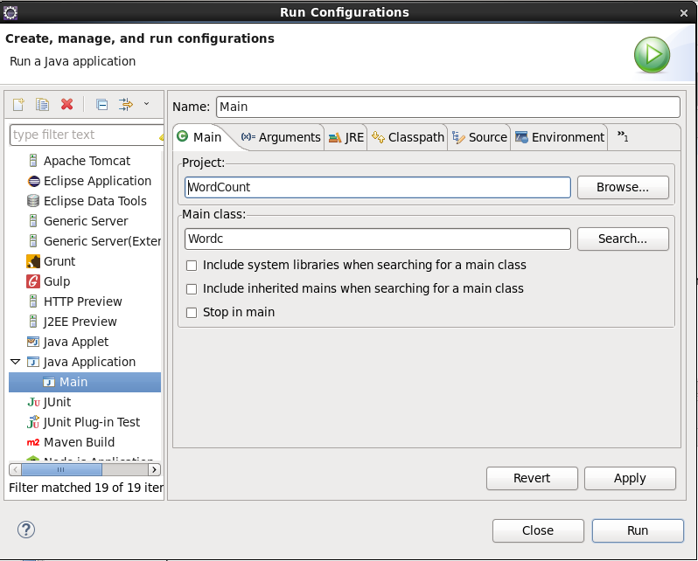

Input and output paths as arguments in the arguments tab:

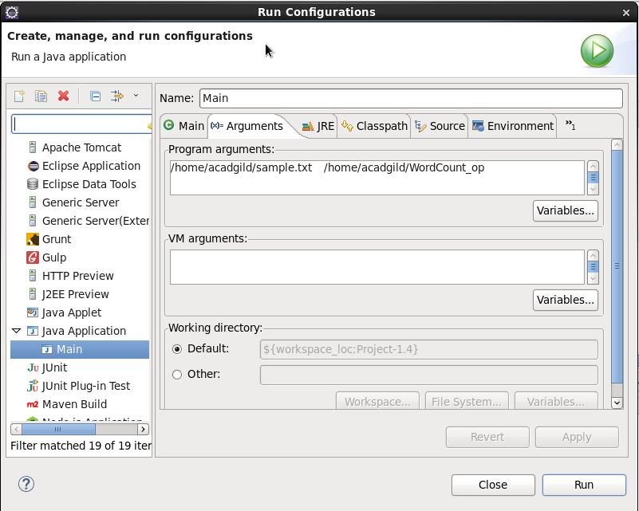

Eclipse Console: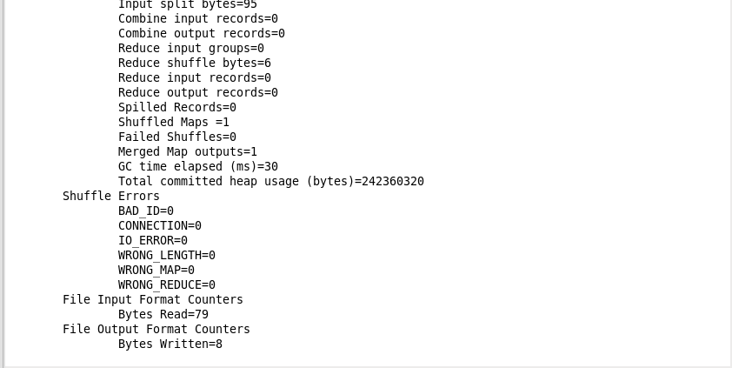

In the above screenshot we can see that the Output is written successfully

Input File:  
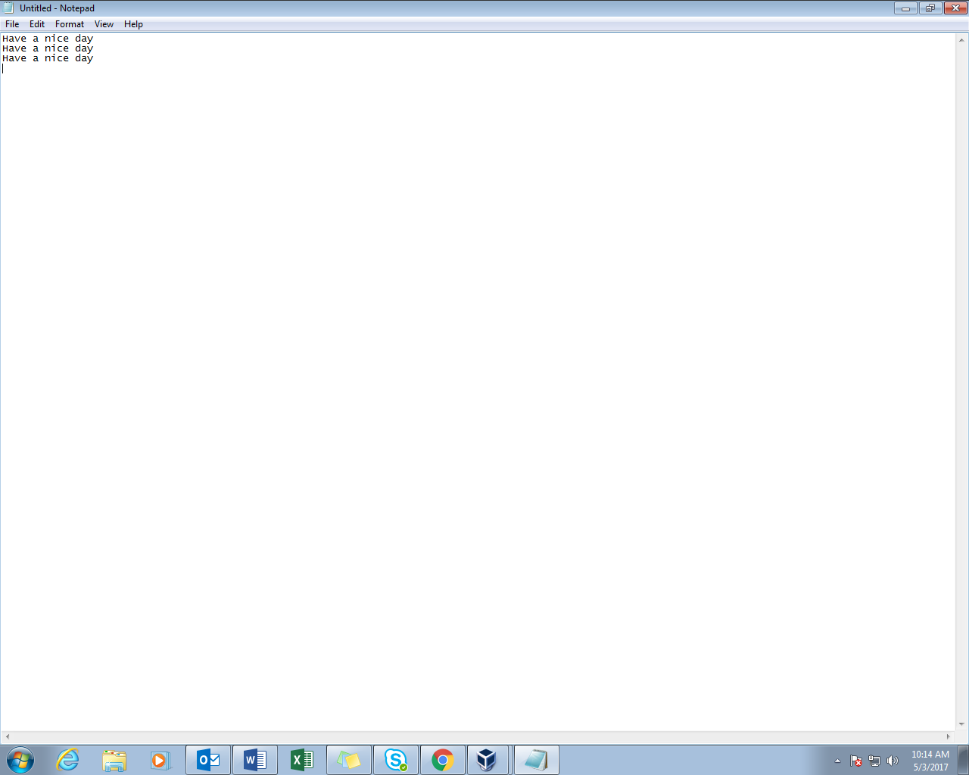

Output File:

