**ASSIGNMENT 16.1 :**

Question :

Using Distributed cache join the two datasets and find out the number of temperature variations in each country using mapreduce.

**DRIVER CLASS:**

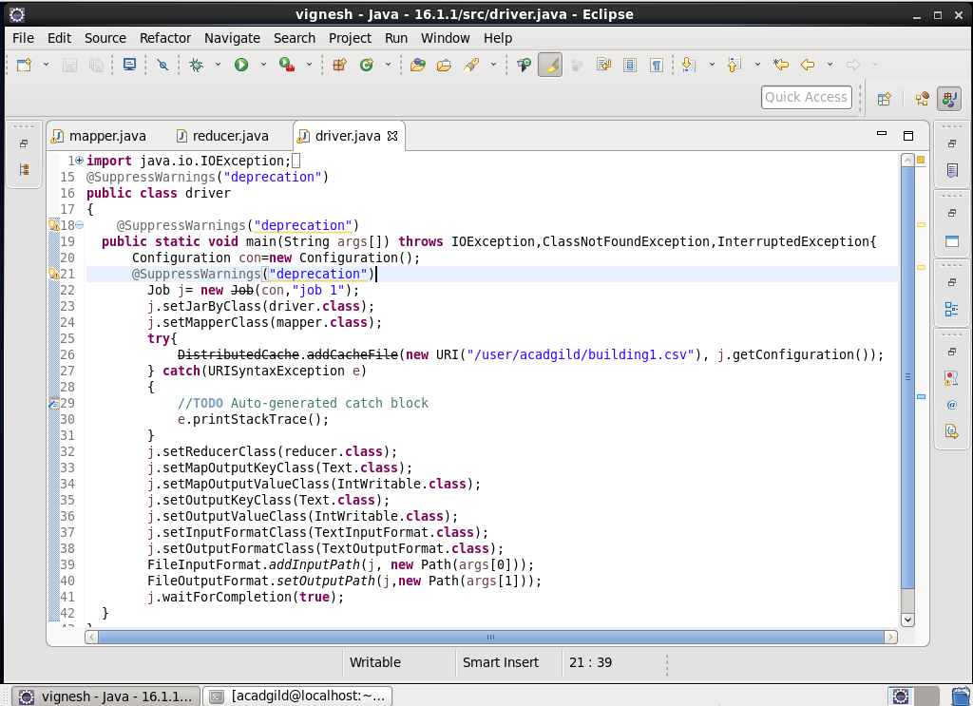

**MAPPER CLASS:**

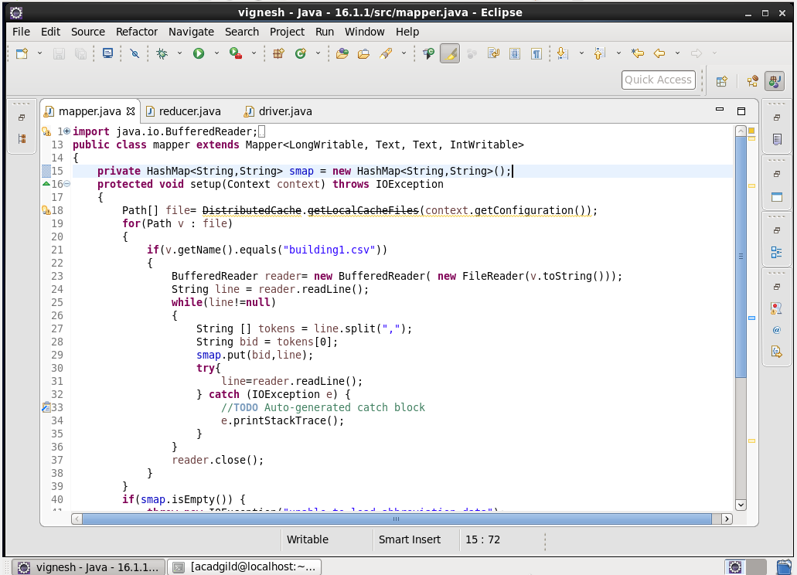

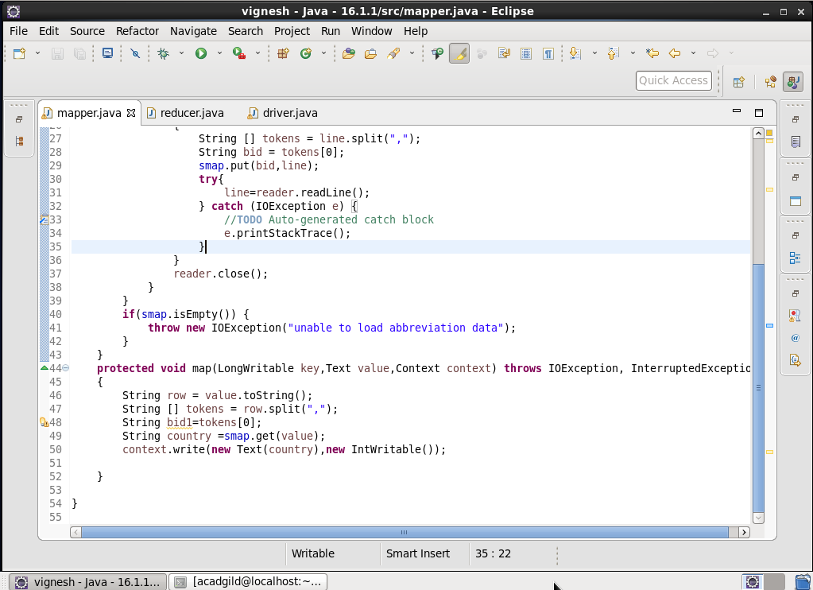

**REDUCER CLASS:** 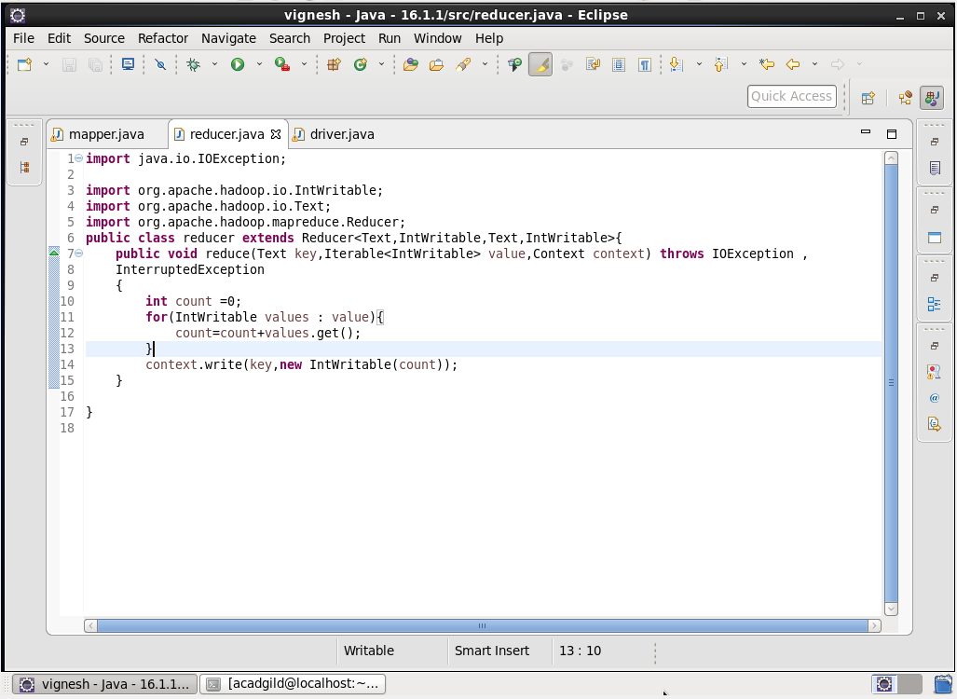

**OUTPUT:**

