**ASSIGNMENT 16.2:**

**Use reduce side join to join the two datasets and find What kind of problems are prevalent, and in which state?**

**DRIVER CLASS:**

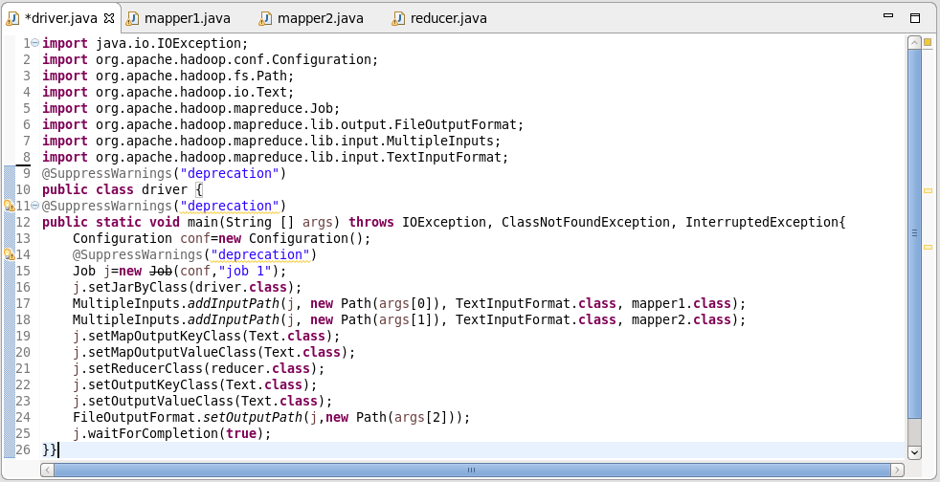

**MAPPER1 CLASS :**

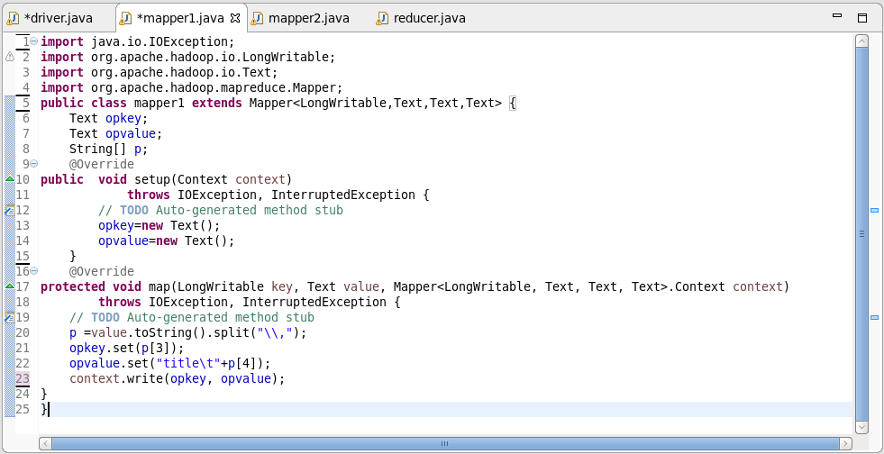

**MAPPER2 CLASS :**

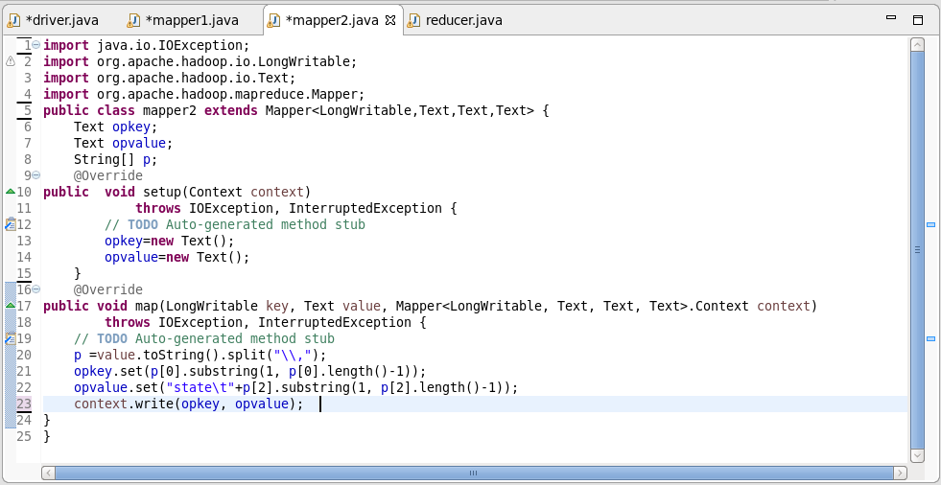**REDUCER CLASS :** 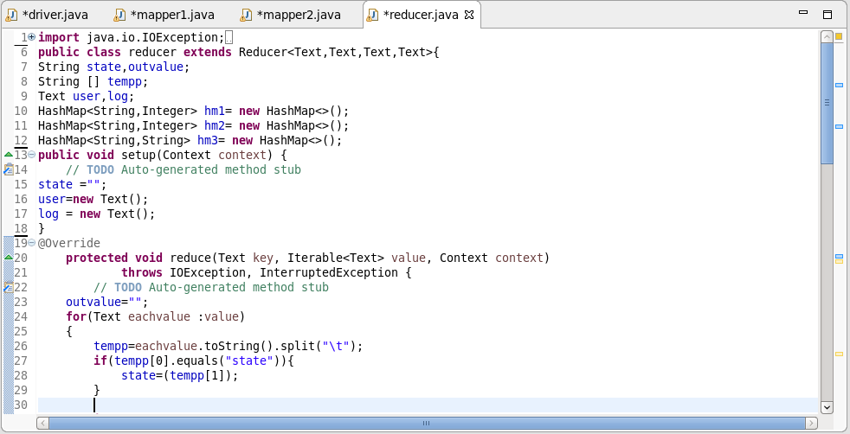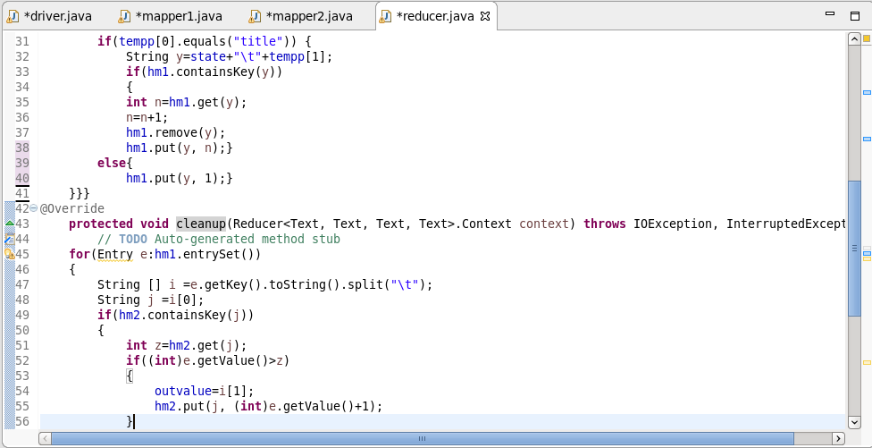

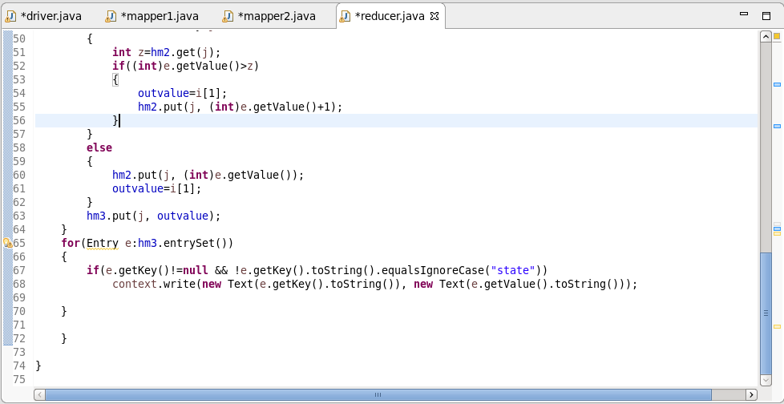

**RUNNING JAR:**

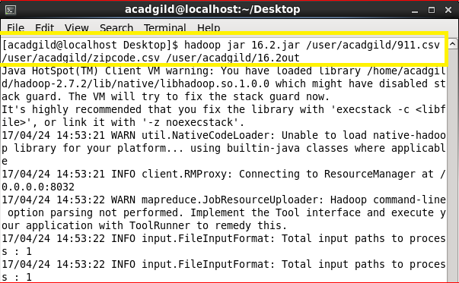

**OUTPUT:**

