**ASSIGNMENT 16.3 :**

**DRIVER CLASS:**

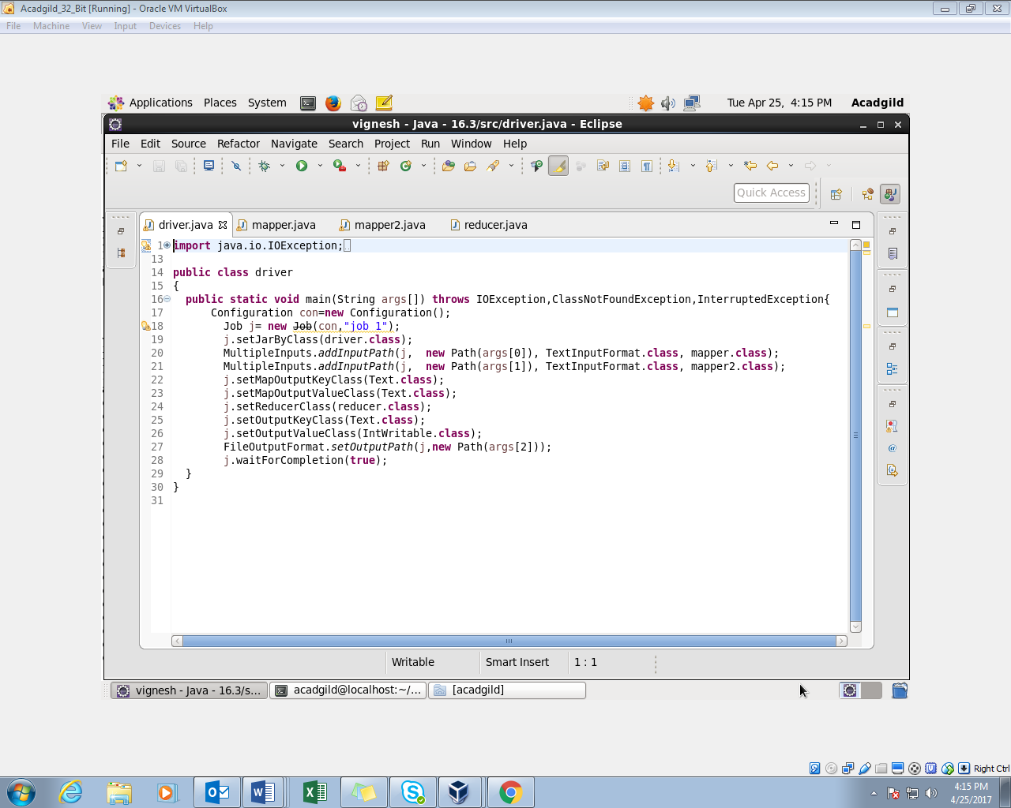

**1ST MAPPER CLASS:**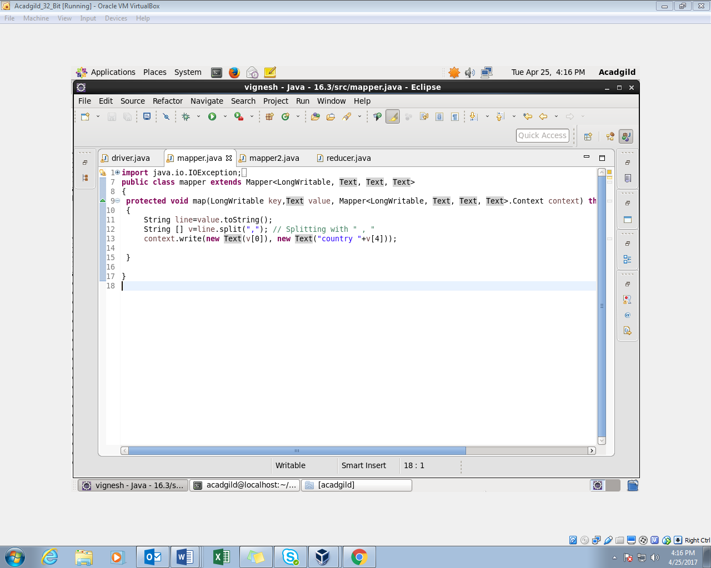

**2ND MAPPER CLASS:**

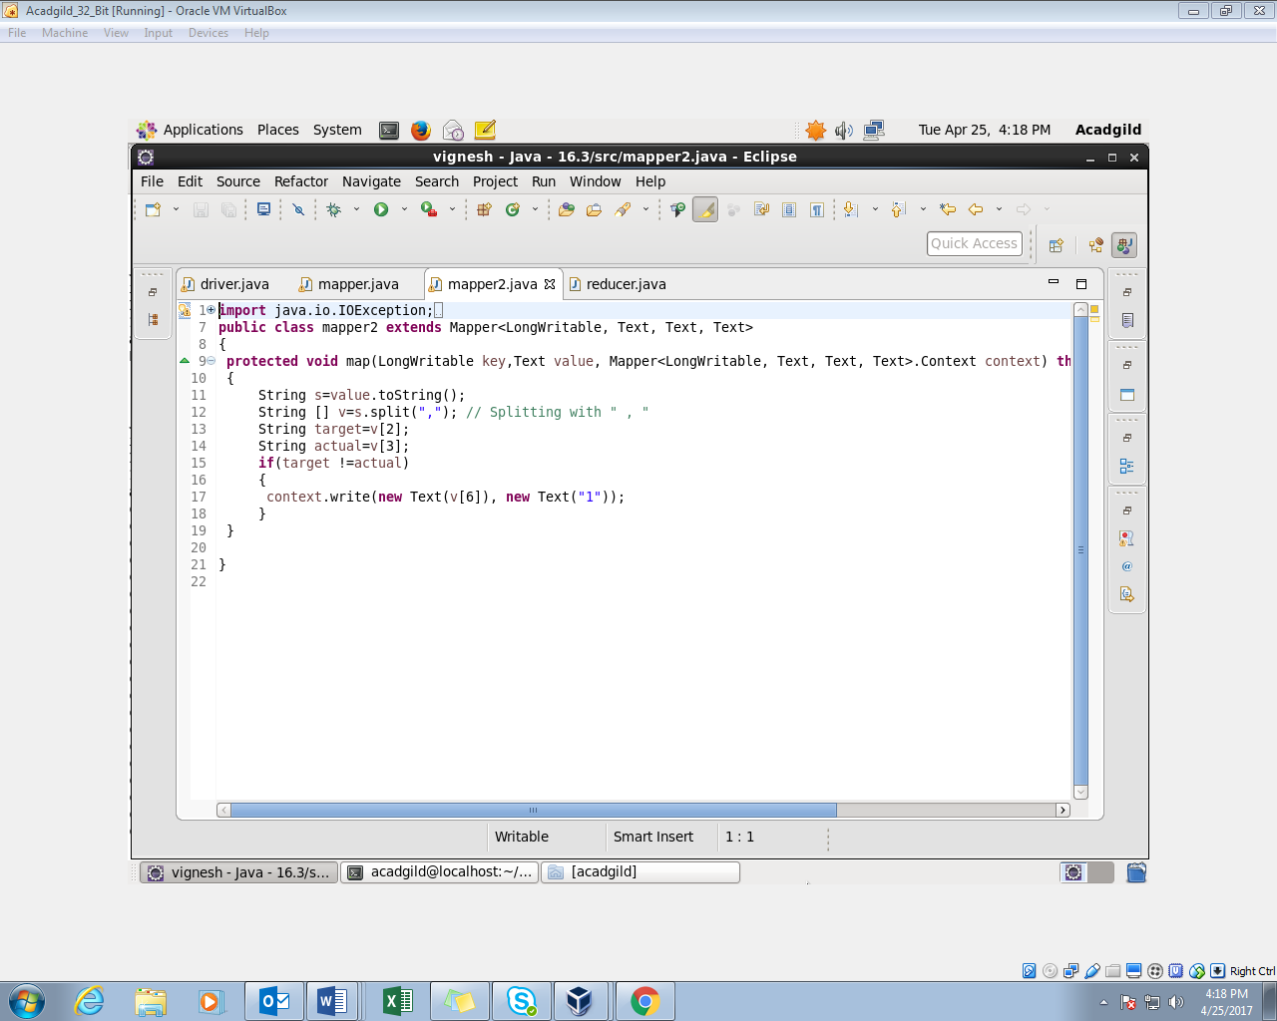

**REDUCER CLASS:**

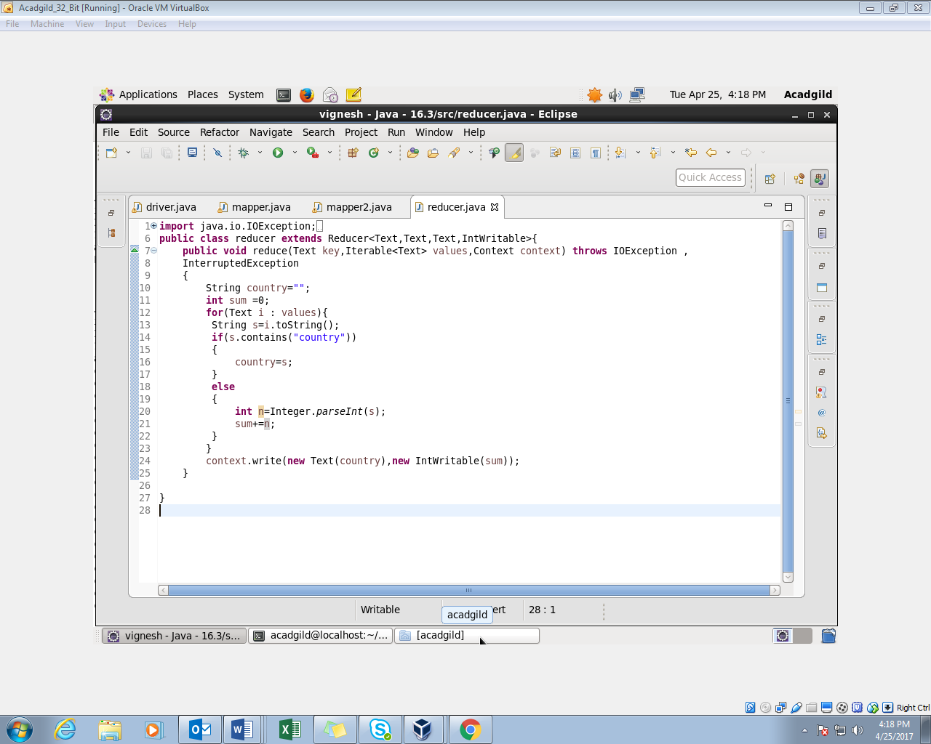

**OUTPUT:**

