**ASSIGNMENT 16.5 :**

**Write a map reduce program to join the below given two datasets**

**using map side join.**

**DRIVER CLASS:**

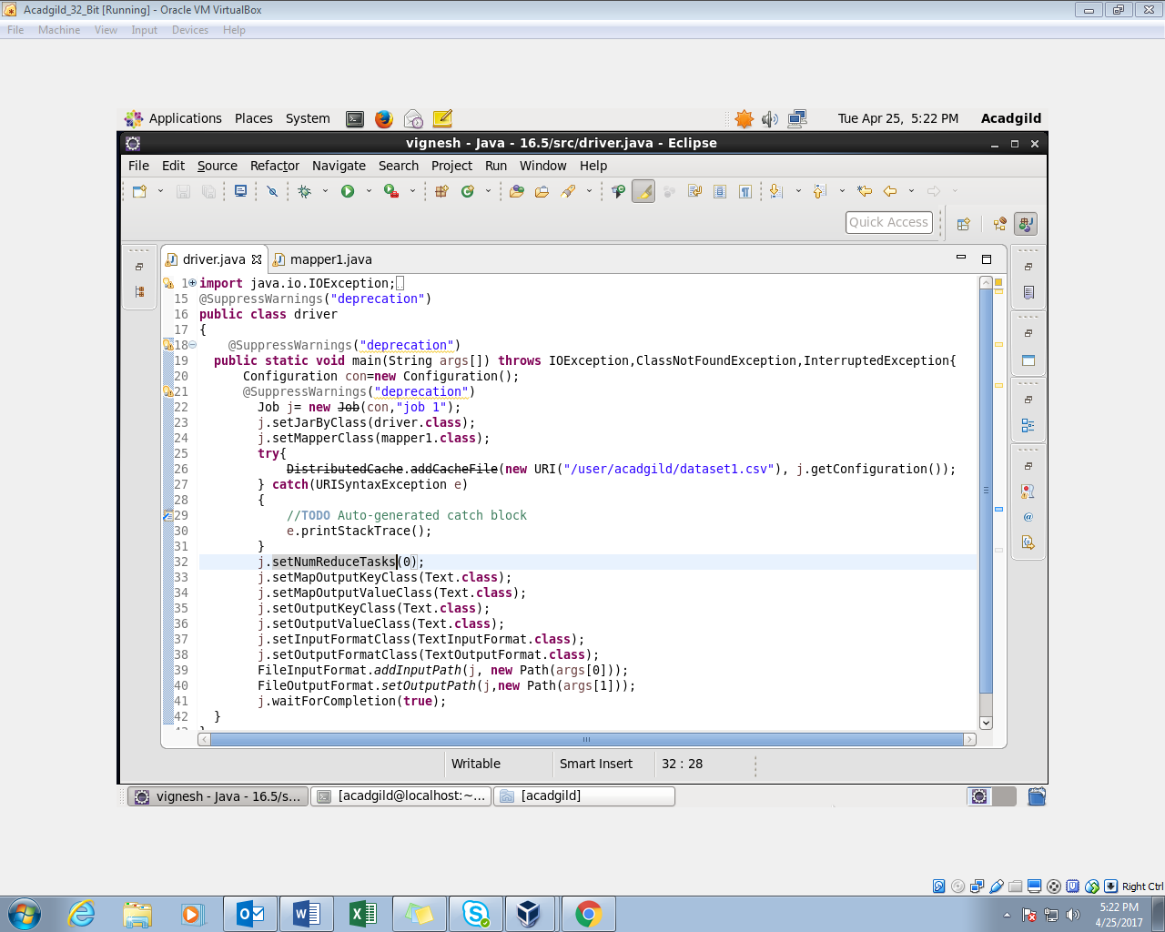

**MAPPER CLASS:**

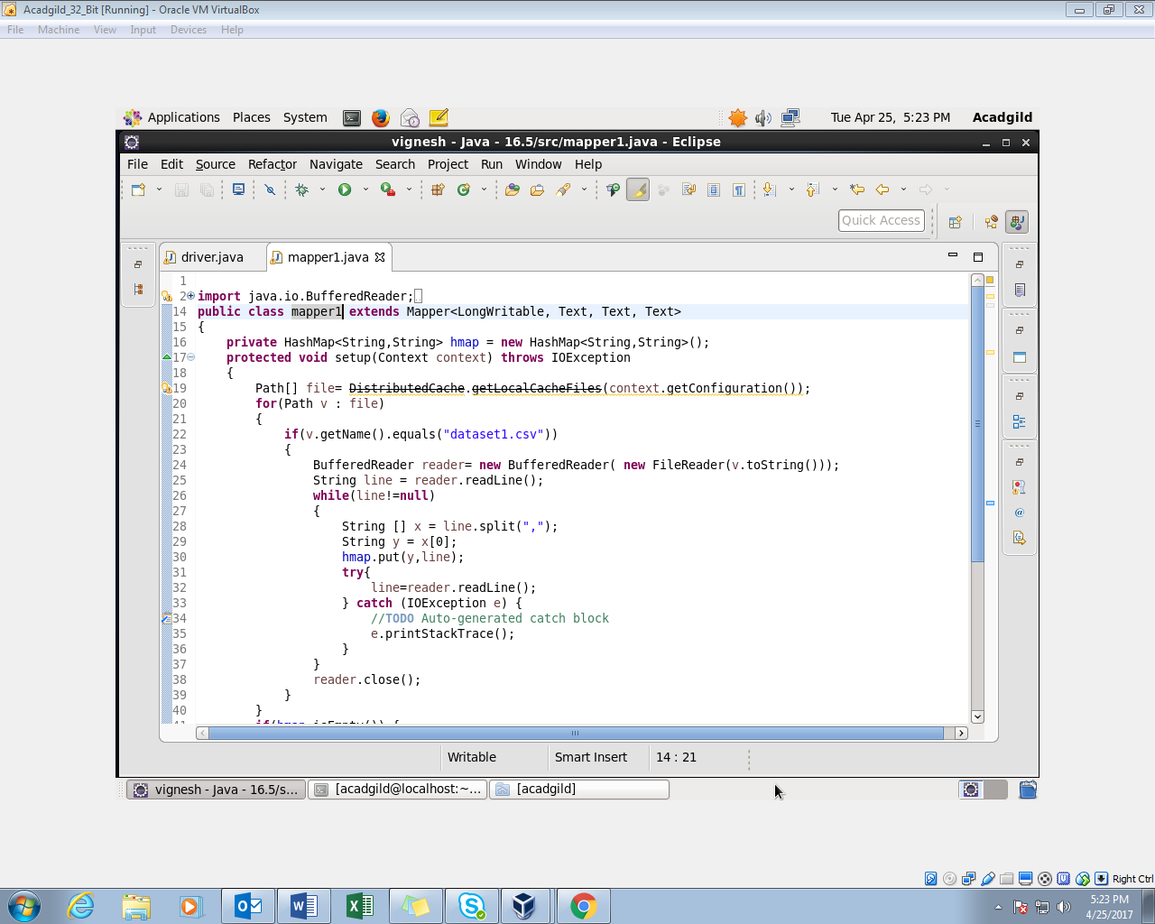

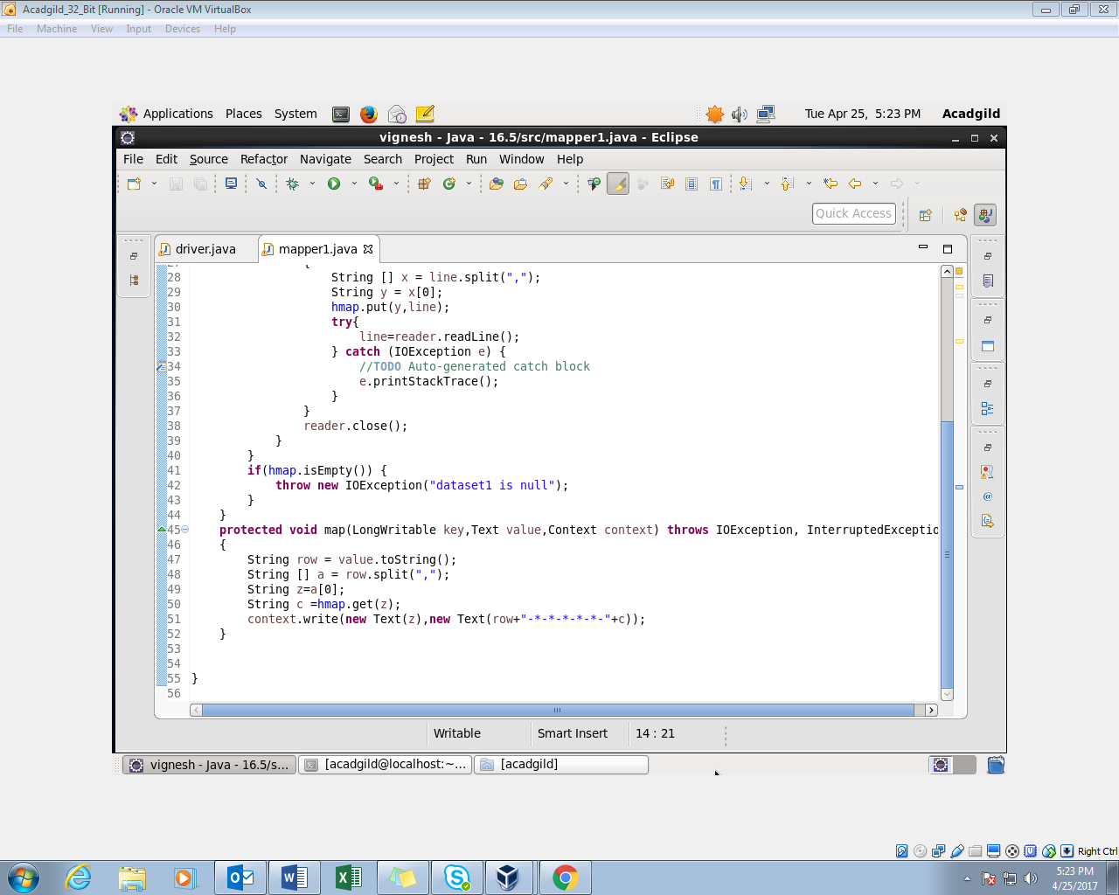

**OUTPUT:**

