**ASSIGNMENT 16.6. Write a map reduce program to join the below given two datasets using Reducer side join.**

**DRIVER CLASS:**

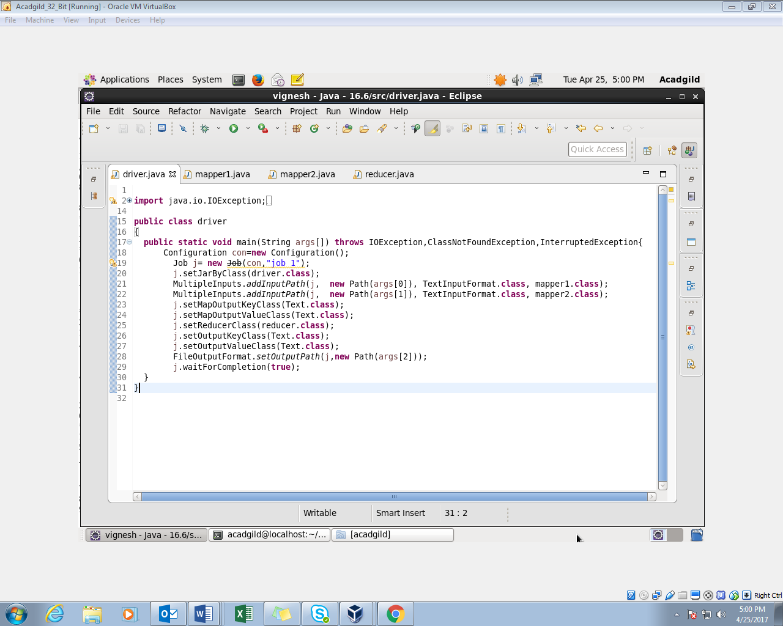

**1ST MAPPER CLASS:**

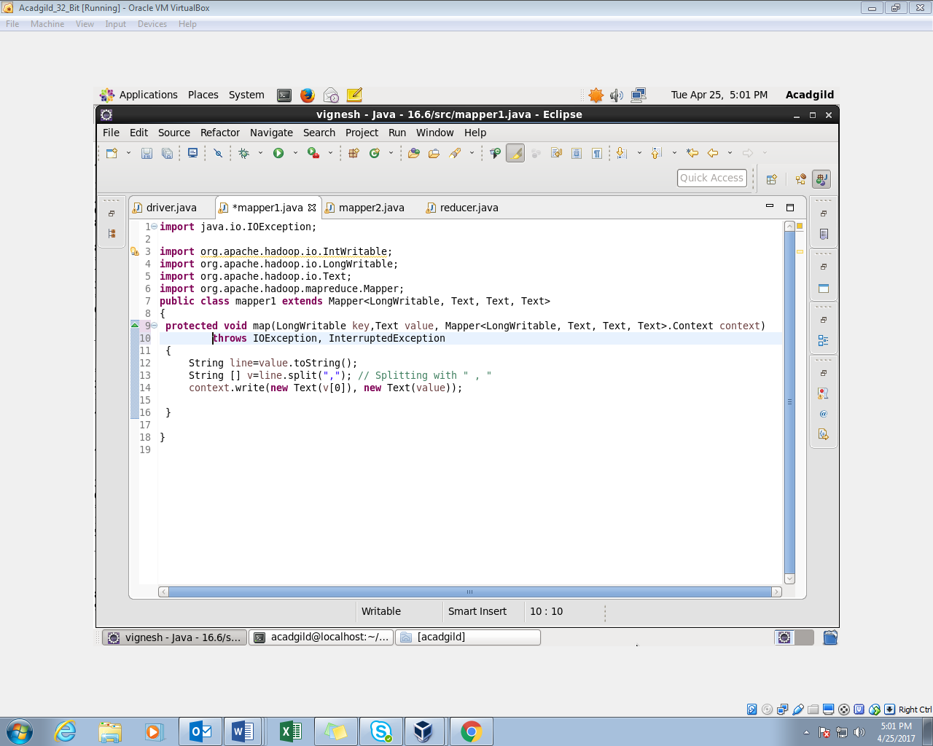

**2ND MAPPER CLASS:**

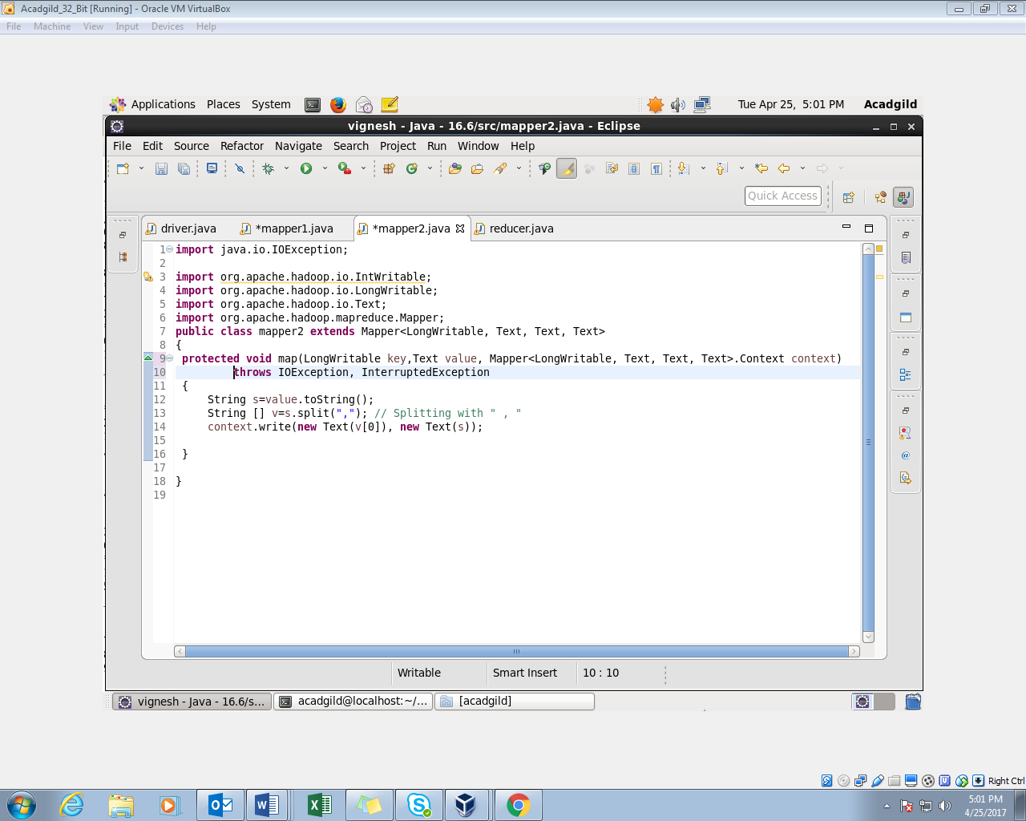

**REDUCER CLASS:**

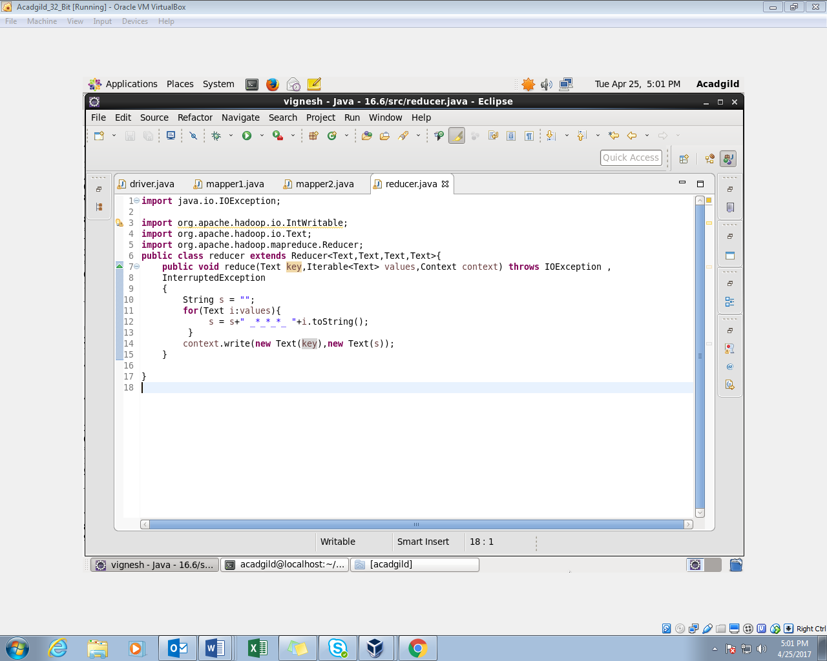

**OUTPUT:**

