**ASSIGNMENT 17.1 :**

**Question :** Write a program that accepts the job_id as argument and returns a custom counter and a system counter (total records input to the map tasks) associated with that job.

**DRIVER CLASS:**

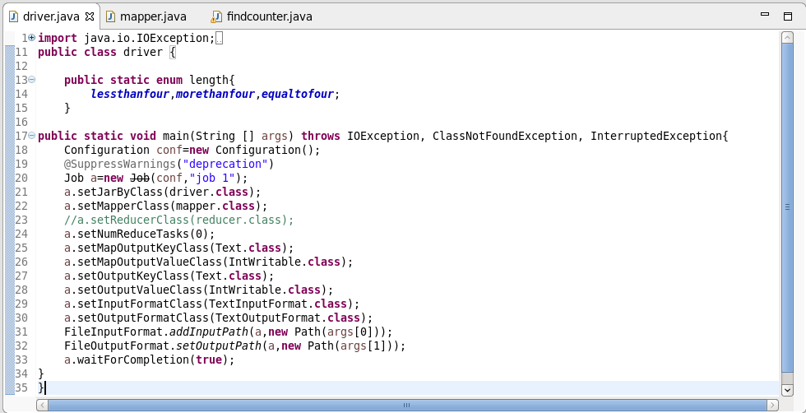

**MAPPER CLASS:**

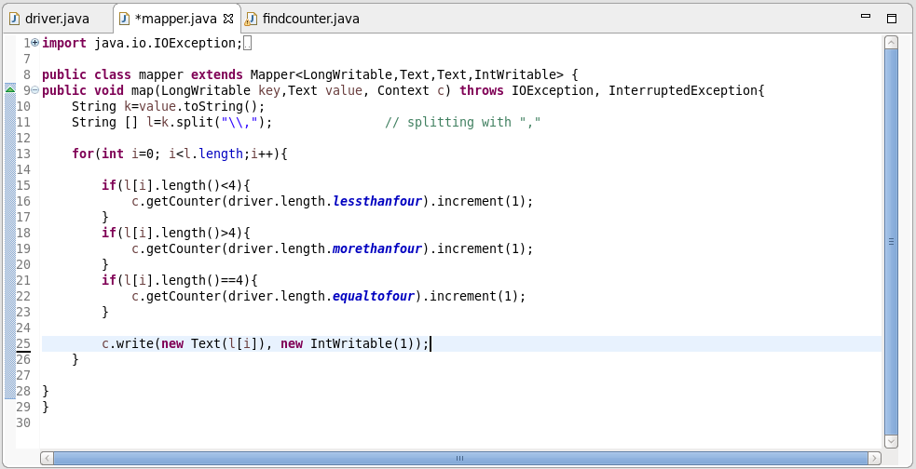

**FINDCOUNTER CLASS:**

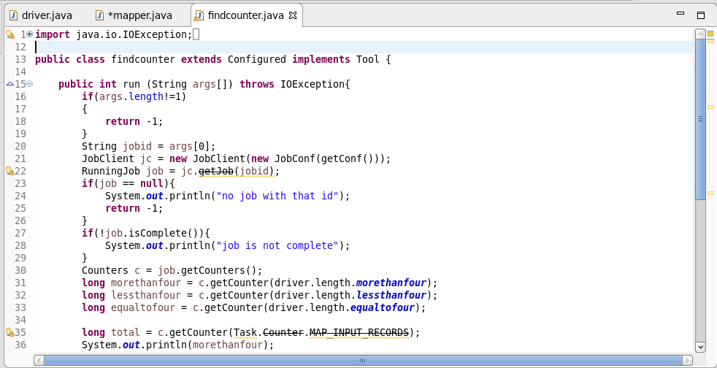

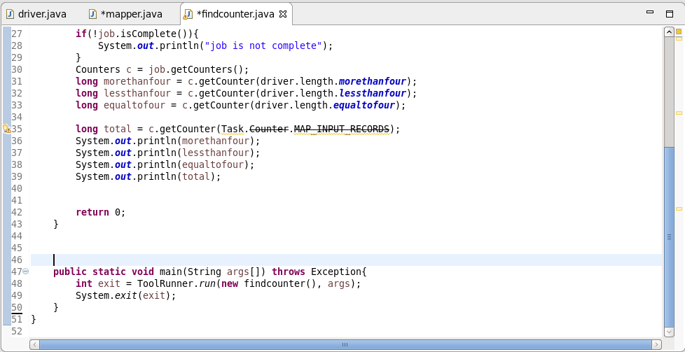

**LOGIC:**

* If the length of the word is greater than 4, variable ‘morethanfour ‘ gets incremented with 1.
* If the length of the word is less than 4, the variable ‘ lessthanfour ‘ gets incremented with 1.
* If the length of the word is equal to 4, ‘ equaltofour ‘ gets incremented with 1.
* While running jar file with driver as main class and arguments as input text file and output path, we will get the first o/p .
* While running jar file with job id as argument, we will get the second o/p.

**FIRST OUTPUT :**

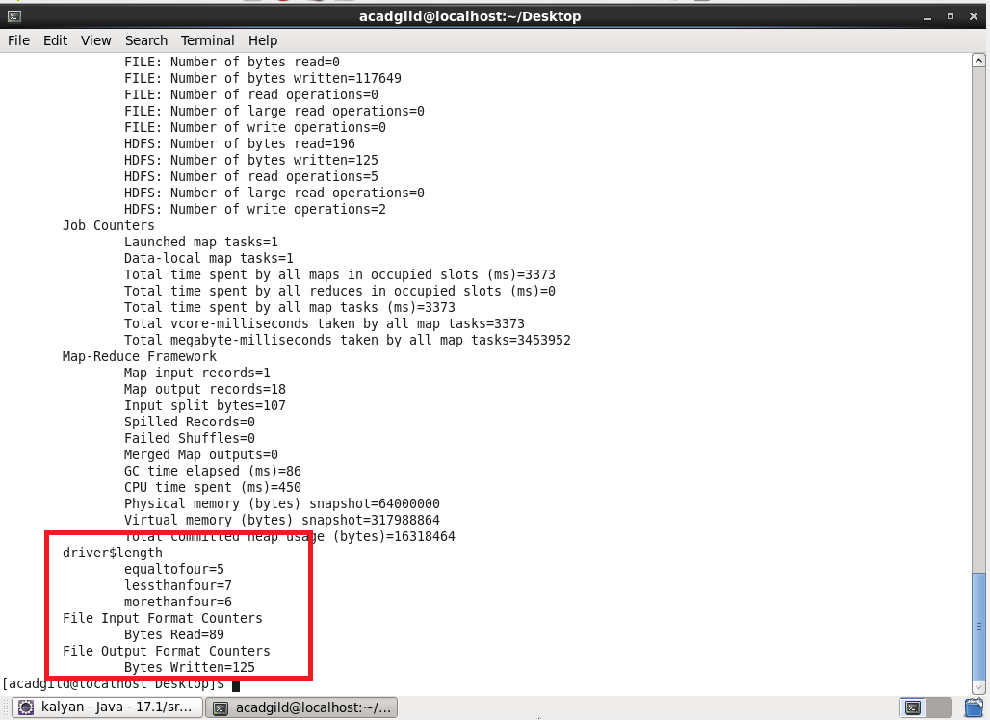

**SECOND OUTPUT:**