**ASSIGNMENT 17.2 :**

**Question : Write a secondary sort program to generate the top 2 maximum temperatures corresponding to every year from the temperature dataset.**

**DRIVER CLASS:**

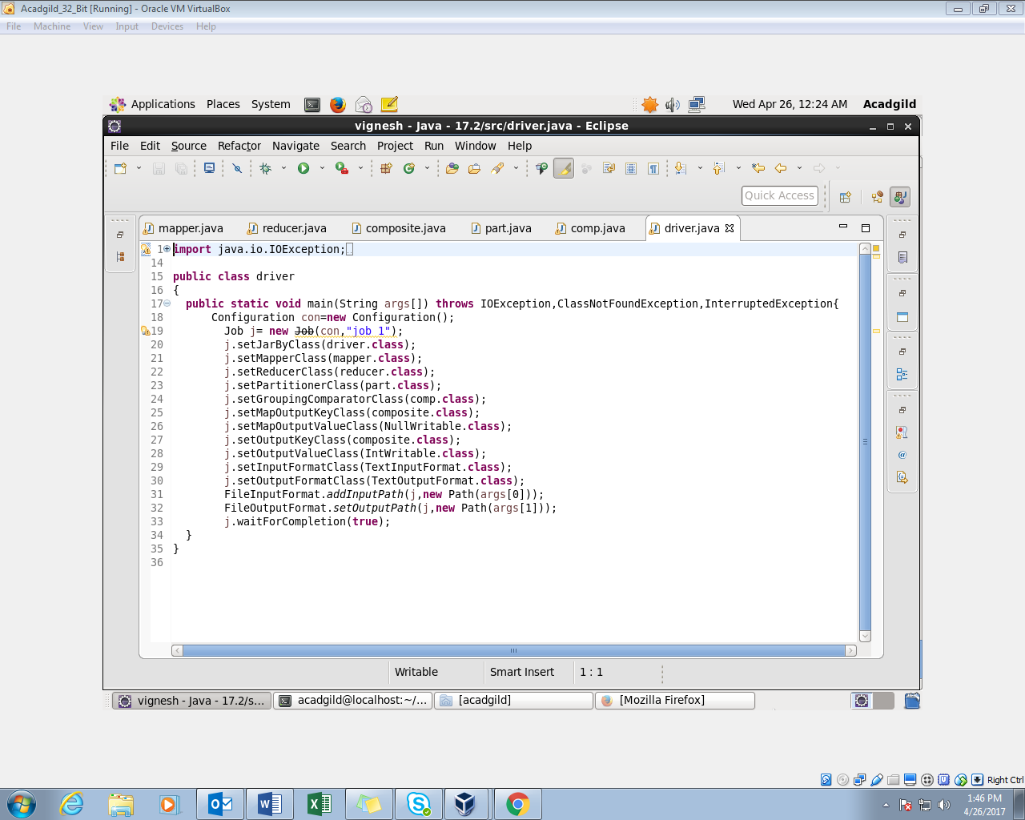

**MAPPER CLASS:**

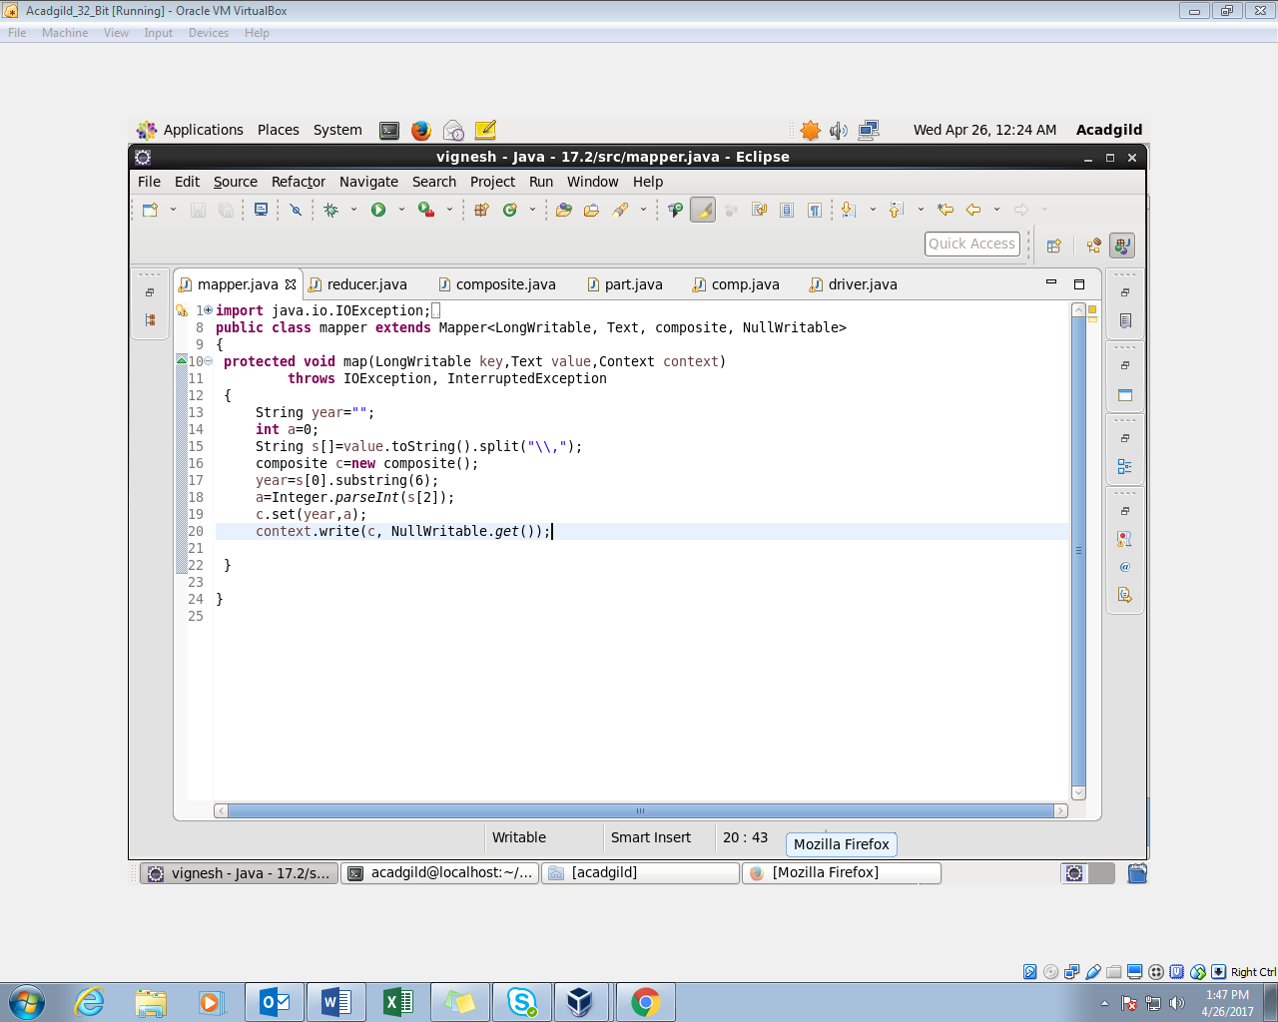

**COMPOSITE KEY CLASS:**

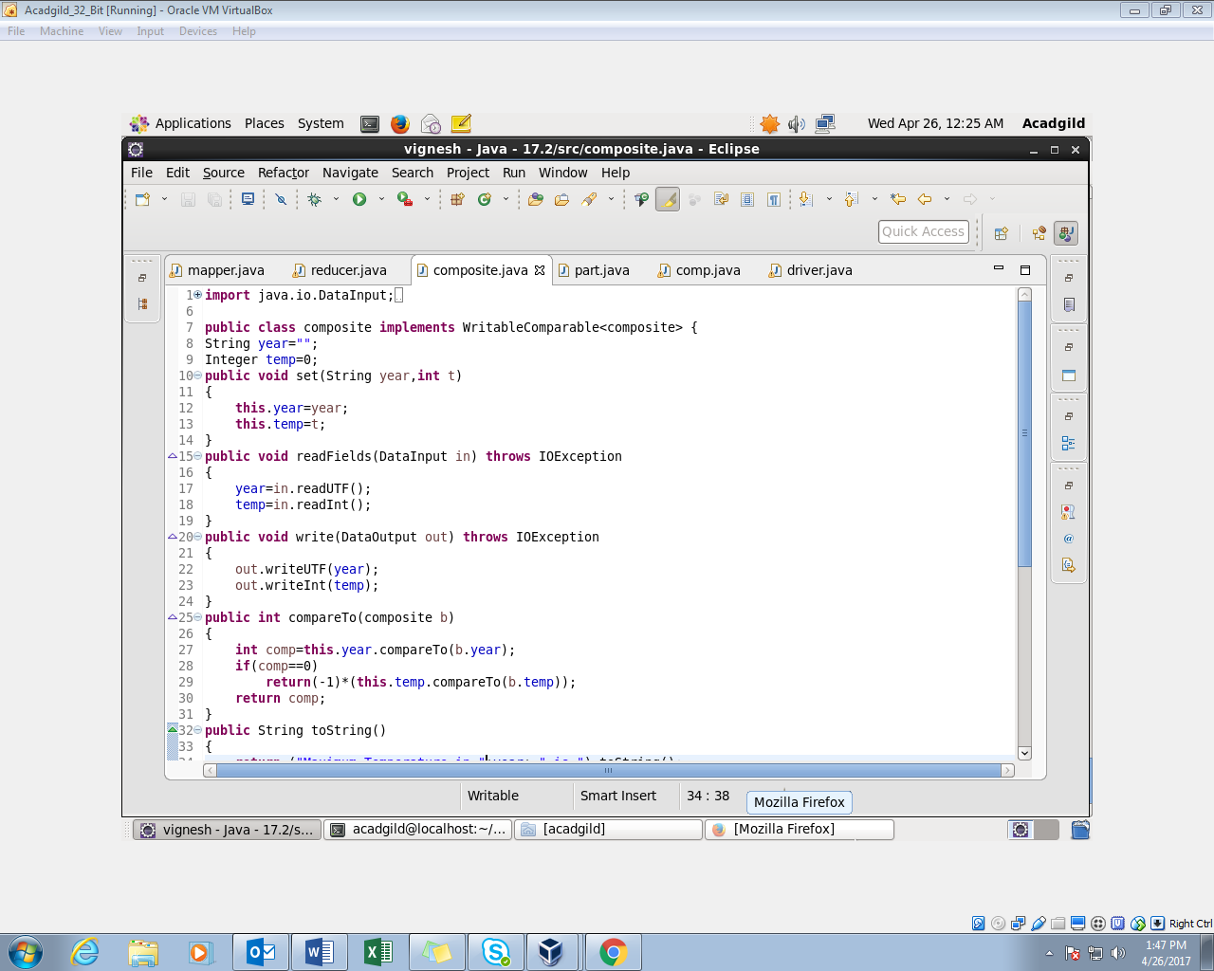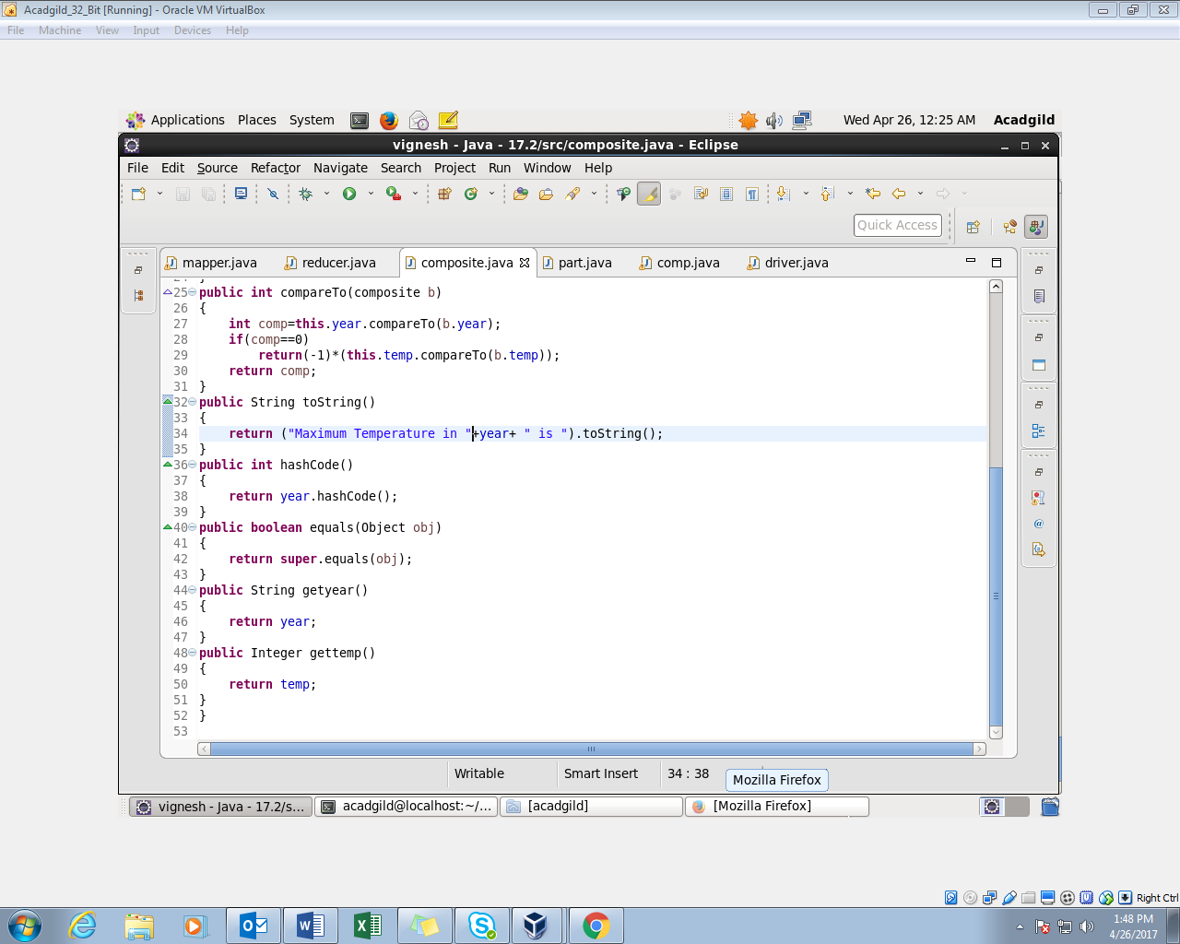

* **Overriding the ‘ compare ‘ Method :**

It is used to check if the year is same, if it is same then it will sort the temperature in the descending order.

* **Overriding ‘ Tostring ‘ Method :**

The composite key must be displayed.

**PARTITIONER CLASS:**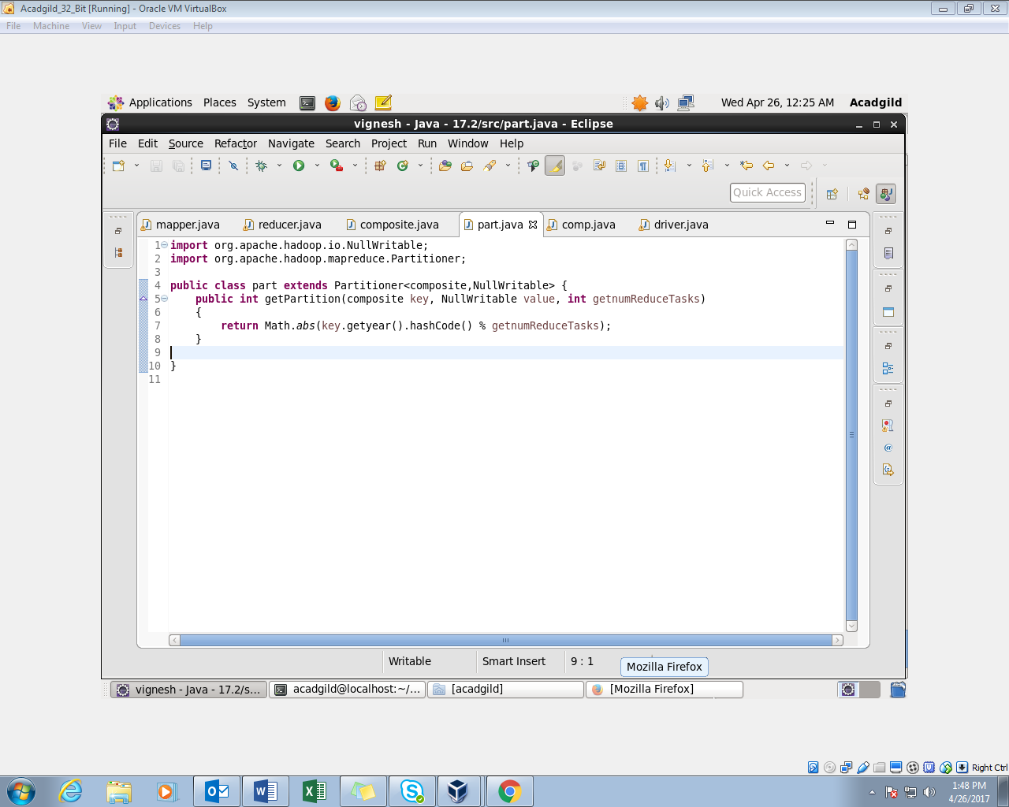

**GROUP COMPARATOR CLASS:**

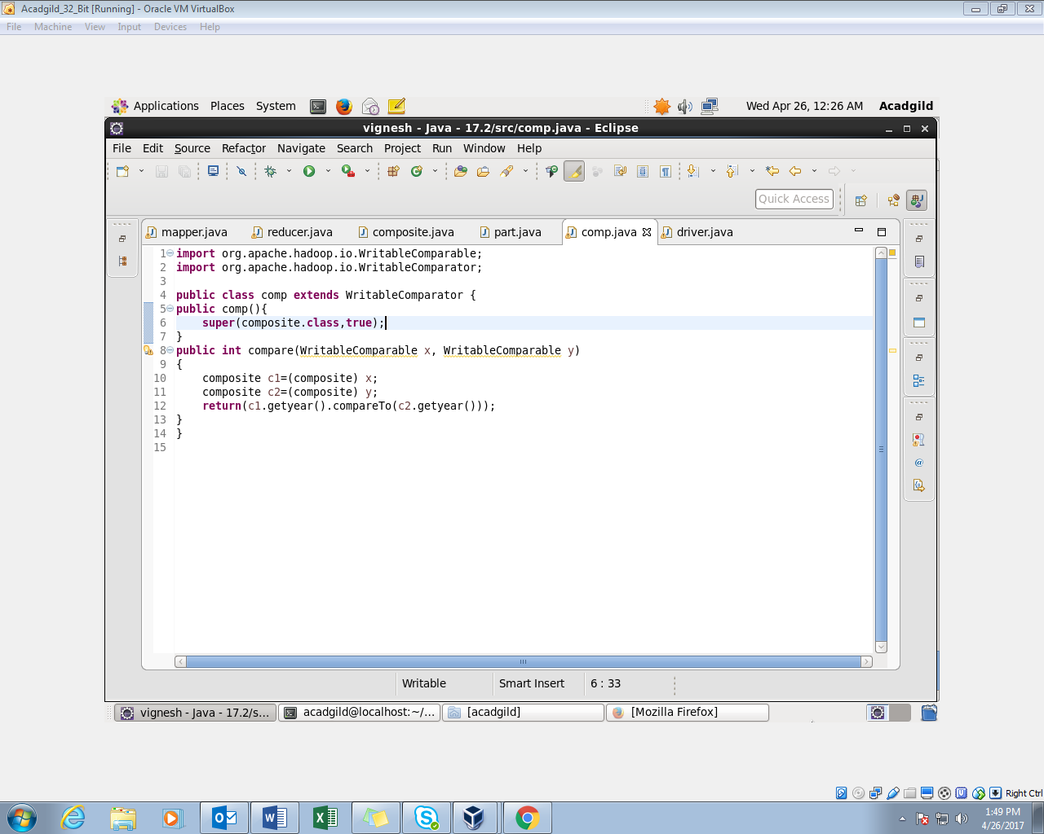

**REDUCER CLASS:**

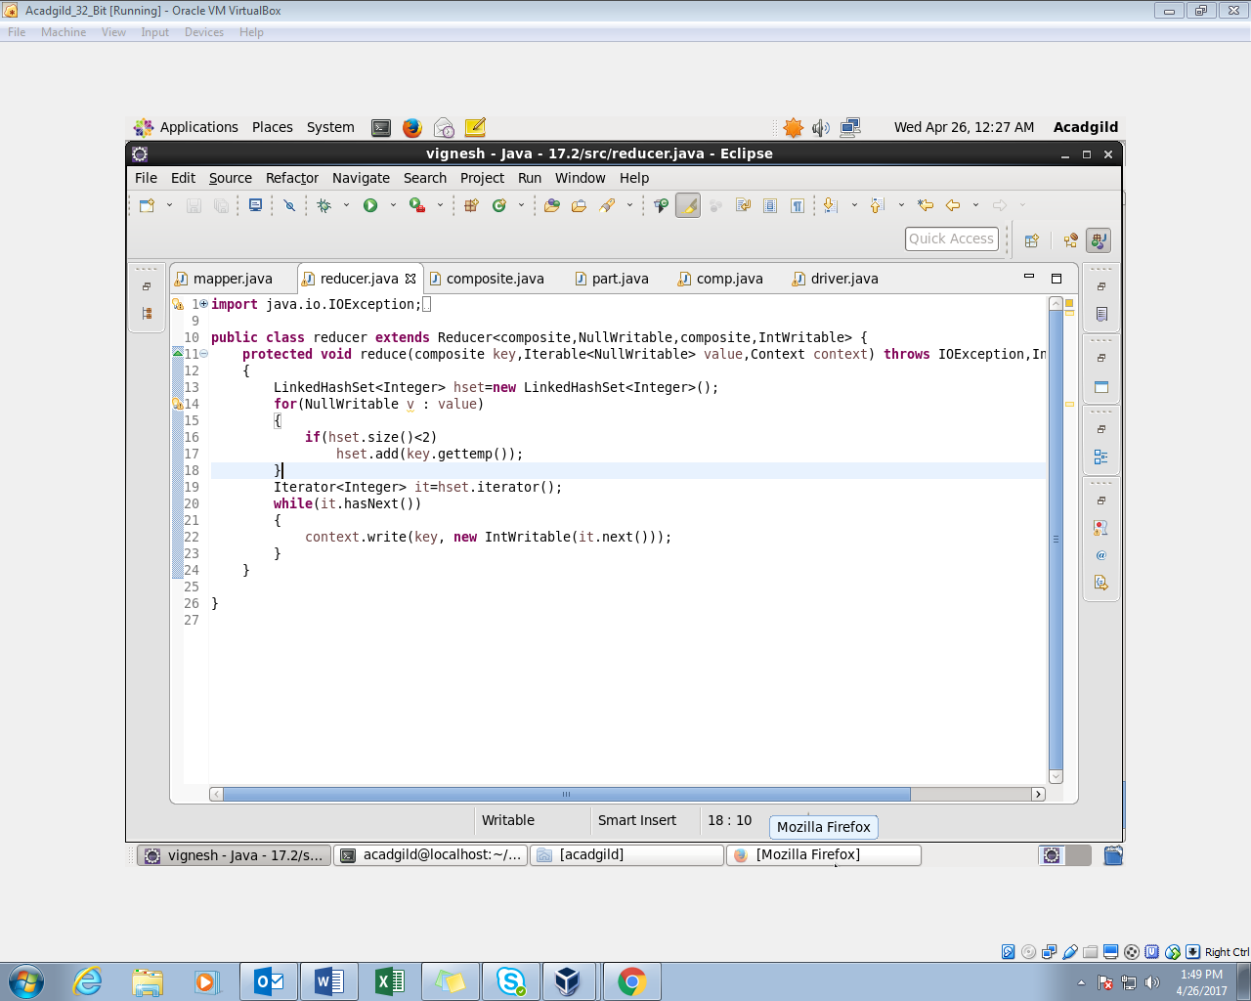

**OUTPUT:**

