**ASSIGNMENT 17.3 :**

Write a mapreduce job that takes configuration from command line (min.word.count). Based on the configuration, it should perform count of words from a document and produce only those words in the output whose count is greater than or equal to the configuration.

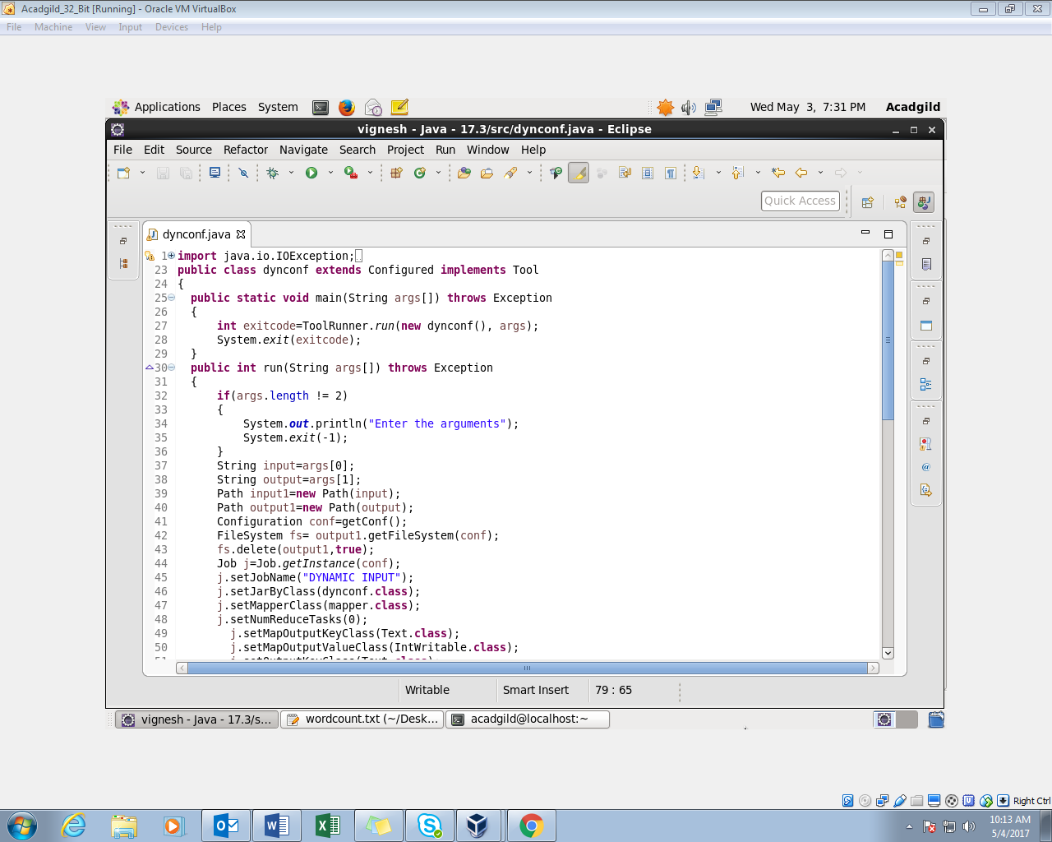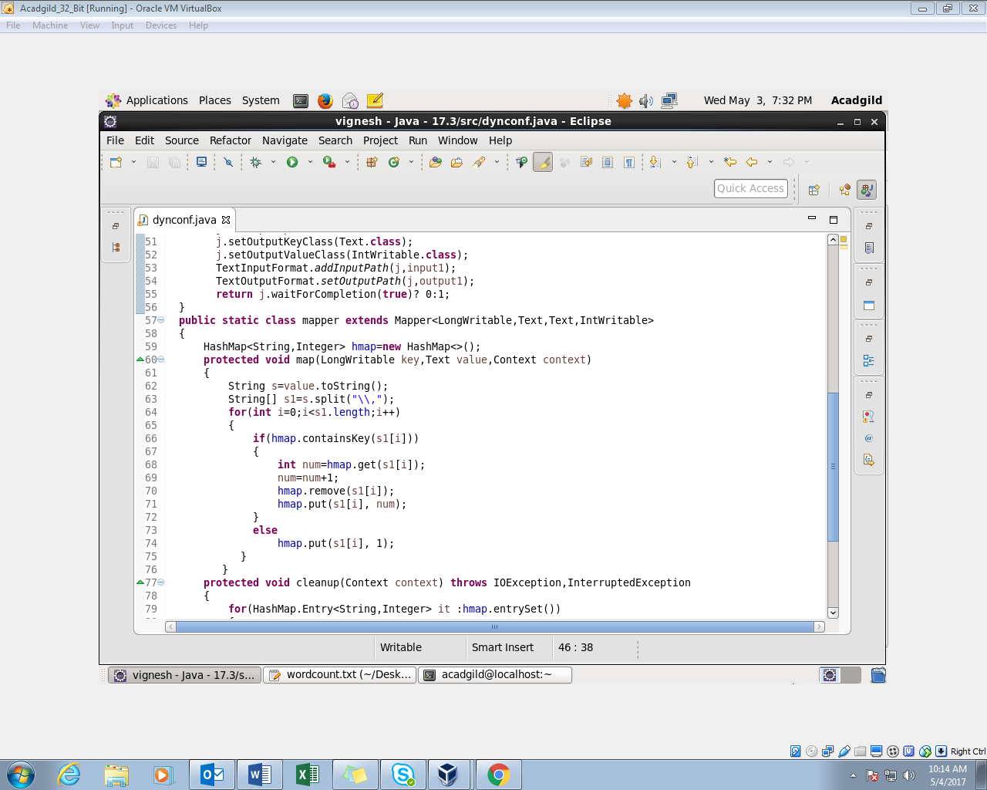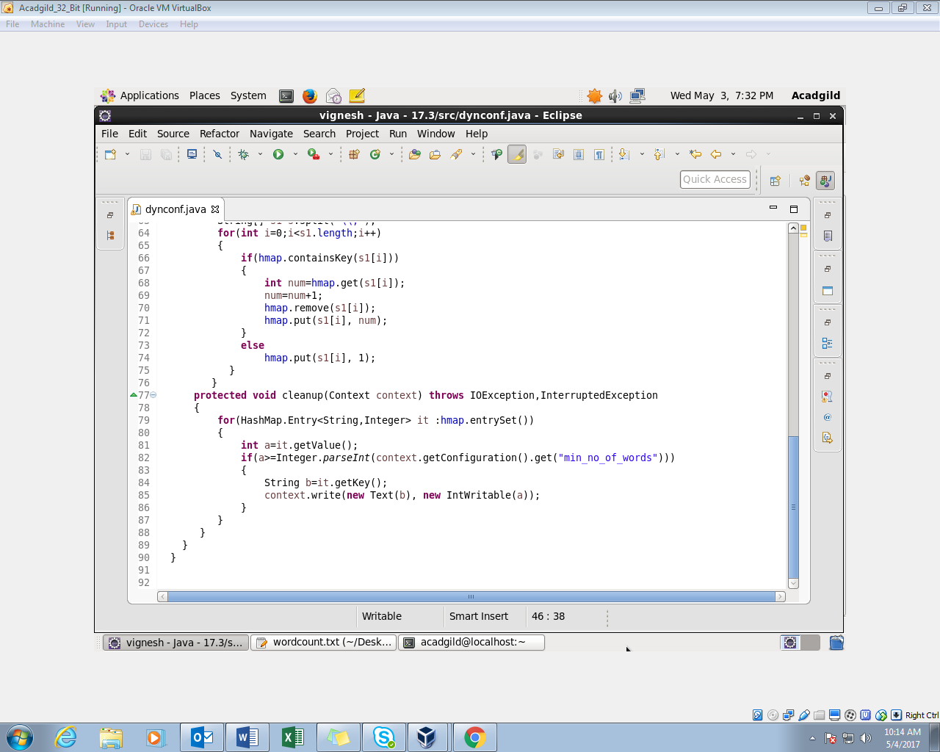

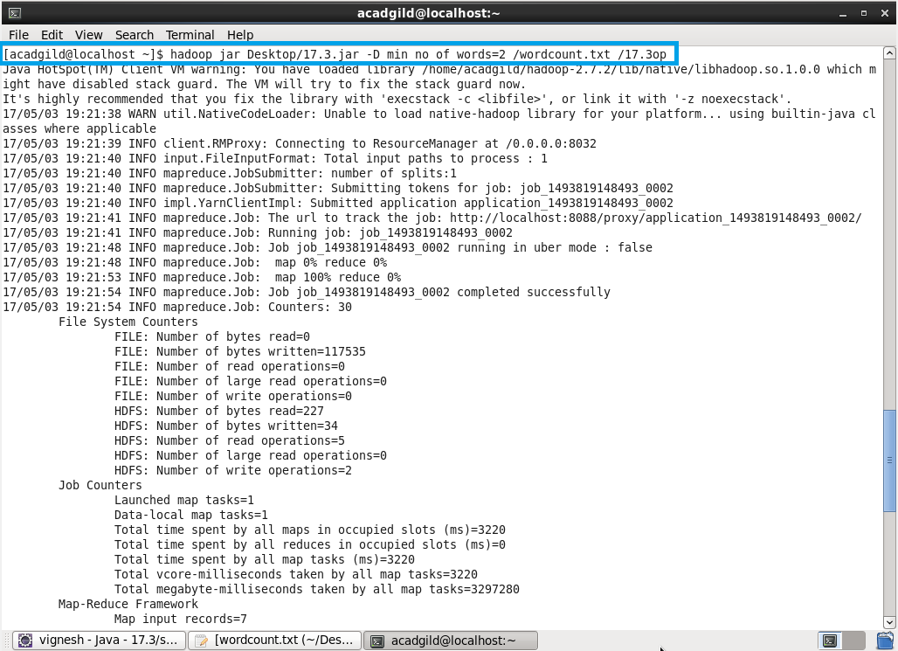

**INPUT FILE :**

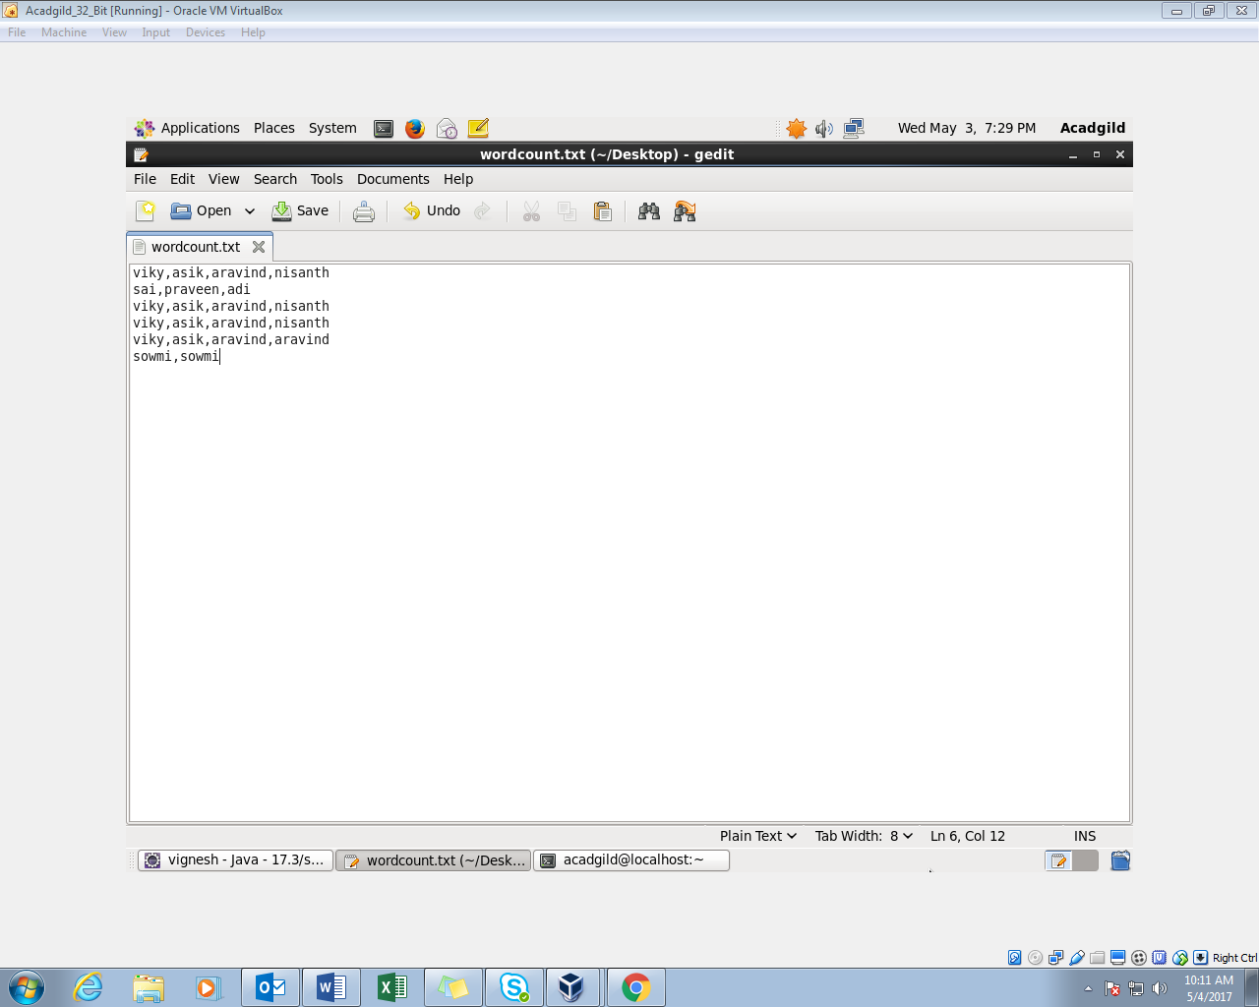

**OUTPUT :**

