**ASSIGNMENT 18.1 :**

a) Run a map only job on the word count program using static configurations.

**DRIVER CLASS:**

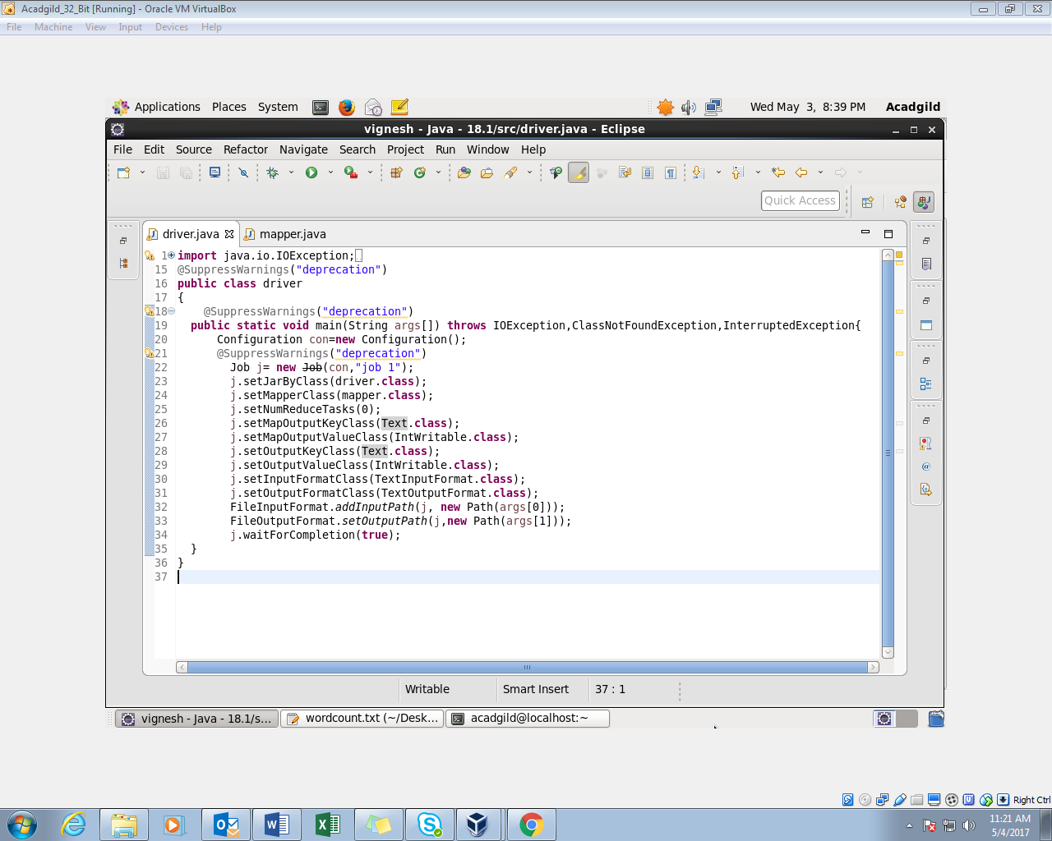

**MAPPER CLASS:**

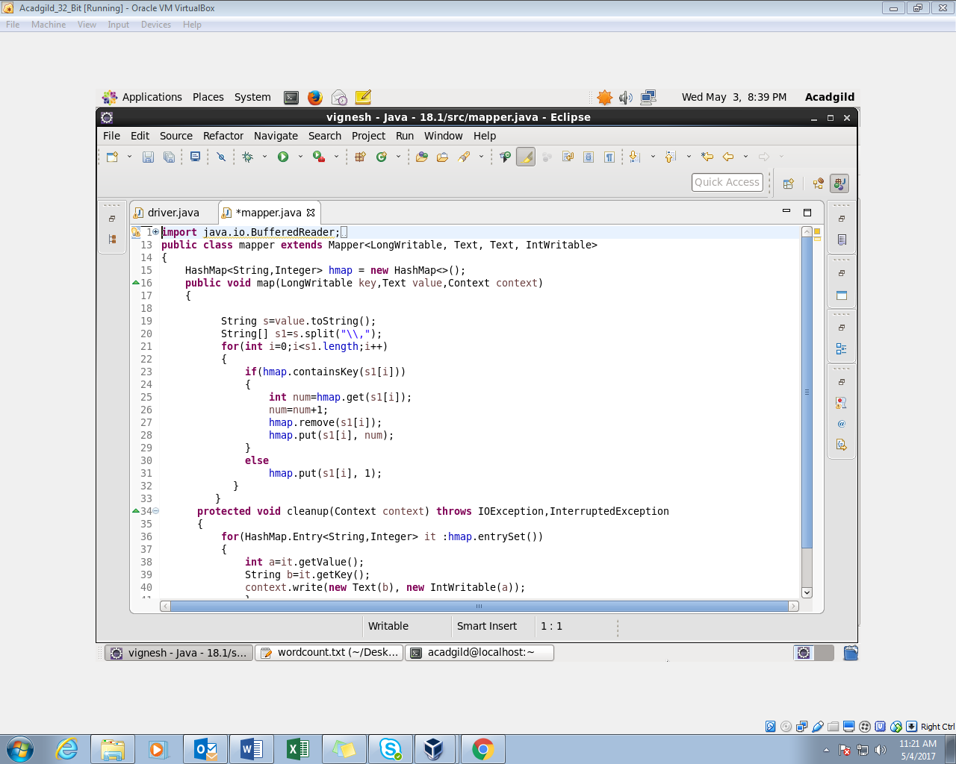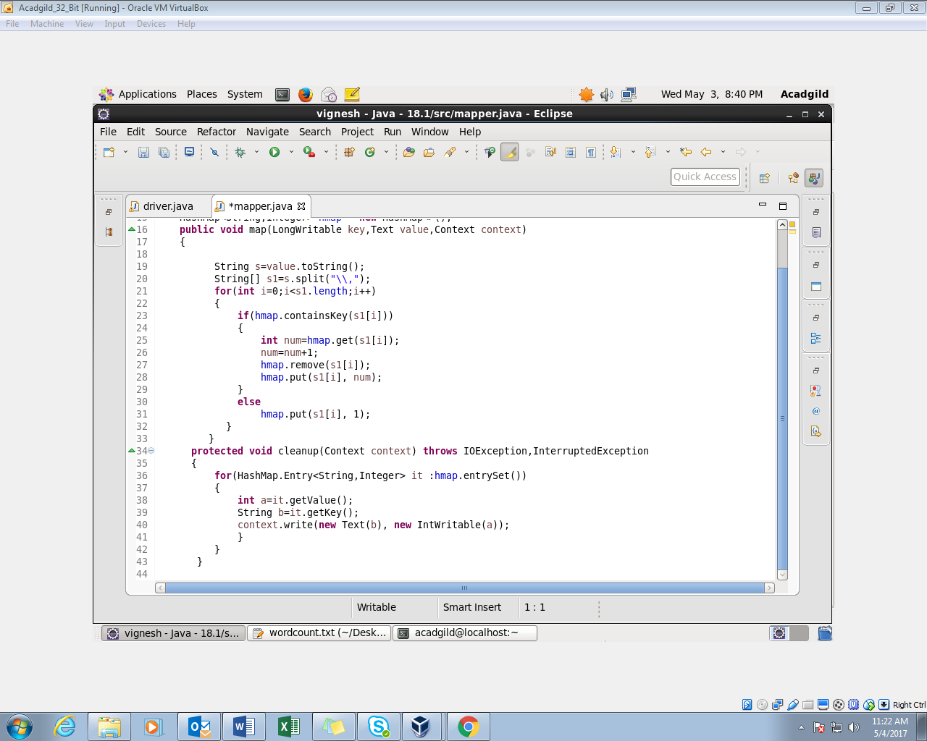

**OUTPUT:**

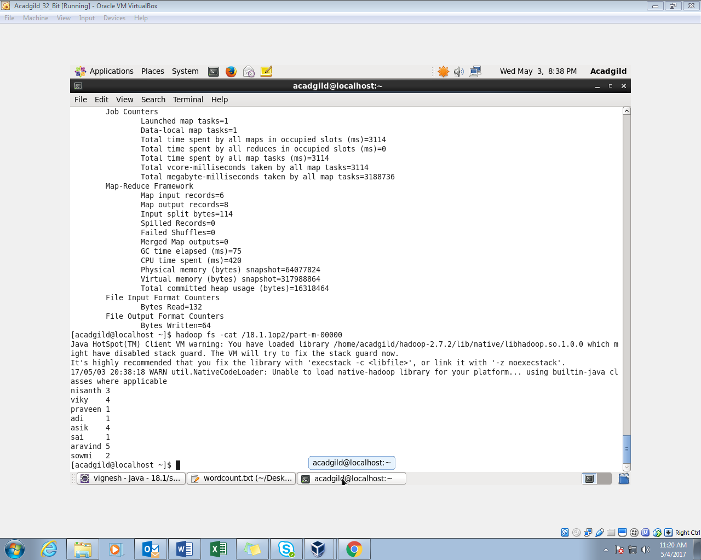

18.1b) Run the map reduce word count program and set the number of reducers to 2 using static configurations.

**INPUT FILE:**

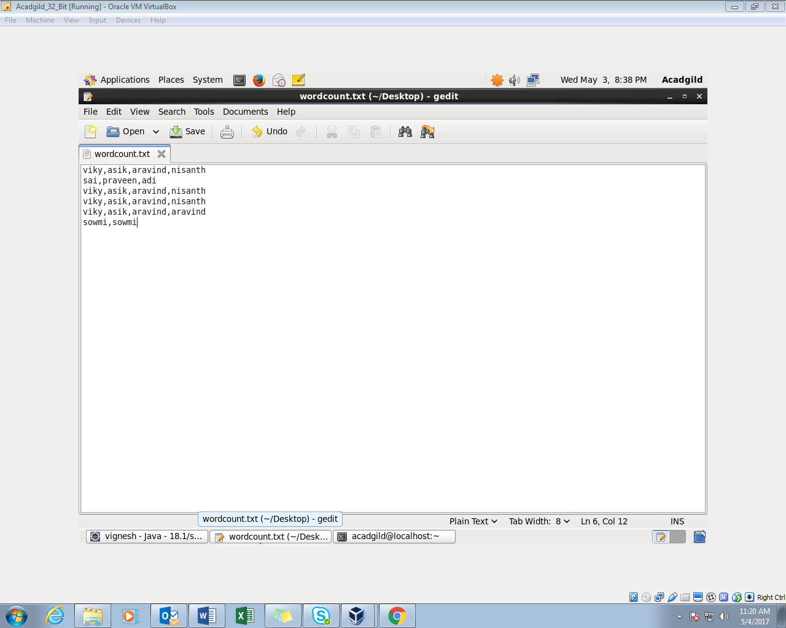

**DRIVER CLASS:**

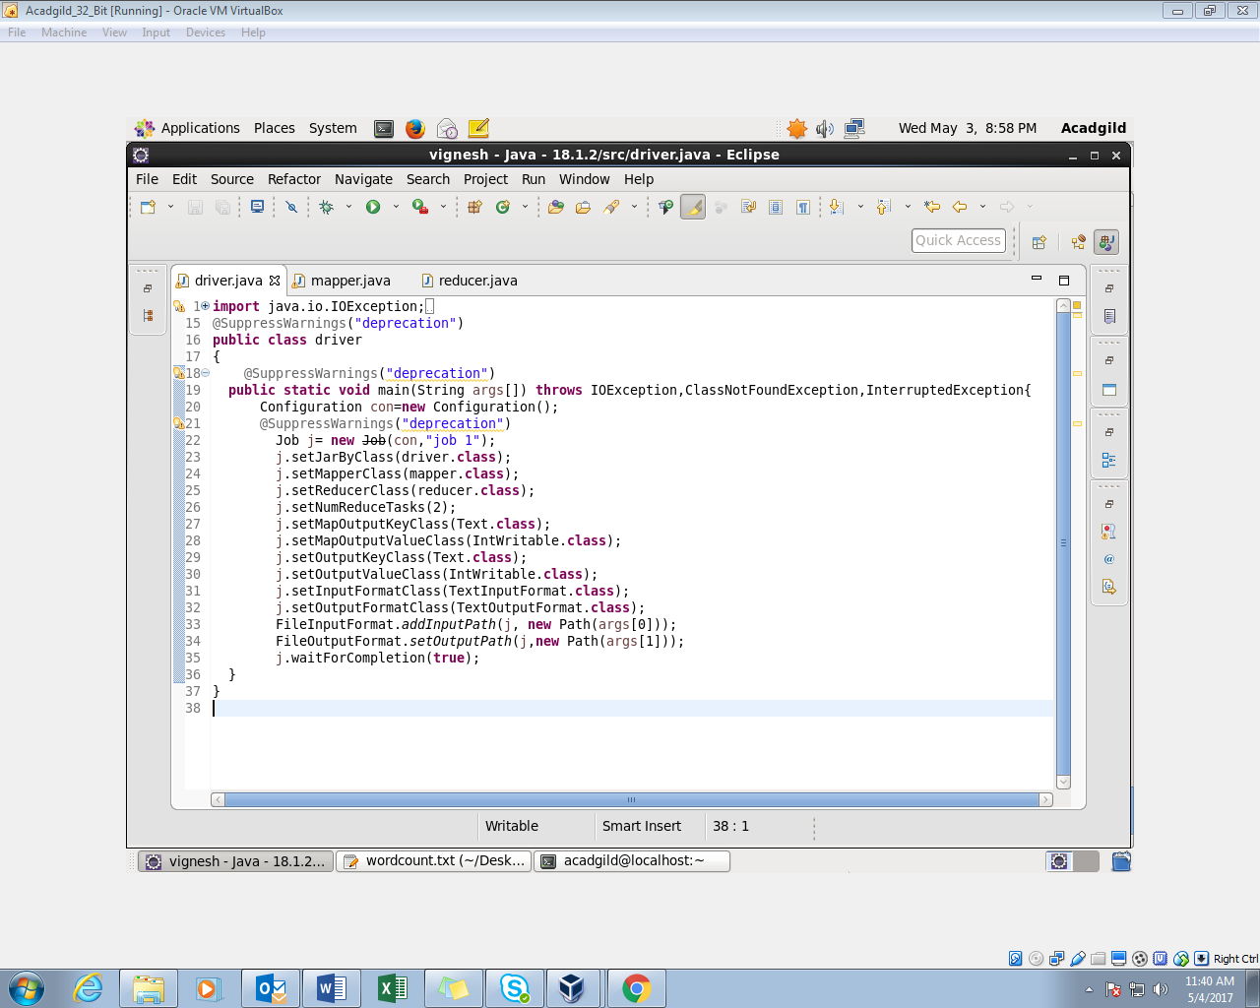

**MAPPER CLASS:**

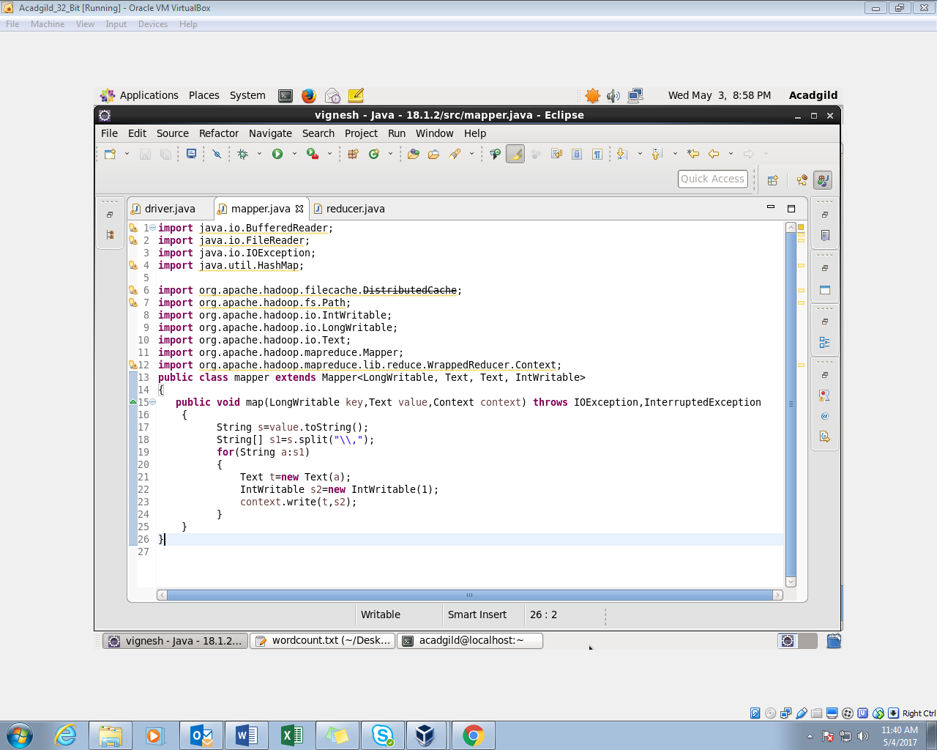

**REDUCER CLASS:**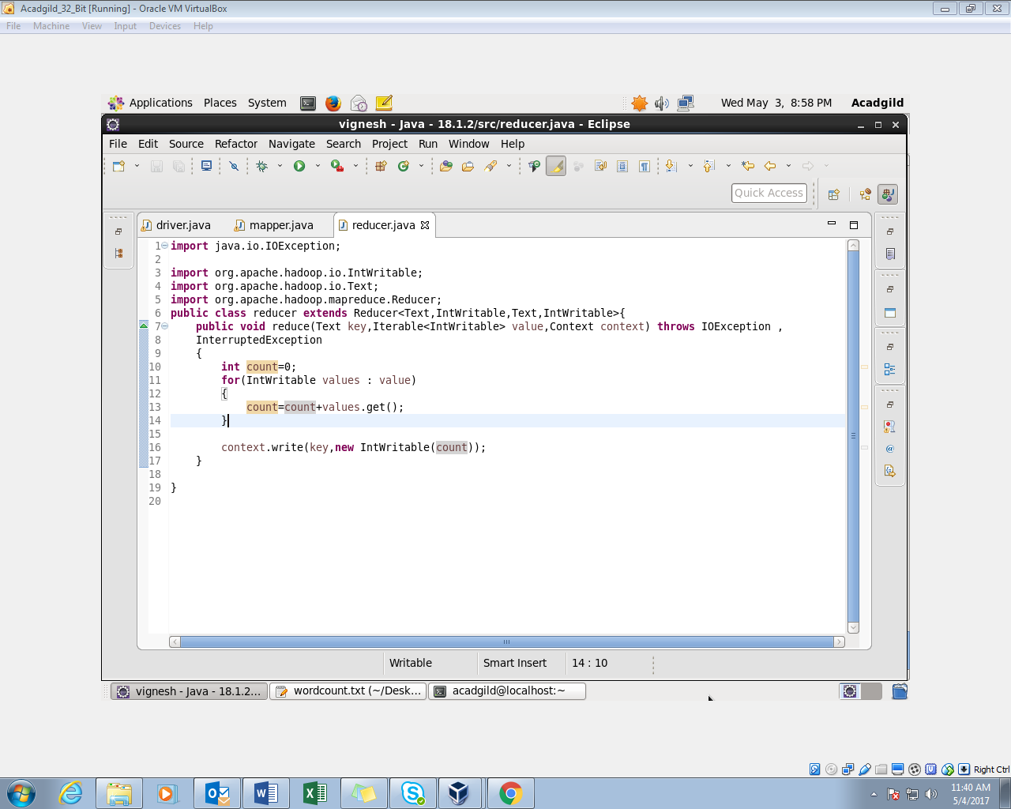

**OUTPUT:**

